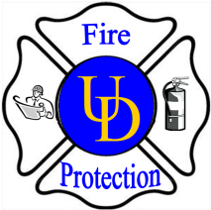
University of Delaware

Environmental Health and Safety

General Services Building Room 132

222 South Chapel Street, Newark, De. 19716

(p)831-8475 (f)831-1528

-Application for Use of Open Flame Devices-

Application MUST be received by EHS office 2 weeks prior to the event date

Please print clearly.

Applicant’s Name:

Applicant’s Organization:

Applicant’s Address:

Applicant’s Email:
Applicant’s Telephone Number: ( ) - Fax: ( ) -
Location where device will be used:
Building Name: Campus:
Room Number:
Date(s) of use:
Hours of use:
Describe in detail the following:
- Reason for request:

- Equipment to be used:

- Open Flame Device:

- Ignition Procedure:

- How close is the nearest smoke detector?

Authorized Signature*: Telephone #:
Print Name of Authorized Signature*: Date:

*Authorized signature must come from building/organization representative and/or staff member

Submit authorized application to Department of Environmental Health & Safety

Revised 9/18/09

