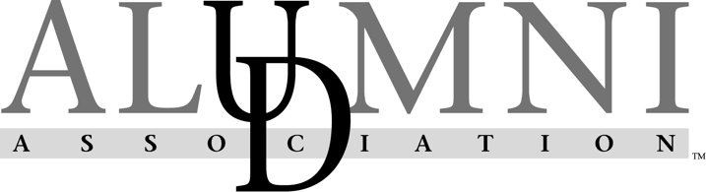
Satellite Assistance Program (SAP)

The Satellite Assistance Program is supported by the Alumni Outreach Committee of the University of Delaware Alumni Association to provide financial assistance to Affinity Alumni Groups or Regional Alumni Clubs for programs, events & projects as they relate to University goals. The University of Delaware Alumni Association is proudly dedicated to engaging our entire alumni community by fostering a tradition of lifelong loyalty and commitment to the University of Delaware. We provide exceptional value and ongoing support to our alumni worldwide.

Program Outline:
- Up to $2,500 per program, event or project may be awarded.
- Funding will not cover alcohol.
- Applications must show how the events are assisting with achieving the University’s goals:
  - Reinforce the UD Brand:
    - Showcase UD faculty and their research.
    - Strengthen the UD network.
  - Partner with Campus departments such as Career Services and Admissions:
    - Offering networking events - include alumni & student interactions.
    - Assisting with admissions yield - host yield events, new student send offs.
  - Addressing ways alumni can engage and stay connected to the University through time, talent and treasure:
    - Educating constituents on how they can help their alma mater and how alumni can give back.
    - Offer events that support the mission of Blue Hens being life-long learners.
  - Showcase the University:
    - Show the UD value-added.
    - Utilize UD Speakers or hosts in order to connect UD experience to the “real world.”

Conditions of Funding:
- Retroactive and late applications will not be considered.
- UDAA must be acknowledged in all marketing materials including website postings, UDaily stories and emails.
- Funded events must be marketed for at least 6 weeks prior to the event.
- Events throughout the year need to be diverse; hitting at least 4 or more of different categories: Social, Formalized Networking, Educational, Cultural, Family-Friendly, Sporting, Service
- Event registration through UDconnection.com is required
- Receipts, final attendance lists, pictures and event recaps must be sent to your UD staff contact within 5 business days of event.

To apply for funding:
- Complete the attached application and approved budget form and e-mail to your UD staff contact.

Applications will be considered on four occasions, according to the following schedule:

*To Staff Liaisons: | Event must take place:
February 1 | June – August
May 1 | September – November
August 1 | December – February
November 1 | March – May
*Staff review is by Staff Liaison and Senior Associate Director before turned into UDAA Liaison.
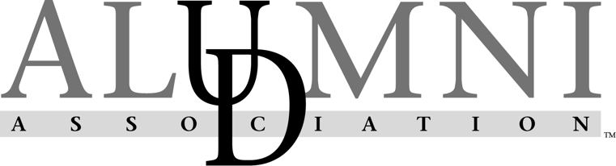

Satellite Assistance Program Application (SAP Application)

Name of Group:
Name of Program/Event:
Date of Program/Event:
Amount Requested: $ |  |  |  |  |  |  |  |  | (not to exceed $2,500)
Total # of Alumni: |  |  |  |  |  | Projected Attendance:
Audience the event will reach (check all that apply)?
☐Alumni ☐Parents ☐Students ☐Friends of the University
Name of Group Contact:
Phone: |  |  |  | E-Mail:
Account Code for Transfer of Funds:
(Applicable if an Affinity Alumni Club is part of a University of Delaware department)

Event Description: Include a detailed description of the program, event, etc. for which your group wishes funding. Include how the program or event fosters the growth of alumni engagement and meets the University’s goals.
  - Reinforce the UD Brand:
    - Showcase UD faculty and their research.
    - Strengthen the UD network.
  - Partner with Campus departments such as Career Services and Admissions:
    - Offering networking events - include alumni & student interactions.
    - Assisting with admissions yield - host yield events, new student send offs.
  - Addressing ways alumni can engage and stay connected to the University through time, talent and treasure:
    - Educating constituents on how they can help their alma mater and how alumni can give back.
    - Offer events that support the mission of Blue Hens being life-long learners.
  - Showcase the University:
    - Show the UD value-added.
    - Utilize UD Speakers or hosts in order to connect UD experience to the “real world.”
Also, include a description of the demographic of the alumni that the event will impact (such as recent graduates, young alumni, alumni with families, etc.)
Is this an annual club event? |  |  | ☐Yes ☐No
If yes, how many years has this event taken place? |  |  |  |  |  |  |  | Past Year Attendance:
Has the group received funding for this event before? ☐Yes ☐No |  |  |  |  | If yes, indicate date(s) & amount:
Outcome/Success of Past Events – Give examples below | - What engagement came out of the event?  - Did volunteer recruitment increase (i.e. new board members sign up)?  - What referrals were made from the event?  - How are you encouraging new attendees? If the event has been held 2 or more years in a row, do you see different group of attendees, or are you seeing the same faces every time?

