ENVIRONMENT AND RESOURCES – UNIVERSITY OF DELAWARE COLLEGE OF HEALTH SCIENCES
The University of Delaware (UD) provides an infrastructure that enhances the impact, scope, and innovation of our research. During the past decade, sponsored activities expenditures at UD have increased to $171.7 million in fiscal year 2020, from $133.4 million in 2011. The Carnegie Foundation for the Advancement of Teaching classifies UD as a research university with very high research activity - a designation accorded less than 3 percent of U.S. colleges and universities. In addition, UD ranks among the Nation’s top 100 universities in federal R&D support for science and engineering. As a state-assisted, privately governed institution, UD offers a broad range of degree programs, including 150 majors and minors and 250 graduate and post-baccalaureate programs. UD’s student body encompasses 18,618 undergraduates, 4,285 graduate students, and 710 students in professional and continuing studies from across the country and around the globe. Among Schools of Allied Health, UD ranked 2nd in fiscal year 2021, as indexed by total NIH funding. There is clear, broad-based support for federally funded research programs at UD.
The College of Health Sciences (CHS) is one of 10 Colleges at the University of Delaware. CHS is made up of 7 units, including 1) Epidemiology, 2) Medical & Molecular Sciences, 3) Behavioral Health & Nutrition, 4) Kinesiology & Applied Physiology, 5) Physical Therapy, 6) Communication Sciences & Disorders, and 7) the School of Nursing. CHS has 153 faculty and 159 staff. Research programs address important societal problems, including pain, aging, sleep, cardiovascular health, neurological diseases, orthopedics, health services research, rehabilitation, women’s and children’s health, and molecular mechanisms of disease. CHS has a particular interest in clinical and translational research, and the University has NIH funded Clinical and Translational Research Program (DE-CTR ACCEL) that supports clinical research. In addition, the University is supported by the federally funded Delaware IDeA Network of Biomedical Research Excellence (INBRE), a collaborative network made up of 6 partner institutions which led by UD. CHS also has an NIH COBRE award in Cardiovascular Health.
In FY20, the College’s sponsored programs totaled $19.3 million. The College is a partner of the Delaware Health Sciences Alliance (DHSA), a partnership of Christiana Care Health System, Nemours, Thomas Jefferson University, and UD. The DHSA is dedicated to conducting research at the forefront of the health sciences that addresses today's most pressing health concerns, providing the finest healthcare education, and improving regional health and health care services.
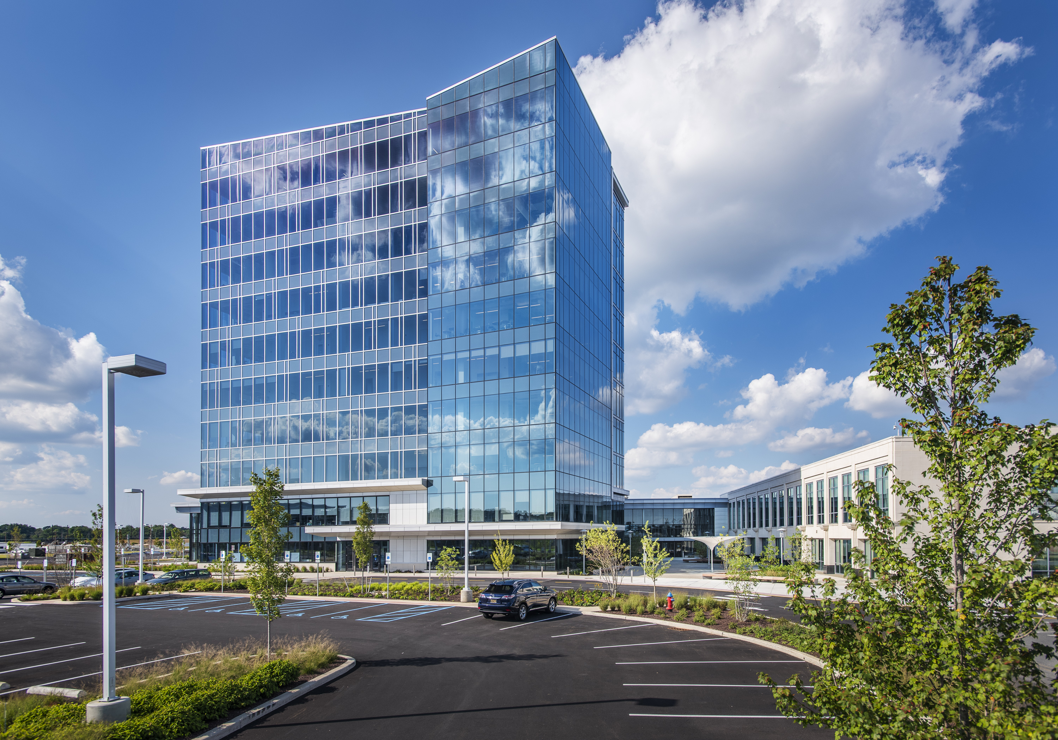
UD’s College of Health Sciences’ Science, Technology & Advanced Research (STAR) Campus and Health Sciences Complex is a multi-disciplinary, collaborative practice, research, and clinical teaching complex devoted to the health sciences. The Health Sciences Complex opened in 2014 and is 106,000 sq ft facility which houses the Physcial Therapy Clinic, the Nurse Magaged Primary Care Center, the Speech-Language-Hearing Clinic, and multiple biomedical research laboratories. The Tower at STAR is a 10-story building with 120,000 square-footage of assignable space that opened in 2018, adjacent to the STAR complex. The Tower at Star additional space at UD to drive research, discovery, and innovation in the region while also helping to educate the next generation of healthcare professionals. Rising from the strong foundation of the STAR Health Sciences Complex, the Tower has allowed for an expansion of basic biomedical and focused research in the areas of diabetes management, sleep, stroke, autism, Parkinson’s, cardiovascular disease, pain and more.
UD Support
Grants Management: The College of Health Sciences grants management office is located on the STAR campus. The team currently consists of one grants manager, three senior grants analysts and one junior grants analyst. They 1) oversee proposal preparation, including organizing the administrative portion of the proposal process for all sponsors and mechanisms; 2) support award management, including set-up, financial oversight and closeout; and 3) interface with UD Research Office, subcontract administrators, and administrators for collaborating non-CHS faculty.
Biostatistics Core: The Biostatistics Core housed within the Epidemiology Program provides statistical support to the College of Health Sciences and collaborators across the University. One of the Biostatistics Core’s primary roles is to provide methodological expertise for use in study design and analysis plans for grant proposals and externally funded research. The Core maintains lead statistical roles in a number of RCT’s and the COBRE on Cardiovascular Health. Core members participate in Delaware-CTR ACCEL’s BERD Core (Biostatistics, Epidemiology, & Research Design) and interface with the University of Delaware’s Data Science Institute.
Currently, the Core’s full-time staff consists of one master’s and two PhD level statisticians, with expertise in study design, including Case Control, RCT’s, Cohort, and Cross Sectional studies; and statistical analyses including Structural Equation Modeling, Mixed Models, Exploratory Analyses, and General and Generalized Linear Models. Core services include Study Design, Statistical Plans and Power Analyses for grants and data analyses for peer-reviewed manuscripts. Additionally, the Core reserves unfunded effort among staff and affiliated graduate students for consultation and future budgeted work.
Center for Human Research Coordination (CHRC): This is a University-wide Core facility focused on supporting University of Delaware researchers with participant recruitment, both on a small and large scale. The core is aimed at improving outreach and diversity in participant recruitment across Delaware and neighboring Maryland and Pennsylvania communities. CHRC coordinates research subject logistics such as screening, scheduling, transportation, and reimbursement. CHRC also provides the university community with data management education, database set-up, repository, maintenance, hardening and security. CHRC supports REDCap across UD, and assisting researchers in building and maintaining patient registries.

Nurse Managed Primary Care Center (NMPCC): This 3,100 sq. foot facility is located in the STAR Complex. The NMPCC partners with UD researchers for a number of research studies in various disciplines. The NMPCCC is staffed with several experienced nurse practitioners that support research studies as well as treat patients in the university and local community. Their services include, but are not limited to, phlebotomy and laboratory analysis, EKG, Stress Testing, VO2max, physical exam and evaluation, medical clearance, on-going evaluation, and medical testing and monitoring of research participants. The NMPCC will provide assistance in enrolling participants for the study.
Information Technology: UD research computing cyberinfrastructure includes many physical and virtual components. Examples include networks, compute servers, mass storage servers, image and video servers, computing sites, videoconferencing and teleconferencing sites and services, application software, cloud-based collaboration tools, survey research tools, data collections and web services, and training resources. The campus-wide network backbone utilizes Gigabit Ethernet and Cisco switches. UD is a member of the Internet2 Abilene project and has an OC-3 (155 Mbs) connection to this nationwide network research vehicle running at OC-48 (2.4Gbs) and OC-192 (10 GBS). The University provides disk space to retain data on the University UNIX systems with direct disk access. Besides network access, the University furnishes large NCS data scanners, printers and data runs, and even magnetic tapes and Bernoulli disks for accessing older data sets.
The University’s campus core IP network is a fully redundant network fabric based on 1-Gbps Ethernet links. The pair of CISCO 6509 core switches each has two 8-port gigabit Ethernet cards. The offices and labs on the main campus are linked to network switches at 100 Mbps. There is access to the University of Delaware’s Library databases. The University library subscribes to more than 270 licensed databases and has three branch libraries in addition to the Main Library. All computers are linked to the University’s computing network via high-speed Ethernet connection and have wireless capability. The University’s Office of Information Technology provides shared drive space to automatically back up and store data. UD offers extensive computing services including graphics, database, and statistical software and 24-hour technical support. The College of Health Sciences also has three full-time IT support staff and several IT interns that ensure local computing needs are met.

