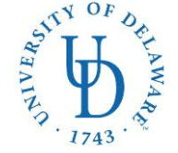

**COLLEGE OF HEALTH SCIENCES—Dept. of Behavioral Health & Nutrition**

**MS IN NUTRITION & DIETETICS/DIETETIC INTERNSHIP (MS/DI)**

26 N. College Ave

023 Carpenter Sports Building

Newark, DE 19716

Ph: (302) 831-3538 Fax: (302) 831-4261

E-mail: [bschwenk@udel.edu](mailto:bschwenk@udel.edu)

**Application Checklist:**

**University of Delaware MS in Nutrition & Dietetics/Dietetic Internship**

* **Local Option**: Please rank your county preferences below. If you are only interested in one county, indicate your first choice only.

____ New Castle County

____ Kent County

____ Sussex County

* **Distance option**

❒ DICAS application submitted online

Applicant’s name (please print) Applicant’s Signature

E-mail address

( )

Phone number State of Residence