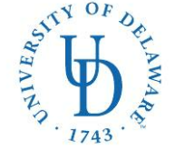
COLLEGE OF HEALTH SCIENCES—Dept. of Health Behavior and Nutrition Sciecnes
MS IN NUTRITION & DIETETICS/DIETETIC INTERNSHIP (MS/DI)
042 Carpenter Sports Building
Newark, DE 19716
Ph: (302) 831-4989
E-mail: aleef@udel.edu
Web: https://www.udel.edu/academics/colleges/chs/departments/hbns/graduate-programs/combined-ms-di/

Application Checklist:
University of Delaware MS in Nutrition & Dietetics/Dietetic Internship

Please rank your county preferences below. If you are only interested in one county, indicate your first choice only.

____ New Castle County
____ Kent County
____ Sussex County
____ Distance
❒ DICAS application submitted online

Applicant’s name (please print) Applicant’s Signature

E-mail address
( )
Phone number State of Residence

