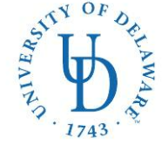
COLLEGE OF HEALTH SCIENCES—Dept. of Health Behavior & Nutrition Sciences
DIETETIC INTERNSHIP
26 N. College Ave
023 Carpenter Sports Building
Newark, DE 19716
Ph: (302) 831-3538 Fax: (302) 831-4261
E-mail: bschwenk@udel.edu

Application Checklist: Local Option
University of Delaware Dietetic Internship

Please rank your county preferences below. If you are only interested in one county, indicate your first choice only.

____ New Castle County
____ Kent County
____ Sussex County

❒ DICAS application submitted online
❒ UD Graduate application submitted online

Applicant’s name (please print) Applicant’s Signature

E-mail address
( )
Phone number State of Residence

