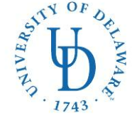
COLLEGE OF HEALTH SCIENCES—Dept. of Health Behavior & Nutrition Sciences
DIETETIC INTERNSHIP
26 N. College Ave
023 Carpenter Sports Building
Newark, DE 19716
Ph: (302) 831-3538 Fax: (302) 831-4261
E-mail: bschwenk@udel.edu

Application Checklist: Distance Option
University of Delaware Dietetic Internship

Check all materials included with this supplementary application packet:

For Office Use Only
Facility/preceptor agreements for:
- Community nutrition rotation 
- Clinical nutrition rotation (must include acute care experience) 

Resumes for:
- Community nutrition rotation preceptor 
- Clinical nutrition rotation preceptor 

Materials submitted online:
- DICAS application submitted online 
- UD Graduate application submitted online 

Applicant’s name (please print) Applicant’s Signature

E-mail address
( )
Phone number State of Residence

