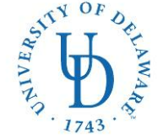
COLLEGE OF HEALTH SCIENCES
DIETETIC INTERNSHIP
042 Carpenter Sports Building
Newark, DE 19716
Ph: (302) 831-4989
E-mail: aleef@udel.edu
Web: www.udel.edu/bhan/dietetic

Application Checklist: Distance Option—Second Round
University of Delaware Dietetic Internship

The following materials should be e-mailed together with this checklist.

For Office Use Only

- Required: Clinical nutrition rotation
  - Preceptor agreement (MUST include acute care experience) 
  - Preceptor’s resume
- Preferred: Community nutrition rotation 
  - Preceptor agreement
  - Resume

Applicant’s name

E-mail address
( )
Phone number

State of Residence

Office Use Only: Date received: _________________________
❒ DICAS application

