Polyglot Play Crossword Puzzle Solution
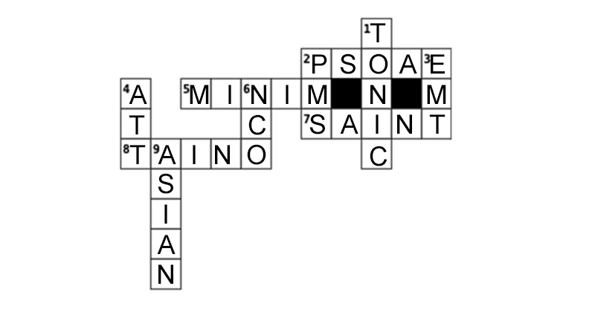

ACROSS
2. Lat. Internal pelvic muscles: PSOAE
5. Paleographic word stroke: MINIM
7. Hagiographic subject: SAINT
8. An extinct Caribbean language: TAINO

DOWN
1. Restorative musical note, or mixed with gin for a similar effect: TONIC
2. Afternoons and Evenings: PMS
3. Provider of out of hospital basic medical care: EMT
4. Multinational telecommunications company: ATT
6. Bootstrapping military member: NCO
9. Language family including Korean, Japanese, Mandarin: ASIAN

