Submission guidelines for the UD Plant Diagnostic Clinic 19 Apr 2021

Contact information for the UD Plant Diagnostic Clinic:
Email: jillp@udel.edu
Phone: (302) 502-1373

We are happy to receive samples! University buildings are still closed to the public until further notice. We are asking you to either submit samples by digital image, mail, or use our physical drop-box on the Newark campus. Details for each option are below.

Digital Images

- Digital images of plant problems for disease diagnosis should be submitted through the local county Extension agent or other designated Extension office personnel.
  - New Castle County: Carrie Murphy (cjmurphy@udel.edu)
  - Kent County: Jake Jones (jgjones@udel.edu) or Blake Moore (rbmoore@udel.edu)
  - Sussex County: Tracy Wootten (wootten@udel.edu)
- Three to four well-focused, quality images that show the pattern of the problem in the location, the overall symptoms on the whole plant, and a close-up image of the symptoms are recommended.
- If a root problem is suspected, dig up and rinse off some roots to photograph.
- The client must fill out the diagnostic form (http://www.udel.edu/007333) as completely as possible. This is a fillable PDF that can be saved and emailed.
- In some cases a digital image is enough for a diagnosis, but we may request a physical sample to ensure an accurate diagnosis.

Mail
- Samples may be sent by mail to the address below, which is checked daily during weekdays.
- We suggest overnighting, or mailing earlier in the week so samples do not sit in transit over the weekend.
- The client must fill out the diagnostic form (http://www.udel.edu/007333) as completely as possible. This is a fillable PDF that can be saved and emailed to jillp@udel.edu, or printed.
- Mail samples to:
Plant Diagnostic Clinic
531 S College Ave
151 Townsend Hall
Newark, DE 19716

Drop-off

- There is a blue cooler chained behind a pillar in front of Townsend Hall, location shown with an “x” in the image below. The box is checked daily on weekdays until 4:30 pm.
- The client must fill out the diagnostic form (http://www.udel.edu/007333) as completely as possible. This is a fillable PDF that can be saved and emailed to jillp@udel.edu, or printed. There are forms in the drop box as well.
531 S College Ave
151 Townsend Hall
Newark, DE 19716

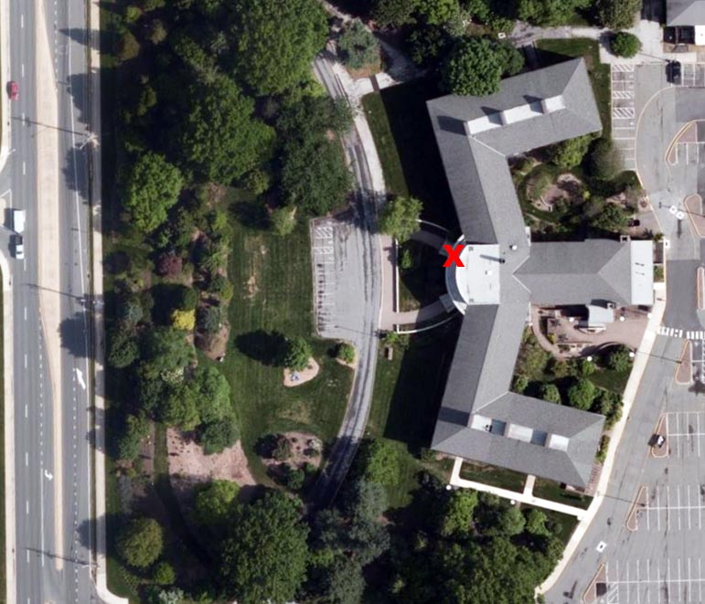

On-site visits: to commercial production operations are an option.

Virtual consultation: is available if you want to set up a video diagnostic call.

