RE-ENROLLMENT CANNOT BEGIN UNTIL AFTER SEPTEMBER 3
Open a web browser and type in: https://de.4honline.com. You will now see the Delaware 4-H Youth Development Log In Page.
- Click "I have a Profile."
- Enter family email address.
- Paste or type your password exactly as sent by 4H online. It is CASE SENSITIVE.

Forgot your password?
Click "I forgot my Password."
Click "Send my Password." Do not close the internet window.
Go to your own email account and find the email sent to you from 4HOnline. It will have your temporary password. If you can’t find it in your Inbox, check Junk Mail. The sender will be “no-reply@4honline.com”
Return to 4H online.

- Choose "Family" from the "Role" drop-down box.
Current members/→
First time logging in
Current members with passwords→
← Do not use!!
- Click "Log In."

- This is a place for your county extension office to share helpful information with you such as newsletters.
- Don’t like your temporary password? Change it here!
- Or you can continue to your family record by clicking on the orange button.

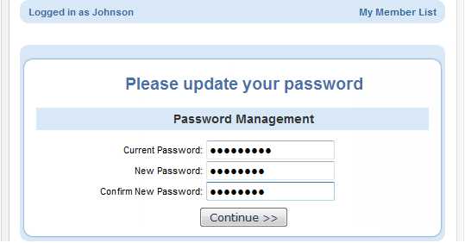
Did you request a new password?
Re-enter current password as sent by 4H Online. Even though the screen looks like it’s been entered, you have to type it into the “Current Password” box.
Enter (twice) a new family password. Click 'Continue.' Your passwords must be a minimum of 8 characters, and must contain 2 of the 3: letters, numbers, symbols.
You will be able to skip these steps if you know/memorize your password for re-entry into the program.

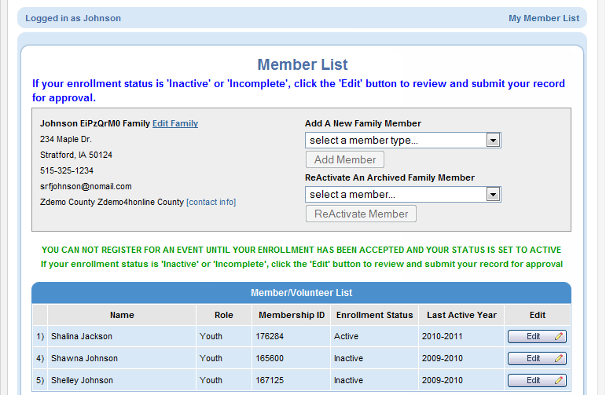
This will take you to the Member List which includes all family members enrolled in 4H: members and volunteers.
Click “Edit” to the right of the “Inactive” member listed. On the Personal Information screen, scroll to the bottom of the page and click “Enroll for (current year)”.
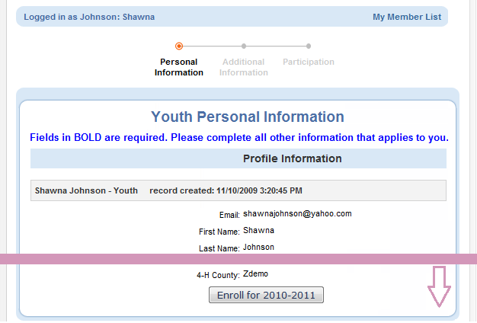

Enroll for 2015-16

Now you will have an editable Personal Information screen as shown at right.
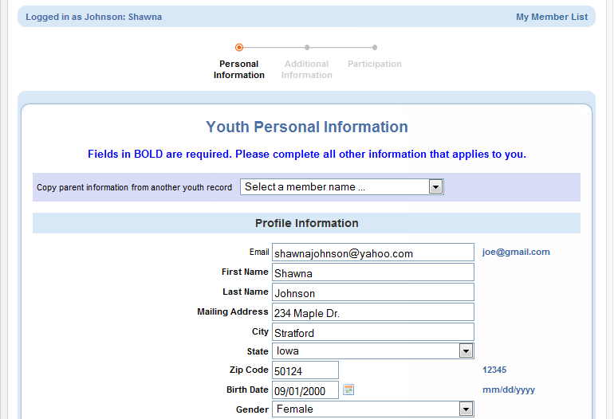
Please complete all information that applies to you.
A few notes:
- Years in 4-H includes the year of 4H that you are entering.
- Ethnicity: You must mark whether you feel you are of Hispanic descent. Other ethnic fields may be checked or mark “prefer not to state.”
- Fill out Residence and Military Service of Family as they apply to your family.
Text messaging: This is optional. Enter a cell number, check the box if you are willing to receive text messages via 4H Online and choose your provider from the list. Texts will be used for last minute meeting notices and other priority information, only from county staff, not auto-generated through the program.
Be sure to enter an emergency contact name and at least one phone number (required fields). This should be someone OTHER than a parent, if possible. Parents are always contacted first, but who should be called if the parents are not available?
When you have completed this page, click "Continue." This brings you to the Additional Information Page.

Authorizations and Releases
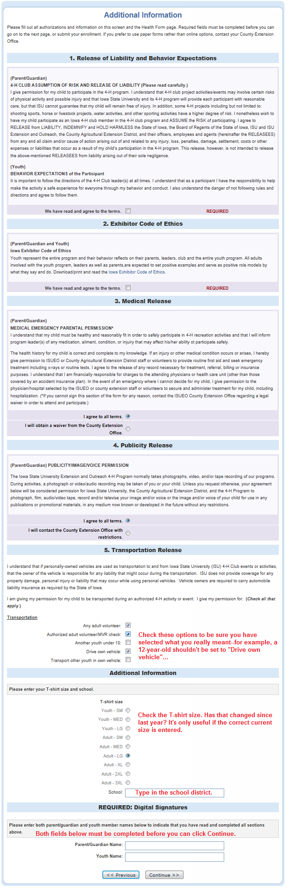
All fields are required. Select an option if there is a choice, or check the “I agree…” box.
Double-check the transportation options that are selected. Are these accurate?
Additional Information
Double-check the t-shirt size. Is this still correct, or has that changed since last year?
Type in the school district name in the box provided.
Digital Signatures
Enter both the name of the parent/guardian and the youth. Both fields must be filled in before you can click the Continue button.
By logging on with your user ID and password, you are indicating that you are the correct person to agree to the terms.
When you have completed this page, click "Continue." This brings you to the Health Page.

Health Form- Check all health conditions and allergies that apply. Any health issues not listed need to be entered in the text boxes.
When you have completed this page, click "Continue."

Your primary club should be listed at the bottom in the Club List. If you have involvement with a secondary club, locate it in the drop-down box and select it. Be sure to click "Add club."
Click "Continue" to enroll in projects.
Choose your primary club in the drop-down box (each time you select a project).
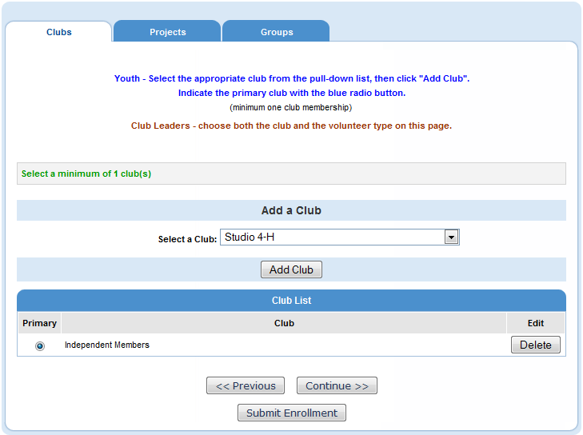
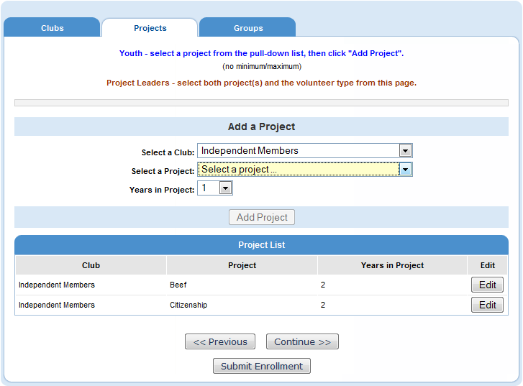

Then, select a project area in the 2nd drop-down box. Select your years in this project area.
If you wish to NOT continue in a current project area listed, click “Edit”, then “Delete”. If you wish to add a Project Leader status, click “Edit”, then “Youth Project leader” from the drop-down box and click “Update.”
When you have selected all of your projects, click “SUBMIT ENROLLMENT”.
When you have completed your re-enrollment, click “Log out” in the upper right-hand corner.
You may return to this page by logging in, at any time during the year—to view or edit your information.

