4th H for Health
November Edition
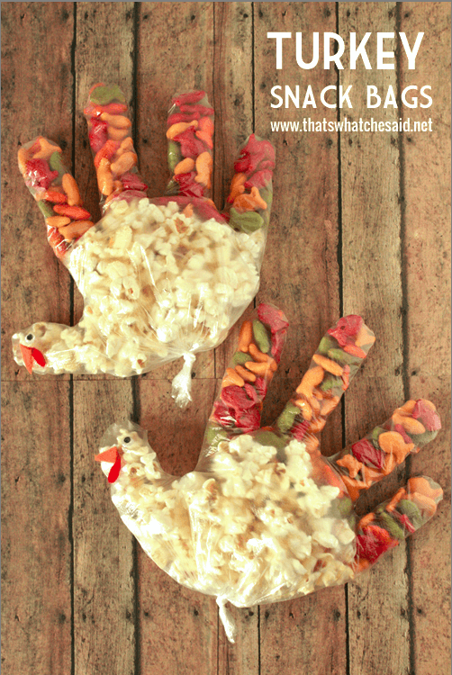
Turkey Snack Bags:

Materials:
Clear Plastic Gloves
Popcorn
Goldfish
Red and Orange Felt
Googly Eyes

Directions:
- Line up your Goldfish in each finger of the glove
- Fill the rest with Popcorn
- Twist the bottom of the glove and tie it in a knot
- Glue on googly eyes on the thumb finger
- Cut an orange triangle from the orange felt and an oval from the red felt
- Glue the orange triangle to the thumb for a beak
- Glue red oval on thumb for the wattle

Enjoy!

Bonus Challenge:

Plogging/ Pliking!

Want to help the environment while improving your physical wellness? Join Delaware 4-H and Consequences of Habit in plogging, an activity that combines jogging and picking up litter. In support of Delaware Goes Purple, we are hosting a plogging campaign, where youth can pick up litter while jogging/walking in their local neighborhoods and parks. This campaign raises awareness of recovery while improving environmental, physical, emotional, and social wellness for all.

The goal of this event is to pick up as much trash as possible while you are out jogging (plogging) or hiking (pliking). Participants have between October 15 - November 30 to complete this event(s). Over the month, weigh how much trash you or your club collect. Clubs who send their total weight collected will be included in a raffle for a $100.00 Amazon gift card.
Plogging for Purple Environmental Event

The first 150 participants will receive a t-shirt, gloves, and a pick up stick per group if needed to use when plogging. ​Email your total weight of trash to krjohn@udel.edu and include a picture of your family and friends plogging to be registered for the gift card raffle.

