Overview: ANFS Peer observation and assessment process May 2013
Peer review of the teaching process can:
  - improve the quality of teaching and learning through open discussion and systematic critique
  - help cultivate a collegial atmosphere through dialogue about common issues of concern
  - provide a more comprehensive evaluation of teaching by examining aspects not covered by student evaluations
  - provide data for promotion and appraisal purposes

The process can be requested by the department chair and /or a faculty member at any time in his/her career, however the results of the observation and assessment are shared only between the observers and the faculty member, unless the faculty member chooses otherwise. The process is a three step process, outlined in more detail in the following pages:

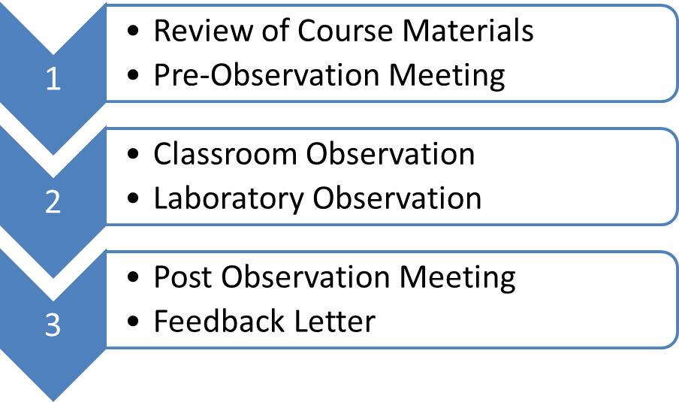

Peer observation and assessment process
The process can be initiated by either the department chair or the faculty member.

- Pre-observation meeting to review syllabus, objectives, handouts, learning strategies, enrollment, and teaching pedagogy (occurs 1 week before classroom observation).
  - Faculty member should provide the materials identified above to peer observers at least 1 week prior to this meeting for review
  - Peer observers should utilize the Questions for the Instructor (page 3) and the syllabus to complete the Course Syllabus Checklist (page 4) and Section 1 table (page 7)
    - Suggest a team of two peer observers, one chosen from the department C&C committee and other, the faculty member’s choice. The pre and post-observation meetings can be held with both observers, but suggest each observer attend a different lecture (or one a lecture and the other a lab if appropriate).
- Classroom observation: the observation should last the entire length of the lecture or lab
  - Peer observer notes positive aspects of the lecture/lab and identifies potential areas for improvement. It would be helpful to read the items in the Section 2 table prior to the observation. Section 2 table (page 8) should be completed as soon as possible after attending the class. The peer observer should not complete the table during the lecture. Three main focus areas for discussion with the lecturer should be identified.
- Post-observation /assessment meeting (within 1-2 weeks)
  - Faculty member should reflect on the lecture and complete Section 3 (page 11) prior to the meeting with the peer observer
  - Peer observers should give the opportunity to the faculty member to discuss his/ her reflection on the lecture and discuss strategies to improve lecture content, delivery, and assessment. Peer observer should provide positive feedback and constructive evaluation points, limited to 3-5 main focus areas.
  - Peer observers should provide final comments and recommendations (limited to 2-3). A confidential written letter is subsequently provided to the faculty member highlighting the major aspects of the peer assessment process, including the strengths of the lecturer and the 3-5 main areas of focus.

Questions for the Instructor:

Please describe your class in terms of enrollment trends; is it required or not; taken by majors or non-majors;

Why did you choose this lecture to be assessed? Is this the first time you are teaching this lecture? If no, what changes have you made to this lecture over the past few times you taught it?

What questions/concerns do you have? What would you particularly like feedback on?

Where is similar content taught in the curriculum? Have you contacted other instructors to determine exactly what they cover? What impact has this had on your lecture and/or student outcomes?

How does this lecture’s content fit within the entire course (e.g. one out of several lectures on the same topic)?

Have you planned any in-class learning activities? If yes, what lecture objectives will these activities meet? Share how these activities facilitate student learning.

Is there anything else that you would like the observer to know about this lecture or the class?

To be filled out by Observer prior to classroom observation
Course Syllabus Checklist (items to consider)
Course details: Included this?

- Course name, number, & term
- When and where the class meets
- Instructor’s name, office location & phone number
- Instructor’s office hours
- Lab or discussion section(s) time & place
- Teaching Assistant’s name, office location, office hours, contact information

Course overview:
- Course description (e.g., course catalogue)
- Teaching approaches / activities (How will students learn the material?
In-class, out-of-class? Online? Hybrid?)
- Learning goals (what will students know, be able to do as a result of
taking the class?)
- Related, what skills will students develop?
- How does the course fit within the program of study?
- How do the course goals support the program goals?
- How do the course goals align with the general education goals?

Course requirements:
- Course prerequisites (what prior knowledge, skills do students need for success?)
- Textbooks and other required materials
- Detailed description of how grades are calculated
- How will student assessment occur? (tests, quizzes, homework, papers)
- How do assignments, exams relate to learning goals?
(e.g., why weekly quizzes: how do they support student learning?)
- Grading policies: How will assignments be graded? Rubrics to guide assignment
development, clarify expectations?
- Class management policies: What is expected from the students?
(Attendance, makeup exams, late policy, academic honesty, participation,
extra credit, cell phones & personal computer usage during class, clickers)
- Course calendar: In what sequence will the course content be taught?
e.g., exam dates, due dates for major projects, other special dates (guest speaker,
field trip), required readings, service-learning component, internships
Other information:
- Recommended readings
- How will students receive timely feedback on their performance?
(Instructor/TA? Self assessment? Peer review? Online-Sakai? In-class?)
- Related, how will students be informed about their progress and grades?
(Sakai?)
- What resources are available to assist students? (Online lecture notes,
study guides, sample quizzes, TA, study groups, Academic Enrichment Center,
Writing Center)
- How will students be able to provide feedback about their learning experience?
(e.g., student feedback early in the term, midterm? Short written feedback)
Also consider
- Are assignments connected to learning goals and teaching methods?
- How detailed and explicit should the syllabus be?
- Will there be some flexibility built into the schedule?
- Is the syllabus “user friendly?”
- Is the language encouraging, does it invoke excitement for the course, does it communicate instructor passion for the material, concern for student learning?

Section 1: Pre-observation visit
The instructor should provide lecture materials (handouts, syllabus, resources, etc.) at least 1 week prior to this meeting

- Not applicable 2. Needs Improvement 3. Effective 4. Highly Effective

To be filled out by the Observer (based on materials provided) prior to classroom observation
 | Score | Comments
- Course objectives are clearly stated in the handout/syllabus
- Course objectives align with the overall course goals
- Handout material appears to be relevant to lecture objectives
- Lecture outline and organization are logical
- Reading list is provided and relevant to lecture objectives
- Planned in-class activities reflect appropriate lecture objectives
- Planned assessment strategies are consistent with lecture objectives
- Instructor appears well prepared for class

Section 2: Classroom Observation Items

Course: _________________ Date: ___________________
Consider each teaching element below and evaluate the teaching skills of the instructor by placing a check mark under the term best describing your evaluation of the instructor's actions. Add comments to support your evaluation. Provide at least a summary evaluation in each category, and evaluations / comments on individual points where you feel you have observed enough to make them.
- Not Applicable 2. Needs Improvement 3. Effective 4. Highly Effective
Class Organization  The instructor: | Score | Comments
1. Started class on time.
2. Introduced lesson (overview or focusing activity)
3. Paced topics appropriately.
4. Sequenced topics logically.
5. Related lesson to previous or future lessons or assignments.
6. Summarized or reviewed major lesson points.
7. Ended class on time.
Summary

Presentation  The instructor: | Score | Comments
8. Presented or explained content clearly.
9. Used good examples to clarify points.
10. Varied explanations to respond to student questions or needs for clarification.
11. Emphasized important points.
12. Used graphics or visual aids or other enhancements to support presentation.
13. Used appropriate voice volume and inflection
14. Presented information or led discussions with enthusiasm and interest.
15. Responded appropriately to student behaviors indicating boredom or confusion.
Summary

Class Interactions  The instructor: | Score | Comments
16. Encouraged student questions.
17. Asked questions to monitor student understanding.
18. Waited sufficient time for students to answer questions.
19. Provided opportunities for students to interact together to discover/discuss or practice content points.
Summary

Mastery of Content  The instructor: | Score | Comments
20. Presented content at an appropriate level for the students.
21. Presented material relevant to the purpose of the course.
22. Demonstrated command of the subject matter.
Summary

Instructor Attitudes  The instructor: | Score | Comments
23. Showed enthusiasm for the content.
24. Showed respect for student questions and answers.
Summary

Course Documents  The instructor: | Score | Comments
25. Posted office hours, was accessible.
26. Provided an appropriate course syllabus (see checklist).
27. Gave appropriate examinations and assignments.
28. Distributed other necessary information.
29. If appropriate for the courses, developed or maintained web-based materials such as a Sakai site, use of UD-Capture or other on-line materials.
30. Used e-mail and/or discussion board to interact with students.
Summary

Notes:

Section 3: Post observation meeting

The instructor should be prepared to discuss items below at this meeting

Instructor’s self-reflection on the lecture:

How do you think the class went?

Is there anything you wanted to accomplish but were unable to do so? If yes, what was it and was it critical? What would you do differently next time to accomplish it?

In your opinion what went really well? Can you provide evidence that it went well?

In your opinion what did not go well? Can you provide evidence that it did not go well?

For items on the pre-observation and classroom observation forms where you gave yourself a rating of “Needs Development” or “Need Significant Development” what are your plans for improvement?

Did the lecture affect or change your plans for assessment?

Did you collect student evaluations of this lecture? What did students report to be the most effective and least effective aspects of your lecture?

What other constructive feedback did you receive through student evaluations? How do you plan to address it?

