CONSERVE Educational Materials

Materials Description:
- Provide educator
  - Learning objectives
  - Lesson concepts
  - Education content standards supported
  - Student educational materials
  - Implementation recommendations
  - Grading rubric
- Provide background information for students and question prompts to establish understanding, make connections to self, and encourage critical thinking
- Educator can pull from question bank either for one subject or we can recommend combined subject questions to create story and cross connections
- With higher grade levels, student questions increasingly problem-based less than ‘right there’ type of questions
Lesson Essential Concepts (uniform across K-12)
- The water on Earth is limited to what we have now. It cannot be created.
- Water sources on Earth
- Human uses of water
- Sources of water used in residences and businesses
- Current sources of water used to grow food
- Water used to irrigate food crops is affected by: quantity (climate/ precipitation/populous demand), quality (salinity/impurities)
- Every time we use water, we add impurities (chemical/biological) and need to remove them before reusing the water.
- Current problems related to drought, water purity, increasing demand
- How various members of society help address problem (individuals including students/families, researchers, producers of clean water and safe food, government regulators)
- Potential consequences of not solving/minimizing problem
Learning Objectives (tiered across K-12)
- Student will understand…
- Student will …
Lesson Essential Questions (tiered across K-12)
- How can I …

Elementary School Materials and Possible Question Bank
Students provided a page of appropriate reading level text that:
- Reviews water cycle
- Illustrates water sources
- Describes problem
- Describes approaches (broad, not specific) to address problems
- Describes possible consequences if not address problem
Students provided at least two visuals
- Diagram (possibly geography/water sources/cycle)
- Data to support text (possibly graph on water usage/quality/availability)
Educator can pull from question bank either by subject or by combining subjects to create story and cross connections

CONSERVE Educational Materials for Elementary School
Purple Pipes
The Earth’s surface is about 71% water that is found in oceans, rivers, lakes, snow, and glaciers, and under the ground. Most of the Earth’s water is salty; only 3% is not salty or considered freshwater. People use water to drink, for personal hygiene, recreation, transportation, energy, growing plants, and to care for animals. Of these many uses of water, humans cannot live healthfully without safe water to drink and to grow food; for these purposes, we rely on freshwater.
You may recall the water cycle in which water on the Earth’s surface evaporates, condenses as clouds, and returns to the Earth’s surface as precipitation. People use water in another type of cycle in which we collect water from the environment, clean it, use it for a variety of purposes, reclean it after use, and return it to the environment for later reuse.
When we pull water from streams or under the ground, it may contain debris such as soil or leaves. We need to remove these before we use the water. When we use water in our homes and businesses, we usually add other types of contaminants to the water. Although soapy wash water or flushed toilet water may go down a drain, it is not forever discarded and replaced by new unused water. Instead, the soap and other contaminants must be removed before the water is returned to the environment and recycled for our later reuse. We cannot make more water, so we must take good care of the water that we have.
Certain types of contaminants may be found in water and can make humans sick. Biological, or living, contaminants may include certain types of microbes, organisms that are too small to see without a microscope, which is a laboratory tool used to view microbes. These microorganisms can include bacteria, viruses, and parasites, sometimes referred to as germs. Most microbes are harmless, even helpful to humans, but some can make us ill if we consume them. These microbes can come from animal waste or even improperly treated human waste. Chemical contaminants can include things that people purposely mix with water such as soap or other contaminants that accidentally end up on the ground and mix with rainwater, such as oil that drips onto the ground from a car leak.
Water collected before and after human use is treated to remove visible debris by a process called flocculation, or clumping of debris for easier separation. Water is then filtered, a process in which water is passed through layers of sand, which traps smaller debris. Water may also be treated with disinfectants to destroy biological contaminants. Communities have laws to ensure that the water we drink is cleaned properly to protect our health, and that the water we use is cleaned properly before being returned to the environment.
One of human’s most critical uses of water is to grow food. Plants draw in water found in the soil through their roots, and up into their stems in order to grow. Water also touches the outer surfaces of plants from rainfall or splashing up from the ground. We eat these plants, so we want the water that contacts the plant to be clean and safe.
Different plants need different amounts of water to grow. Ideally, rain would fall reliably in the exact amount and at the exact time needed for plants to grow. However, this doesn’t always happen. Sometimes there is too little rain for plants to grow. Sometimes it rains so much that crop fields can flood with not only the rainwater, but also ground contaminants that wash into fields with the rain. The amount of rain that falls varies by different geographical regions and can also vary from year to year.
When there is not enough rainfall for crops, we need to water plants to keep them growing in order to make our food. This watering process is called irrigation. Irrigation can be done in different ways, such as spraying water on top of plants or watering closer to the roots in the ground. You may even do this for a plant at your home. For large fields of food crops, water used for irrigation is pulled from freshwater surface sources, such as streams, or from groundwater. The water is then pumped through pipes that connect to systems that spray water on top of crops for spray irrigation systems. Alternatively, for drip irrigation systems, the pipes connect to tubes that are punctured with holes to allow water to leak out, and the tubes are placed on the ground near crops. The process of moving water from under the ground or from streams to irrigate crops is similar to the process communities use to move surface water to treatment facilities that clean water and send it through pipes to our homes. Our reliance on groundwater and surface water to make water to drink and to irrigate food crops is a critical reason to keep our environmental water clean.
But what if there is so little rainfall that even the streams and ponds have very low water levels? This condition is called a drought. When there is a drought, individuals and communities may reserve use of available water for their most critical needs and avoid use of water for less important activities. For example, community leaders may ask residents to avoid washing cars during a drought, so that the little water available can be conserved for drinking or to grow food. Some communities may seek water from other regions to help in times of water shortages.
Obtaining enough clean water to irrigate crops is already a challenge due to droughts and environmental contamination. This challenge will become greater as the human population continues to increase because the water usage and the quantity of food needed to feed everyone are also expected to increase. Action is needed now to address current and anticipated challenges with clean water shortages so that communities are prepared and able to respond to their evolving needs. The high demand on water resources has prompted scientists to explore the usefulness of sources of water other than groundwater and surface water for irrigation of crops. An example of an alternative water source is the water that is used to wash vegetables before produce is delivered to grocery stores. Scientists are studying what types of contaminants are in this type of wash wastewater and new methods to remove the contaminants to make the water safe enough to reuse for irrigation of food crops. Some communities already capture used water and clean it enough to be safe for application to agricultural land, although it may not quite meet legal standards for drinking water. This reclaimed or recycled water is distributed through pipes that are frequently painted the color purple so that community members will know appropriate uses of the water.
Possible figure examples: water cycle, water reclaimation, irrigation, water types and use
http://heightstechnology.edublogs.org/files/2009/01/water-cycle.jpg
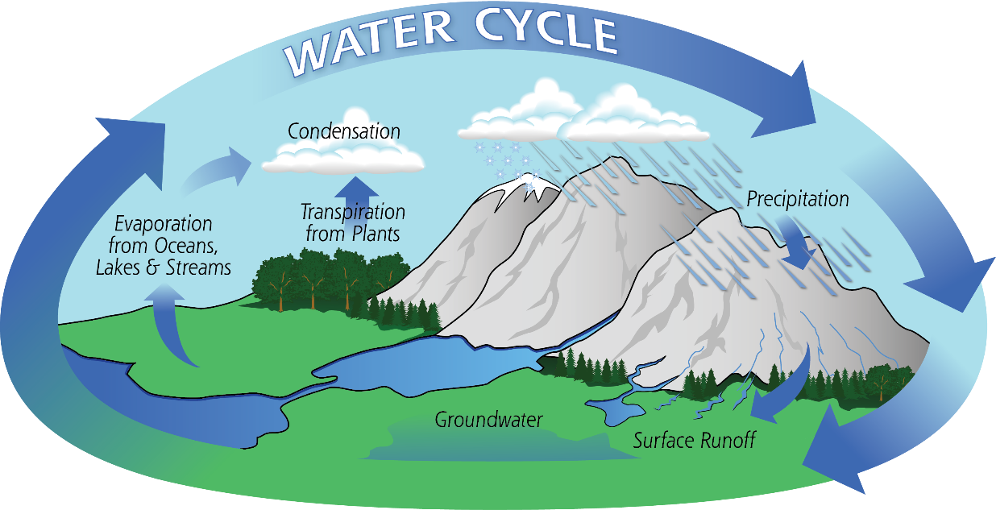
http://gpm.nasa.gov/education/sites/default/files/article_images/Water-Cycle-Art2A.png

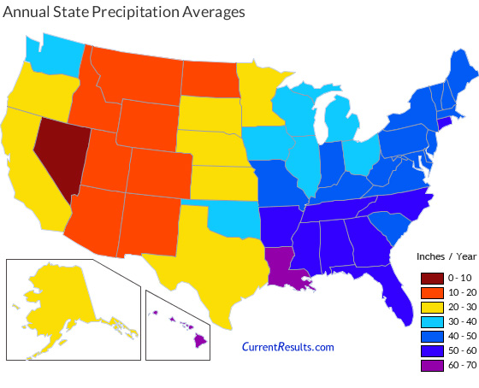
https://www.currentresults.com/Images/Maps/usa-state-precipitation-year.jpg

Possible Questions – Organized by Education Content Standard (Some overlap)

English Language Arts/Literacy (Common Core)
Education Content Standard Supported | Question Bank
Recognition of text type and purpose | - The genre of this text is:  - Opinion  - Realistic fiction  - Information  - Fantasy
Reading Standards for Informational Text K-5, Craft and Structure, Grade 4  Determine the meaning of general academic and domain-specific words or phrases in a text relevant to a grade 4 topic or subject area | - According to the text, the word irrigation means:  - Too little rainfall  - Process of watering crops when there is no rainfall  - A type of contamination  - A type of saltwater
Reading Standards for Informational Text K-5, Key Ideas and Details, Grade 4  Determine the main idea of a text and explain how it is supported by key details; summarize the text | - Restate the main problem(s) described in the text. Cite evidence from the text to support your response. {or make multiple choice format }  Water must be cleaned before and after human use.  Crops must be irrigated when there is too little rain.  Increased water demands require new sources of irrigation water.
Writing Standards K-5, Research to Build and Present Knowledge, Grade 4  Recall relevant information from experiences… | - List five ways you use water every day.
Writing Standards K-5, Research to Build and Present Knowledge, Grade 4  Draw evidence from literary or informational texts to support analysis, reflection, and research. | - Complete the following statement with supporting information from the text:  Clean water is important to my food because __________________________________________________________________.
Reading Standards for Informational Text K-5, Integration of Knowledge and Ideas, Grade 4 Interpret information presented visually, orally, or quantitatively … and explain how the information contributes to an understanding of the text in which it appears | - From the list of provided words, match the appropriate word to the parts of the following diagram. (illustration of environment, illustrates water sources, irrigation processes, student labels parts marked with arrows)  - Groundwater  - Surface water  - Precipitation  - Spray irrigation  - Drip irrigation
Reading Standards for Informational Text K-5, Integration of Knowledge and Ideas, Grade 4 Interpret information presented visually, orally, or quantitatively … and explain how the information contributes to an understanding of the text in which it appears | - Which statement is not supported by the text and Figure # that illustrates the typical yearly precipitation amounts across the United States of America?  - Nevada has the lowest precipitation amounts  - Hawaii and Louisiana have the highest precipitation amounts
Reading Standards for Informational Text K-5, Key Ideas and Details, Grade 4  Determine the main idea of a text and explain how it is supported by key details; summarize the text | - According to the text, scientists are researching new sources of irrigation water because _________________________________________________________________.

Science Standards (NGSS)
Education Content Standard Supported | Question Bank
4-ESS3-1. Earth and Human Activity, Disciplinary Core Ideas: Energy and fuels that humans use are derived from natural sources, and their use affects the environment in multiple ways. Some resources are renewable over time, and others are not. | - List five ways you use water every day. Ask four other people to list five ways they use water every day. Draw bars on the provided graph to illustrate the data.  (provide xy axis with y axis labeled number of people and x axis labeled water use)
3-5-ETS1-2. Engineering Design, Crosscutting Concepts, Influence of Engineering, Technology, and Science on Society and the Natural World: Engineers improve existing technologies or develop new ones to increase their benefits, decrease known risks, and meet societal demands. | - According to the text, the word irrigation means:  - Too little rainfall  - Process of watering crops when there is no rainfall  - A type of contamination  - A type of saltwater
5-LS2-1. Ecosystems: Interactions, Energy, and Dynamics, Crosscutting Concepts, Systems and System models: A system can be described in terms of its components and their interactions. | - From the list of provided words, match the appropriate word to the parts of the following diagram. (drawing of environment, illustrates water sources, irrigation processes, student labels parts marked with arrows)  - Groundwater  - Surface water  - Precipitation  - Spray irrigation  - Drip irrigation
3-ESS3-1. Earth and Human Activity, Crosscutting Concepts, Connections to Nature of Science: Science is a human endeavor. Science affects everyday life.  5-LS2.A. Ecosystems: Interactions, Energy, and Dynamics, Disciplinary Core Ideas: Interdependent relationships in ecosystems: The food of almost any kind of animal can be traced back to plants. Organisms can only survive in environments in which their particular needs are met. | - Complete the following statement with supporting information from the text:  Clean water is important to my food because __________________________________________________________________.
5-LS2.A. Ecosystems: Interactions, Energy, and Dynamics, Disciplinary Core Ideas: Interdependent relationships in ecosystems: The food of almost any kind of animal can be traced back to plants. Organisms can only survive in environments in which their particular needs are met.  5-LS2.B: Ecosystems: Interactions, Energy, and Dynamics, Disciplinary Core Ideas: Cycles of matter and energy transfer in ecosystems: matter cycles between the air and soil and among plants, animals and microbes as these organisms live and die. Organisms obtain gases, and water, from the environment, and release waste matter (gas, liquid, or solid) back into the environment. | - According to the text, scientists are researching new sources of irrigation water because _________________________________________________________________.
3-ESS2-2. Earth’s Systems, Disciplinary Core Ideas: Climate describes a range of an area’s typical weather conditions and the extent to which those conditions vary over years. | - Which statement is not supported by the text and Figure # that illustrates the typical yearly precipitation amounts across the United States of America?  - Nevada has the lowest precipitation amounts  - Hawaii and Louisiana have the highest precipitation amounts
4-ESS3-1. Earth and Human Activity, Crosscutting Concepts, Connections to Engineering, Technology, and Applications of Science, Interdependence of Science, Engineering, and Technology: Knowledge of relevant scientific concepts and research findings is important in engineering. | - Different methods are used to irrigate crops. Two of these methods include overhead irrigation that sprays a mist of water over crops and drip irrigation that releases water from tubing close to the ground around the crops. Which of these two methods do you think is likely to lose more water due to evaporation? Explain your answer.
3-5-ETS1. Engineering Design, Crosscutting Concepts, Influence of Engineering, Technology, and Science on Society and the Natural World: 1) People’s needs and wants change over time, as do their demands for new and improved technologies; 2) Engineers improve existing technologies or develop new ones to increase their benefits, decrease known risks, and meet societal demands.  5-ESS1. Earth’s Place in the Universe, Crosscutting Concepts, Scale, Proportion, and Quantity: Natural objects exist from the very small to the immensely large. | - The following graph illustrates the number of microbes remaining in water samples after being filtered through two cylinders packed with different materials designed to trap microbes. The data represent the amount of microbes that are released from the cylinders along with the water. Which method is more effective at removing microbes from the water? Explain how you came to this conclusion.  (provide graphs of breakthrough curves or input/output bar graph data)
Mathematics (Common Core)
Education Content Standard Supported | Question Bank
Measurement and Data, Grades 3 to 5: Represent and interpret data.  Geometry, Grade 5: Graph points on the coordinate plane to solve real-world mathematical problems | - List five ways you use water every day. Ask four other people to list five ways they use water every day. Draw bars on the provided graph to illustrate the data.  (provide xy axis with y axis labeled number of people and x axis labeled water use)
Measurement and Data, Grades 3 to 5: Represent and interpret data. | - Which statement is not supported by the text and Figure # that illustrates the typical yearly precipitation amounts across the United States of America?  - Nevada has the lowest precipitation amounts  - Hawaii and Louisiana have the highest precipitation amounts
Operations and Algebraic Thinking, Grade 4: Use the four operations with whole numbers to solve problems | - If an irrigation water source contains 10,000 of a certain type of microbe in 1 ml of water and the legal maximum number of this microbe allowed for use of the water for irrigation of a food crop is 100 microbes in 1 ml, how many microbes must be removed from the water to make it legal to use?
Measurement and Data, Grades 3 to 5: Represent and interpret data. | - The following graph illustrates the number of microbes remaining in water samples after being filtered through two cylinders packed with different materials designed to trap microbes. The data represent the amount of microbes that are released from the cylinders along with the water. Which method is more effective at removing microbes from the water? Explain how you came to this conclusion.  (provide graphs of breakthrough curves or input/output bar graph data)
Geometry, Grade 3: Reason with shapes and their attributes  Geometry, Grade 5: Classify two-dimensional figures into categories based on their properties | - A cylinder is filled and packed tightly with small grains of sand to make a water filter. The bottom of the cylinder has a screen with tiny holes that allow water to pass through but not sand or large particles trapped by the sand. Water containing particles of varying size is poured into the top of the cylinder. If the diameter of the holes in the screen at the bottom of the cylinder is 0.1 mm, which of the following particles in the water will be trapped in the filter? (maybe include illustration)  - Pebble – diameter 1 mm  - Soil particle – diameter 0.1 mm  - Bacterium – diameter 0.001 mm  - Virus – diameter 0.00003 mm
Operations and Algebraic Thinking, Grade 4: Use the four operations with whole numbers to solve problems | - If ## amount of water is needed to grow enough of a food crop for 100 people, how much water is needed to grow enough of the same food crop for 1,000,000 people?
Operations and Algebraic Thinking, Grade 4: Use the four operations with whole numbers to solve problems | - If ## amount of water is needed to grow {fill in crop and quantity}, how much water is needed to grow {fill in some multiple quantity of same crop}?
Operations and Algebraic Thinking, Grade 4: Use the four operations with whole numbers to solve problems | - If a water filtration system can clean ## gallons of water per hour, how many hours will it take to clean ## gallons of water?
Operations and Algebraic Thinking, Grade 4: Use the four operations with whole numbers to solve problems | - If an acre of a food crop field requires ##gallons of irrigation water and a water filtration system can clean ## gallons of needed water, how many filtration systems are needed to clean enough water for ## acres of land for the food crop?
Measurement and Data, Grades 3 to 5: Represent and interpret data. | - According to Figure #, what is the predicted human population for the year 2050? {include graph}

Social Studies (State of DE)
Education Content Standard Supported | Question Bank
Geography 4-5a: Students will apply knowledge of topography, climate, soils, and vegetation … to understand how human society alters, and is affected by, the physical environment. | - List five ways you use water every day. Ask four other people to list five ways they use water every day. Draw bars on the provided graph to illustrate the data.  (provide xy axis with y axis labeled number of people and x axis labeled water use)
Geography K-3a: Students will understand the nature and uses of maps, globes, and other geo-graphics.  Geography K-3a: Students will distinguish different types of climate …  Geography 4-5a: Students will understand the reasons for the locations of human activities …. | - Which statement is not supported by the text and Figure # that illustrates the typical yearly precipitation amounts across the United States of America?  a. Nevada has the lowest precipitation amounts  b. Hawaii and Louisiana have the highest precipitation amounts  c.  d.
Geography 4-5a: Students will apply knowledge of topography, climate, soils, and vegetation … to understand how human society alters, and is affected by, the physical environment. | - From the list of provided words, match the appropriate word to the parts of the following diagram. (drawing of environment, illustrates water sources, irrigation processes, student labels parts marked with arrows)  - Groundwater  - Surface water  - Precipitation  - Spray irrigation  - Drip irrigation
Civics 4-5a: Students will understand that governments … exist for many purposes … | - If an irrigation water source contains 10,000 of a certain type of microbe in 1 ml of water and the legal maximum number of this microbe allowed for use of the water for irrigation of a food crop is 100 microbes in 1 ml, how many microbes must be removed from the water to make it legal to use?
Civics K-3a: Students will understand that American citizens have distinct rights, responsibilities, and privileges. | - If your community had limited supply of water due to a drought, what uses of water would you avoid until the water supply increased? How would you continue to use water during a drought?
Civics K-3b: Students will understand that positions of authority carry responsibilities and should be respected.  Civics 4-5a: Students will understand that governments … exist for many purposes … | - If you were a community leader and your region had limited supply of water due to drought, what would you do to assure there was enough water to meet basic needs?
Civics K-3b: Students will understand that positions of authority carry responsibilities and should be respected. | - What role do you think scientists have in solving clean water scarcity issues?
Geography K-3a: Students will understand the nature and uses of maps, globes, and other geo-graphics. | - According to Figure #, what is the predicted human population for the year 2050?
Geography 4-5a: Students will apply knowledge of topography, climate, soils, and vegetation … to understand how human society alters, and is affected by, the physical environment. | - Water used to irrigate food crops must meet the same safety standards no matter where the water is obtained. Reclaimed water is checked # (frequency) for the presence of chemicals or microorganisms that could be harmful to people. Environmental waters are tested ##. If you needed irrigation water for food crops, which water would you use and why?

Health Education (State of DE)
Education Content Standard Supported | Question Bank
Standard 1.1: Describe the relationship between healthy behaviors and personal health | - List five ways you use water every day. Ask four other people to list five ways they use water every day. Draw bars on the provided graph to illustrate the data.  (provide xy axis with y axis labeled number of people and x axis labeled water use)
Standard 1.3: Describe ways to prevent communicable diseases  Standard 1.1: Describe the relationship between healthy behaviors and personal health | - Complete the following statement with supporting information from the text:  Clean water is important to my food because __________________________________________________________________.
Standard 5.1: Identify health-related situations that might require a thoughtful decision. | - If your community had limited supply of water due to a drought, what uses of water would you avoid until the water supply increased? How would you continue to use water during a drought?
Standard 5.1: Identify health-related situations that might require a thoughtful decision.  Standard 1.3: Describe ways in which a safe and healthy … community environment can promote personal health. | - If you were a community leader and your region had limited supply of water due to drought, what would you do to assure there was enough water to meet basic needs?
Standard 2.5: Describe ways technology can influence personal health. | - From the list of provided words, match the appropriate word to the parts of the following diagram. (drawing of environment, illustrates water sources, irrigation processes, student labels parts marked with arrows)  - Groundwater  - Surface water  - Precipitation  - Spray irrigation  - Drip irrigation
Standard 1.3: Describe ways to prevent communicable diseases | - If an irrigation water source contains 10,000 of a certain type of microbe in 1 ml of water and the legal maximum number of this microbe allowed for use of the water for irrigation of a food crop is 100 microbes in 1 ml, how many microbes must be removed from the water to make it legal to use?
Standard 1.3: Describe ways to prevent communicable diseases  Standard 2.5: Describe ways technology can influence personal health.  Standard 7.2: Consider a variety of healthy practices to maintain or improve personal health. | - The following graph illustrates the number of microbes remaining in water samples after being filtered through two cylinders packed with different materials designed to trap microbes. The data represent the amount of microbes that are released from the cylinders along with the water. Which method is more effective at removing microbes from the water? Explain how you came to this conclusion.  (provide graphs of breakthrough curves or input/output data)
Standard 3.1: Recognize trusted adults and professionals who can help promote health.  Standard 2.5: Describe ways technology can influence personal health. | - What role do you think scientists have in solving clean water scarcity issues?
Standard 1.3: Describe ways in which a safe and healthy … community environment can promote personal health. | - Restate the main problem(s) described in the text. Cite evidence from the text to support your response. {or make multiple choice format}  Water must be cleaned before and after human use.  Crops must be irrigated when there is too little rain.  Increased water demands require new sources of irrigation water.

Acknowledgement:
This material is based upon work that is supported by the National Institute of Food and Agriculture, U.S. Department of Agriculture, under award number 2016-68007-25064. Any opinions, findings, conclusions, or recommendations expressed in the publication are those of the author(s) and do not necessarily reflect the view of the U.S. Department of Agriculture.

