Foodborne Illness Outbreak Investigation
Case Study: Hepatitis A Virus
Teacher Version

Six physicians in County A, Pennsylvania have notified the Pennsylvania Department of Health of 20 individuals who presented symptoms of Hepatitis A infection and tested positive for hepatitis A virus (HAV). The PA Dept of Health has consulted the United States Centers for Disease Control and Prevention (CDC) for assistance with an investigation to determine the source of the outbreak.

As an epidemiologist with the CDC, it is your job to determine how widespread the outbreak has become, the source of infection, and means to halt the outbreak. This involves interviewing food borne illness victims, determining common exposures, determining what potential vehicles (food, individuals, environmental samples, other) should be tested, interpreting laboratory results, helping to determine necessary actions to stop the outbreak, and helping to determine actions necessary to prevent future outbreaks.

You interview the patients to determine a possible common source of infection. From these interviews, you are able to identify one commonality: all patients had eaten at Restaurant A within 2 to 6 weeks prior to the onset of symptoms. Were their illnesses the result of consumption of a one type of contaminated food, several different contaminated foods, the restaurant environment, and/or exposure to an infected restaurant employee? Or is the restaurant a purely coincidental commonality and not the source of infection?

Most of the patients are showing signs of recovery; however, three individuals have since died as a result of their illnesses. Additional cases of hepatitis in the region have been reported. More people are likely to get sick if you cannot identify the source quickly and recommend actions necessary to stop the outbreak. The public is counting on you to solve this case.

- You realize you must gather more data and the best means to do so is to interview the newly identified patients as well as additional patrons of Restaurant A. You ask the owner of Restaurant A for the names of patrons who had eaten at the establishment. Based on the incubation period for hepatitis A, from what dates should patron names be pulled from credit card receipts?

Answer: Approximately 2 to 6 weeks prior to onset of illnesses (approximately August 24 to November 3)

- Aside from talking with patrons who contracted Hepatitis A, who else should you interview to help determine what could have been the source of the illness versus what menu items or other exposures did not cause illness?

Answer: Restaurant employees and restaurant patrons from the same time period who did not contract hepatitis A virus to serve as negative case controls.

- You have been provided with names of interviewees. Based on the information you already have (Table 1), prepare a list of interview questions to gather more of the same type of information from the new interviewees.

Answer:
  - Health condition and symptoms?
  - Onset date of symptoms?
  - Have you ever been diagnosed with Hepatitis A infection, and if so, when?
  - Have you ever been vaccinated against Hepatitis A infection?
  - Have you recently been exposed to someone diagnosed with or exhibiting symptoms of Hepatitis A illness?
  - Have you eaten at Restaurant A? If so, when?
  - What did you eat at Restaurant A?
  - With whom did you eat at Restaurant A?
  - Do you work at Restaurant A? If so, please provide your work schedule from the past 60 days.
  - Food/beverage intake history in past 6 weeks?
  - Prior health conditions?
  - Have you traveled in the past 6 weeks?

- Using the set of questions you developed, conduct interviews with those individuals identified by the owner of Restaurant A. Compile interview responses in Table 1.

Answer: Interview actors selected by teacher. Scripted answers are provided in Appendix A and compiled in Table 1.

- Graphs are helpful to quickly visualize patterns in large data sets. Using data from Table 1, prepare the following:
  - A bar graph of the number of patients who developed symptoms for the dates of symptom onset.
  - On the same graph as plotted for part a, plot the number of patients who developed symptoms for the dates dined at Restaurant A.
  - Table 2 completed with data on the foods consumed by all individuals and whether the foods were positively or negatively associated with illness.

Answer: Provided in Table 2 and bar graph in Figure 3.

- Based on the bar graph developed for exercises 5a and 5b and individual interview responses, could a food handler carrying hepatitis A virus employed by Restaurant A have been the original source of the outbreak? Why or why not?

Answer: Restaurant employees diagnosed in this outbreak could not have been the original source of the contamination because onset of employees’ symptoms occurred at a date later than that of initial cases accounting for overlapping incubation periods.

- One of the individuals diagnosed with Hepatitis A infection is a food handler in another restaurant, Restaurant B. What additional measures should be taken to protect the public?

Answer: All individuals with symptoms of HAV infection should be advised of measures they should take to prevent spreading the disease. These individuals should wash hands after using the restroom and should not prepare foods for others. The public should be notified of possible exposure at Restaurant B with information on relevant dates eaten at restaurant, whether or not cases have stemmed from this restaurant, and treatment options.

- News of the outbreak and the postulated link to Restaurant A has hit news sources including newspapers, radio, television, and the internet. As a result, numerous individuals other than those sought during the interviews have contacted their doctors, public health professionals, and/or attorneys with concerns they may also be victims in this food borne illness outbreak. Review the symptoms and circumstances of the cases presented in Table 3, and determine which individuals may be additional victims of food borne illness due to this particular outbreak versus which individuals are not likely to be cases associated with this outbreak. Provide an explanation for your assessment on each individual.

Answer:
Individual 1: No indication that victim of this outbreak. Symptom and duration not consistent with HAV infection. Onset and date eaten at Restaurant A not consistent with other cases of this outbreak.
Individual 2: Possibly victim of this outbreak. Should be tested for HAV infection and interviewed furthered.
Individual 3: While date at Restaurant A in line with other cases, incubation period and duration not consistent with HAV infection. Not likely victim of this outbreak.
Individual 4: Symptoms, time period, and exposure consistent with possible secondary case of outbreak (possibly contracted from close contact with sick family member). Individual should be evaluated further as possible secondary victim of outbreak.
Individual 5: Symptoms consistent with HAV infection, but time period and exposure route not clear with other victims. Individual should be tested and interviewed further. Other illnesses with similar symptoms should not be overlooked.

- If today’s date is November 24, who may benefit by receiving immune globulin shots?

Answer: Individuals who were exposed to HAV within the past two weeks (since November 10) may prevent the onset of symptoms by receiving immune globulin injections. None of the individuals listed in Table 1 are candidates for this treatment, but anyone who has been exposed to infected individuals since November 10 may benefit by preventative treatment.

- From the data compiled in Table 2, calculate the odds ratio to determine what foods are positively associated with illness?

Answer: Data in Table 2.

- What would you want to have tested for Hepatitis A contamination?

Answer: As determined by odds ratio in question 10, foods positively associated with illness (nachos, salsa) and their individual ingredients, preferably from unopened containers, if possible, to help determine point of contamination. Note that for illnesses with long incubation periods or for which a perishable food item was implicated, food samples may not be available for testing.

- Give a reason why would you not necessarily want to have all foods tested.

Answer: Testing is time consuming and costly. Time spent testing foods not reasonably associated with illness could slow the determination of the true source of illness and subsequently delay actions needed to remove contaminated source and prevent additional cases.

- In any outbreak, when there are multiple foods associated with illness, what could be the reasons for several foods being implicated?

Answer: Common ingredient in each of the menu items, cross contamination between foods, common processing setting for different companies’ products, infected food handler contaminating multiple foods, secondary case of illness from close contact with infected individual rather than ingestion of contaminated food at original source.

- Laboratory data for various foods consumed by Restaurant A patrons are presented in Figures 1 and 2. Two laboratory tests were conducted to detect HAV contamination. These tests include detection of genetic material specific to viable as well as nonviable HAV (Figure 1), and cell culture assay to show infectivity of viable HAV (Figure 2).

  - Do the laboratory results support your hypothesis on which foods were associated with illness? Explain your response.

Answer: (Depends on previous answers) The data in Figures 1 and 2 indicate presence of HAV genetic material and infectious HAV, respectively, in salsa and green onions. Nacho chips, tomatoes and peppers were negative for HAV contamination. Green onions are likely the source of contamination of salsa as the tomato and pepper ingredients were negative for HAV.

  - Can you draw any conclusions on which specific ingredient(s) may be HAV-contaminated?

Answer: Salsa and green onion samples give a band with PCR and show cytopathic effect in cell culture.

Note to teacher: PCR is used for outbreak investigations due to rapid turnaround time for results. Demonstration of cytopathology in cell culture assay is not required.

- If it is concluded that a product grown by one company, processed by another, and served at Restaurant A is the vehicle for hepatitis A infection, provide an opinion statement on who is responsible for contamination. Provide an opinion statement on who should be held financially accountable (grower, distributor, food service, other) for expenses associated with the outbreak including:
  - Individuals’ medical expenses, lost wages
  - Costs associated with determining source of outbreak (epidemiologist wages, lab tests, etc.)
  - Expenses associated with recall and destruction of food

Answer: Opinion

- Hepatitis A vaccinations are available. The vaccine is administered intramuscularly in two doses 6 months apart. The cost for each shot is approximately $100. The vaccine protects individuals from illness such that the virus cannot replicate to sufficient numbers to cause disease symptoms. The vaccine also protects others indirectly because the virus is not shed in large numbers in the feces of exposed, vaccinated individuals.
  - Please state your opinion on whether or not restaurant employees should be vaccinated and explain the reason(s) for your opinion.
  - Please state your opinion on whether food handlers at the farm level should be vaccinated and explain the reason(s) for your opinion.
  - If you recommend vaccination of food handlers, state your opinion on whether vaccination should be voluntary or required for employment.
  - If shots are to be administered, in your opinion, who should be financially responsible for the shots?

Answer: Opinion

- Prepare a 60-second television news piece that informs the public of the critical information related to the case.

Answer: Suggested for inclusion: source of contamination, relevant time exposures, number individuals affected, region individuals affected, basic facts about hepatitis A virus, symptoms, treatment, how to prevent spread, what to do if concerned about exposure or if develop some symptoms, and reliable resources for more information. No sensationalism.

- Prepare a 15-minute presentation for the class giving an overview of case study.

Table 1. Data from Interviews with Individuals
Individual | Gender | Age (yrs) | Symptoms | Date Symptom Onset | Date Dined at Restaurant A | Employee, Patron, Close Contact | Consumed at Restaurant A | HAV vaccinated | Special Health Concerns | Previously infected with HAV | Current  Health Status
1 | Female | 4 | A, N, V, F, J | Oct 14 | Oct 3 | Patron | N/S, R, T, I | No | NK | No | Deceased
2 | Female | 32 | N, V, J | Oct 30 | Oct 3 | Patron | N/S, C | No | NK | No | Recovering
3 | Male | 34 | N, V, J | Oct 29 | Oct 3 | Patron | N/S, B, R, C | No | NK | No | Recovering
4 | Female | 8 | A, N, V, F, J | Oct 16 | Oct 3 | Patron | N/S, Q, I | No | NK | No | Recovering
5 | Male | 22 | A, N, V, F, J | Oct 31 | Oct 3 | Patron | N/S | No | NK | No | Recovering
6 | Male | 23 | A, N, V, F, J | Oct 31 | Oct 3 | Patron | N/S | No | NK | No | Recovering
7 | Male | 26 | N, V, J | Nov 1 | Oct 3 | Patron | N/S | No | NK | No | Recovering
8 | Male | 24 | N, V, J | Oct 31 | Oct 3 | Patron | N/S | No | Alcoholic | No | Deceased
9 | Female | 50 | N, V, J | Oct 31 | Oct 4 | Patron | Q, C, F | No | NK | No | Recovering
10 | Female | 52 | N, V, J | Nov 1 | Oct 4 | Patron | Q, C, I | No | NK | No | Recovering
11 | Male | 28 | N, V, J | Oct 31 | Oct 4 | Patron | N/S, T, R | No | NK | No | Recovering
12 | Female | 27 | N, V, J | Oct 31 | Oct 4 | Patron | N/S, Q, R | No | NK | No | Recovering
13 | Male | 44 | A, N, V, F | Nov 8 | Oct 5 | Patron | C, I | No | NK | No | Poor
14 | Male | 16 | A, N, V, F | Nov 10 | Oct 5 | Patron | N/S, T | No | NK | No | Poor
15 | Male | 15 | N, V, J | Oct 30 | Oct 5 | Patron | N/S, T | No | NK | No | Recovering
16 | Female | 70 | N, V, J | Nov 1 | Oct 6 | Patron | N/S, R, F | No | Cancer | No | Deceased
17 | Female | 41 | N, V, J | Oct 30 | Oct 6 | Patron | N/S, B, R | No | NK | No | Poor
18 | Female | 10 | N, V, J | Oct 30 | Oct 6 | Patron | N/S, T | No | NK | No | Recovering
19 | Female | 12 | A, N, V, F | Oct 30 | Oct 6 | Patron | N/S, T | No | NK | No | Recovering
20 | Male | 41 | A, N, V, F | Nov 22 | Oct 7 | Employee | N/S, B, R | No | NK | No | Poor
21* | Male | 27 | None | NA | Oct 3 | Patron | Q, C | No | NK | No | Good
22* | Female | 20 | None | NA | Oct 6 | Patron | N/S, C | No | NK | No | Good
23* | Female | 22 | None | NA | Oct 6 | Patron | Q, B, R, F | No | NK | No | Good
24* | Male | 19 | None | NA | Oct 5 | Employee | T, R, I | No | NK | No | Good
25* | Female | 17 | None | NA | NA | Employee | None | No | NK | No | Good
26* | Female | 20 | None | NA | Oct 4 | Patron | N/S, C | No | NK | Yes | Good
27* | Male | 35 | None | NA | Oct 3 | Patron | N/S, C | Yes | NK | No | Good
* Data gathered by students through mock interviews
Symptoms Key: A, anorexia; N, nausea; V, vomiting; F, fever; J, jaundice
Food Key: N/S, nachos/salsa; R, rice; Q, quesadilla; T, taco; B, burrito; C, chili; F, flan; I, fried ice cream
NA, Not applicable
NK, None known

Table 2. Foods Served at Restaurant A and Association with Illness
Food | # Ate and Sick | # Ate and Not Sick | # Not Eat and Sick | # Not Eat and Not Sick | Odds Ratio
Nachos/Salsa (N/S) | 17 | 3* | 3 | 4 | 7.56
Burrito (B) | 3 | 1 | 17 | 6 | 1.06
Rice (R) | 7 | 2 | 13 | 5 | 1.35
Quesadilla (Q) | 4 | 2 | 16 | 5 | 0.78
Chili (C) | 5 | 4* | 15 | 3 | 0.25
Taco (T) | 6 | 1 | 14 | 6 | 2.57
Flan (F) | 2 | 1 | 18 | 6 | 0.67
Fried Ice Cream (I) | 4 | 1 | 16 | 6 | 1.5
* Two of whom either previously had HAV infection or were vaccinated for HAV.
Odds Ratio = [(#Ate and Sick) ÷ (#Not Eat and Sick)]
[(#Ate Not Sick) ÷ (#Not Eat and Not Sick)]

Table 3. New Cases - Related to Outbreak?

Individual | Symptoms | Symptom Onset | Symptom Duration | Date Eaten at Restaurant A | Current Health Status
1 | Diarrhea | Sept 15 | 2 days | Aug 30 | Good
2 | Vomiting, jaundice | Nov 5 | Nearly gone | Oct 4 | Recovering
3 | Vomiting, diarrhea | Oct 15 | 3 days | Oct 5 | Good
4 | Nausea, vomiting, fever, abdominal pain | Nov 25 | Ongoing | NA, mother of sick teen who ate at Restaurant A on Oct 5 | Poor
5 | Vomiting, fever, abdominal pain, jaundice | Dec 5 | Ongoing | NA, no known contact with sick patron, employee | Poor

Figures 1 and 2. Laboratory Data from Food Products Consumed at Restaurant A

Figure 1. PCR (polymerase chain reaction) results visualized in gel. PCR creates multiple copies of selected piece of genetic material unique to organism of interest. The base sequence and length of the genetic piece to be copied are known. Sufficient numbers of copies are made during PCR such that they can be detected and visualized by a chemical reaction with DNA. The sample containing copies of the genetic material are filled in wells created in the gel. An electric current is applied to make the sample move through the gel based on size. Samples containing small pieces move faster while larger pieces move slower because passage through the gel is more difficult. This method is used to detect the presence of specific genetic material in a sample of food, but does not necessarily indicate whether the genetic material came from live or dead organisms.

Lane 1 2 3 4 5 6 7 8 9 10
Lane
1 DNA size ladder
2 None loaded
3 None loaded
4 Negative control
5 Positive control
6 Salsa
7 Green onion
8 Tomato
9 Pepper
10 Nacho chips

Figure 2. Cytopathology test for infectious HAV. Cells that are susceptible to HAV infection can be grown in the laboratory in flasks. Healthy cells appear growing side by side in a monolayer and are well adherent to the plastic surface on which they are grown (Figure 2A). If cells are exposed to infectious HAV, a cytopathic effect will be visible, that is, the cells will look unhealthy or dead. Infected cells may look raised and/or detached from the plastic surface (Figure 2B).

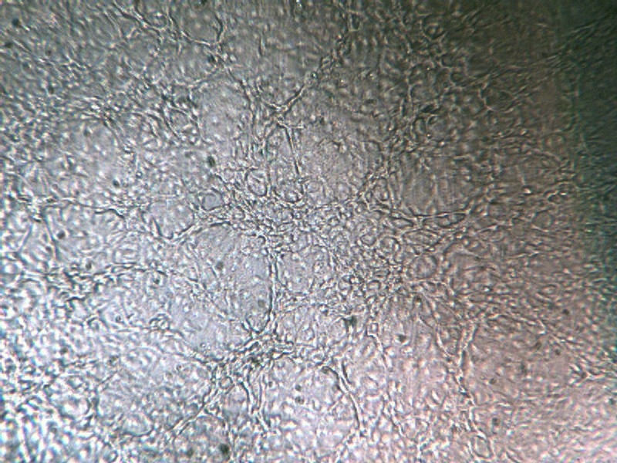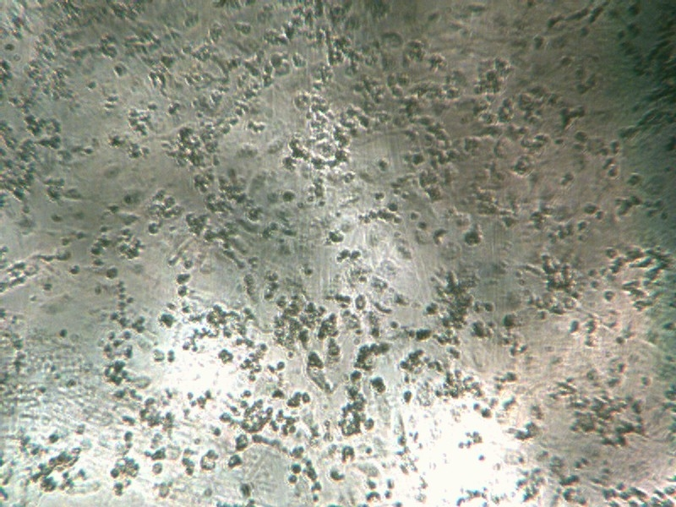
A
B

Salsa
Green onions
Tomatoes
Nacho chips
Peppers

Figure 3. Bar Graph for Questions 5a and 5b

Appendix A
Actor Responses for Interviewees # 21- 27 to Complete Table 1.

Note: Only provide answers if questions asked. Do not offer unsolicited information.

Actor 1:
Male, age 27 years.
Not sick, health currently good. No known health problems.
Never been vaccinated for HAV. Never diagnosed with HAV.
Patron of Restaurant A on October 3.
Ate quesadilla and chili.

Actor 2:
Female, age 20 years.
Not sick, health currently good. No known health problems.
Never been vaccinated for HAV. Never diagnosed with HAV.
Patron of Restaurant A on October 6.
Ate nachos with salsa.

Actor 3:
Female, age 22 years.
Not sick, health currently good. No known health problems.
Never been vaccinated for HAV. Never diagnosed with HAV.
Patron of Restaurant A on October 6.
Ate quesadilla, burrito, rice, and flan.

Actor 4:
Male, age 19 years.
Not sick, health currently good. No known health problems.
Never been vaccinated for HAV. Never diagnosed with HAV.
Employee of Restaurant A. Ate at restaurant on October 5.
Ate taco, rice, and fried ice cream.

Actor 5:
Female, age 17 years.
Not sick, health currently good. No known health problems.
Never been vaccinated for HAV. Never diagnosed with HAV.
Employee of Restaurant A.
Did not eat at Restaurant A.

Actor 6:
Female, age 20 years.
Not sick, health currently good. No known health problems.
Never been vaccinated for HAV. Previously diagnosed with HAV (10 years ago).
Patron of Restaurant A on October 4.
Ate nachos with salsa, chili.

Actor 7:
Male, age 35 years.
Not sick, health currently good. No known health problems.
Vaccinated for HAV. Never diagnosed with HAV.
Patron of Restaurant A on October 3.
Ate nachos with salsa, chili.

Background Information:

Hepatitis A virus (HAV) is a small, nonenveloped, RNA virus transmitted among humans via the fecal-oral route. HAV illness symptoms may include anorexia, nausea, vomiting, fever, and jaundice. It is most commonly associated with undercooked oysters or fresh produce that has been contaminated by an infected handler. It is inactivated by adequate cooking. Its long incubation period of up to 50 days and presumed low infectious dose of less than 100 virus particles complicate traceback and control efforts in illness outbreaks. Individuals who have been exposed to HAV can be treated with immune globulin shots within 14 days of exposure; otherwise infection is cleared in time by most healthy individuals. A vaccine is available to prevent HAV illness if exposed. The vaccine is administered intramuscularly in two doses approximately six months apart. Vaccination is recommended for children by the Advisory Committee on Immunization Practices, American Academy of Pediatrics, and American Academy of Family Physicians (CDC, 2008). HAV is related to other hepatitis-causing viruses based on pathogenicity and not virus structures, transmission routes, or interventions.

This case study was based on a 2003 outbreak of hepatitis A virus in Pennsylvania which resulted in more than 500 illnesses and three deaths. A restaurant was the common source of exposure through consumption of contaminated green onions which were an ingredient in mild salsa. Local officials determined the restaurant was not the original point of contamination based on timing of illnesses among restaurant workers which occurred concurrently with other cases. The CDC and FDA investigated the outbreak to determine the likely vehicle and trace the source. Green onions from Mexico were implicated, and four farms were identified as supplying the product. An import alert was issued to reject shipments of green onions from these sources. Physical evidence implicating the green onions was not available, and Mexican authorities did not accept the conclusions. While the restaurant was not the original point of contamination, storage practices were suggested to have contributed to cross contamination of green onion batches which may have contributed to the magnitude of the outbreak. Shortly prior to the outbreak in Pennsylvania, there were outbreaks of hepatitis A virus in Tennessee, North Carolina, and Georgia which were associated with undercooked green onions from Mexico in two of these state outbreaks, a conclusion that came after the onset of the outbreak in Pennsylvania.

References:

Calvin, L., Avendaño, B., and R. Schwentesuis. 2004. The economics of food safety: The case of green onions and hepatitis A outbreaks. Electronic Outlook Report from the Economic Research Service of the United States Department of Agriculture. VGS-305-1.

Centers for Disease Control and Prevention. 2003. Hepatitis A outbreak associated with green onions at a Restaurant — Monaca, Pennsylvania, 2003. Morbidity and Mortality Weekly Report 52(47): 1155-1157.

Centers for Disease Control and Prevention. 2008. Recommended immunization schedules for persons aged 0–18 years—United States, 2008. Morbidity and Mortality Weekly Report 57:Q1–Q4.

Possible means to shorten exercise if desired:
- Question 4 – provide data from Appendix A to eliminate need for interviews.
- Skip questions 17, 18 or opinion-based questions (15, 16).

This case study was prepared by the University of Delaware. This material is based upon work supported by the Cooperative State Research, Education, and Extension Service, U. S. Department of Agriculture, under Award No. 2009-38414-19698. Any opinions, findings, conclusions, or recommendations expressed in this publication are those of the author(s) and do not necessarily reflect the view of the U.S. Department of Agriculture.

