Foodborne Illness Outbreak Investigation
Case Study: Hepatitis A Virus

Six physicians in County A, Pennsylvania have notified the Pennsylvania Department of Health of 20 individuals who presented symptoms of Hepatitis A infection and tested positive for hepatitis A virus (HAV). The PA Dept of Health has consulted the United States Centers for Disease Control and Prevention (CDC) for assistance with an investigation to determine the source of the outbreak.

As an epidemiologist with the CDC, it is your job to determine how widespread the outbreak has become, the source of infection, and means to halt the outbreak. This involves interviewing food borne illness victims, determining common exposures, determining what potential vehicles (food, individuals, environmental samples, other) should be tested, interpreting laboratory results, helping to determine necessary actions to stop the outbreak, and helping to determine actions necessary to prevent future outbreaks.

You interview the patients to determine a possible common source of infection. From these interviews, you are able to identify one commonality: all patients had eaten at Restaurant A within 2 to 6 weeks prior to the onset of symptoms. Were their illnesses the result of consumption of a one type of contaminated food, several different contaminated foods, the restaurant environment, and/or exposure to an infected restaurant employee? Or is the restaurant a purely coincidental commonality and not the source of infection?

Most of the patients are showing signs of recovery; however, three individuals have since died as a result of their illnesses. Additional cases of hepatitis in the region have been reported. More people are likely to get sick if you cannot identify the source quickly and recommend actions necessary to stop the outbreak. The public is counting on you to solve this case.

- You realize you must gather more data and the best means to do so is to interview the newly identified patients as well as additional patrons of Restaurant A. You ask the owner of Restaurant A for the names of patrons who had eaten at the establishment. Based on the incubation period for hepatitis A, from what dates should patron names be pulled from credit card receipts?

- Aside from talking with patrons who contracted Hepatitis A, who else should you interview to help determine what could have been the source of the illness versus what menu items or other exposures did not cause illness?

- You have been provided with names of interviewees. Based on the information you already have (Table 1), prepare a list of interview questions to gather more of the same type of information from the new interviewees.

- Using the set of questions you developed, conduct interviews with those individuals identified by the owner of Restaurant A. Compile interview responses in Table 1.

- Graphs are helpful to quickly visualize patterns in large data sets. Using data from Table 1, prepare the following:
  - A bar graph of the number of patients who developed symptoms for the dates of symptom onset.
  - On the same graph as plotted for part a, plot the number of patients who developed symptoms for the dates dined at Restaurant A.
  - Table 2 completed with data on the foods consumed by all individuals and whether the foods were positively or negatively associated with illness.

- Based on the bar graph developed for exercises 5a and 5b and individual interview responses, could a food handler carrying hepatitis A virus employed by Restaurant A have been the original source of the outbreak? Why or why not?

- One of the individuals diagnosed with Hepatitis A infection is a food handler in another restaurant, Restaurant B. What additional measures should be taken to protect the public?

- News of the outbreak and the postulated link to Restaurant A has hit news sources including newspapers, radio, television, and the internet. As a result, numerous individuals other than those sought during the interviews have contacted their doctors, public health professionals, and/or attorneys with concerns they may also be victims in this food borne illness outbreak. Review the symptoms and circumstances of the cases presented in Table 3, and determine which individuals may be additional victims of food borne illness due to this particular outbreak versus which individuals are not likely to be cases associated with this outbreak. Provide an explanation for your assessment on each individual.

- If today’s date is November 24, who may benefit by receiving immune globulin shots?

- From the data compiled in Table 2, calculate the odds ratio to determine what foods are positively associated with illness?

- What would you want to have tested for Hepatitis A contamination?

- Give a reason why would you not necessarily want to have all foods tested.

- In any outbreak, when there are multiple foods associated with illness, what could be the reasons for several foods being implicated?

- Laboratory data for various foods consumed by Restaurant A patrons are presented in Figures 1 and 2. Two laboratory tests were conducted to detect HAV contamination. These tests include detection of genetic material specific to viable as well as nonviable HAV (Figure 1), and cell culture assay to show infectivity of viable HAV (Figure 2).

  - Do the laboratory results support your hypothesis on which foods were associated with illness? Explain your response.

  - Can you draw any conclusions on which specific ingredient(s) may be HAV-contaminated?

- If it is concluded that a product grown by one company, processed by another, and served at Restaurant A is the vehicle for hepatitis A infection, provide an opinion statement on who is responsible for contamination. Provide an opinion statement on who should be held financially accountable (grower, distributor, food service, other) for expenses associated with the outbreak including:
  - Individuals’ medical expenses, lost wages
  - Costs associated with determining source of outbreak (epidemiologist wages, lab tests, etc.)
  - Expenses associated with recall and destruction of food

- Hepatitis A vaccinations are available. The vaccine is administered intramuscularly in two doses 6 months apart. The cost for each shot is approximately $100. The vaccine protects individuals from illness such that the virus cannot replicate to sufficient numbers to cause disease symptoms. The vaccine also protects others indirectly because the virus is not shed in large numbers in the feces of exposed, vaccinated individuals.
  - Please state your opinion on whether or not restaurant employees should be vaccinated and explain the reason(s) for your opinion.
  - Please state your opinion on whether food handlers at the farm level should be vaccinated and explain the reason(s) for your opinion.
  - If you recommend vaccination of food handlers, state your opinion on whether vaccination should be voluntary or required for employment.
  - If shots are to be administered, in your opinion, who should be financially responsible for the shots?

- Prepare a 60-second television news piece that informs the public of the critical information related to the case.

- Prepare a 15-minute presentation for the class giving an overview of case study.

This case study was prepared by the University of Delaware. This material is based upon work supported by the Cooperative State Research, Education, and Extension Service, U. S. Department of Agriculture, under Award No. 2009-38414-19698. Any opinions, findings, conclusions, or recommendations expressed in this publication are those of the author(s) and do not necessarily reflect the view of the U.S. Department of Agriculture.

Table 1. Data from Interviews with Individuals
Individual | Gender | Age (yrs) | Symptoms | Date Symptom Onset | Date Dined at Restaurant A | Employee, Patron, Close Contact | Consumed at Restaurant A | HAV vaccinated | Special Health Concerns | Previously infected with HAV | Current  Health Status
1 | Female | 4 | A, N, V, F, J | Oct 14 | Oct 3 | Patron | N/S, R, T, I | No | NK | No | Deceased
2 | Female | 32 | N, V, J | Oct 30 | Oct 3 | Patron | N/S, C | No | NK | No | Recovering
3 | Male | 34 | N, V, J | Oct 29 | Oct 3 | Patron | N/S, B, R, C | No | NK | No | Recovering
4 | Female | 8 | A, N, V, F, J | Oct 16 | Oct 3 | Patron | N/S, Q, I | No | NK | No | Recovering
5 | Male | 22 | A, N, V, F, J | Oct 31 | Oct 3 | Patron | N/S | No | NK | No | Recovering
6 | Male | 23 | A, N, V, F, J | Oct 31 | Oct 3 | Patron | N/S | No | NK | No | Recovering
7 | Male | 26 | N, V, J | Nov 1 | Oct 3 | Patron | N/S | No | NK | No | Recovering
8 | Male | 24 | N, V, J | Oct 31 | Oct 3 | Patron | N/S | No | Alcoholic | No | Deceased
9 | Female | 50 | N, V, J | Oct 31 | Oct 4 | Patron | Q, C, F | No | NK | No | Recovering
10 | Female | 52 | N, V, J | Nov 1 | Oct 4 | Patron | Q, C, I | No | NK | No | Recovering
11 | Male | 28 | N, V, J | Oct 31 | Oct 4 | Patron | N/S, T, R | No | NK | No | Recovering
12 | Female | 27 | N, V, J | Oct 31 | Oct 4 | Patron | N/S, Q, R | No | NK | No | Recovering
13 | Male | 44 | A, N, V, F | Nov 8 | Oct 5 | Patron | C, I | No | NK | No | Poor
14 | Male | 16 | A, N, V, F | Nov 10 | Oct 5 | Patron | N/S, T | No | NK | No | Poor
15 | Male | 15 | N, V, J | Oct 30 | Oct 5 | Patron | N/S, T | No | NK | No | Recovering
16 | Female | 70 | N, V, J | Nov 1 | Oct 6 | Patron | N/S, R, F | No | Cancer | No | Deceased
17 | Female | 41 | N, V, J | Oct 30 | Oct 6 | Patron | N/S, B, R | No | NK | No | Poor
18 | Female | 10 | N, V, J | Oct 30 | Oct 6 | Patron | N/S, T | No | NK | No | Recovering
19 | Female | 12 | A, N, V, F | Oct 30 | Oct 6 | Patron | N/S, T | No | NK | No | Recovering
20 | Male | 41 | A, N, V, F | Nov 22 | Oct 7 | Employee | N/S, B, R | No | NK | No | Poor
21*
22*
23*
24*
25*
26*
27*
* Data gathered by students through mock interviews
Symptoms Key: A, anorexia; N, nausea; V, vomiting; F, fever; J, jaundice
Food Key: N/S, nachos/salsa; R, rice; Q, quesadilla; T, taco; B, burrito; C, chili; F, flan; I, fried ice cream
NA, Not applicable
NK, None kno
Table 2. Foods Served at Restaurant A and Association with Illness
Food | # Ate and Sick | # Ate and Not Sick | # Not Eat and Sick | # Not Eat and Not Sick | Odds Ratio
Nachos/Salsa (N/S)
Burrito (B)
Rice (R)
Quesadilla (Q)
Chili (C)
Taco (T)
Flan (F)
Fried Ice Cream (I)
Odds Ratio = [(#Ate and Sick) ÷ (#Not Eat and Sick)]
[(#Ate Not Sick) ÷ (#Not Eat and Not Sick)]

Table 3. New Cases - Related to Outbreak?

Individual | Symptoms | Symptom Onset | Symptom Duration | Date Eaten at Restaurant A | Current Health Status
1 | Diarrhea | Sept 15 | 2 days | Aug 30 | Good
2 | Vomiting, jaundice | Nov 5 | Nearly gone | Oct 4 | Recovering
3 | Vomiting, diarrhea | Oct 15 | 3 days | Oct 5 | Good
4 | Nausea, vomiting, fever, abdominal pain | Nov 25 | Ongoing | NA, mother of sick teen who ate at Restaurant A on Oct 5 | Poor
5 | Vomiting, fever, abdominal pain, jaundice | Dec 5 | Ongoing | NA, no known contact with sick patron, employee | Poor

Figures 1 and 2. Laboratory Data from Food Products Consumed at Restaurant A

Figure 1. PCR (polymerase chain reaction) results visualized in gel. PCR creates multiple copies of selected piece of genetic material unique to organism of interest. The base sequence and length of the genetic piece to be copied are known. Sufficient numbers of copies are made during PCR such that they can be detected and visualized by a chemical reaction with DNA. The sample containing copies of the genetic material are filled in wells created in the gel. An electric current is applied to make the sample move through the gel based on size. Samples containing small pieces move faster while larger pieces move slower because passage through the gel is more difficult. This method is used to detect the presence of specific genetic material in a sample of food, but does not necessarily indicate whether the genetic material came from live or dead organisms.

Lane 1 2 3 4 5 6 7 8 9 10
Lane
1 DNA size ladder
2 None loaded
3 None loaded
4 Negative control
5 Positive control
6 Salsa
7 Green onion
8 Tomato
9 Pepper
10 Nacho chips

Figure 2. Cytopathology test for infectious HAV. Cells that are susceptible to HAV infection can be grown in the laboratory in flasks. Healthy cells appear growing side by side in a monolayer and are well adherent to the plastic surface on which they are grown (Figure 2A). If cells are exposed to infectious HAV, a cytopathic effect will be visible, that is, the cells will look unhealthy or dead. Infected cells may look raised and/or detached from the plastic surface (Figure 2B).

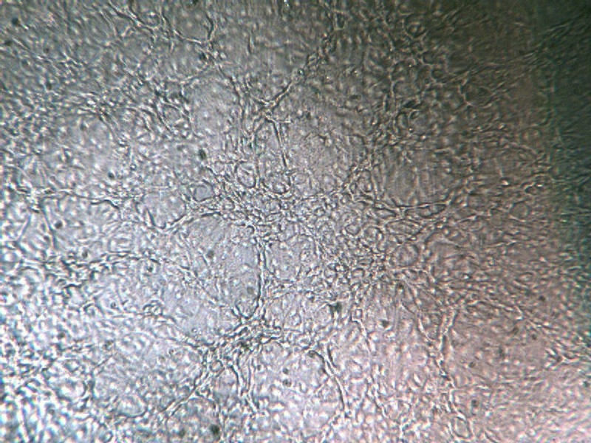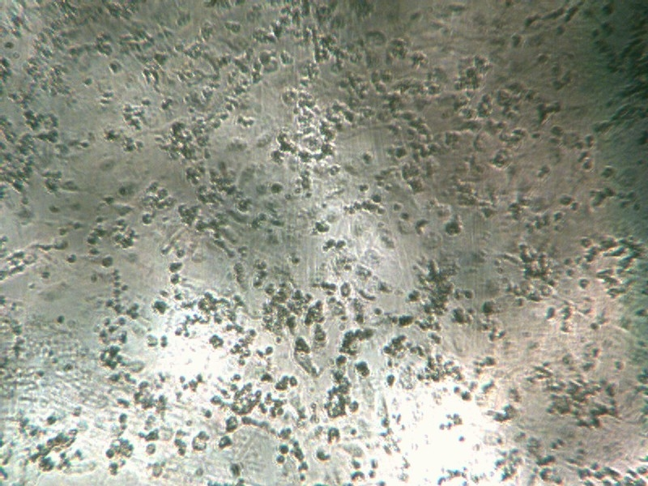
A
B

Salsa
Green onions
Tomatoes
Nacho chips
Peppers

