Foodborne Illness Outbreak Investigation
Case Study: Cyclospora cayetanensis
Teacher Version

Public health officials in 14 states have reported clusters of cases of cyclosporiasis to the Centers for Disease Control and Prevention (CDC). As the CDC epidemiologist assigned to the case, it is your responsibility to determine the source of illness and to suggest means to prevent others from becoming ill. This involves interviewing patients, determining potential exposure sources, determining what should be tested, interpreting laboratory results, helping to determine necessary actions to prevent others from becoming ill, and helping to determine actions necessary to prevent future occurrences. As you gather information from case patients, you notice that this outbreak bears numerous similarities to an outbreak that occurred in the previous year. Using the data presented, address the following specific concerns regarding the probable contaminated vehicle(s), source(s), and intervention strategies.

- Detailed histories of food and beverage consumption were collected from case patients and case controls (who did not get sick). Select data are provided in Table 1 which lists foods that were associated with illnesses from various outbreak clusters in different states. However, the associated foods were of mixed composition, and data from individual outbreaks were insufficient to confidently implicate any one ingredient. Using collective data from the clusters compiled in Table 1, calculate the odds ratios for the associated foods. Indicate what, if any, more precise determination of the illness source can be epidemiologically linked now that you can compare data among clusters.

Answer: Odds ratios are presented in Table 1. The higher this value, the greater association with illness. Foods with mixed fresh fruit that include raspberries are most associated with illness. Outbreak clusters B, E (fruit salad without raspberries), and H with foods that had low association with illness suggest strawberries and blackberries are less associated with illness than raspberries were for other outbreak clusters with mixed fruits associated with illness.

- Figure 1 presents the distribution of cases of Cyclosporiasis for the current outbreak by state (Fig. 1A) and source of exposure (Fig. 1B). Propose a hypothesis as to whether the contamination was more likely to have occurred on the farm, by a food service handler, or either scenario with equal likelihood. Provide an explanation for your hypothesis.

Answer: The multistate distribution of contaminated product and multiple routes of exposure through various settings suggest a broad contamination event. This is more likely to have occurred at the farm level prior to distribution (which might involve several different ports) or handling at the local food service level. Had contamination occurred at the point of distribution or point of sale, the number and distribution of cases would be expected to be smaller and/or more localized.

- Using the data in Figure 2, compare the onset illness dates for the various outbreak clusters (Fig. 2A) with all sources of product received during the season (Fig. 2B). Indicate whether the implicated product was produced domestically, was imported, or if the data are insufficient to draw conclusions.

Answer: The outbreak began prior to availability of domestic product (Country D). The outbreak began after almost one month after Country A product became available on the market and continued nearly two months after the last market availability. Given the typical incubation period for illness (approximately one week) and perishable nature of the product, Country A is an unlikely source of the contaminated product. Though the time periods are different for product from Country C, the same reasoning holds that this country was not the most likely source of the contaminated product. Market availability dates for product from Country B correspond most closely with illness onset dates. Given the potential for overlap in availability from different sources and possibility of sporadic contamination, the source and lots of product directly associated with outbreak cases should be used to more specifically determine the source of contaminated product.

- C. cayetanensis is endemic in the country of origin of the implicated food. A year-long study of infection rates of the citizens of this country is presented in Figure 3. What, if any, correlations can you make regarding the seasonality of cyclosporiasis illnesses?

Answer: The number of cases increases with spring/summer months. The seasonal nature of illness does not appear to be related to temperature as the yearly high and low temperatures are fairly steady. While the increase in cases occurs during the rainy season, the increase in number of cases precedes the onset of wet days.

- An inspection of farming practices of the farms where the suspect product was grown ensues. Why are inspectors interested in the following as they relate to this outbreak?

  - Availability and proximity of toilet facilities to field
  - Availability and proximity of hand washing facilities to field
  - Proximity of field to natural bodies of water
  - Source of field irrigation water
  - Source of water for mixing pesticides and fertilizers
  - Proximity of field to human sewage disposal and treatment

Answer: Contamination of the food on the farm could occur by direct contact with infected human handler with poor hygiene practices. Broader contamination of a field could occur by contaminated water sources including natural bodies of water, run-off during rain events, and water used for irrigation or mixing with pesticides and fertilizers.

- The following good agricultural practices (GAPs) were not implemented on the farms in question: (1) livestock were kept within close proximity to the fields, and (2) workers had inadequate hand washing facilities. In consideration of the known reservoirs for this protozoan parasite, which of these GAPs might be more critical to prevent contamination of fields by C. cayetanensis? State the reason for your choice.

Answer: Human waste contamination presents a greater risk than other animals based on current science of humans being the only known reservoir for C. cayetanensis.

- For two consecutive years, C. cayetanensis outbreaks have been linked to a particular product from one country. After the outbreak of the first year, changes in farming, handling, and distribution practices were required of producers from the implicated country of origin in order to continue to sell their product. In spite of this, outbreaks occurred the following year and were linked to the same country of production.

  - What could explain this?

Answer: Recommendations and/or implementation were inadequate.

  - What is your recommendation to authorities for permitting distribution of the product from the implicated country of origin in the third year?

Answer: Opinion, please refer to background information on how this was handled in the actual case.

- Current scientific understanding is that C. cayetanensis completes its life cycle exclusively in humans. It cannot be grown in a laboratory, model animals, or cell culture. This presents a challenge for researchers trying to gather specimens and study the protozoan, particularly means to inactivate it. Given these limitations, in your opinion, which of the following is the best approach to try to understand C. cayetanensis and ways to prevent and/or remediate contamination of foods? Please provide a reason for your selection and indicate potential limitations.

  - Study a closely-related organism and hope the information gained applies accurately to C. cayetanensis
  - Collect C. cayetanensis from stool samples during outbreaks and study changes in integrity of physical structures as an indication of changes in infectivity
  - Conduct human volunteer studies with C. cayetanensis

Answer: Opinion. Each of these approaches is used, and each has limitations. For approach (a), the closely-related (structurally and genetically) protozoan Eimeria acervulina which infects chickens has been used as a surrogate. The main limitation of approach (a) is that surrogates could behave differently in some respect important for food safety and cannot be predicted. For approach (b), changes in sporulation, physical appearance by microscopy, and DNA are used to study inactivation, transmission, and other properties of C. cayetanensis. With approach (b), there is a limit on the amount and nature of information gained, and studies with individual physical structures do not always provide a perfect indication of behavior of the whole, viable oocyst. Human volunteer studies (approach (c)) are costly, time consuming, and limited by ethical standards for acceptable risk in conducting such studies.

- Prepare a 10-minute presentation of the case for the class.

Table 1. Foods Consumed by Case Patients and Controls

Outbreak Cluster | Food | # Ate and Sick | # Ate and Not Sick | # Not Eat and Sick | # Not Eat and Not Sick | Odds Ratio
A | Fruit Salad (strawberries, honeydew, cantaloupe, watermelon, grapes, raspberries) | 17 | 1 | 3 | 5 | 28.3
B | Cheesecake with blackberry puree | 2 | 2 | 17 | 6 | 0.3
C | Pancakes with raspberry topping | 10 | 1 | 1 | 13 | 50.0
D | Ice cream with strawberry, raspberry topping | 6 | 2 | 3 | 15 | 5.0
E | Fresh fruit (mixed) smoothie | 5 | 4 | 1 | 8 | 6.3
E | Fruit Salad (strawberries, honeydew, cantaloupe, watermelon, tangerine slices, grapes) | 2 | 23 | 3 | 10 | 0.1
F | Spongecake with blackberry/raspberry garnish | 6 | 2 | 14 | 6 | 1.1
G | Yogurt with added fresh raspberries and blackberries | 8 | 1 | 2 | 15 | 20.0
H | Strawberry shortcake | 1 | 15 | 1 | 12 | 0.3
Odds Ratio = [(#Ate and Sick) ÷ (#Not Eat and Sick)]
[(#Ate Not Sick) ÷ (#Not Eat and Not Sick)]

A B 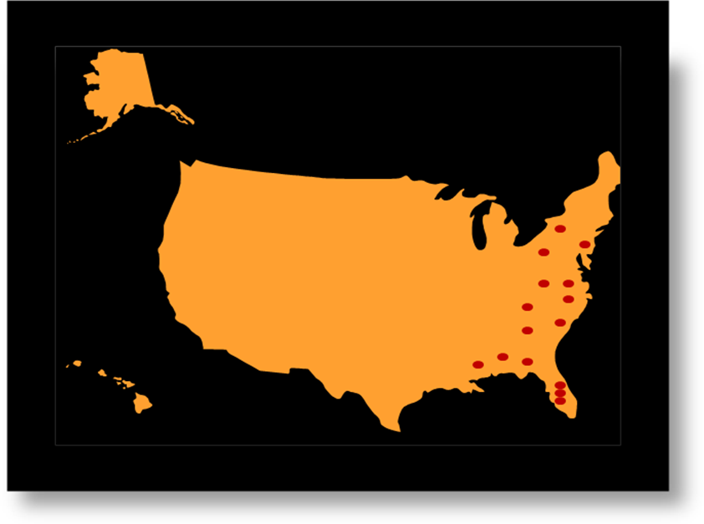 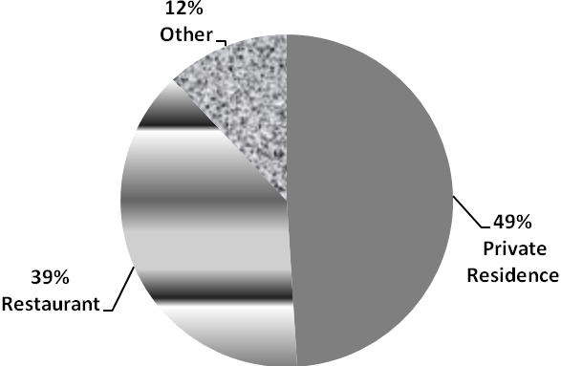

Figure 1. Cases of Cyclosporiasis. A, national distribution. B, location of exposure

A
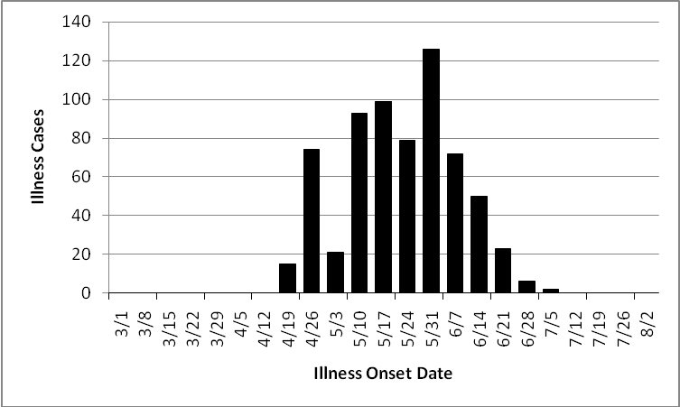

B
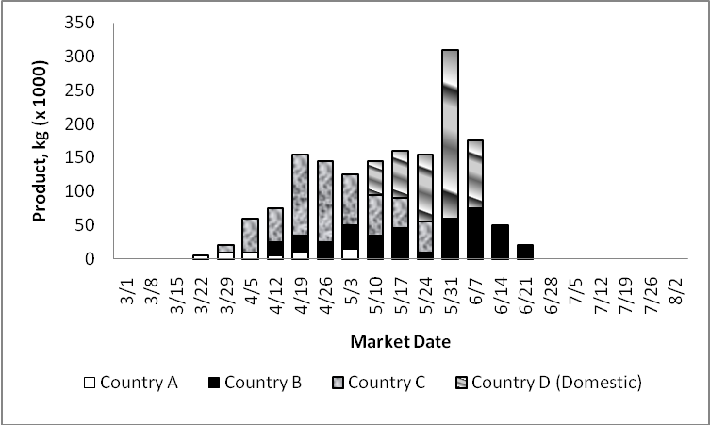

Figure 2. (A) Illness onset dates, (B) Volume of product and dates of market-availability for product from various countries.

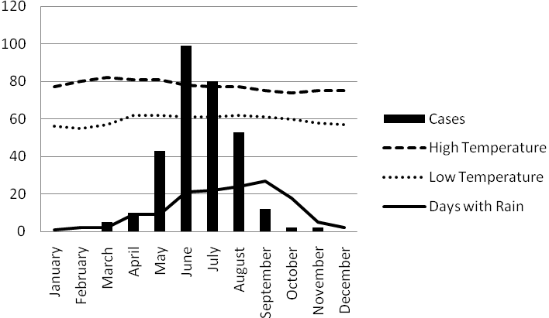
Figure 3. One-year study of cyclosporiasis cases and seasonal conditions in country where product is grown and Cyclospora cayetanensis is endemic.

Background Information:

Cyclospora is a protozoan parasite first associated, retrospectively, with illness that occurred in 1977. The first documented outbreak in the United States occurred in 1990, and the name Cyclospora cayetanensis was proposed in 1994. Multiple outbreaks attributed to C. cayetanensis occurred in North America between 1995 and 1999 and were associated with various types of produce. Illness is generally characterized by watery diarrhea, anorexia, nausea, vomiting, abdominal pain, and fatigue. The incubation period averages 7 days. Illness duration can be prolonged, lasting more than a week. Symptoms are generally self-limiting, but C. cayetanensis infection can be treated with trimethoprim-sulfamethoxaxole (TMP-SMZ). Oocysts are excreted in stool during illness in an unsporulated, noninfectious state. Sporulation occurs in the environment to yield the infectious oocyst, thus direct person-to-person spread is considered unlikely. Humans are the only known reservoirs. In countries where C. cayetanensis is endemic, there are seasonal patterns in infection, though they vary by region. A moist environment is speculated to be more conducive to survival and sporulation of C. cayetanensis. (Herwaldt, 2000)

This case study was based on a series of outbreaks of C. cayetanensis associated with raspberries imported from Guatemala. The raspberries were from the spring growing season. The outbreaks occurred in 1996 and 1997 and involved 55 and 41 illness clusters, 14 and 13 states, and 725 and 762 associated cases (approximately 33 and 25% of which were laboratory confirmed) in 1996 and 1997, respectively. Illnesses were also reported in Ontario and Quebec, Canada. Contaminated water used in growing raspberries was believed to be the original source of contamination. (Herwaldt et al., 1999) Raspberry imports from Guatemala were suspended in 1998 by the United States; Canada permitted importation. No cyclosporiasis outbreaks were associated with raspberries in 1998 in the U.S. while cases were reported in Canada in the same year.

References

Herwaldt, B. L. 2000. Cyclospora cayetanensis: A review, focusing on the outbreaks of cyclosporiasis in the 1990s. Clinical Infectious Diseases 31: 1040-57.

Herwaldt, B. L. 1999. The return of Cyclospora in 1997: Another outbreak of Cyclosporiasis in North America associated with imported raspberries. Annals of Internal Medicine 130(3): 210-220.

This case study was prepared by the University of Delaware. This material is based upon work supported by the Cooperative State Research, Education, and Extension Service, U. S. Department of Agriculture, under Award No. 2009-38414-19698. Any opinions, findings, conclusions, or recommendations expressed in this publication are those of the author(s) and do not necessarily reflect the view of the U.S. Department of Agriculture.

