Foodborne Illness Outbreak Investigation
Case Study: Cyclospora cayetanensis

Public health officials in 14 states have reported clusters of cases of cyclosporiasis to the Centers for Disease Control and Prevention (CDC). As the CDC epidemiologist assigned to the case, it is your responsibility to determine the source of illness and to suggest means to prevent others from becoming ill. This involves interviewing patients, determining potential exposure sources, determining what should be tested, interpreting laboratory results, helping to determine necessary actions to prevent others from becoming ill, and helping to determine actions necessary to prevent future occurrences. As you gather information from case patients, you notice that this outbreak bears numerous similarities to an outbreak that occurred in the previous year. Using the data presented, address the following specific concerns regarding the probable contaminated vehicle(s), source(s), and intervention strategies.

- Detailed histories of food and beverage consumption were collected from case patients and case controls (who did not get sick). Select data are provided in Table 1 which lists foods that were associated with illnesses from various outbreak clusters in different states. However, the associated foods were of mixed composition, and data from individual outbreaks were insufficient to confidently implicate any one ingredient. Using collective data from the clusters compiled in Table 1, calculate the odds ratios for the associated foods. Indicate what, if any, more precise determination of the illness source can be epidemiologically linked now that you can compare data among clusters.

- Figure 1 presents the distribution of cases of Cyclosporiasis for the current outbreak by state (Fig. 1A) and source of exposure (Fig. 1B). Propose a hypothesis as to whether the contamination was more likely to have occurred on the farm, by a food service handler, or either scenario with equal likelihood. Provide an explanation for your hypothesis.

- Using the data in Figure 2, compare the onset illness dates for the various outbreak clusters (Fig. 2A) with all sources of product received during the season (Fig. 2B). Indicate whether the implicated product was produced domestically, was imported, or if the data are insufficient to draw conclusions.

- C. cayetanensis is endemic in the country of origin of the implicated food. A year-long study of infection rates of the citizens of this country is presented in Figure 3. What, if any, correlations can you make regarding the seasonality of cyclosporiasis illnesses?

- An inspection of farming practices of the farms where the suspect product was grown ensues. Why are inspectors interested in the following as they relate to this outbreak?

  - Availability and proximity of toilet facilities to field
  - Availability and proximity of hand washing facilities to field
  - Proximity of field to natural bodies of water
  - Source of field irrigation water
  - Source of water for mixing pesticides and fertilizers
  - Proximity of field to human sewage disposal and treatment

- The following good agricultural practices (GAPs) were not implemented on the farms in question: (1) livestock were kept within close proximity to the fields, and (2) workers had inadequate hand washing facilities. In consideration of the known reservoirs for this protozoan parasite, which of these GAPs might be more critical to prevent contamination of fields by C. cayetanensis? State the reason for your choice.

- For two consecutive years, C. cayetanensis outbreaks have been linked to a particular product from one country. After the outbreak of the first year, changes in farming, handling, and distribution practices were required of producers from the implicated country of origin in order to continue to sell their product. In spite of this, outbreaks occurred the following year and were linked to the same country of production.

  - What could explain this?

  - What is your recommendation to authorities for permitting distribution of the product from the implicated country of origin in the third year?

- Current scientific understanding is that C. cayetanensis completes its life cycle exclusively in humans. It cannot be grown in a laboratory, model animals, or cell culture. This presents a challenge for researchers trying to gather specimens and study the protozoan, particularly means to inactivate it. Given these limitations, in your opinion, which of the following is the best approach to try to understand C. cayetanensis and ways to prevent and/or remediate contamination of foods? Please provide a reason for your selection and indicate potential limitations.

  - Study a closely-related organism and hope the information gained applies accurately to C. cayetanensis
  - Collect C. cayetanensis from stool samples during outbreaks and study changes in integrity of physical structures as an indication of changes in infectivity
  - Conduct human volunteer studies with C. cayetanensis

- Prepare a 10-minute presentation of the case for the class.

This case study was prepared by the University of Delaware. This material is based upon work supported by the Cooperative State Research, Education, and Extension Service, U. S. Department of Agriculture, under Award No. 2009-38414-19698. Any opinions, findings, conclusions, or recommendations expressed in this publication are those of the author(s) and do not necessarily reflect the view of the U.S. Department of Agriculture.

Table 1. Foods Consumed by Case Patients and Controls

Outbreak Cluster | Food | # Ate and Sick | # Ate and Not Sick | # Not Eat and Sick | # Not Eat and Not Sick | Odds Ratio
A | Fruit Salad (strawberries, honeydew, cantaloupe, watermelon, grapes, raspberries) | 17 | 1 | 3 | 5
B | Cheesecake with blackberry puree | 2 | 2 | 17 | 6
C | Pancakes with raspberry topping | 10 | 1 | 1 | 13
D | Ice cream with strawberry, raspberry topping | 6 | 2 | 3 | 15
E | Fresh fruit (mixed) smoothie | 5 | 4 | 1 | 8
E | Fruit Salad (strawberries, honeydew, cantaloupe, watermelon, tangerine slices, grapes) | 2 | 23 | 3 | 10
F | Spongecake with blackberry/raspberry garnish | 6 | 2 | 14 | 6
G | Yogurt with added fresh raspberries and blackberries | 8 | 1 | 2 | 15
H | Strawberry shortcake | 1 | 15 | 1 | 12
Odds Ratio = [(#Ate and Sick) ÷ (#Not Eat and Sick)]
[(#Ate Not Sick) ÷ (#Not Eat and Not Sick)]

A B 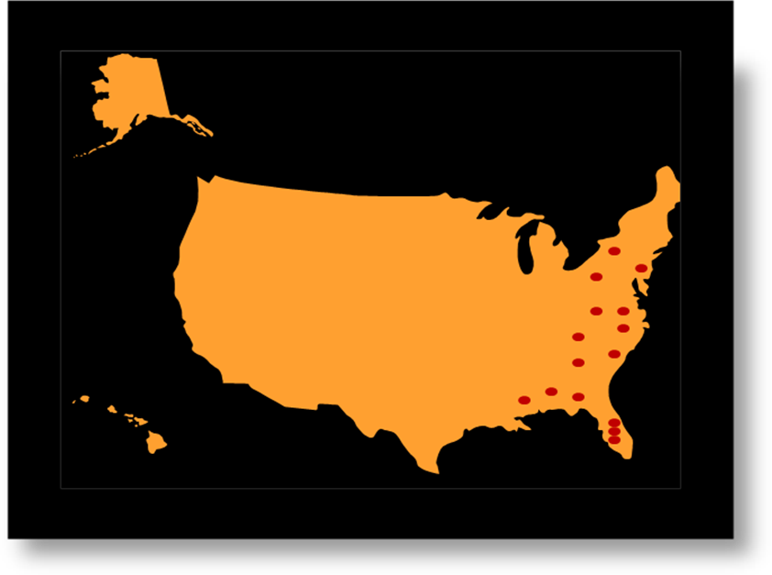 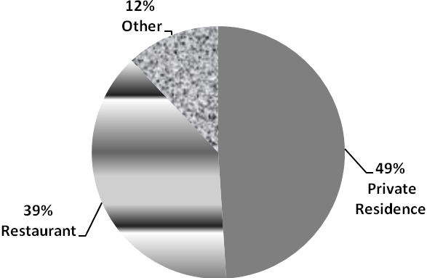

Figure 1. Cases of Cyclosporiasis. A, national distribution. B, location of exposure

A
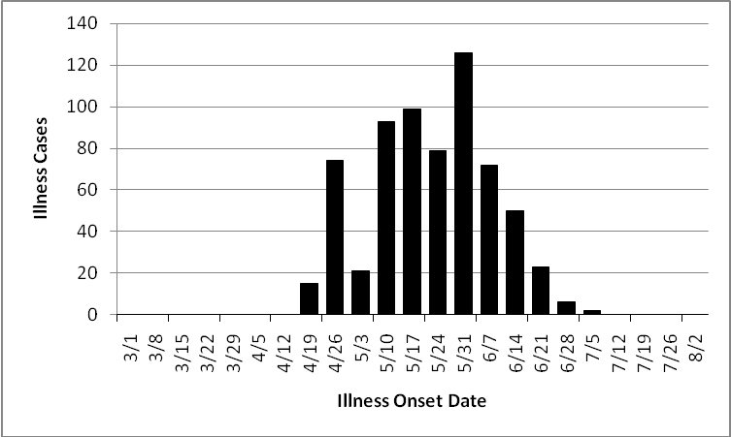

B
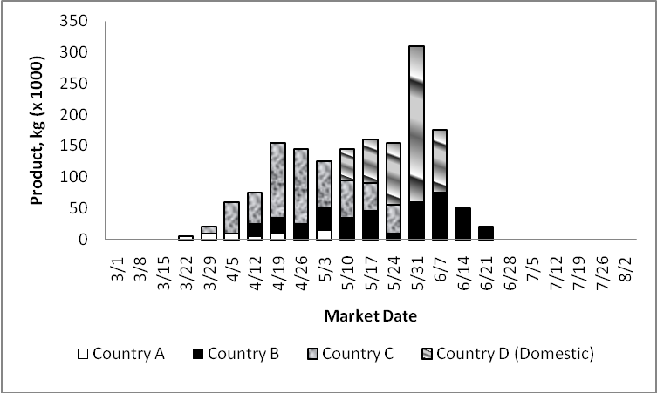

Figure 2. (A) Illness onset dates, (B) Volume of product and dates of market-availability for product from various countries.

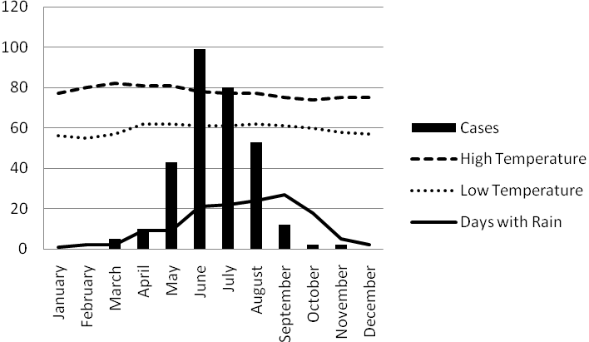
Figure 3. One-year study of cyclosporiasis cases and seasonal conditions in country where product is grown and Cyclospora cayetanensis is endemic.

