University of Delaware
Goodstay Mansion and Arsht Hall

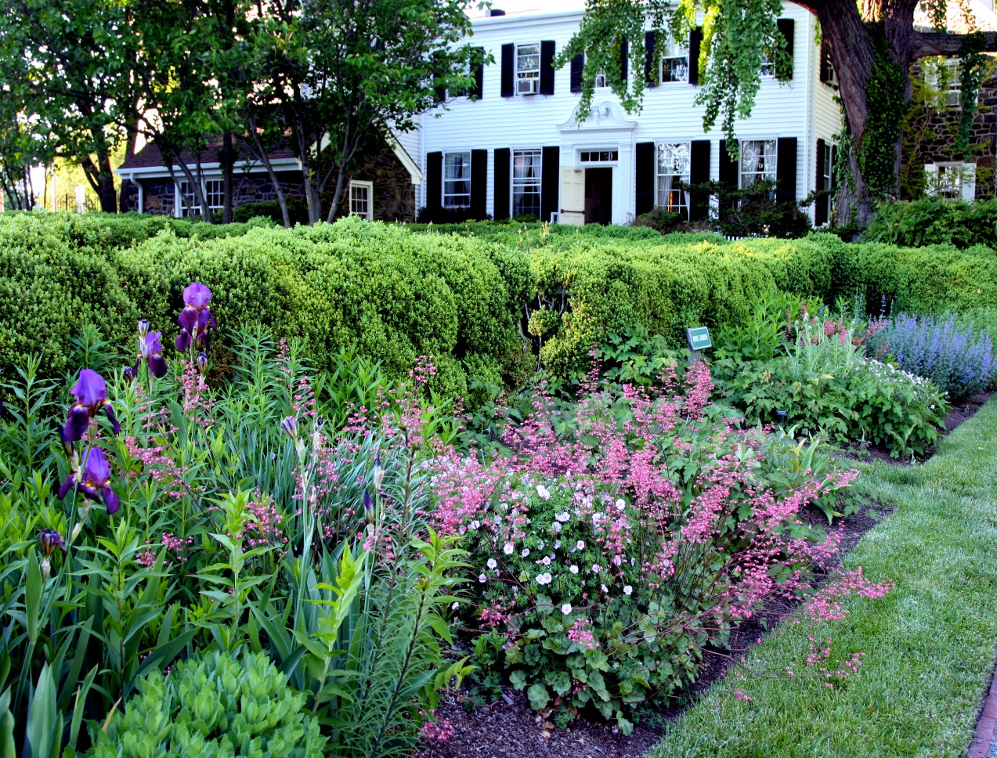

Goodstay Mansion and Arsht Hall
2700 Pennsylavania Avenue
Wilmington, De 19806
302-573-4419 or 302-573-4401
Toll Free 800-823-2214
www.udel.edu/conferences

GARDEN CEREMONIES

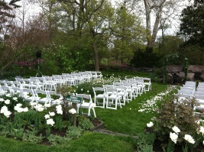AT GOODSTAY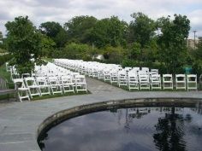

Ceremony

White Padded Chairs Included

Ceremony Coordinator

Ceremony Rehearsal

Chair Set-up and Rental

Manicured Gardens

Wedding Party Dressing Rooms

(Available two hours prior to ceremony)

Rain Space

$1,500.00

Ceremony with Reception

$2000.00

Ceremony Only (up to 200 guests)

$2500.00 (over 200 guests)

UNIVERSITY OF DELAWARE RECEPTION PACKAGE

Reception with 50 or More Adult Guests Include

Prices range from $93 - $146 per person

Prices are effective through 2015

Five Hour Dinner Reception

Four Hour Open Bar Includes Premium Brands of Liquor and

Domestic Beer, House Wine, Mixers, Juices and Soft Drinks

Champagne Toast (Non-Alcoholic Toast Available)

Skirted Head Table or Sweetheart Table

Skirted Gift Table, Cake Table and Place Card Table

China Service

Facility Charge and Gratuity

Cake Cutting Service

Dance Floor

Suite at the Hotel DuPont for the Couple

Transportation Provided from Reception to Hotel

Fresh Flowers Centerpieces for Each Table

Wedding Coordinator

Free Parking

Use of Our Beautiful Grounds for Pictures

*Split entrée choices will be charged at the higher package price

*Weekend events are subject to a $200 maximum University Public Safety Charge

SERVED DINNER SELECTIONS

Four Hour Premium Open Bar

COCKTAIL HOUR
Domestic and Imported Cheese Display with Assorted Gourmet Crackers
Fresh Fruit and Vegetable Crudités with Ranch and Yogurt Dips
Spinach Artichoke Dip, Tomato Basil Bruschetta, and Roasted Red Pepper Hummus served with Crostini’s and Bread Stick

Butlered and Stationary Hot Hors d ’Oeuvres are Optional for an Additional Fee

Add a Hot Dip $4.50 per person
Choose from Crab, Mushroom Truffle Dip, Artichoke Dip, or Baked Brie

Add 3 Butlered Hors d ‘Oeuvres $11.50 per person
Choices:
Chef Carl’s Mini Crab cakes with Remoulade
Spanakopita
Coconut Chicken with Dipping Sauce
Goat cheese Crostini
Tenderloin of Beef Crostini with Horseradish Sauce
Sesame Crusted Ahi Tuna
(Additional choices available upon request)

FIRST COURSE
(choose one)
Seasonal Mixed Greens with Choice of Dressing
Classic Caesar Salad
Spinach Salad with Candied Pecans, Red Onion, Roquefort Cheese, Warm Bacon Balsamic Dressing

ENTRÉE
All entrees served with Chef’s fresh vegetable, starch and assorted rolls with butter
(choose one)

Filet of Beef and Salmon Filet
$146.00 per Person

Grilled Flat Iron Stead with a Mushroom Demi-Glace
$124.00 per Person

Filet of Beef
$131.00 per Person

Delaware Combo
Broiled Crab Cake and Grilled Breast of Chicken with Lemon Butter and Capers
$124.00 per Person

Sweet Chili Glazed Salmon
$112.00 per Person

Herb Crusted Mahi Mahi with a Spicy Mango Sauce
$112.00 per Person

Roasted Tenderloin of Pork with a Cracked Pepper Brandy Sauce
$107.00 per Person

Chicken Oscar
Sautéed Supreme Chicken Breast with Crab Meat, Asparagus, finished off with a Hollandaise Sauce
$118.00 per Person

Pan Seared Ancho Chili Lime Chicken Breast, Caramelized Chipolini Onion, Roasted Corn and Sweet Potato Cake
$107.00 per Person

Grilled Breast Chicken Vin Blanc
$105.00 Per Person

Portobello Florentine
$97.00 Per Person

Vegetable Wellington In a Puff Pastry Crust
$95.00 Per Person

Champagne Toast
All Entrees include Chef’s Choice of Vegetables
All Dinners are served with Warm Rolls and Butter,
Coffee, Decaffeinated Coffee, Selection of Hot Teas and Iced Tea

BUFFET SELECTIONS

COCKTAIL HOUR
Domestic and Imported Cheese Display, assorted gourmet crackers
Fresh Fruit and Vegetable Crudités with Ranch and Yogurt Dips.
Spinach Artichoke Dip, Tomato Basil Bruschetta, and Roasted Red Pepper Hummus served with Crostini’s and Bread Sticks

Butlered and Stationary Hot Hors d ‘Oeuvres are optional at an additional expense

Add a Hot Dip $4.50 per person
(Crab, Mushroom Truffle Dip, Artichoke Dip, or Baked Brie)

Add 3 Butlered Hors d ‘Oeuvres $11.50 per person
Choices:
Chef Carl’s Mini Crabcakes with Remoulade
Spanakopita
Coconut Chicken with Dipping Sauce
Goat Cheese Crostini
Tenderloin of Beef Crostini with Horseradish Sauce
Sesame Crusted Ahi Tuna
(Additional choices available upon request)

SALADS
(choose one)
Spring Greens with Choice of Two Dressings
Caesar Salad, Spinach Salad
Pasta Salad with Fresh Vegetables
Orzo with Fresh Vegetables
Spinach Salad with Candied Pecans, Red Onion, Roquefort Cheese, Warm Bacon Balsamic Dressing

ENTRÉE
Chicken with Champagne Cream Sauce
Carved Pork Loin with Cracked Pepper Brandy Sauce
Shrimp and Scallop Scampi
Chicken Chesapeake with Hollandaise and Asparagus
Grilled Breast of Chicken with Fresh Tarragon
Penne Pasta with Porcini Mushroom Cream Sauce (Vegetarian)
Portobello Florentine (Vegetarian)

VEGETABLES
(choose one)
Fresh Green Beans with Toasted Almonds
Ginger Stir Fry Vegetable Medley
Citrus Glazed Whole Baby Carrots
Broccoli and Cauliflower Florets with Herb Butter
Zucchini, Yellow Squash, and Carrots

ACCOMPANIMENTS
(choose two)
Roasted Potatoes with Fresh Rosemary
Rice Pilaf
Herbed Cous Cous
Garlic Mashed Potatoes
Baked Stuffed Potato

DESSERTS
(choose one)
Seasonal Sliced Fruits
Assorted Gourmet Mini Pastries
Assorted Dessert Mousses

Champagne Toast
Warm Rolls and Butter
Coffee, Decaffeinated Coffee, Assorted Hot Teas and Iced Tea

2 Entrée Choices - $121.00 per Person
3 Entrée Choices - $131.00 per Person

STATION SELECTIONS

COCKTAIL HOUR
Domestic and Imported Cheese Display, assorted gourmet crackers
Fresh Fruit and Vegetable Crudités with Ranch and Yogurt Dips.
Spinach Artichoke Dip, Tomato Basil Bruschetta, and Roasted Red Pepper Hummus served with Crostini’s and Bread Sticks

Butlered and Stationary Hot Hors d ‘Oeuvres are optional at an additional expense

Add a Hot Dip $4.50 per Person
(Crab, Mushroom Truffle Dip, Artichoke Dip, or Baked Brie)

Add 3 Butlered Hors d ‘Oeuvres $11.50 per Person
Choices:
Chef Carl’s Mini Crabcakes with Remoulade
Spanakopita
Coconut Chicken with Dipping Sauce
Goat Cheese Crostini
Tenderloin of Beef Crostini with Horseradish Sauce
Sesame Crusted Ahi Tuna
(Additional choices available upon request)

SECOND AND THIRD HOURS

CARVING STATION WITH ATTENDANT
Choice of one:
Smoked Turkey Breast
Honey-Glazed Ham
Pork Tenderloin
Ahi Tuna
Served with rolls and condiments

CHOICE OF TWO OF THE FOLLOWING ACTION STATIONS

ASIAN STATION
Choice of two Stir Fry Entrees:
Chicken, Pork or Shrimp
Served with White Rice, Vegetables, Soy Sauce,
Sweet and Sour Sauce, Szechwan Sauce

PASTA STATION
Two Pastas and two Sauces:
Penne and Tortellini Pasta, Marinara and Alfredo
Vegetables, Garlic, Sundried Tomato Pesto, Parmesan Cheese
Served with Fresh Vegetables, Caesar Salad, and Bread Sticks

RISOTTO STATION
Orzo and Risotto
Lemon Chardonnay Cream Sauce, Rosemary Sweet Potato Sauce, Herbs,
Bleu Cheese, Parmesan, Baby Shrimp, Shallots and Garlic, Peas

FOURTH AND FIFTH HOURS

Seasonal Sliced Fruits
Assorted Gourmet Mini Pastries
Assorted Dessert Mousses

Champagne Toast
Coffee, Decaffeinated Coffee, Assorted Hot Teas and Iced Tea

$133.00 per Person

