New Program Proposal: MA Education Leadership

I. DESCRIPTION
The Master of Arts in Education Leadership (MA-EL) is a non-matriculating program within the Ed.D. in Education Leadership degree. The objectives of the program are the same as that of the Ed.D. – to improve the leadership and decision making capabilities of practitioners in educational organizations through rigorous coursework in organizational improvement and evidence-based decision-making. However, the MA-EL will provide an option for candidates to utilize earned credits in the event that a student is unable to complete the Ed.D. for personal or professional reasons. Students will not be admitted into the MA-EL and all requirements will be consistent with the Ed.D. program. The MA-EL will be 30-credit, non-thesis degree. No new courses or requirements are added as a result of this program, and there is no impact on the Ed.D. or other academic program.

II. RATIONALE AND DEMAND
- Institutional factors.
The Ed.D. in Education Leadership is a doctoral level degree for practitioners comprised of 54 credits, inclusive of 27 credits of core courses, 15 credits of electives, and 12 credits for capstone work, which is the Education Leadership Portfolio (ELP). Students in the program are typically full-time professionals and part-time students, taking approximately 12 credits of courses per year. However, as this is a professional program serving adults, students in the program experience changes in their personal and professional lives that sometimes make it difficult to complete the program, even though they are in good standing according to the program policy document. The Ed.D. faculty wish to create a Master level option so that in these instances, students may use earned credits toward the degree and as such have a credential to show for their work in this rigorous program.

- Explain how the proposed program is compatible with the Academic Priorities of the University.
The proposed program is contained entirely within the Ed.D. program, which has permanent status and is compatible with the academic priorities of the University.

- Describe the planning process which resulted in the development and submission of this proposal.
Ed.D. faculty have over several years discussed the need for this type of option for students in the program. Core faculty – those teaching core courses – collaboratively developed this proposal and represent the will of the program faculty.

- Describe any significant impact the proposed curricula might have on other instructional, research, or service programs of the University.
There should be no impact on these programs as the proposed program is non-matriculating and is contained within the current curriculum and requirements of the Ed.D. in Education Leadership.

- Describe how the proposed curricula would more fully utilize existing resources.
The proposed curricula are the Ed.D. core courses and therefore utilizes only existing resources.

2. Student demand
1. Describe how enrollment projections have been derived. Show estimated credit hours to be generated, number of new majors, and number of program graduates. Indicate the extent to which the new curriculum is expected to attract majors and the extent to which it will provide service courses or electives to other majors. Indicate whether new majors will be wholly new to the campus or internal transfers.
We estimate 0-2 Ed.D. students will elect to earn the MA-EL each year and will fluctuate annually based on students’ personal and professional lives. As a non-matriculating program, there will be no students admitted into the program.

- State whether the curriculum is designed to meet the needs of specific student clienteles, e.g., part-time students, currently employed professionals, non-traditional students, those preparing to reenter the job market, etc.
Like the Ed.D. program, individuals earning the MA-EL degree will meet the needs of full-time professionals interested in rigorous coursework supporting their professional growth in areas of organizational improvement and evidence-based decision-making. It will further meet their needs in that it creates an opportunity to utilize earned credits if they are unable to complete the doctoral program.

- Transferability. Indicate the number of graduates expected to transfer. Document any unique agreements concerning the transfer of students or credits.
No students will be able to transfer into the MA-EL. Students transferring into the Ed.D. are rare but would be eligible for the MA-EL if they meet program requirements. Students in the Ed.D. program are permitted to transfer in up to 9 credits of relevant courses and substitutions for core courses are only granted with the approval of program faculty and the School of Education Committee for Graduate Studies in Education. Ed.D. policies for transfer of courses would apply to the MA-EL.

- Access to graduate and professional programs Please respond to this item only if the proposed course of study will prepare students for entry into graduate or professional schools. Describe briefly (1) the requirements for admission into the appropriate graduate or professional program, and (2) the prospects for appropriate employment after completion of the advanced program.
The MA-EL will not confer certification for leadership roles in education and is not subject to accreditation for educational leadership or administration. However, the degree will prepare leaders to facilitate organizational improvement and to use evidence to support educational decision-making – skills highly valued in the education profession.

- Demand and employment factors Please respond to this item only if preparing students for specific employment opportunities is a key objective. In such cases, describe the audience and unique career paths.
Career paths available to graduates are the same as those for the Ed.D. and include school-, district- and other organizational leadership positions in education.

- Regional, state, and national factors
Regional, state, and national factors are not pertinent to the inclusion of the MA-EL as part of the Ed.D. in Education Leadership. The degree will not confer certification and is not influenced by policy or employment contexts separately from the Ed.D..

- Describe other strengths.
Not applicable.

III. ENROLLMENT, ADMISSIONS AND FINANCIAL AID
- Enrollment If enrollments are to be limited, e.g., by size, by pre-requisites, or by academic performance, describe the restrictions and the reasons for them. Be sure to indicate the effective academic year. A letter of support from the Admissions Office for undergraduate programs or Office of Graduate Studies will also be helpful in projecting enrollments for the proposed program.
There is no direct enrollment into the MA-EL.

- Admission Requirements
Students are not admitted into the MA-EL. Admission to the Ed.D. in Education Leadership is guided by criteria in the program policy document. Students in the Ed.D. program are permitted to transfer in up to 9 credits of relevant courses and substitutions for core courses are only granted with the approval of program faculty and the School of Education Committee for Graduate Studies in Education. Ed.D. policies for transfer of courses would apply to the MA-EL.

- Student Expenses and Financial Aid.
There are no expenses specifically associated with the MA-EL and financial aid opportunities are available to all students in the Ed.D. program.

IV. CURRICULUM SPECIFICS

- Institutional Factors State the degree to be awarded to those who complete the program and explain why this is the appropriate form of recognition.
Students earning the MA-EL will be awarded a Master of Arts for completion of 30 credits of graduate study, which is typical of graduate degrees.

- Describe the curriculum
The curriculum consists of the 27 credits of core courses in the Ed.D. program with an additional 3 credits of elective course work at the graduate (600+) level. The following courses constitute the 27 credits of core coursework:
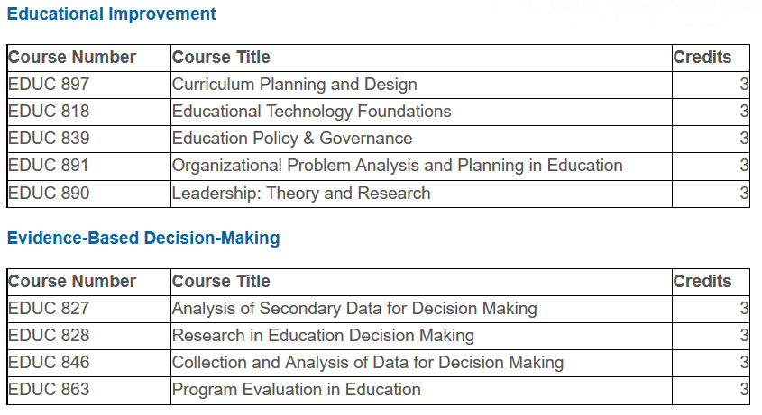

- Describe requirements involving total credit hours, credit hour distribution, field experiences, etc.
There will be 30 credit hours total, with no field experiences. Students must be in good standing and meet the 3.0 gpa requirement of the Ed.D. program to be eligible for the MA-EL. There are no other program requirements.

- Provide a sample curriculum by following the format in the Undergraduate and Graduate Catalog.
Not applicable

- Indicate how the curriculum satisfies University of Delaware, college and departmental requirements, such as ENGL110, multicultural, college core, etc.
Not applicable.
- In the Appendices, provide approval from affected departments for all newly required courses that support the proposed curriculum.
Not applicable.

V. RESOURCES AVAILABLE and VI. RESOURCES REQUIRED.
The MA-EL does not require any additional resources beyond those provided for and available to the Ed.D. in Education Leadership.

VII. IMPLEMENTATION AND EVALUATION
- Implementation Plan Describe how the curriculum will be implemented.
Students will be advised of this option as part of standard program advisement. No additional implementation plan is needed.

- Assessment Plan Indicate how the program will be evaluated and assessed. Some measures should be quantitative, other qualitative. Success should be measured against the criteria listed including stated learning outcomes and against whatever objectives have been set forth in the first section of the proposal. Academic units are encouraged to consult with the Office of Educational Assessment in developing the appropriate learning outcomes, assessment criteria, and benchmarks for success.
The MA-EL will be evaluated by tracking the number of EdD students seeking the degree and the academic outcomes of those students by way of academic grades in the 27 credit core. Degrees in excess of the predicted 0-2 per year will result in faculty discussion of the role of the MA-EL and determination of problems within the larger EdD that need to be considered. Academic performance will be considered to ensure that the MA-EL is not used to remove struggling students from the Ed.D. program. These data will be reviewed annually by faculty.

