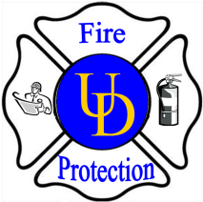
University of Delaware

Environmental Health and Safety

General Services Building Room 132

222 South Chapel Street, Newark, De. 19716

(p)831-8475 (f)831-1528

fire-safe@udel.edu

-Application for Tent Use on University Property-

Application MUST be received by the EHS office 2 weeks prior to the event date

Please print clearly.

Applicant’s Name:

Applicant’s Organization:

Applicant’s Address:
Applicant’s Email:
Applicant’s Telephone Number: ( ) - Fax: ( ) -
Please provide the following information as it will help us in evaluating your tent event:
Event date(s):
Event time:
Event location:
Event description:
Tent vendor:
Tent vendor contact name:
Tent vendor contact number:
Tent size(s)?:
Will the tent have side walls (Yes/No):
Will fire extinguishers be provided by the tent vendor (Yes/No):
Exit signs provided by the vendor (Yes/No):
How is the tent anchored to the ground (stake/weighed)?:
Date of tent setup:
Date of tent take down:
Generator needed for power (Yes/No):
If yes to answer above; is the generator UD supplied (Yes/No):
Will food be provided (yes/no):
If yes to the question above will it be prepared onsite or brought in:

Please be prepared to have an interior tent layout ready for review with respect to table/chair layout/placement.

Submit applications to Department of Environmental Health & Safety

Revised 3/25/14

