Direction on How to Apply to the
4+1 (BS in Nutrition and Dietetics/MS in Human Nutrition) Program
Fall 2024

To fully submit your application, you will need the following items:
- Completed and signed Graduate Course Approval Form for 4+1 Admission Application. This form requires a signature from your undergraduate advisor (Lori Mayhew, lmayhew@udel.edu) and graduate program director (Prof. Anja Leefeldt, aleef@udel.edu).
- A Resume/CV
- The Name, position/title and email of two individuals who will provide recommendations. Make sure you ask their permission before submitting their names.
- A personal statement that clearly explains how admission to the program will facilitate your professional objectives.

Step-by-Step Directions for Submitting your Application:

- Go to the Graduate College website: https://www.udel.edu/academics/colleges/grad/. Scroll down and click ‘APPLY NOW’

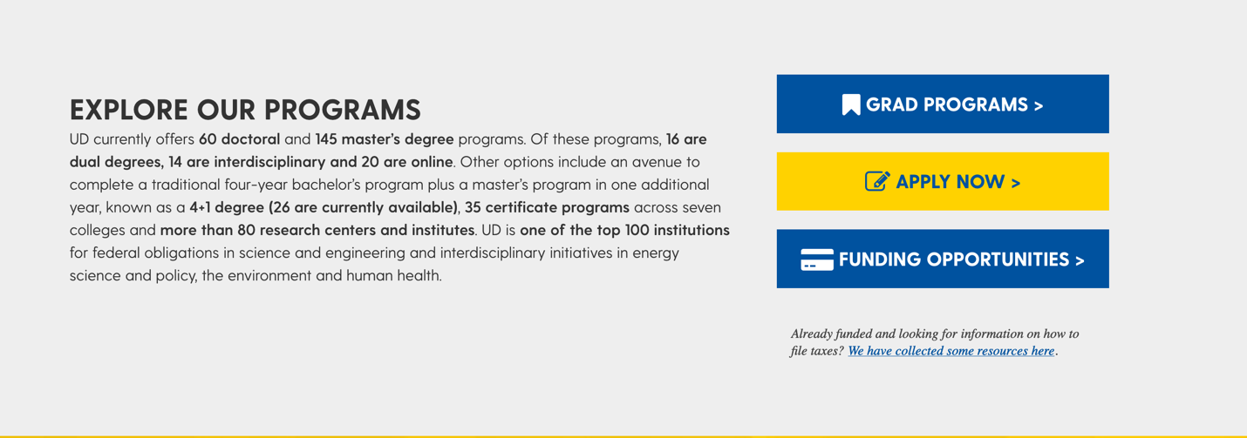

- Then click ‘SUBMIT APPLICATION’

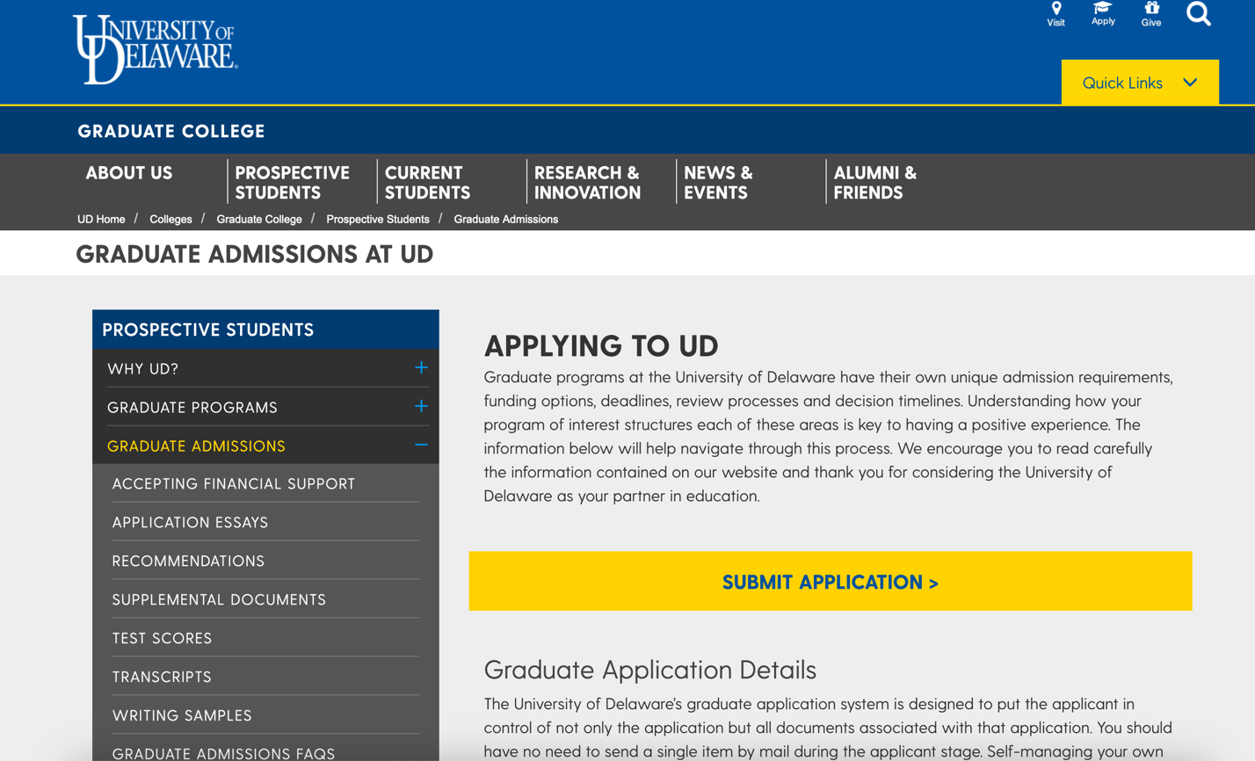

- Create an account for first-time users. Click ‘Create an account’ circled in red below.

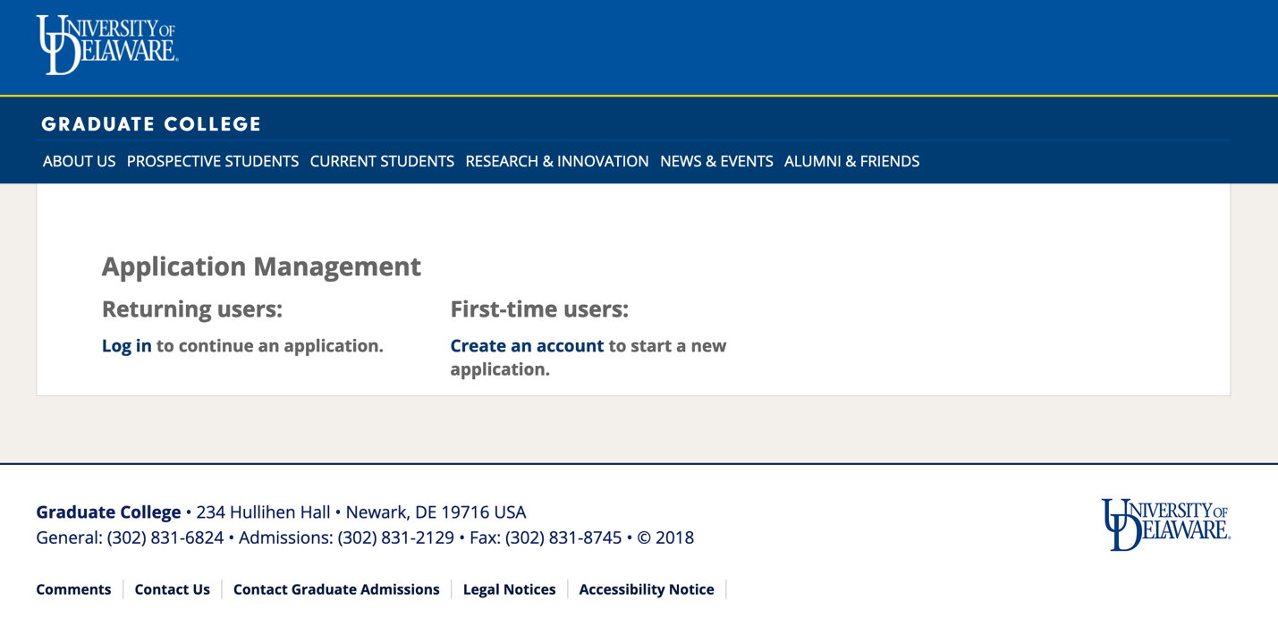
- You will create an account. To create an account, you will be required to enter your email address, first name, last name, and date of birth. You will then be emailed a temporary pin to the email entered when creating an account.

- You will enter the temporary pin into the system and then be required to create a password.

- You will then be prompted to start an application. Click on ‘Start New Application’.

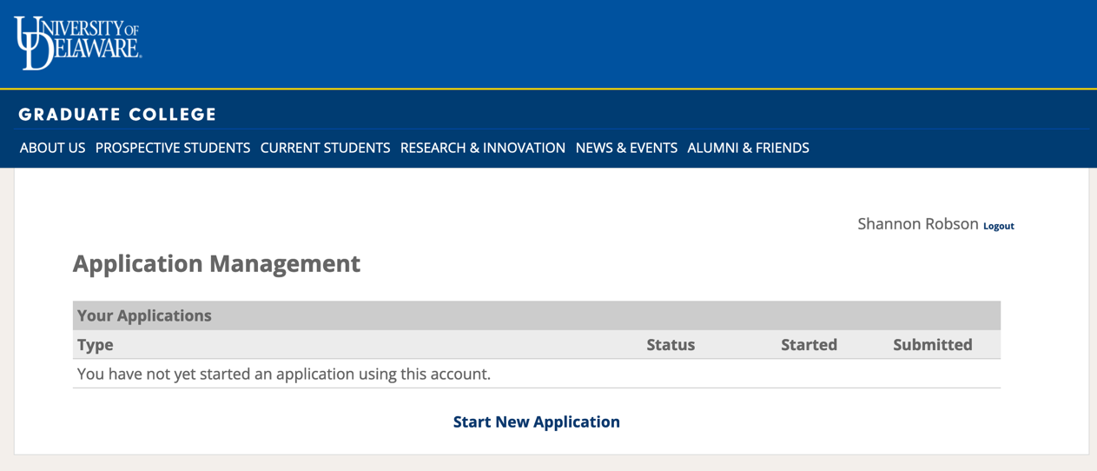

- A pop-up window will be displayed. Click ‘Create Application’.

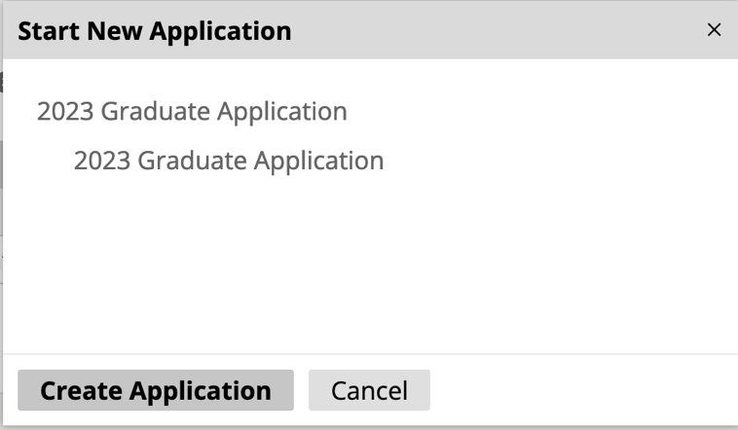
- A pop-up window will again be displayed. Click ‘Open Application’.

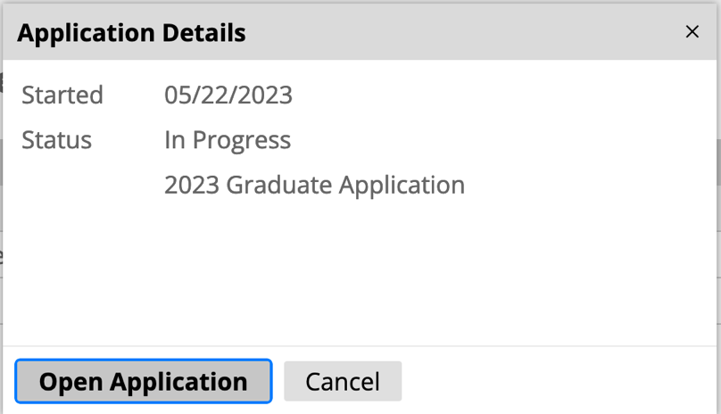

- You will then be prompted to add your Biographical Information. At the bottom of the Biographical Information page, you must select ‘Yes’ to the questions ‘Have you previously been, or are you currently, a student at the University of Delaware?’ and ‘Are you currently an undergraduate student at the University of Delaware?’. Once completed, click Continue.
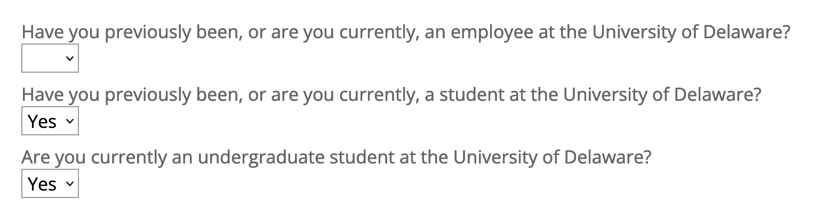

- You will be prompted to identify the Program of Study. In the Search bar type Human Nutrition. It will also automatically fill in the Program of Study box. Once completed,
click Continue.

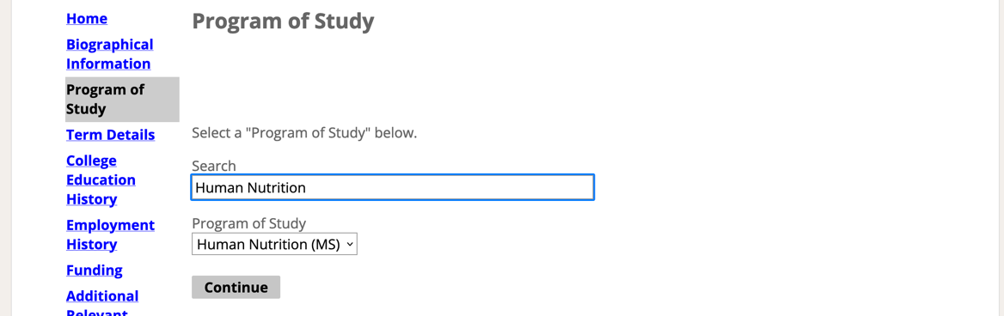

- On the Term Details page, you will select the responses as shown below. This is where you indicate you are applying to the 4+1 Program and upload the completed and signed Graduate Course Approval Form for 4+1 Application. Once completed, click Continue.

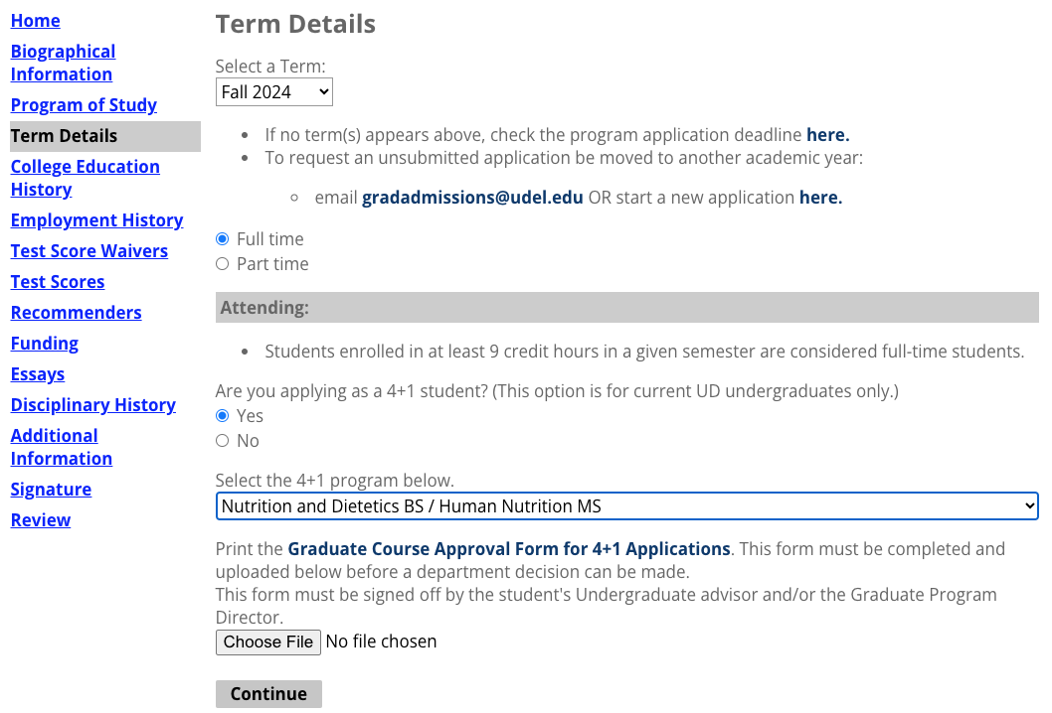

- You will then be prompted to add information about your College Education History. Once completed, click Continue.

- You will then be prompted to add information about your Employment History. Here you will upload a copy of your Resume/CV. Once completed, click Continue.

- Next, under Test Score Waiver, click Continue and then under Test Score, click Continue.

- Under Recommenders you will click on Add Recommender (circled in red below).

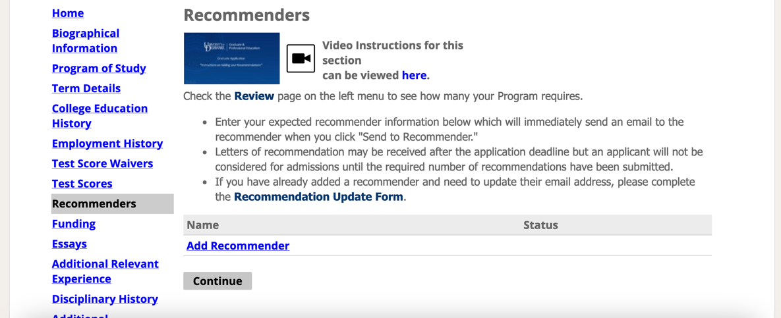

- The Add Recommender pop up screen will show up where you will enter the information of your recommender. Then click ‘Send to Recommender’. The 4+1 Application requires two letters of recommendation. Once completed, click Continue.
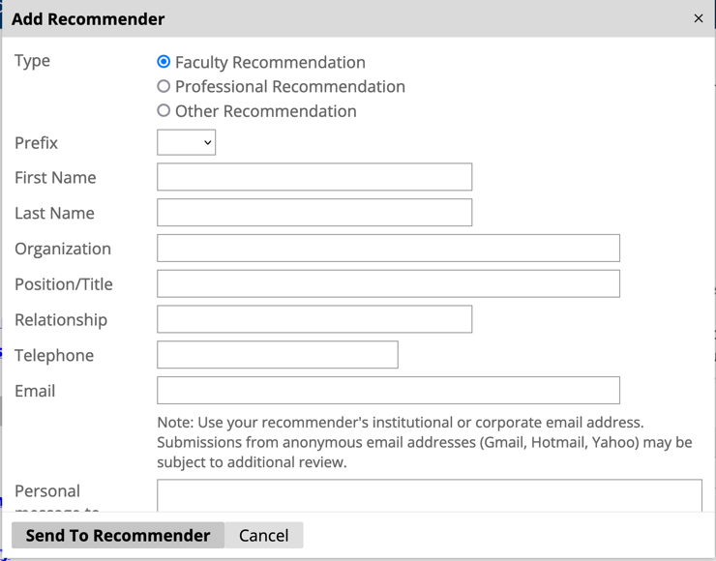

- Complete information about funding, this is not required. Currently there is not Department provided assistantships for the 4+1 Program. Once completed, click Continue.
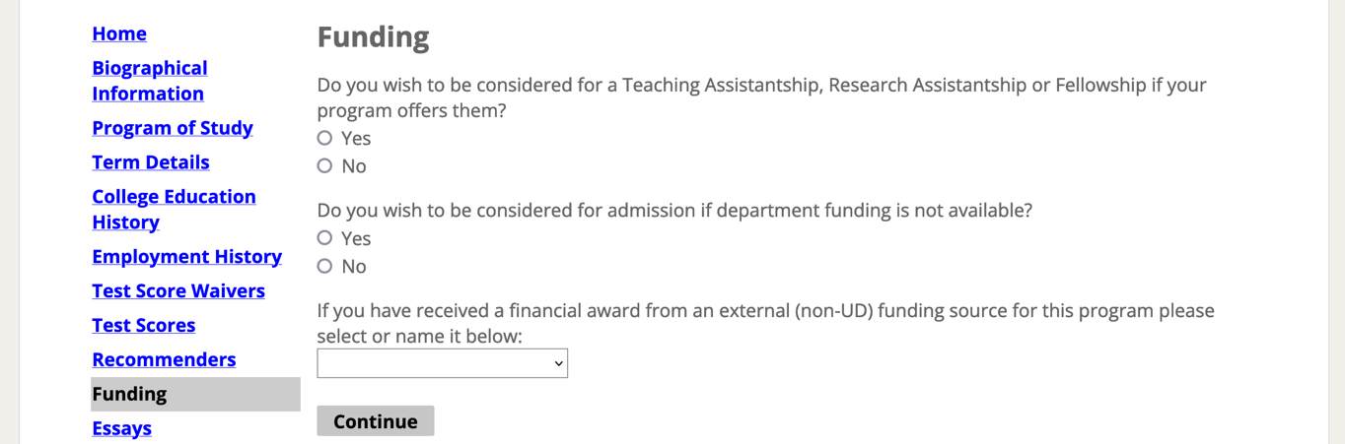

- On the Essay page you will upload your Personal Statement. Once completed, click Continue.
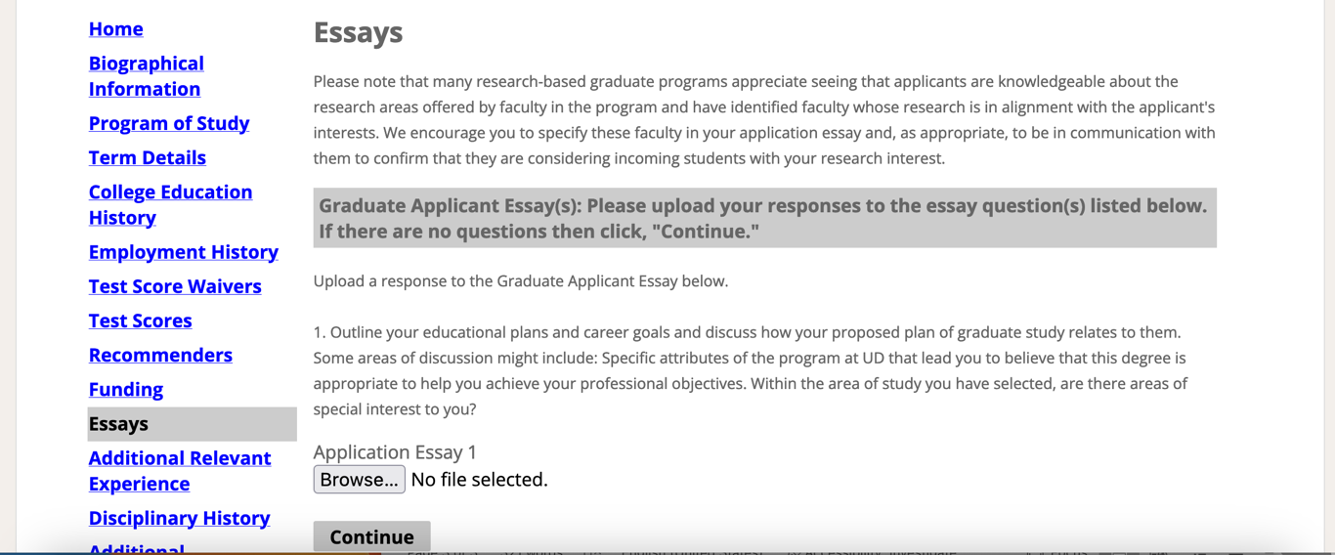

- On the Additional Relevant Experience page, you are welcome to highlight any additional experiences, but this is not required. Once completed, click Continue.

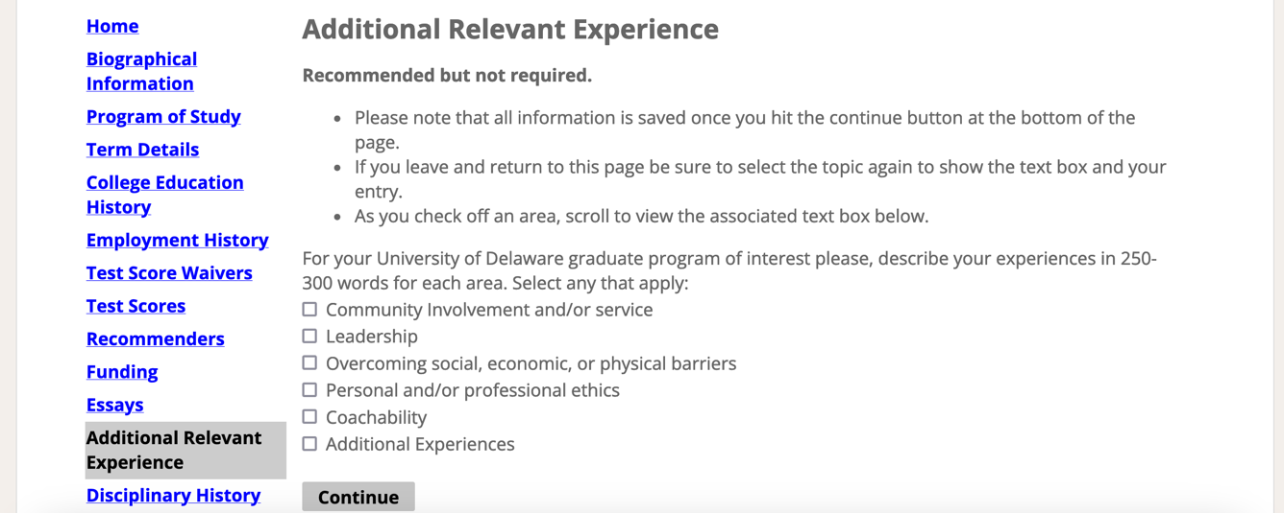

- You will be prompted to respond to two questions related to Disciplinary History. Once completed, click Continue.

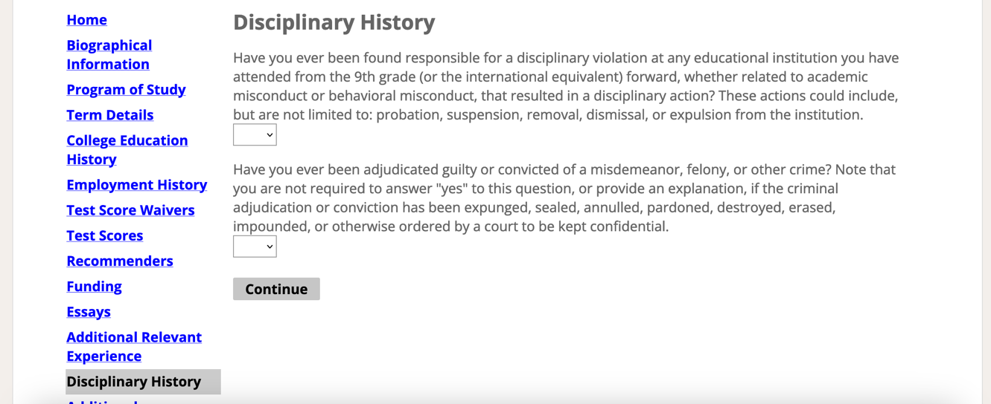

- You will be prompted to provide Additional Information. Once completed, click Continue.

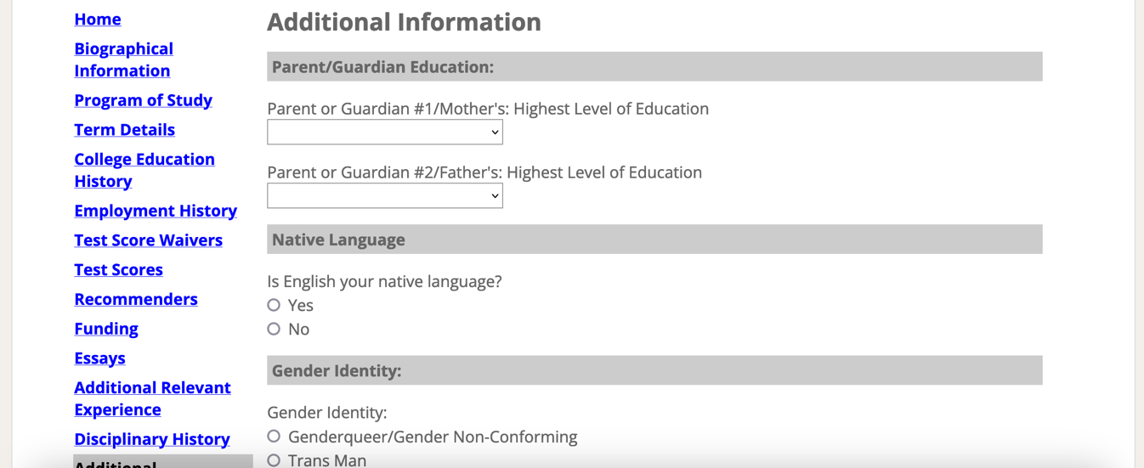

- The last step of the application is to provide your electronic signature. Once signed, click Continue.

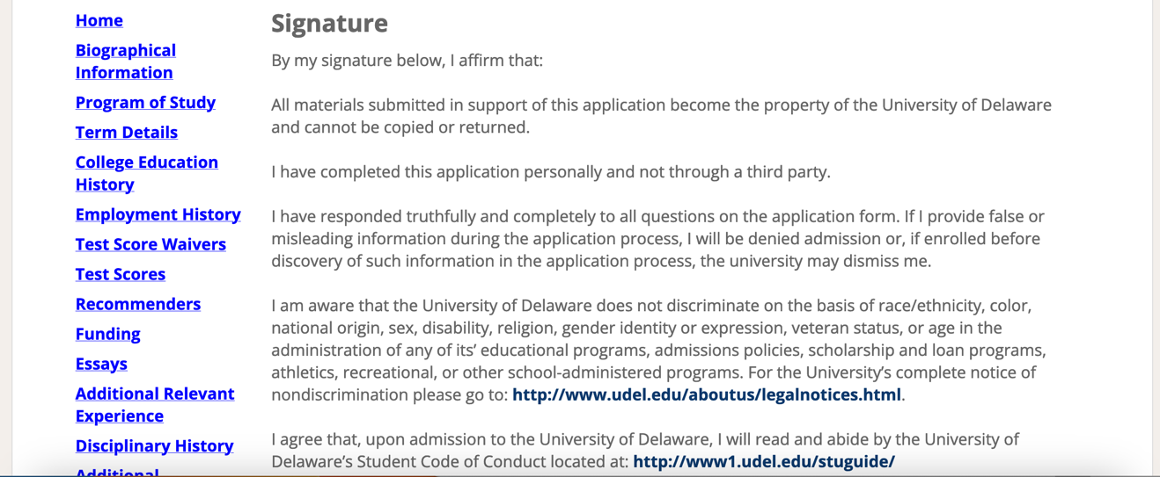

- You will then Review your application. Any missing information will be shown.

