Delaware Field and Vegetable Crop Insect Pest Management Trials
2021
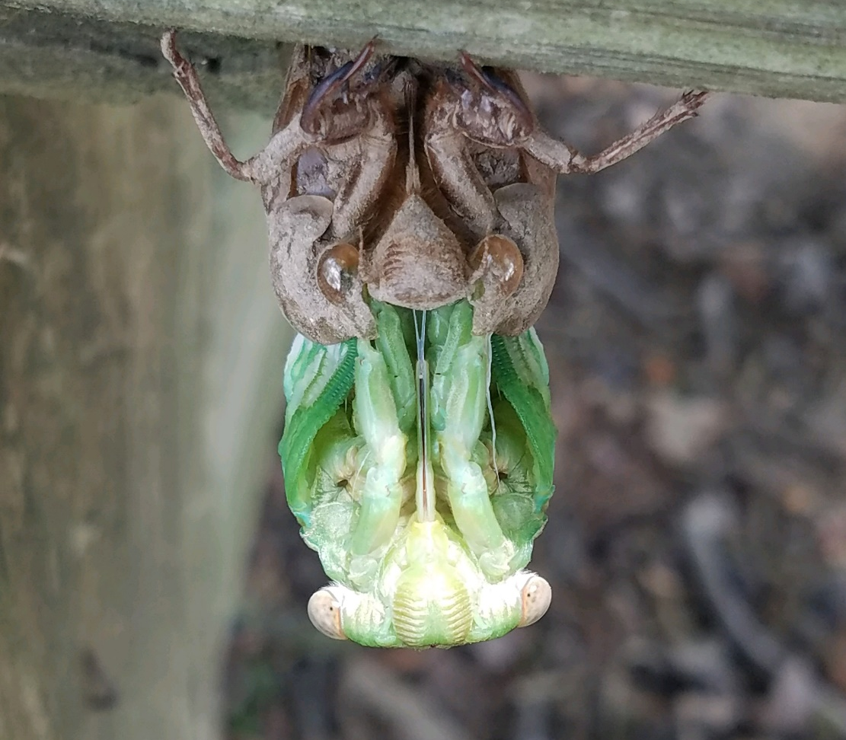
David Owens
Entomology Extension Specialist
Carvel Research and Education Center
16483 County Seat Highway
Georgetown, DE 19947
E-mail owensd@udel.edu; (302) 698-7125 (cell)

Joseph Deidesheimer Dylan Wilkerson Cody Stubbs
Entomology Research Associate Term Researcher UD ENWC Master’s Student
Carvel REC Carvel REC Carvel REC
E-mail carvelent@gmail.com E-mail wilkers@udel.edu E-mail bookman@udel.edu

Technical Support: Dereck Booth, Mary Chupp, Calista Turman, Carson Mears, Dick Monaco

The purpose of this book is to disseminate insect, mite, and mollusk efficacy and field survey results for information only. These data are not meant to be used for marketing purposes. Inclusion or exclusion of a product from a trial is not meant as an endorsement of one or discrimination against another. Please note that not all products evaluated might be labeled for use on the crop in which they were tested on. If you have questions or concerns, feel free to contact David Owens anytime.

Acknowledgements

This research could not have been possible without the support from numerous individuals, farmers, and organizations, many of whom are listed below:

Carvel REC faculty and staff, especially:
Dr. Mark Isaacs (Director)
Brian Hearn (Farm Manager)
James Adkins
Ward Harris
Warren Wiley
Dr. Gordon Johnson
Dr. Emmalea Ernest

UMD Lower Eastern Shore Research and Education faculty and staff, especially:
David Armentrout (Farm Manager)

Sussex County Council

Competitive Grants:
DDA Specialty Crop Block Grant Program
Northeast IPM Center
Northeast SARE
Delaware Soybean Board
USDA-NIFA EIPM

Industry Support:
Corteva
Bayer
UPL
Nichino America
Syngenta
BASF
IR-4
Pioneer
Dyna-Gro Seed
Brotherton Seed
TRIC

University Collaborators:
Dr. Alan Taylor, Cornell University
Dr. Kelly Hamby, University of Maryland
Dr. Sally Taylor, Virginia Tech Tidewater AREC
Dr. Dominic Reisig, NCSU Vernon James REC
Dr. Galen Dively, University of Maryland
Emily Zobel, University of Maryland
Sara Hirsch, University of Maryland

Farmers and Consultants:
Aaron Thompson
Adam Dickerson
Bill Owens
Bobby and Curt Fifer
Bryan Melvin
Charles West
Charlie Smith
Chris and Mel Wyatt
Cory LeCates
Craig Murray
Gary Calloway
Gary Conaway
Geno Lowe
Geno Lowe
Grier Stayton
Guy and Dale Phillips
Henry Bergfelder
Hudson Consulting
Jason Frye
Jay Baxter
Joanne Whalen
Keith and Will Carlisle
Kenny Blessing
Kevin Evans
Kevin Evans
Lee Richardson
Luke McConnell
Mark Collins
Mark Wilson
Matt Daudt
Matt Weber
Nathan Hudson
Paul Townsend
Phillip Sylvester
R.C. and Brent Willin
Ray and Clay Vincent
Richard Ellis
Richard Papen
Richard Sapp
Richard Woolyhan
Robbie Emmerson
Roland Hill
Roland Hill
Steve Isaacson
Stuart Cooper
Tim Duffy
Tony Gundry
Trapwoods Consulting
Travis Hastings
Wade Dunning
Will Betts

Table of Contents
Vegetables
Cabbage 2021 Aphids 6
Green Onions 2021 Thrips 7
Lima Bean 2021 Tarnished Plant Bug Variety Test 11
Seedcorn Maggot 2021 Onion 1 13
Seedcorn Maggot 2021 Peas 1 14
Seedcorn Maggot 2021 Peas 2 16
Seedcorn Maggot 2021 Radish 1 17
Seedcorn Maggot 2021 Snap Bean 19
Seedcorn Maggot 2021 Sweet Corn 1 20
Seedcorn Maggot 2021 Sweet Corn 2 22
Snap Bean 2021 General Insects 23
Strawberry 2021 Spider Mites (UVC) 24
Sweet Corn 2021 CEW 1 30
Sweet Corn 2021 CEW 2 32
Sweet Corn 2021 CEW 3 34
Sweet Corn 2021 CEW 4 37
Sweet Corn 2021 Sentinel Plot CEW Bt Susceptibility 40
Watermelon 2021 Striped Cucumber Beetle 41
Watermelon 2021 Two Spotted Spider Mite 44
Watermelon 2021 Two Spotted Spider Mite 46
Field Crops
Alfalfa 2021 Alfalfa Weevil 47
Alfalfa 2021 Aphids 48
Cover Crops 2021 Common Experiment 2: Cover Crop Termination Effects 49
Field Corn 2021 Brown Stink Bug 53
Sorghum 2021 Sugarcane Aphid Variety Trial 54
Soybean 2021 CEW 56
Soybean 2021 Stink Bug 60
Slug Monitoring 61
Soybean Prophylactic Insecticide Treatment Evaluation 69
Insect Trapping, Bioassays, and Other Observations
Corn Earworm Pyrethroid Susceptibility Bioassay 2021 84
Poultry 2021 Darkling Beetle Insecticide Bioassay 85
Striped Cucumber Beetle Insecticide Efficacy Bioassay 88
Insect Trapping 2021 89
Hemp 2021 CEW Survey 91
Soybean 2021 Dectes Stem Borer Observations 92
Soybean pest loss survey 94

Cabbage 2021 Aphids
Location: Carvel REC, Georgetown, DE
Variety: ‘Early Dutch Round’
Transplant Date: 24 August
Experimental Design: Randomized complete block design with 8 treatments and 5 replicates
Plot size: 1 rows x 12 plants
Treatment Method: CO₂-pressurized backpack sprayer with single-row boom equipped with 3 D2 tips and #25 cores. The outer two nozzles were on 8” drop tubes and oriented sideways to spray the sides of the plant. The boom was calibrated to deliver 39 GPA at 35 PSI.
Treatment Date: 21 September
Sample Size: 5 plants per plot
Data Analysis: ANOVA; Student’s t means separation

TRT | Material | Rate | 0D PRE | 6 DAT | 13 DAT | 23 DAT
1 | UTC | --- | 91.0 ± 46.8 | 94.6 ± 44.7 | 308.6 ± 168.9 | 295.3 ± 138.4 a
2 | Organic Experimental | 4.0 pts/A | 84.8 ± 40.9 | 141.4 ± 81.6 | 201.0 ± 139.8 | 251.4 ± 121.7 ab
3 | Sivanto Prime | 7.0 fl oz/A | 64.0 ± 22.2 | 17.8 ± 11.2 | 31.0 ± 17.4 | 15.5 ± 4.5 bc**
4 | Syngenta Experimental | 5.0 fl oz/A | 60.8 ± 18.7 | 10.2 ± 8.3 | 31.0 ± 14.2 | 46.8 ± 11.4 c
5 | Versys | 1.5 fl oz/A | 61.4 ± 19.1 | 3.4 ± 2.0 | 12.0 ± 5.1 | 8.6 ± 3.1 c
6 | Torac | 19.0 fl oz/A | 61.0 ± 18.7 | 5.0 ± 3.2 | 31.6 ± 15.4 | 50.2 ± 17.9 c
7 | Verimark* | 10.0 fl oz/A | 59.6 ± 18.8 | 0.2 ± 0.2 | 11.2 ± 6.3 | 22.2 ± 5.9 c
8 | Admire Pro | 1.3 fl oz/A | 59.6 ± 18.6 | 15.8 ± 12.3 | 17.6 ± 8.9 | 27.8 ± 8.4 c
ANOVA |  |  | P = 0.981  F = 0.21; df = 7, 32 | P = 0.040  F = 2.44; df = 7, 32 | P = 0.055  F = 2.27; df = 7, 31 | P = 0.018  F = 3.00; df = 7, 28
*Verimark is only labeled as a soil treatment. This application should have been Exirel. The amount applied foliarly contained the same amount of active ingredient, cyantraniliprole, as Exirel’s high rate at 20.5 fl oz/A.
**Several TRT 3 plots were not examined. Incomplete data is the reason for the bc letter grouping even with a lower mean compared to the other c letter groups.

Green Onions 2021 Thrips
Location: Carvel REC, Field 2
Variety: ‘Parade’
Planting Date: 23 April
Experimental Design: Randomized complete block design with 11 treatments and 4 replicates
Plot size: 6 rows x 12’
Row Spacing: approximately15”
Seeding Rate: 1 seed per inch, Jang JP-1 push seeder
Treatment Method: CO₂ pressurized backpack sprayer with a 5’ boom equipped with 4 D5- 25 nozzles spaced 20” apart calibrated to deliver 30 GPA at 41 PSI.
Treatment Date: June 12, June 18, June 25, and July 3
Sample Size: 10 plants per plot or 10 leaves (2nd mature leaf from terminal) per plot
Data Analysis: ANOVA; Tukey-Kramer HSD means separation

Field was treated with Dacthal on 24 April and Dual Magnum on 5 June. Thrips species present were identified by Dr. Sean Malone (Virginia Tech) as tobacco thrips, Frankliniella fusca.
TRT | Material | Rate
1 | UTC | ---
2 | Radiant | 10 fl oz
3 | Sivanto HL | 7 fl oz
4 | Agri-Mek | 3.5 fl oz
5 | Prev-Am | 0.4% v/v
6 | Agri-Mek + Prev-Am | 3.5 fl oz + 0.4% v/v
7 | Harvanta | 16.4 fl oz
8 | Rimon | 12 fl oz
9 | Experimental | 2.5 fl oz
10 | Azera | 2 pints
11 | ALS Experimental | 2 qts
Induce was added to all treatments at a rate of 0.5% v/v except for treatments 5 and 6.
TRT | June 10 PRE
 | Adults/ leaf | Larvae/ leaf | Total/ leaf
1 | 1.2 ± 0.2 | 0.8 ± 0.4 | 2.0 ± 0.4
2 | 0.9 ± 0.6 | 2.0 ± 1.1 | 2.9 ± 0.9
3 | 1.8 ± 0.8 | 2.1 ± 1.4 | 3.9 ± 2.2
4 | 0.9 ± 0.3 | 2.5 ± 1.9 | 3.4 ± 2.1
5 | 1.1 ± 0.6 | 1.8 ± 0.8 | 2.8 ± 1.3
6 | 1.5 ± 0.6 | 3.6 ± 0.8 | 5.1 ± 1.4
7 | 1.0 ± 0.2 | 1.1 ± 0.5 | 2.1 ± 0.7
8 | 1.1 ± 0.3 | 2.9 ± 0.9 | 4.0 ± 0.8
9 | 1.3 ± 0.3 | 2.8 ± 1.7 | 4.0 ± 1.9
10 | 1.3 ± 0.3 | 2.4 ± 1.7 | 3.7 ± 1.9
11 | 1.3 ± 0.4 | 1.3 ± 0.9 | 2.6 ± 0.6
ANVOA | P = 0.962  F = 0.34; df = 10, 33 | P = 0.868  F = 0.51; df = 10, 33 | P = 0.923  F = 0.43; df = 10, 33

TRT | June 17; 5 DAT1
 | Adults/ leaf | Larvae/ leaf | Total/ leaf
1 | 2.6 ± 0.8 | 3.7 ± 1.3 | 6.3 ± 1.9
2 | 2.3 ± 0.4 | 2.6 ± 1.5 | 4.8 ± 1.7
3 | 2.1 ± 0.8 | 2.3 ± 1.1 | 4.4 ± 1.5
4 | 2.3 ± 0.7 | 1.8 ± 0.8 | 4.1 ± 0.6
5 | 3.3 ± 0.8 | 4.5 ± 1.7 | 7.8 ± 2.2
6 | 3.7 ± 1.0 | 2.3 ± 0.9 | 5.9 ± 1.5
7 | 3.3 ± 1.1 | 1.2 ± 0.3 | 4.4 ± 0.9
8 | 1.6 ± 0.8 | 0.9 ± 0.5 | 2.5 ± 1.0
9 | 1.9 ± 0.8 | 1.0 ± 0.4 | 4.4 ± 1.9
10 | 1.9 ± 0.8 | 1.2 ± 0.5 | 3.1 ± 1.1
11 | 2.5 ± 1.3 | 0.5 ± 0.2 | 3.0 ± 1.3
ANVOA | P = 0.902  F = 0.46; df = 10, 33 | P = 0.144  F = 1.62; df = 10, 33 | P = 0.425  F = 1.05; df = 10, 33

TRT | June 25; 7 DAT2
 | Adults/ leaf | Larvae/ leaf | Total/ leaf
1 | 0.2 ± 0.0 | 0.5 ± 0.2 | 0.6 ± 0.2
2 | 0.1 ± 0.0 | 0.2 ± 0.1 | 0.3 ± 0.1
3 | 0.2 ± 0.1 | 0.1 ± 0.1 | 0.3 ± 0.1
4 | 0.2 ± 0.0 | 0.1 ± 0.0 | 0.3 ± 0.1
5 | 0.1 ± 0.0 | 0.5 ± 0.1 | 0.6 ± 0.1
6 | 0.2 ± 0.1 | 0.2 ± 0.1 | 0.4 ± 0.1
7 | 0.1 ± 0.0 | 0.5 ± 0.2 | 0.6 ± 0.2
8 | 0.2 ± 0.0 | 0.4 ± 0.2 | 0.5 ± 0.2
9 | 0.1 ± 0.0 | 0.4 ± 0.4 | 0.6 ± 0.4
10 | 0.1 ± 0.0 | 0.1 ± 0.0 | 0.3 ± 0.0
11 | 0.2 ± 0.1 | 1.3 ± 0.7 | 1.5 ± 0.7
ANVOA | P = 0.935  F = 0.40; df = 10, 33 | P = 0.171  F = 1.54; df = 10, 33 | P = 0.106  F = 1.77; df = 10, 33

TRT | 1 July; 6 DAT3
 | Adults/ leaf | Larvae/ leaf | Total/ leaf
1 | 0.2 ± 0.1 | 2.2 ± 0.8 | 2.4 ± 0.9
2 | 0.1 ± 0.1 | 0.4 ± 0.2 b | 0.5 ± 0.2
3 | 0.1 ± 0.1 | 1.5 ± 0.5 | 1.6 ± 0.5
4 | 0.2 ± 0.1 | 1.1 ± 0.3 | 1.3 ± 0.2
5 | 0.1 ± 0.0 | 1.3 ± 0.5 | 1.3 ± 0.5
6 | 0.1 ± 0.0 | 1.2 ± 0.6 | 1.3 ± 0.6
7 | 0.1 ± 0.0 | 0.7 ± 0.3 | 0.8 ± 0.3
8 | 0.2 ± 0.1 | 1.2 ± 0.2 | 1.4 ± 0.2
9 | 0.1 ± 0.0 | 0.7 ± 0.3 | 0.8 ± 0.3
10 | 0.1 ± 0.0 | 2.7 ± 0.7 a | 2.8 ± 0.7
11 | 0.1 ± 0.1 | 0.6 ± 0.1 b | 0.7 ± 0.1
ANVOA | P = 0.746  F = 0.67; df = 10, 32 | P = 0.026  F = 2.46; df = 10, 32 | P = 0.029; F = 2.41; df = 10, 32

TRT | July 8, 7 DAT4
 | Adults/ leaf | Larvae/ leaf | Total/ leaf
1 | 1.0 ± 0.5 | 9.7 ± 3.3 | 10.7 ± 3.8
2 | 0.3 ± 0.1 | 0.8 ± 0.2 | 1.1 ± 0.3
3 | 0.9 ± 0.5 | 4.6 ± 1.2 | 5.5 ± 1.6
4 | 0.4 ± 0.1 | 3.9 ± 1.1 | 4.3 ± 1.1
5 | 0.8 ± 0.1 | 6.9 ± 2.5 | 7.7 ± 2.5
6 | 0.9 ± 0.4 | 4.4 ± 0.6 | 5.2 ± 0.9
7 | 0.7 ± 0.5 | 5.4 ± 1.1 | 6.1 ± 1.5
8 | 0.7 ± 0.3 | 4.9 ± 1.4 | 5.5 ± 1.6
9 | 1.6 ± 1.0 | 4.9 ± 2.0 | 6.5 ± 2.8
10 | 1.0 ± 0.4 | 8.1 ± 1.4 | 9.0 ± 1.4
11 | 0.5 ± 0.1 | 6.1 ± 0.8 | 6.6 ± 7.7
ANVOA | P = 0.769  F = 0.64; df = 10, 32 | P = 0.075  F = 1.94; df = 10, 32 | P = 0.136  F = 1.65; df = 10, 32

TRT | July 15, 14 DAT4
 | Adults/ leaf | Larvae/ leaf | Total/ leaf
1 | 0.7 ± 0.1 | 5.4 ± 2.9 | 6.1 ± 2.9
2 | 0.5 ± 0.2 | 1.4 ± 0.8 | 1.9 ± 0.9
3 | 0.5 ± 0.2 | 2.7 ± 0.9 | 3.2 ± 1.0
4 | 0.5 ± 0.2 | 2.6 ± 1.0 | 3.1 ± 1.2
5 | 0.6 ± 0.3 | 4.8 ± 2.6 | 5.4 ± 2.5
6 | 0.5 ± 0.3 | 5.4 ± 2.2 | 5.9 ± 2.3
7 | 0.6 ± 0.2 | 3.9 ± 1.3 | 4.5 ± 1.4
8 | 0.6 ± 0.3 | 3.8 ± 1.5 | 4.4 ± 1.8
9 | 0.3 ± 0.2 | 3.6 ± 1.0 | 3.9 ± 1.1
10 | 1.3 ± 0.4 | 6.8 ± 2.6 | 8.0 ± 2.3
11 | 0.6 ± 0.2 | 4.2 ± 1.3 | 4.8 ± 1.3
ANVOA | P = 0.504  F = 0.95; df = 10, 32 | P = 0.722  F = 0.69; df = 10, 32 | P = 0.635  F = 0.79; df = 10, 32

Cumulative Totals following Application 1, 2, and 3:
TRT
 | Adults/ leaf | Larvae/ leaf | Total/ leaf
1 | 2.9 ± 0.9 | 5.8 ± 1.6 | 8.7 ± 2.4
2 | 2.5 ± 0.4 | 3.1 ± 1.4 | 5.6 ± 1.7
3 | 2.4 ± 0.8 | 4.0 ± 0.9 | 6.3 ± 1.4
4 | 2.7 ± 0.7 | 3.0 ± 0.7 | 5.6 ± 0.6
5 | 3.5 ± 0.8 | 6.2 ± 2.0 | 9.7 ± 2.5
6 | 4.0 ± 0.9 | 3.6 ± 1.5 | 7.6 ± 2.0
7 | 3.5 ± 1.1 | 2.4 ± 0.4 | 5.9 ± 0.9
8 | 1.9 ± 0.9 | 2.5 ± 0.4 | 4.4 ± 1.0
9 | 3.6 ± 1.8 | 2.2 ± 0.8 | 5.8 ± 2.5
10 | 2.1 ± 0.8 | 4.0 ± 1.0 | 6.2 ± 1.6
11 | 2.8 ± 1.3 | 2.4 ± 0.8 | 5.2 ± 1.3
ANVOA | P = 0.923  F = 0.43; df = 10, 33 | P = 0.230  F = 1.39; df = 10, 33 | P = 0.603  F = 0.83; df = 10, 33

Lima Bean 2021 Tarnished Plant Bug Variety Test
Location: Carvel REC, Georgetown
Variety: C-Elite Select; UC Beija Flor
Planting Date: 24 June
Experimental Design: Randomized complete block design with three row-replicates; 8 cages per variety (4 with and 4 without tarnished plant bugs) and 4 sections without cages.
Plot size: Cages covered 3 row feet; planted rows were 20’ long and variety randomized.
Row Spacing: 30” rows
Seeding Rate: 3”
Cage Infestation: 18 August; 12 TPB per cage.
Harvest Date: 17 September
Sample Size: all plants per cage (6 – 16, average 9.4 plants per segment)
Data Analysis: ANOVA

Variety | Treatment | No. plants | Flat pods/plant | Full pods/plant | Dry Flat pods / plant | Dry Full pods/ plant | % succulent beans | % stung succulent beans | Succulent weight/ plant | % dry beans | % stung dry | Dry weight / plant | Weight / plant
Suscept | No Cage |  | 1.1 ± 0.3 | 14.8 ± 0.8 | 0.6 ± 0.2 | 2.1 ± 0.8 | 88.3 ± 4.8 | 6.9 ± 2.5 | 19.3 ± 1.3 | 11.7 ± 4.8 | 11.6 ± 8.5 | 1.8 ± 0.7 | 21.1 ± 1.8
 | Cage  - bug |  | 0.6 ± 0.1 | 10.8 ± 2.3 | 1.5 ± 0.4 | 4.6 ± 1.0 | 72.1 ± 2.4 | 3.4 ± 2.5 | 17.8 ± 3.4 | 27.9 ± 2.4 | 7.8 ± 4.8 | 4.0 ± 0.9 | 20.8 ± 3.1
 | Cage  + bug |  | 0.7 ± 0.4 | 12.1 ± 2.5 | 0.6 ± 0.3 | 2.7 ± 2.1 | 91.7 ± 4.0 | 2.7 ± 0.7 | 22.4 ± 3.7 | 8.3 ± 4.0 | 27.4 ± 24.3 | 3.1 ± 2.6 | 25.6 ± 6.1
ANOVA |  |  | P = 0.445  F = 0.89; df = 2, 9 | P = 0.401  F = 1.01; df = 2, 9 | P = 0.152  F = 2.34; df = 2, 9 | P = 0.461  F = 0.85; df = 2, 9 | P = 0.013 F = 7.33; df = 2, 9 | P = 0.350  F = 1.18; df = 2, 9 | P = 0.559  F = 0.62; df = 2, 9 | P = 0.013  F = 7.33; df = 2, 9 | P = 0.639  F = 0.47; df = 2, 9 | P = 0.676  F = 0.41; df = 2, 8 | P = 0.670  F = 0.42; df = 2, 9
Resist | No Cage |  | 0.3 ± 0.1 | 11.5 ± 3.7 | 2.2 ± 2.6 | 16.3 ± 1.6 | 33.3 ± 8.5 |  | 17.7 ± 4.9 | 75.0 ± 10.3 | 3.8 ± 2.5 | 18.2 ± 3.0 | 31.5 ± 7.6
 | Cage  - bug |  | 1.0 ± 0.6 | 8.2 ± 3.2 | 2.0 ± 1.1 | 7.2 ± 3.0 | 66.5 ± 11.7 | SB nymphs present in cage | 11.1 ± 2.3 | 33.5 ± 11.7 | 49.7 ± 26.5 | 7.2 ± 4.0 | 18.3 ± 6.2
 | Cage  + bug |  | 0.9± 0.6 | 13.8 ± 5.7 | 1.3 ± 0.5 | 8.6 ± 2.9 | 63.2 ± 11.2 |  | 20.9 ± 3.9 | 36.8 ± 11.2 | 3.1 ± 1.3 | 10.3 ± 3.1 | 31.2 ± 3.3
ANOVA |  |  | P = 0.571  F = 0.60; df = 2, 8 | P = 0.308  F = 1.37; df = 2, 8 | P = 0.819 F = 2.06; df = 2, 7 | P = 0.067 F = 3.86; df = 2, 8 | P = 0.149  F = 2.43; df = 2, 8 |  | P = 0.263  F = 1.62; df = 2, 7 | P = 0.048  F = 4.32; df = 2, 9 | P = 0.100  F = 3.01; df = 2, 9 | P = 0.97  F = 3.16; df = 2, 8 | P = 0.300  F = 1.40; df = 2, 8
Suscept |  |  | 0.8 ± 0.2 | 12.6 ± 1.2 | 0.9 ± 0.2 | 3.1 ± 0.8 | 84.0 ± 3.3 | 4.3 ± 1.2 | 19.9 ± 1.7 | 16.0 ± 3.3 | 15.6 ± 8.3 | 2.9 ± 0.9 | 22.5 ± 2.9
Resist |  |  | 0.7 ± 0.3 | 11.4 ± 1.4 | 1.9 ± 0.5 | 11.0 ± 1.8 | 56.3 ± 7.3 | 19.8 ± 17.4 | 17.0 ± 2.4 | 48.4 ± 8.1 | 18.8 ± 10.4 | 12.3 ± 2.2 | 27.8 ± 3.0
ANOVA |  |  | NS | NS | P = 0.045  T = 1.78; df = 21 | P<0.001  T = 4.09; df = 22 | P<0.001  T = 3.59;  df = 22 | NS | NS | P<0.001  T = 3.72; df = 22 | NS | P<0.001  T = 3.97; df = 20 | NS

Seedcorn Maggot 2021 Onion 1
Location: Carvel REC, Field 9
Variety: ‘Talon’
Planting Date: 6 April using a Jang planter
Experimental Design: Randomized complete block design with 9 treatments and 5 replicates
Plot size: 15’
Row Spacing: 15”
Seeding Rate: target goal was 12/ft
Treatment Method: Treated seed supplied by Syngenta

Sample Size: 6 row-ft from 2 rows
Data Analysis: ANOVA; Tukey-Kramer HSD means separation
Notes: 4 tons/acre poultry manure was spread and incorporated on March 30. Dog food with high poultry byproduct and meat meal content was spread over the plots on April 6 at a rate 15 grams per row foot. Dog food was moistened with water after weighing and prior to spreading.

All seed was treated with Metalaxyl-M, Fludioxonil, and Azoxystrobin)

TRT | Material | Rate | 27 April |  | 6 May | 18 May
 |  |  | Stand | Dead Plants | Stand | Stand
1 | UTC | --- | 6.3 ± 1.4 | 0.6 ± 0.6 | 0.9 ± 0.6 | 0.4 ± 0.3 c
2 | Regard SC | 0.1 mg a.i./seed | 8.0 ± 2.1 | 0.3 ± 0.3 | 5.0 ± 0.7 | 6.9 ± 2.1 ab
3 | Regard SC | 0.2 mg a.i./seed | 6.5 ± 1.1 | 0.1 ± 0.1 | 3.5 ± 0.6 | 3.6 ± 0.6 abc
4 | Trigard 75 WP | 0.225 mg a.i./seed | 7.9 ± 2.1 | 0 | 2.5 ± 1.1 | 1.9 ± 1.2 bc
5 | Experimental | --- | 5.8 ± 1.1 | 0.3 ± 0.3 | 12.8 ± 2.1 | 9.3 ± 2.7 a
6 | Experimental | --- | 16.6 ± 2.3 | 0.5 ± 0.5 | 9.3 ± 1.3 | 7.5 ± 1.5 ab
ANOVA |  |  | P = 0.001  F = 5.34; df = 5, 42 | P = 0.835  F = 0.42; df = 5, 42 | P <0.001  F = 13.99; df = 5, 42 | P = 0.001  F = 5.13; df = 5, 40

Seedcorn Maggot 2021 Peas 1
Location: Carvel REC, Field 5
Variety: ‘Gallant’
Planting Date: 11 May using a cone planter
Experimental Design: Randomized complete block design with 7 treatments and 4 replicates
Plot size: 2 rows by 20’
Row Spacing: 30”
Seeding Rate: 300 seeds per row
Treatment Method: Treated seed supplied by Syngenta

Sample Size: 6 row-ft from 2 rows
50 plants at harvest
Data Analysis: ANOVA; Tukey-Kramer HSD means separation
Notes: 2 tons/acre poultry manure was spread and incorporated on May 6.

TRT | Material | Rate | 21 May | 28 May |  | 28 May Destructive Sample
 |  |  | Stand | Stand | Runts | Clean plants | Infested plants | Damaged plants
1 | UTC | --- | 46.0 ± 8.8 | 60.3 ± 7.4 | 5.3 ± 1.1 | 8.8 ± 2.9 | 4.5 ± 2.2 | 3.3 ± 1.5
2 | Cruiser 5FS | 1.28 fl oz/cwt | 63. ± 6.7 | 63.3 ± 4.1 | 2.3 ± 0.9 | 9.3 ± 1.9 | 1.5 ± 0.9 | 1.0 ± 1.0
3 | Experimental | 0.0959 fl oz/cwt | 53.7 ± 9.3 | 66.3 ± 5.8 | 3.3 ± 0.7 | 8.5 ± 1.9 | 2.8 ± 1.8 | 0.8 ± 0.5
4 | Experimental | 0.192 fl oz/cwt | 64.0 ± 3.8 | 70.3 ± 1.5 | 4.3 ± 1.2 | 9.5 ± 0.9 | 3.0 ± 0.9 | 0.3 ± 0.3
5 | Experimental | 0.384 fl oz/cwt | 55.8 ± 7.2 | 64.0 ± 8.5 | 4.3 ± 1.5 | 10.5 ± 2.6 | 4.0 ± 0.8 | 0.5 ± 0.5
6 | Cruiser 5FS + Experimental | 1.29 fl oz/cwt + 0.192 fl oz/cwt | 66.0 ± 4.5 | 66.0 ± 4.0 | 1.7 ± 0.9 | 14.5 ± 2.3 | 0.5 ± 0.3 | 0
7 | Lorsban | 2 oz/cwt | 68.0 ± 4.0 | 64.3 ± 4.6 | 3.5 ± 0.6 | 11.3 ± 2.2 | 4.5 ± 0.9 | 0.5 ± 0.5
ANOVA |  |  | P = 0.253  F = 1.45; df = 6, 17 | P = 0.951  F = 0.25; df = 6, 17 | P = 0.316  F = 1.28; df = 6, 17 | P = 0.514  F = 0.90; df = 6, 21 | P = 0.232  F = 1.48; df = 6, 21 | P = 0.102  F = 2.06; df = 6, 21

Harvest June 30
TRT | 50 plant weight (grams) | Pod weight (grams) | Seed weight (grams)
1 | 942.5 ± 182.8 | 434 ± 48.4 | 154.3 ± 10.2
2 | 978.5 ± 110.8 | 406.3 ± 59.8 | 150.5 ± 25.7
3 | 1047.5 ± 134.2 | 415.0 ± 101.1 | 145.3 ± 39.5
4 | 1030.5 ± 119.7 | 438.8 ± 43.9 | 144.0 ± 13.7
5 | 873.0 ± 70.2 | 374.5 ± 42.8 | 136.3 ± 19.9
6 | 1025.8 ± 107.1 | 439.0 ± 37.5 | 161.3 ± 19.4
7 | 899.8 ± 146.4 | 391.5 ± 64.0 | 150.3 ± 21.9
ANOVA | P = 0.939  F = 0.28; df = 6, 21 | P = 0.981  F = 0.17; df = 6, 21 | P = 0.993  F = 0.12; df = 6, 21

Seedcorn Maggot 2021 Peas 2
Location: Carvel REC, Field 5
Variety: ‘Jumpstart’
Planting Date: 10 May using an Earthway push planter
Experimental Design: Randomized complete block design with 4 treatments and 4 replicates
Plot size: 6 rows by 15’
Row Spacing: 15”
Seeding Rate: small pea/bean plate with a 3.6” spacing target
Treatment Method: Treated seed supplied by Brotherton Seed Company. Insecticide was applied to soil surface using a CO2 powered backpack sprayer with a 9’ boom equipped with 6, 8004 nozzles calibrated to deliver 20 GPA at 42 PSI.
Sample Size: 5 row-ft from 2 rows
Data Analysis: ANOVA; Tukey-Kramer HSD means separation
Notes: 2 tons/acre poultry manure was spread and incorporated on May 6.

UTC, Capture, and Diazinon plots did not have a fungicide on the seed. Lorsban treated seed also had Maxim + Apron XL.

TRT | Material | 21 May | 28 May |  | 28 May Destructive Sample
 |  | Stand | Stand | Runts | Clean plants | Infested plants | Damaged plants
1 | UTC | 26.0 ± 5.3 | 25.8 ± 5.6 | 5.3 ± 0.6 a | 1.8 ± 1.4 | 4.3 ± 2.7 | 10.0 ± 2.5
2 | Lorsban sd trt | 39.0 ± 5.6 | 39.8 ± 5.0 | 2.5 ± 0.3 b | 1.5 ± 1.0 | 17.0 ± 4.9 | 4.0 ± 1.7
3 | Capture LFR 8.5 fl oz PPI | 36.0 ± 6.0 | 40.0 ± 7.9 | 4.8 ± 0.8 ab | 4.0 ± 2.2 | 6.8 ± 2.2 | 13.3 ± 3.0
4 | Diazinon 3 qt PPI | 42.0 ± 4.7 | 42.8 ± 4.8 | 3.0 ± 0.4 ab | 7.5 ± 1.0 | 11.0 ± 2.3 | 6.0 ± 1.5
ANOVA |  | P = 0.230  F = 1.65; df = 3, 12 | P = 0.229  F = 1.66; df = 3, 12 | P = 0.011  F = 5.86; df = 3, 12 | P = 0.048  F = 3.54; df = 3, 12 | P = 0.071  F = 3.03; df = 3, 12 | P = 0.054  F = 3.40; df = 3, 12

Seedcorn Maggot 2021 Radish 1
Location: Carvel REC, Field 5
38°38’06.3”N; 75°27’42.3”W
Variety: ‘Champion’
Planting Date: 6 April using a Jang planter
Experimental Design: Randomized complete block design with 4 treatments and 4 replicates
Plot size: 6 rows x 15’
Row Spacing: 15”
Seeding Rate: target goal was 12/ft
Treatment Method: Treated seed supplied by Syngenta
Sample Size: stand: 6 row-ft, 2 rows per plot
Destructive sample: 3 row feet per plot
Harvest: 6 row feet per plot
Harvest Date: 8 May
Data Analysis: ANOVA; Tukey-Kramer HSD means separation
Notes: 4 tons/acre poultry manure was spread and incorporated on March 30. Dog food with high poultry byproduct and meat meal content was spread over the plots on April 6 at a rate 15 grams per row foot. Dog food was moistened with water after weighing and prior to spreading.

All seed was treated with Metalaxyl-M, Fludioxonil, and Azoxystrobin, including the untreated check.

TRT | Material | 15 April | 20 April |  | 27 April |  | 4 May
 |  | Stand | Stand | Runts | Stand | Runts | Stand
1 | UTC | 173.9 ± 4.2 a | 164.9 ± 3.4 ab | 3.1 ± 1.2 a | 136.8 ± 2.5 | 4.6 ± 1.0 a | 126.8 ± 4.7 b
2 | Exp. | 165.4 ± 1.7 ab | 171.4 ± 3.0 a | 1.0 ± 0.5 ab | 158.4 ± 5.4 | 2.4 ± 0.9 ab | 151.9 ± 5.1 a
3 | Exp. | 152.8 ± 5.5 b | 159.4 ± 3.5 ab | 0 b | 154.9 ± 7.7 | 0.9 ± 0.6 b | 140.0 ± 6.4 ab
4 | Exp. | 154.6 ± 5.2 b | 157.1 ± 4.6 b | 0.6 ± 0.5 ab | 153.9 ± 7.4 | 0.9 ± 0.4 b | 133.3 ± 5.5 ab
ANOVA |  | P = 0.007  F = 5.03; df = 3, 28 | P = 0.049  F = 2.97; df = 3, 28 | P = 0.021  F = 3.79; df = 3, 28 | P = 0.079  F = 2.52; df = 3, 28 | P = 0.004  F = 5.52; df = 3, 28 | P = 0.019  F = 3.97; df = 3, 26

Destructive Sample: 3 May
TRT | Healthy | Damaged | Dead
1 | 18.3 ± 3.3 | 25.3 ± 1.1 | 6.0 ± 1.2 a
2 | 27.8 ± 1.9 | 23.0 ± 1.5 | 1.3 ± 0.9 b
3 | 22.8 ± 3.2 | 19.0 ± 2.2 | 1.3 ± 0.5 b
4 | 20.8 ± 2.5 | 21.0 ± 3.2 | 2.8 ± 0.9 ab
ANOVA | P = 0.154  F = 2.10; df = 3, 12 | P = 0.247  F = 1.58; df = 3, 12 | P = 0.010  F = 5.98; df = 3, 12

Harvest Sample: 8 May
TRT | # Marketable radishes | Weight (lbs) | # Damaged radishes | Weight (lbs) | # runts | Weight (lbs)
1 | 26.5 ± 6.1 b | 1.02 ± 0.28 | 96.5 ± 8.0 | 5.25 ± 0.46 a | 10.5 ± 1.5 | 0.05 ± 0.01
2 | 58.3 ± 15.1 ab | 2.25 ± 0.77 | 86.3 ± 11.4 | 3.62 ± 0.34 ab | 9.5 ± 2.4 | 0.03 ± 0.01
3 | 48.0 ± 9.4 ab | 1.86 ± 0.49 | 85.7 ± 3.9 | 4.15 ± 0.48 ab | 9.0 ± 3.3 | 0.03 ± 0.01
4 | 71.0 ± 3.9 a | 3.05 ± 0.31 | 72.0 ± 8.7 | 3.17 ± 0.40 b | 8.5 ± 1.3 | 0.03 ± 0.01
ANOVA | P = 0.039  F = 3.84; df = 3, 12 | P = 0.084; F = 2.81; df = 3, 12 | P = 0.284  F = 1.43; df = 3, 12 | P = 0.025  F = 4.49; df = 3, 12 | P = 0.935  F = 0.14; df = 3, 12 | P = 0.047  F = 3.57; df = 3, 12

Seedcorn Maggot 2021 Snap Bean
Location: Carvel REC, Field 5
Planting Date: 9 April using an Earthway planter
Experimental Design: Randomized complete block design with 7 treatments and 4 replicates
Plot size: 4 rows by 15”
Row Spacing: 30”
Seeding Rate: bean seed plate with 3.6” spacing
Treatment Method: Treated seed supplied by Syngenta

Sample Size: 6 row-ft from 2 rows
Data Analysis: ANOVA; Tukey-Kramer HSD means separation
Notes: 4 tons/acre poultry manure was spread and incorporated on March 30. Dog food with high poultry byproduct and meat meal content was spread over the plots on April 6 at a rate 15 grams per row foot. Dog food was moistened with water after weighing and prior to spreading.

All seed was treated with Vibrance Maxx Pulses RTA (Mefenoxam, Fludioxonil, Sedaxane, and Thiabendazole)
TRT | Material | Rate | 27 April |  | 4 May | 18 May
 |  |  | Stand | Dead | Stand | Stand | Runts
1 | UTC | --- | 0 b | 0 | 0.1 ± 0.1 b | 0 | 0 b
2 | Cruiser 5FS | 1.28 fl oz/cwt | 0.1 ± 0.1 b | 0 | 0.1 ± 0.1 b | 0 | 0 b
3 | Experimental | 0.0959 fl oz/cwt | 0.6 ± 0.3 b | 0.6 ± 0.3 | 1.9 ± 0.8 b | 2.0 ± 0.8 | 0.3 ± 0.3 ab
4 | Experimental | 0.192 fl oz/cwt | 1.3 ± 0.4 b | 0.5 ± 0.3 | 1.4 ± 0.5 b | 2.8 ± 1.1 | 0.3 ± 0.2 b
5 | Experimental | 0.384 fl oz/cwt | 1.8 ± 0.6 b | 0.4 ± 0.3 | 3.3 ± 1.0 b | 3.8 ± 1.1 | 0.5 ± 0.4 ab
6 | Cruiser 5FS + Experim. | 1.29 fl oz/cwt + 0.192 fl oz/cwt | 3.9 ± 1.6 b | 1.1 ± 0.5 | 8.1 ± 2.9 ab | 6.7 ± 2.7 | 2.2 ± 1.2 ab
7 | Lorsban | 2 oz/cwt | 15.8 ± 2.9 a | 1.3 ± 0.3 | 21.9 ± 7.8 a | 34.3 ± 4.0 | 3.1 ± 0.5 a
ANOVA |  |  | P <0.001  F = 19.10; df = 6, 49 | P = 0.02  F = 2.80; df = 6, 49 | P <0.001  F = 6.04; df = 6, 49 | P <0.001  F = 33.94; df = 6, 49 | P = 0.002  F = 4.20; df = 6, 49

Seedcorn Maggot 2021 Sweet Corn 1
Location: Carvel REC, Field 5
Variety: ‘Awesome’
Planting Date: 5 April using a cone planter
Experimental Design: Randomized complete block design with 3 treatments and 4 replicates
Plot size: 20’
Row Spacing: 30”
Seeding Rate: Each row with 42 seeds, seeds spaced 6” apart.
Treatment Method: Seed treated by Dr. Alan Taylor at Cornell University

Sample Size: Stand counts on rows 2, 3; destructive sample from 3 row feet in row 1 or row 4 on April 30. Harvest from row 2 or row 3.
Harvest Date: 3 July
Data Analysis: ANOVA; Tukey-Kramer HSD means separation
Notes: 4 tons/acre poultry manure was spread and incorporated on March 30. Dog food with high poultry byproduct and meat meal content was spread over the plots on April 6 at a rate 15 grams per row foot. Dog food was moistened with water after weighing and prior to spreading.

TRT | Material | Rate | 20 April | 27 April |  | 4 May |  | 18 May
 |  |  | healthy | healthy | Wireworm | healthy | Runts | healthy | Runts
1 | UTC | --- | 21.9 ± 2.1 | 26.8 ± 2.4 b | 0.6 ± 0.3 | 26.8 ± 3.1 | 4.6 ± 0.6 | 24.9 ± 2.2 b | 3.1 ± 0.5
2 | Entrust 80 SC | 0.25 mg ai/seed | 21.0 ± 18.2 | 34.6 ± 0.8 a | 0.1 ± 0.1 | 32.0 ± 1.9 | 5.0 ± 0.5 | 32.0 ± 0.7 a | 2.6 ± 0.5
3 | Entrust 80 SC | 0.5 mg ai/seed | 23.3 ± 1.0 | 35.5 ± 1.1 a | 0.1 ± 0.1 | 33.9 ± 0.6 | 4.6 ± 0.7 | 33.6 ±0.8 a | 2.1 ± 0.5
ANOVA |  |  | P = 0.575  F = 0.568; df = 2, 21 | P = 0.001  F = 9.17; df = 3, 21 | P = 0.107  F = 2.49; df = 2, 21 | P = 0.073  F = 2.97; df = 2, 9 | P = 0.869  F = 0.141; df =2, 21 | P = 0.001  F = 11.28; df = 2, 21 | P = 0.398  F = 0.96; df = 2, 21

Destructive Sample
TRT | Clean | Infested | Damaged | Total SCM
1 | 0.5 ± 0.5 | 1.8 ± 0.6 | 3.8 ± 0.9 | 5.5 ± 1.2
2 | 1.5 ± 0.6 | 2.3 ± 0.5 | 3.0 ± 1.1 | 5.3 ± 1.4
3 | 1.0 ± 0.6 | 2.0 ± 0.7 | 3.0 ± 0.7 | 5.0 ± 0.6
ANOVA | P = 0.50  F = 0.75; df = 2, 9 | P = 0.849  F = 0.17; df = 2, 9 | P = 0.80  F = 0.23; df = 2, 9 | P = 0.950  F = 0.05; df = 2, 9

Harvest
TRT | Ears>6” | Ears<6”, filled, mature | Total marketable | Immature, Undersized, delayed ears | Total Ears
1 | 7.8 ± 1.3 | 7.5 ± 0.9 | 15.3 ± 2.01 | 8.8 ± 3.1 | 24.0 ± 2.7
2 | 13.5 ± 2.3 | 9.0 ± 1.6 | 22.5 ± 2.99 | 7.0 ± 1.4 | 29.5 ± 1.8
3 | 12.3 ± 2.0 | 11.0 ± 2.4 | 23.3 ± 2.1 | 6.5 ± 1.4 | 29.8 ± 1.0
ANOVA | P = 0.138  F = 2.48; df = 2, 9 | P = 0.393  F = 1.04; df = 2, 9 | P = 0.082  F = 3.34; df = 2, 9 | P = 0.741  F = 0.31; df = 2, 9 | P = 0.119  F = 2.72; df = 2, 9

Seedcorn Maggot 2021 Sweet Corn 2
Location: Carvel REC, Field 5
Variety: ‘Awesome’
Planting Date: 10 May using a cone planter
Experimental Design: Randomized complete block design with 3 treatments and 4 replicates
Plot size: 20’
Row Spacing: 30”
Seeding Rate: Each row with 42 seeds, seeds spaced 6” apart.
Treatment Method: Seed treated by Dr. Alan Taylor at Cornell University

Sample Size: Stand counts on rows 2, 3. Harvest from row 2 or row 3.
Harvest Date: 20 July
Data Analysis: ANOVA; Tukey-Kramer HSD means separation
Notes: 1.5 tons/acre poultry manure was spread and incorporated prior to planting.

TRT | 21 May | 28 May |  |  | Harvest
 | Stand | Stand | Runts | Wire worm injured plants | Marketable | Not Marketable
UTC | 32.0 ± 2.7 | 33.9 ± 0.7 b | 1.8 ± 0.4 | 3.1 ± 0.4 | 32.3 ± 0.6 | 3.3 ± 0.9
Entrust 80 SC 0.25 mg | 34.0 ± 1.4 | 37.6 ± 0.4 a | 1.4 ± 0.5 | 3.0 ± 0.5 | 33.8 ± 1.0 | 3.5 ± 1.0
Entrust 80 SC 0.5 mg | 33.5 ± 1.4 | 35.5 ± 0.9 ab | 1.1 ± 0.4 | 2.4 ± 0.5 | 33.0 ± 0.9 | 3.5 ± 0.9
ANOVA | P = 0.753  F = 0.29; df = 2, 9 | P = 0.004  F = 7.18; df = 2, 21 | P = 0.585  F = 0.55; df = 2, 21 | P = 0.525  F = 0.67; df = 2, 21 | P = 0.506  F = 0.736; df = 2, 9 | P = 0.976; F = 0.02; df = 2, 9

Snap Bean 2021 General Insects
Location: Carvel REC, Georgetown
Variety: PV857
Planting Date: ~ May 15
Experimental Design: Randomized complete block design with 6 treatments and 4 replicates
Plot size: 4 rows x 20’
Row Spacing: 30”
Seed Spacing: 8 seeds/ft
Treatment Method: CO₂ pressurized backpack sprayer with a 5’ boom equipped with 3 nozzles calibrated to deliver 15 GPA at 22 PSI.

Treatment Date: 23 June
Sample Size: 5 sweeps per plot per sample date, 5 leaflets and 5 flowers

TRT | Material | Rate | 1 d PRE |  |  | 2 DAT
 |  |  | Leafhopper | Thrips (foliar) | Thrips (flowers) | Leafhopper | Thrips (foliar) | Thrips (flowers) | No. Beans | % Worm Damage
1 | UTC | --- | 9.0 ± 2.5 | 2.0 ± 0.6 | 1.3 ± 0.6 | 6.3 ± 3.1 | 4.0 ± 1.1 | 9.8 ± 3.2 | 98.0 ± 11.9 | 1.5 ± 1.0
2 | Entrust | 2 oz | 11.8 ± 1.4 | 1.5 ± 0.9 | 1.0 ± 0.4 | 2.8 ± 0.8 | 3.3 ± 0.8 | 5.8 ± 1.1 | 118.3 ± 15.6 | 3.5 ± 1.5
3 | ALS experimental | --- | 9.0 ± 2.1 | 4.8 ± 1.2 | 1.0 ± 0.6 | 1.0 ± 0.4 | 3.8 ± 1.0 | 2.8 ± 0.8 | 96.8 ± 16.2 | 2.1 ± 1.0
4 | Azera | 32 fl oz | 13.8 ± 2.3 | 3.0 ± 1.5 | 1.5 ± 0.6 | 2.5 ± 0.9 | 4.8 ± 0.9 | 3.5 ± 1.2 | 92.8 ± 14.9 | 0.8 ± 0.8
5 | Besiege | 8 fl oz | 8.5 ± 2.9 | 4.3 ± 1.9 | 1.5 ± 1.2 | 0.8 ± 0.5 | 4.0 ± 1.5 | 4.8 ± 2.8 | 105.8 ± 15.1 | 1.7 ± 0.6
6 | Vantacor + Sivanto Prime | 2 fl oz + 10 fl oz | 10.3 ± 1.7 | 2.5 ± 1.3 | 4.5 ± 1.4 | 4.0 ± 1.7 | 2.5 ± 1.3 | 7.5 ± 1.4 | 122.8 ± 6.5 | 0.8 ± 0.04
ANOVA |  |  | P = 0.421; F = 1.05; df = 5, 18 | P = 0.466; F = 0.96; df = 5, 18 | P = 0.093; F = 2.26; df = 5, 18 | P = 0.165; F = 1.79; df = 5, 18 | P = 0.784; F = 0.48; df = 5, 18 | P = 0.167; F = 1.78; df = 5, 18 | P = 0.567; F = 0.80; df = 5, 18 | P = 0.336; F = 1.23; df = 5, 18

Strawberry 2021 Spider Mites (UVC)
Location: Carvel REC, Georgetown
Variety: ‘Camarosa’, ‘Chandler’, ‘Ruby June’, and ‘Rutgers’
Experimental Design: Complete block split plot design with 2 whole plot treatments and 4 sub plot treatments; all treatments were replicated 4 times.
Plot size: 1 row x 40’
Row Spacing: 7’
Treatment Method: A Robot developed by TRIC Robotics shone UVC light on plots at night. Robot was run every 3 days from April 8 to June 29.

Sample Size: 10 leaflets / subplot
Data Analysis: Repeated Measures Split Plot with Date, TRT, Date*Variety main effects and Variety [TRT] as a random effect; Tukey-Kramer HSD means separation

Date | Mites Per 10 Leaflets | Eggs
11/16 | 0.3 | 2.7
4/12 | 1.9 | 9.6
4/19 | 1.9 | 13.0
4/26 | 4.5 | 44.6
5/3 | 16.9 | 56.1
5/11 | 13.1 | 40.1
5/17 | 39.4 | 217.8
5/24 | 90.5 | 334.5
6/1 | 81.2 | 92.5
6/8 | 42.3 | 134.1
6/14 | 8.5 | 16.3
Effect Test | F = 40.2; df = 10; P <0.001 | F = 35.7; df = 10, P <0.001

TRT | Mites Per 10 Leaflets | Eggs
UVC | 23.8 ± 3.9 | 100.9
Check | 30.8 ± 3.9 | 73.9
Effect Test | F = 1.65; df = 1, P = 0.247 | F = 1.57; df = 1, P = 0.257

TRT*Variety | Mites Per 10 Leaflets | Eggs
Ruby June Check | 37.4 ± 4.4 a | 104.5 ± 14.9 abc
Chandler Check | 34.3 ± 4.4 ab | 62.4 ± 14.9 c
Ruby June UVC | 32.9 ± 4.4 ab | 129.9 ± 14.9 ab
Camarosa UVC | 29.7 ± 4.4 ab | 136.7 ± 14.9 a
Camarosa Check | 29.4 ± 4.4 ab | 71.1 ± 14.9 bc
Rutgers Check | 22.3 ± 4.4 ab | 57.5 ± 14.9 c
Rutgers UVC | 16.5 ± 4.4 b | 71.2 ± 15.1 bc
Chandler UVC | 16.0 ± 4.4 b | 65.7 ± 14.9 bc
Effect Test | F = 3.17, df = 6, P = 0.005 | F = 4.18; df = 6, P = 0.001

Cumulative Mite Days
TRT | Camarosa | Chandler | Ruby June | Rutgers
UVC | 2260.8 ± 227.2 | 1180.3 ± 188.4 | 2453.3 ± 449.9 | 1206.0 ± 157.2
Check | 2174.3 ± 599.1 | 1255.4 ± 627.7 | 2843.8 ± 210.1 | 1686.0 ± 247.9
T-test | P = 0.899  t = 0.14 | P = 0.107  t = 2.15 | P = 0.473  t = 0.79 | P = 0.162  t = 1.64

Camarosa – low numbers of predatory mites on 8 June.
TRT | Mobiles per leaflet
 | 12 April | 19 April | 26 April | 3 May | 11 May | 17 May | 24 May | 1 June | 8 June | 14 June
UVC | 1.3 ± 1.3 | 2.0 ± 1.7 | 4.8 ± 3.5 | 14.8 ± 12.8 | 22.5 ± 11.9 | 39.5 ± 2.6 | 112.3 ± 22.5 | 99.0 ± 30.6 | 28.5 ± 9.7 | 2.5 ± 1.0
Check | 10.0 ± 9.7 | 0 | 1.0 ± 0.6 | 14.5 ± 9.9 | 7.8 ± 7.1 | 24.0 ± 11.7 | 103.8 ± 34.3 | 111.0 ± 43.7 | 49.0 ± 12.3 | 2.3 ± 0.5
T-test | P = 0.434  t = 0.90 | P = 0.320  t = 1.19 | P = 0.370  t = 1.04 | P = 0.988  t = 0.02 | P = 0.338  t = 1.06 | P = 0.280  t = 1.29 | P = 0.844  t = 0241 | P = 0.830  t = 0.23 | P = 0.241  t = 1.31 | P = 0.837  t = 0.22
Eggs per leaflet
UVC | 47.5 ± 47.5 | 24.3 ± 23.6 | 90.0 ± 58.1 | 26.3 ± 22.3 | 81.3 ± 43.7 | 218.3 ± 93.1 | 553.3 ± 139.8 | 189.3 ± 54.0 | 259.3 ± 52.4 | 14.0 ± 3.9
Check | 19.8 ± 12.0 | 0 | 19.8 ± 5.0 | 69.8 ± 52.5 | 22.8 ± 16.3 | 131.5 ± 53.1 | 251.0 ± 113.1 | 102.8 ± 16.5 | 145.3 ± 30.6 | 19.5 ± 4.1
T-test | P = 0.607  t = 0.57 | P = 0.380  t = 1.03 | P = 0.313  t = 1.21 | P = 0.488  t = 0.763 | P = 0.281  t = 1.26 | P = 0.457  t = 0.809 | P = 0.146  t = 1.68 | P = 0.209  t = 1.53 | P = 0.121  t = 1.88 | P = 0.974  t = 0.97
Predatory Mites
UVC |  |  |  |  |  |  |  |  | 0.8 ± 0.8 | 7.3 ± 0.3
Check |  |  |  |  |  |  |  |  | 1.3 ± 0.9 | 16.0 ± 1.7
T-test |  |  |  |  |  |  |  |  | P = 0.694  t = 0.41 | P = 0.012  t = 5.14

Chandler
TRT | Mobiles per leaflet
 | 12 April | 19 April | 26 April | 3 May | 11 May | 17 May | 24 May | 1 June | 8 June | 14 June
UVC | 0.8 ± 0.5 | 4.3 ± 3.0 | 1.3 ± 0.8 | 6.3 ± 3.2 | 0 | 48.8 ± 13.9 | 37.8 ± 15.5 | 30.0 ± 11.0 | 46.3 ± 13.7 | 1.3 ± 0.8
Check | 0.5 ± 0.3 | 0.8 ± 0.3 | 2.0 ± 2.0 | 18.8 ± 9.5 | 2.8 ± 1.5 | 41.0 ± 10.8 | 129.3 ± 44.1 | 82.3 ± 15.5 | 89.0 ± 37.4 | 11.5 ± 6.3
T-test | P = 0.674  t = 0.45 | P = 0.326  t = 1.17 | P = 0.744  t = 0.35 | P = 0.285  t = 1.25 | P = 0.174  t = 1.78 | P = 0.677  t = 0.44 | P = 0.127  t = 1.96 | P = 0.037  t = 2.76 | P = 0.347  t = 1.07 | P = 0.200  t = 1.63
Eggs per leaflet
UVC | 0 | 6.5 ± 6.5 | 5.5 ± 4.0 | 37.8 ± 18.7 | 0.8 ± 0.8 | 233.8 ± 49.2 | 223.5 ± 71.0 | 57.5 ± 29.1 | 154.3 ± 23.4 | 2.8 ± 1.8
Check | 0.8 ± 0.5 | 0.8 ± 0.8 | 4.0 ± 4.0 | 37.8 ± 21.8 | 6.3 ± 3.6 | 115.8 ± 30.1 | 330.3 ± 104.8 | 60.8 ± 23.9 | 109.3 ± 31.6 | 20.8 ± 9.0
T-test | P = 0.215  t = 1.57 | P = 0.443  t = 0.88 | P = 0.800  t = 0.265 | P = 1.0  t = 0.0 | P = 0.226  t = 1.49 | P = 0.048  t = 2.05 | P = 0.436  t = 0.84 | P = 0.934  t = 0.09 | P = 0.299  t = 1.15 | P = 0.138  t = 1.96
Predatory Mites
UVC |  |  |  |  |  |  |  |  | 0 | 0.3 ± 0.3
Check |  |  |  |  |  |  |  |  | 0.5 ± 0.5 | 0.5 ± 0.5
T-test |  |  |  |  |  |  |  |  | P = 0.391  t = 1.00 | P = 0.676  t = 0.45

Ruby June
TRT | Mobiles per leaflet
 | 12 April | 19 April | 26 April | 3 May | 11 May | 17 May | 24 May | 1 June | 8 June | 14 June
UVC | 1.0 ± 1.0 | 0 | 7.3 ± 4.5 | 32.0 ± 28.0 | 17.5 ± 7.2 | 45.5 ± 13.1 | 86.8 ± 6.8 | 94.3 ± 26.9 | 42.5 ± 14.0 | 33.5 ± 27.1
Check | 0.3 ± 0.3 | 3.3 ± 1.9 | 10.8 ± 5.9 | 30.0 ± 10.5 | 25.3 ± 7.1 | 49.3 ± 16.4 | 126.0 ± 28.9 | 114.5 ± 45.1 | 45.8 ± 17.7 | 5.8 ± 2.8
T-test | P = 0.514  t = 0.73 | P = 0.184  t = 1.72 | P = 0.653  t = 0.47 | P = 0.950  t = 0.07 | P = 0.174  t = 1.78 | P = 0.864  t = 0.18 | P = 0.269  t = 1.32 | P = 0.716  t = 0.39 | P = 0.890  t = 0.14 | P = 0.383  t = 1.02
Eggs per leaflet
UVC | 1.0 ± 1.0 | 0.5 ± 0.5 | 66.5 ± 35.2 | 17.5 ± 7.2 | 58.8 ± 29.1 | 374.0 ± 201.3 | 401.5 ± 82.9 | 134.0 ± 37.7 | 178.8 ± 86.9 | 62.8 ± 52.0
Check | 3.0 ± 3.0 | 22.0 ± 16.3 | 47.3 ± 19.7 | 25.3 ± 7.1 | 35.0 ± 13.0 | 366.5 ± 73.1 | 422.5 ± 144.7 | 96.0 ± 23.5 | 114.0 ± 78.1 | 3.3 ± 1.7
T-test | P = 0.564  t = 0.63 | P = 0.279  t = 1.32 | P = 0.654  t = 0.48 | P = 0.47  t = 0.88 | P = 0.496  t = 0.74 | P = 0.974  t = 0.04 | P = 0.905  t = 0.13 | P = 0.431  t = 0.85 | P = 0.600  t = 0.55 | P = 0.335  t = 1.14
Predatory Mites
UVC |  |  |  |  |  |  |  |  | 1.3 ± 1.3 | 0.3 ± 0.3
Check |  |  |  |  |  |  |  |  | 5.5 ± 2.6 | 0
T-test |  |  |  |  |  |  |  |  | P = 0.391  t = 1.00 | P = 0.391  t = 1.00

Rutgers
TRT | Mobiles per leaflet
 | 12 April | 19 April | 26 April | 3 May | 11 May | 17 May | 24 May | 1 June | 8 June | 14 June
UVC | 1.3 ± 1.3 | 3.0 ± 3.0 | 7.0 ± 3.7 | 11.5 ± 10.2 | 11.5 ± 6.6 | 39.3 ± 16.6 | 63.8 ± 12.1 | 33.5 ± 7.1 | 7.0 ± 1.0 | 1.8 ± 1.8
Check | 0 | 1.8 ± 1.0 | 2.0 ± 2.0 | 7.8 ± 3.3 | 17.3 ± 4.3 | 28.3 ± 10.5 | 64.5 ± 12.2 | 85.0 ± 26.5 | 28.0 ± 13.5 | 9.3 ± 4.0
T-test | P = 0.391  t = 1.00 | P = 0.715 t = 0.39 | P = 0.292  t = 1.19 | P = 0.7454  t = 0.35 | P = 0.498  t = 0.73 | P = 0.864  t = 0.18 | P = 0.967  t = 0.04 | P = 0.146  t = 1.88 | P = 0.214  t = 1.57 | P = 0.157  t = 1.73
Eggs per leaflet
UVC | 4.8 ± 4.8 | 29.0 ± 29 | 82.8 ± 37.8 | 34.5 ± 19.5 | 50.3 ± 15.9 | 182.0 ± 27.5 | 287.5 ± 72.1 | 49.0 ± 32.1 | 35.3 ± 7.4 | 3.8 ± 1.8
Check | 0 | 21.3 ± 13.4 | 40.8 ± 27.0 | 71.8 ± 30.4 | 65.8 ± 18.1 | 120.3 ± 37.0 | 206.3 ± 56.2 | 50.8 ± 32.0 | 52.0 ± 19.8 | 3.5 ± 1.3
T-test | P = 0.391  t = 1.00 | P = 0.820  t = 0.24 | P = 0.404  t = 0.90 | P = 0.349  t = 1.03 | P = 0.545  t = 0.64 | P = 0.233  t = 1.34 | P = 0.411  t = 0.89 | P = 0.967  t = 0.04 | P = 0.477  t = 0.79 | P = 0.915  t = 0.11
Predatory Mites
UVC |  |  |  |  |  |  |  |  | 0 | 0.8 ± 0.5
Check |  |  |  |  |  |  |  |  | 1.0 ± 0.7 | 0.8 ± 0.5
T-test |  |  |  |  |  |  |  |  | P = 0.252  t = 1.41 | P = 1.0  t = 0

Sweet Corn 2021 CEW 1
Location: Carvel REC, Georgetown
Variety: ‘Awesome’
Planting Date: ~ May 15
Experimental Design: Randomized complete block design with 16 treatments and 4 replicates.
Plot size: 3 rows x 20’, rows 1-2 treated, row 3 guard row.
Row Spacing: 30”
Seeding Rate: 24,000/A
Treatment Method: Directed ear spray; CO₂-pressurized backpack sprayer with single-row boom equipped with 2 D2 tips and #25 cores delivering 40 GPA at 38 PSI.
Harvest Date: 15 July
Sample Size: 25 ears/plot
Data Analysis: ANOVA; Tukey-Kramer HSD means separation

Application Rates and Dates:
6/29, 7/3, 7/7, 7/10
TRT | Material | Rate | Application Dates | App. No.
1 | UTC | --- | ---
2 | Vantacor | 2.5 fl oz | 6/29, 7/3, 7/7, 7/10 | A-D
3 | Besiege | 10 fl oz | 6/29, 7/7 | A, C
 | Baythroid | 2.8 fl oz | 7/3, 7/10 | B, D
4 | Elevest | 9.6 fl oz | 6/29, 7/7 | A, C
 | Baythroid | 2.8 fl oz | 7/3, 7/10 | B, D
5 | Endigo ZCX |  | 6/29, 7/3, 7/7, 7/10 | A-D
6 | Warrior II | 1.92 fl oz | 6/29, 7/3, 7/7, 7/10 | A-D
7 | Baythroid | 2.8 fl oz | 6/29, 7/3, 7/7, 7/10 | A-D
8 | Declare | 1.5 fl oz | 6/29, 7/3, 7/7, 7/10 | A-D
9 | Hero | 10.3 fl oz | 6/29, 7/3, 7/7, 7/10 | A-D
10 | Warrior + Radiant | 1.92 fl oz + 6.0 fl oz | 6/29, 7/3, 7/7, 7/10 | A-D
11 | Warrior + Rimon | 1.92 fl oz + 12.0 fl oz | 6/29, 7/3, 7/7, 7/10 | A-D
12 | Rimon | 12.0 fl oz | 6/29, 7/3, 7/7, 7/10 | A-D
Induce was added to all treatments at a rate of 1 pint/100 gallons spray volume. Treatments were made according to nearby pheromone trap capture. Treatments initiated at 100% first silk.

TRT | Worms per 25 ears
 | Small CEW | Med CEW | Large CEW | Total
1 | 0.8 ± 0.5 | 0.8 ± 0.5 | 1.3 ± 0.6 a | 3.5 ± 1.7 a
2 | 0 | 0.3 ± 0.3 | 0 b | 0.3 ± 0.3 b
3 | 0.5 ± 0.5 | 0.3 ± 0.3 | 0 b | 0.8 ± 0.5 b
4 | 0 | 0 | 0 b | 0 b
5 | 0 | 1.0 ± 0.0 | 0 b | 1.0 ± 0 ab
6 | 0 | 0 | 0 b | 0 b
7 | 0 | 0 | 0 b | 0 b
8 | 0 | 0.3 ± 0.3 | 0 b | 0.3 ± 0.3 b
9 | 0 | 0 | 0 b | 0 b
10 | 0 | 0 | 0 b | 0 b
11 | 0 | 0 | 0.7 ± 0.7 ab | 0.5 ± 0.5 b
12 | 0 | 1.0 ± 0.4 | 0.3 ± 0.3 ab | 1.3 ± 0.3 ab
ANOVA | P = 0.0174  F = 1.50; df = 11, 35 | P = 0.005  F = 3.10; df = 11, 35 | P = 0.019  F = 2.52; df = 11, 35 | P = 0.002  F = 3.53; df = 11, 36

TRT | % Clean ears | % Clean + tip ears | % Damaged ears | # sap beetle damaged kernels | # stink bug damaged kernels
1 | 83.7 ± 7.0 b | 94.9 ± 2.6 b | 5.1 ± 2.6 a | 17.8 ± 7.4 a | 13.0 ± 7.6
2 | 95.7 ± 3.1 ab | 98.9 ± 1.1 ab | 1.1 ± 1.1 ab | 10.8 ± 5.3 ab | 9.5 ± 7.9
3 | 96.9 ± 2.0 a | 100 a | 0 b | 1.3 ± 1.3 ab | 13.0 ± 7.5
4 | 99.0 ± 1.0 a | 100 a | 0 b | 1.8 ± 1.8 ab | 4.0 ± 1.5
5 | 93.9 ± 2.0 ab | 100 a | 0 b | 0.8 ± 0.8 b | 0
6 | 95.9 ± 1.6 ab | 99.0 ± 1.0 ab | 1.0 ± 1.0 ab | 0.5 ± 0.5 b | 0
7 | 97.9 ± 1.2 a | 98.9 ± 1.1 ab | 1.1 ± 1.1 ab | 2.0 ± 1.7 ab | 6 ± 5.0
8 | 96.6 ± 1.2 a | 100 a | 0 b | 0.8 ± 0.5 b | 1.0 ± 1.0
9 | 100 a | 100 a | 0 b | 1.0 ± 1.0 b | 14.0 ± 11.5
10 | 99.0 ± 1.0 a | 100 a | 0 b | 2.8 ± 2.8 ab | 10.5 ± 8.6
11 | 93.9 ± 1.3 ab | 98.7 ± 1.3 ab | 1.3 ± 1.3 ab | 1.0 ± 1.0 b | 4.0 ± 2.0
12 | 94.0 ± 1.2 ab | 100 a | 0 b | 7.8 ± 5.4ab | 13.0 ± 10.7
ANOVA | P = 0.010  F = 2.81; df = 11, 35 | P = 0.035  F = 2.24; df = 11, 35 | P = 0.035  F = 2.24; df = 11, 35 | P = 0.016  F = 2.58; df = 11, 35 | P = 0.773  F = 0.65; df = 11, 35

Sweet Corn 2021 CEW 2
Location: Carvel REC, Georgetown
Variety: ‘Temptation’ and ‘Temptation II’
Planting Date: July 6
Experimental Design: Randomized complete block design with 5 treatments and 4 replicates per variety.
Plot size: 3 rows x 20’, rows 1-2 treated, row 3 guard row.
Row Spacing: 30”
Seeding Rate: 24,000/A
Treatment Method: Directed ear spray; CO₂-pressurized backpack sprayer with single-row boom equipped with 2 D2 tips and #25 cores delivering 40 GPA at 38 PSI.

Harvest Date: 3 September
Sample Size: 25 ears/plot
Data Analysis: ANOVA; Tukey-Kramer HSD means separation

Application Rates, Dates, and Notes:
TRT | Notes | Material | Rate | Application Dates | App. No.
1 |  | UTC | --- | ---
2 | Target at first silk | Besiege  Baythroid | 10 fl oz  2.8 fl oz | 8/16, 8/21, 8/27  8/19, 8/24 | A, C, E
3 | Target at 100% silk | Besiege  Baythroid | 10 fl oz  2.8 fl oz | 8/18, 8/23  8/21, 8/26 | B, D
4 | Stretch spray program 1 day – will Temp.II forgive it? | Besiege  Baythroid | 10 fl oz  2.8 fl oz | 8/16, 8/23  8/20, 8/27 | A, C  B, D
5 | Alternative Pheromone Trap Spray Interval | Besiege  Baythroid | 10 fl oz  2.8 fl oz | 8/16, 8/23  8/20, 8/27 | A, C  B, D
Induce was added to all treatments at a rate of 1 pint/100 gallons spray volume. Treatments were made according to nearby pheromone trap capture. Treatments initiated at 50% first silk.

TRT | Worms per 25 ears
 | Small CEW | Med CEW | Large CEW | Total
 |  | Temptation
1 | 3.5 ± 1.3 a | 4.0 ± 0.7 a | 3.8 ± 0.6 a | 12.0 ± 2.9 a
2 | 0.3 ± 0.3 b | 0 b | 0.5 ± 0.3 b | 0.8 ± 0.3 b
3 | 0.3 ± 0.3 b | 0 b | 0 b | 0.3 ± 0.3 b
4 | 0.5 ± 0.5 b | 0.3 ± 0.3 b | 0.3 ± 0.3 b | 1.0 ± 0.4 b
5 | 0.8 ± 0.3 ab | 0 b | 0.5 ± 0.3 b | 1.3 ± 0.5 b
ANOVA | P = 0.011  F = 4.75; df = 4, 15 | P <0.001  F = 27.67; df = 4, 15 | P <0.001  F = 10.25; df = 4, 15 | P <0.001  F = 13.95; df = 4, 15
 |  | Temptation II
1 | 7.3 ± 1.6 a | 6.3 ± 0.9 a | 5.0 ± 2.0 a | 21.0 ± 4.3 a
2 | 0 b | 0.8 ± 0.8 b | 0 b | 1.0 ± 1.0 b
3 | 0.5 ± 0.3 b | 1.3 ± 0.3 b | 0.3 ± 0.3 b | 2.0 ± 0.0 b
4 | 0.8 ± 0.5 b | 0.8 ± 0.5 b | 0.3 ± 0.3 b | 1.8 ± 0.9 b
5 | 1.0 ± 0.4 b | 0 b | 0 b | 1.3 ± 0.6 b
ANOVA | P <0.001  F = 14.93; df = 4, 15 | P <0.001  F = 20.17; df = 4, 15 | P = 0.004  F = 6.02; df = 4, 15 | P <0.001  F = 18.33; df = 4, 15

TRT | % Clean ears | % Clean + tip ears | % Damaged ears | # sap beetle damaged kernels | # stink bug damaged kernels
Temptation
1 | 1.0 ± 1.0 | 9.0 ± 2.5 | 91.0 ± 2.5 | 139.0 ± 46.7 | 41.5 ± 20.9
2 | 87.0 ± 3.4 | 93.0 ± 1.0 | 7.0 ± 1.0 | 17.0 ± 14.2 | 0
3 | 80.0 ± 4.9 | 95.0 ± 3.0 | 5.0 ± 3.0 | 17.0 ± 10.0 | 0.8 ± 0.8
4 | 81.0 ± 5.0 | 95.0 ± 1.0 | 5.0 ± 1.0 | 9.0 ± 3.8 | 0.8 ± 0.8
5 | 85.0 ± 3.4 | 93.0 ± 1.0 | 7.0 ± 1.0 | 15.8 ± 6.3 | 8.3 ± 6.6
ANOVA | P <0.001  F = 92.81; df = 4, 15 | P <0.001  F = 394.36; df = 4, 15 |  | P = 0.004  F = 6.12; df = 4, 15 | P = 0.041  F = 3.27; df = 4, 15
Temptation II
1 | 2.0 ± 1.1 | 31.0 ± 5.3 | 69.0 ± 5.3 | 29.3 ± 2.7 | 42.5 ± 23.5
2 | 86.0 ± 12.7 | 97.0 ± 3.0 | 3.0 ± 3.0 | 2.0 ± 2.0 | 0
3 | 82.0 ± 3.5 | 89.0 ± 3.0 | 11.0 ± 3.0 | 9.3 ± 4.8 | 2.8 ± 2.8
4 | 80.5 ± 10.5 | 97.0 ± 1.0 | 3.0 ± 1.0 | 4.0 ± 3.7 | 6.8 ± 3.6
5 | 89.0 ± 2.5 | 98.0 ± 1.1 | 2.0 ± 1.1 | 2.0 ± 1.4 | 4.0 ± 2.3
ANOVA | P <0.001  F = 23.54; df = 4, 15 | P <0.001  F = 87.29; df = 4, 15 |  | P<0.001  F = 13.32; df = 4, 15 | P = 0.072  F = 2.69; df = 4, 15

Sweet Corn 2021 CEW 3
Location: Carvel REC, Georgetown
Variety: ‘American Dream’
Planting Date: July 6
Experimental Design: Randomized complete block design with 16 treatments and 4 replicates.
Plot size: 3 rows x 20’, rows 1-2 treated, row 3 guard row.
Row Spacing: 30”
Seeding Rate: 24,000/A
Treatment Method: Directed ear spray; CO₂-pressurized backpack sprayer with single-row boom equipped with 2 D2 tips and #25 cores delivering 40 GPA at 38 PSI.

Harvest Date: 7 September
Sample Size: 25 ears/plot
Data Analysis: ANOVA; Tukey-Kramer HSD means separation

Application Rates and Dates:
TRT | Material | Rate | Application Dates | App. No.
1 | UTC | --- | ---
2 | Besiege | 10.0 fl oz | 8/20, 8/26, 9/1 | A, C, E
 | Baythroid | 2.8 fl oz | 8/23,8/29, 9/4 | D, E, F
3 | Elevest | 9.6 fl oz | 8/20, 8/26, 9/1 | A, C, E
 | Baythroid | 2.8 fl oz | 8/23,8/29, 9/4 | D, E, F
4 | Baythroid | 2.8 fl oz | 8/20, 8/23, 8/26, 8/29, 9/1, 9/4 | A-F
5 | Warrior II | 1.92 fl oz | 8/20, 8/23, 8/26, 8/29, 9/1, 9/4 | A-F
6 | Hero | 10.3 fl oz | 8/20, 8/23, 8/26, 8/29, 9/1, 9/4 | A-F
7 | Declare | 1.5 fl oz | 8/20, 8/23, 8/26, 8/29, 9/1, 9/4 | A-F
8 | Rimon | 12 fl oz | 8/20, 8/23, 8/26, 8/29, 9/1, 9/4 | A-F
9 | Rimon + Warrior II | 12 fl oz + 1.92 fl oz | 8/20, 8/23, 8/26, 8/29, 9/1, 9/4 | A-F
10 | Intrepid Edge + Warrior II | 12 fl oz + 1.92 fl oz | 8/20, 8/23, 8/26, 8/29, 9/1, 9/4 | A-F
11 | Experimental | --- | 8/20, 8/23, 8/26, 8/29, 9/1, 9/4 | A-F
12 | Besiege | 9 fl oz | 8/20, 8/23, 9/4 | A, B, F
 | Hero | 9 fl oz | 8/26, 9/1 | C, E
 | Lannate + Warrior II | 1.92 fl oz + 16 fl oz | 8/29 | D
13 | Vantacor + Baythroid | 1.5 fl oz + 2.8 fl oz | 8/20, 8/23, 8/20 | A, B, D
 | Lannate + Warrior II | 16 fl oz + 1.92 fl oz | 8/26 | C
 | Hero | 9 fl oz | 9/1 | E
 | Warrior II | 1.92 fl oz | 9/4 | F
14 | Radiant + Warrior II | 6 fl oz + 1.92 fl oz | 8/20, 8/23, 8/26, 8/29, 9/1, 9/4 | A-F
15 | Radiant | 6 fl oz | 8/20, 8/23, 8/26, 8/29, 9/1, 9/4 | A-F
16 | Endigo ZCX  Warrior II | 4.5 fl oz | 8/20, 8/26, 9/1 | A,C,E
 |  | 1.92 fl oz | 8/23, 8/29, 9/4 | B,D,E
Induce was added to all treatments at a rate of 1 pint/100 gallons spray volume. Treatments were made according to nearby pheromone trap capture. Treatments initiated at 50% first silk.

TRT | Worms per 25 ears
 | Small CEW | Med CEW | Large CEW | Exits | Total
1 | 5.5 ± 1.3 b | 6.0 ± 2.1 a | 4.5 ± 1.8 ab | 5.3 ± 2.3 | 21.3 ± 5.7 a
2 | 0.3 ± 0.3 d | 0 c | 0.3 ± 0.3 b | 0 | 0.5 ± 0.3 c
3 | 0.3 ± 0.3 d | 0 c | 0.5 ± 0.3 ab | 0 | 0.8 ± 0.5 c
4 | 1.3 ± 0.6 cd | 1.8 ± 0.6 bc | 0.5 ± 0.5 ab | 0.5 ± 0.3 | 4.0 ± 1.0 c
5 | 2.8 ± 1.0 bcd | 1.8 ± 0.6 bc | 2.0 ± 0.9 ab | 3.0 ± 1.7 | 9.5 ± 1.8 bc
6 | 1.0 ± 0.4 cd | 1.3 ± 0.8 bc | 0.5 ± 0.3 ab | 0 | 2.8 ± 1.0 c
7 | 2.5 ± 0.3 bcd | 1.3 ± 0.8 bc | 1.5 ± 0.9 ab | 2.3 ± 1.3 | 7.5 ± 2.9 bc
8 | 10.5 ± 2.1 a | 5.0 ± 1.1 ab | 3.0 ± 1.8 ab | 2.5 ± 1.6 | 21.0 ± 4.7 a
9 | 2.3 ± 0.5 bcd | 1.3 ± 0.6 bc | 1.3 ± 0.9 ab | 0.3 ± 0.3 | 5.0 ± 1.5 bc
10 | 0 d | 0.3 ± 0.3 c | 0.3 ± 0.3 b | 0.3 ± 0.3 | 0.8 ± 0.3 c
11 | 5.5 ± 1.0 b | 1.8 ± 0.6 bc | 5.5 ± 2.1 a | 3.3 ± 2.6 | 16.0 ± 1.2 ab
12 | 0.8 ± 0.5 d | 0 c | 0.3 ± 0.3 b | 2.0 ± 0.9 | 3.0 ± 0.6 c
13 | 1.0 ± 0.4 cd | 0 c | 0 b | 0 | 1.0 ± 0.4 c
14 | 0.3 ± 0.3 d | 0.3 ± 0.3 c | 0.3 ± 0.3 b | 0.3 ± 0.3 | 1.0 ± 0.4 c
15 | 0.5 ± 0.3 d | 0.8 ± 0.5 c | 1.8 ± 0.9 ab | 0.5 ± 0.3 | 3.5 ± 1.4 c
16 | 5.0 ± 0.4 bc | 2.3 ± 0.3 abc | 2.0 ± 0.9 ab | 0.3 ± 0.3 | 9.5 ± 1.0 bc
ANOVA | P <0.001  F = 13.30; df = 15, 48 | P <0.001  F = 5.70; df = 15, 48 | P = 0.005  F = 2.70; df = 15, 48 | P = 0.039  F = 1.97; df = 15, 48 | P <0.001  F = 10.50; df = 15, 48

TRT | % Clean ears | % Clean + tip ears | % Damaged ears | # sap beetle damaged kernels | # stink bug damaged kernels
1 | 4.0 ± 4.0 ef | 52.0 ± 10.1 c | 48.0 ± 10.1 a | 38.5 ± 19.8 ab | 6.8 ± 6.8
2 | 84.0 ± 2.3 ab | 100 a | 0 c | 5.0 ± 1.8 b | 0.3 ± 0.3
3 | 89.0 ± 3.4 a | 99 ± 1.0 a | 1.0 ± 1.0 c | 2.8 ± 2.8 b | 1.0 ± 1.0
4 | 64.8 ± 4.2 abc | 94.0 ± 1.1 ab | 6.0 ± 1.1 bc | 0.8 ± 0.5 b | 0
5 | 25.0 ± 4.4 def | 82.0 ± 7.8 ab | 18.0 ± 7.7 bc | 11.0 ± 2.5 b | 0
6 | 80.0 ± 6.3 ab | 92.0 ± 3.7 ab | 8.0 ± 3.7 bc | 1.0 ± 1.0 b | 0
7 | 28.0 ± 7.8 de | 88.0 ± 1.6 ab | 12.0 ± 1.6 bc | 15.3 ± 12.3 b | 0.5 ± 0.5
8 | 0 f | 80.0 ± 6.9 ab | 20.0 ± 6.9 bc | 71.5 ± 19.8 a | 2.8 ± 2.1
9 | 47.0 ± 4.4 cd | 91.0 ± 4.4 ab | 9.0 ± 4.4 bc | 13.0 ± 4.8 b | 0
10 | 85.0 ± 4.4 ab | 98.0 ± 1.2 a | 2.0 ± 1.2 c | 3.3 ± 1.1 b | 0.5 ± 0.5
11 | 6.0 ± 3.5 ef | 73.0 ± 4.4 bc | 27.0 ± 4.4 ab | 17.5 ± 4.9 b | 0
12 | 81.0 ± 5.3 ab | 97.0 ± 1.9 a | 3.0 ± 1.9 c | 3.3 ± 1.2 b | 0.5 ± 0.5
13 | 83.0 ± 3.0 ab | 99.0 ± 1.0 a | 1.0 ± 1.0 c | 4.3 ± 1.7 b | 0.3 ± 0.3
14 | 88.0 ± 4.3 a | 97.0 ± 1.0 a | 3.0 ± 1.0 c | 2.3 ± 1.0 b | 3.3 ± 3.3
15 | 62.0 ± 6.8 bc | 91.0 ± 4.4 ab | 9.0 ± 4.4 bc | 11.5 ± 8.5 b | 3.8 ± 2.8
16 | 28.0 ± 8.2 de | 85.0 ± 3.8 ab | 15.0 ± 3.8 ab | 8.3 ± 2.3 b | 0
ANOVA | P <0.001  F = 45.25; df = 15, 48 | P <0.001  F = 8.11; df = 15, 48 | P <0.001  F = 8.11; df = 15, 48 | P <0.001  F = 4.90; df = 15, 48 | P = 0.627  F = 0.84; df = 15, 48

Sweet Corn 2021 CEW 4
Location: Carvel REC, Georgetown
Variety: ‘Overland’
Planting Date: July 15
Experimental Design: Randomized complete block design with 16 treatments and 4 replicates.
Plot size: 3 rows x 20’, rows 1-2 treated, row 3 guard row.
Row Spacing: 30”
Seeding Rate: 24,000/A
Treatment Method: Directed ear spray; CO₂-pressurized backpack sprayer with single-row boom equipped with 2 D2 tips and #25 cores delivering 40 GPA at 38 PSI.
Harvest Date: September 24
Sample Size: 25 ears/plot
Data Analysis: ANOVA; Tukey-Kramer HSD means separation
FAW comprised 1.5% of confirmed worms

Application Rates and Dates:
TRT | Material | Rate | Application Dates | App. No.
1 | UTC | --- | ---
2 | Baythroid + Warrior II | 2.8 fl oz + 1.92 fl oz | 9/4, 9/7, 9/10, 9/13, 9/16, 9/19 | A-F
3 | Besiege | 10.0 fl oz | 9/4, 9/7, 9/10 | A, B, C
 | Baythroid | 2.8 fl oz | 9/13, 9/16, 9/19 | D, E, F
4 | Besiege | 10.0 fl oz | 9/4, 9/10, 9/16 | A, C, E
 | Baythroid | 2.8 fl oz | 9/7, 9/13, 9/19 | B, D, F
5 | Baythroid | 2.8 fl oz | 9/4, 9/7, 9/10, 9/13, 9/16, 9/19 | A-F
6 | Brigade | 6.4 fl oz | 9/4, 9/7, 9/10, 9/13, 9/16, 9/19 | A-F
7 | Warrior II + Brigade + Mustang | 1.6 fl oz + 4.0 fl oz + 3 fl oz | 9/4, 9/7, 9/10, 9/13, 9/16, 9/19 | A-F
8 | Warrior II | 1.92 fl oz |  | A-F
9 | Besiege | 10 fl oz | 9/4 | A
 | Elevest | 9.6 fl oz | 9/7 | B
 | Intrepid Edge + Warrior II | 6.4 fl oz + 1.92 fl oz | 9/10 | C
 | Radiant + Baythroid | 6.0 fl oz + 2.8 fl oz | 9/13 | D
 | Hero | 9 fl oz | 9/16 | E
 | Lannate + Warrior II | 1 pt + 1.92 fl oz | 9/19 | F
10 | Besiege | 10 fl oz | 9/4, 9/16 | A, E
 | Intrepid Edge + Baythroid | 6.4 fl oz + 2.8 fl oz | 9/7 | B
 | Elevest | 9.4 fl oz | 9/10 | C
 | Lannate + Baythroid | 1 pt + 2.8 fl oz | 9/13, 9/19 | D, F
11 | Endigo ZCX | 4.5 fl oz | 9/4, 9/10 | A, C
 | Warrior II | 1.92 fl oz | 9/7, 9/13, 9/16, 9/19 | B, D, E, F
12 | Besiege | 9 fl oz | 8/28, 9/1, 9/13 | A’, A”, D
 | Hero | 9 fl oz | 9/4, 9/10, 9/16 | A, C, E
 | Lannate + Warrior II | 16 fl oz + 1.92 fl oz | 9/7, 9/19 | B, F
13 | Vantacor + Baythroid | 1.5 fl oz + 2.8 fl oz | 8/28, 9/1, 9/7 | A’, A”, B
 | Lannate + Warrior II | 1 pt + 1.92 fl oz | 9/4, 9/16 | A, E
 | Hero | 9 fl oz | 9/10, 9/19 | C, F
 | Warrior II | 1.92 fl oz | 9/13 | D
Induce was added to all treatments at a rate of 1 pint/100 gallons spray volume. Treatments were made according to nearby pheromone trap capture. Treatments initiated at 25% first silk. Treatment protocols 12 and 13 were to begin 29 and 26 days prior to harvest, which in this trial began at tassel push.

TRT | Worms per 25 ears
 | Small CEW | Med CEW | Large CEW | Exits | Total
1 | 7.5 ± 1.0 a | 10.5 ± 1.6 a | 7.8 ± 2.9 a | 6.0 ± 1.4 a | 32.3 ± 3.2 a
2 | 2.0 ± 0.7 bc | 2.0 ± 1.0 b | 1.3 ± 1.9 b | 2.0 ± 0.7 b | 8.0 ± 1.6 bc
3 | 0.5 ± 0.3 c | 0.8 ± 0.3 b | 1.0 ± 0.4 b | 0.3 ± 0.3 b | 4.5 ± 1.6 c
4 | 0.5 ± 0.5 c | 0 b | 0.3 ± 0.3 b | 0.3 ± 0.3 b | 1.5 ± 0.9 c
5 | 1.0 ± 0.7 bc | 2.8 ± 0.8 b | 2.8 ± 0.8 b | 1.5 ± 1.0 b | 8.8 ± 2.3 bc
6 | 0.5 ± 0.5 c | 2.8 ± 0.9 b | 1.5 ± 0.9 b | 2.3 ± 1.0 b | 8.5 ± 0.3 bc
7 | 0.5 ± 0.3 c | 1.3 ± 0.6 b | 0.8 ± 0.5 b | 0.5 ± 0.5 b | 4.3 ± 1.3 c
8 | 0.5 ± 0.3 c | 3.5 ± 0.6 b | 4.3 ± 0.6 ab | 3.5 ± 1.0 ab | 13.0 ± 0.8 b
9 | 0.3 ± 0.3 c | 0.3 ± 0.3 b | 0 b | 0.5 ± 0.5 b | 3.0 ± 0.8 c
10 | 0.5 ± 0.3 c | 0.5 ± 0.3 b | 0 b | 0.5 ± 0.3 b | 2.0 ± 0.9 c
11 | 3.5 ± 1.2 b | 2.3 ± 1.3 b | 1.0 ± 0.4 b | 2.5 ± 0.5 ab | 9.8 ± 3.3 bc
12 | 0.3 ± 0.3 c | 1.0 ± 0 b | 0.5 ± 0.3 b | 0.8 ± 0.3 b | 2.8 ± 0.3 c
13 | 1.3 ± 0.3 bc | 0.8 ± 0.3 b | 0.5 ± 0.3 b | 0.8 ± 0.5 b | 3.3 ± 0.9 c
ANOVA | P <0.001  F = 12.35; df = 12, 39 | P <0.001  F = 13.15; df = 12, 39 | P <0.001  F = 5.32; df = 12, 39 | P <0.001  F = 5.39; df = 12, 39 | P <0.001  F = 23.23; df = 12, 39

TRT | % Clean ears | % Clean + tip ears | % Damaged ears | # sap beetle damaged kernels | # stink bug damaged kernels
1 | 5.0 ± 1.9 e | 33.0 ± 5.6 f | 67.0 ± 5.3 a | 45.5 ± 26.3 a | 23.8 ± 13.3 a
2 | 67.0 ± 7.4 abcd | 77.0 ± 4.4 cde | 23.0 ± 4.4 bcd | 3.3 ± 3.3 b | 0 b
3 | 82.0 ± 6.2 abc | 92.0 ± 2.8 abcd | 8.0 ± 2.8 cdef | 0.5 ± 0.5 b | 1.5 ± 1.5 b
4 | 94.0 ± 3.5 a | 98.0 ± 1.2 a | 2.0 ± 1.2 f | 1.0 ± 1.0 b | 0 b
5 | 67.0 ± 8.5 abcd | 85.0 ± 5.5 abcd | 15.0 ± 5.5 cdef | 0 b | 0 b
6 | 65.0 ± 4.4 bcd | 76.0 ± 3.3 de | 24.0 ± 3.3 bc | 5.0 ± 5.0 b | 0 b
7 | 83.0 ± 5.3 abc | 91.0 ± 3.0 abcd | 9.0 ± 3.0 cdef | 1.5 ± 1.5 b | 0 b
8 | 54.0 ± 4.8 d | 67.0 ± 4.4 e | 33.0 ± 4.4 b | 1.5 ± 1.0 b | 0 b
9 | 88.0 ± 3.3 abc | 99.0 ± 1.0 a | 1.0 ± 1.0 f | 0 b | 0 b
10 | 92.0 ± 3.7 ab | 98.0 ± 1.2 a | 2.0 ± 1.2 f | 0.5 ± 0.5 b | 1.5 ± 1.5 b
11 | 64.0 ± 9.8 cd | 80.0 ± 4.9 bcde | 20.0 ± 4.9 bcde | 3.8 ± 3.1 b | 0 b
12 | 89.0 ± 1.0 abc | 94.0 ± 1.2 abc | 6.0 ± 1.2 def | 0 b | 0 b
13 | 87.0 ± 3.4 abc | 96.0 ± 2.8 ab | 4.0 ± 2.8 ef | 0 b | 0 b
ANOVA | P <0.001  F = 19.31; df = 12, 39 | P <0.001  F = 26.69; df = 12, 39 | P <0.001  F = 26.69; df = 12, 39 | P = 0.011  F = 2.65; df = 12, 39 | P = 0.004  F = 3.10; df = 12, 39

Sweet Corn 2021 Sentinel Plot CEW Bt Susceptibility
Location: Carvel REC, Field 31 East
Variety: See Table
Planting Date: 6 July
Experimental Design: Randomized complete block design with 5 varieties, 4 replicates
Plot size: 4 rows x 25’; minimum 5’ alley between plots. Two large alleys separated Sh2 from Se/SH2 corn.
Row Spacing: 30”
Seeding Rate: 24,000 seeds/A

Harvest Date: 12 September
Sample Size: 25 ears/plot from rows 2 and 3
Data Analysis: ANOVA; Tukey-Kramer HSD means separation
Variety | Type | Protein | % Clean Ears | % Clean + Tip | % Damage | Total # Sap Beetle kernels | Area Damaged (cm²)
Obsession | Sh2 | --- | 9.2 ± 3.9 b | 54.7 ± 13.1 b | 45.3 ± 13.1 a | 208.3 ± 73.4 | 2.8 ± 1.1
Obsession II | Sh2 | Cry1A.105 + Cry2Ab2 | 3.2 ± 1.3 b | 68.9 ± 3.2 b | 31.1 ± 3.2 a | 140.0 ± 29.5 | 4.0 ± 0.9
Providence | SE, Sh2 | --- | 0.8 ± 0.8 b | 64.7 ± 3.8 b | 35.3 ± 3.8 a | 90.5 ± 31.2 | 3.6 ± 0.5
BC0805 Attribute | SE, Sh2 | Cry1Ab | 3.5 ± 1.8 b | 67.6 ± 2.1 b | 32.4 ± 2.1 a | 137.8 ± 71.5 | 3.1 ± 0.6
Remedy  Attribute II | SE, Sh2 | Cry1Ab + Vip3A | 94.0 ± 4.8 a | 100 a | 0 b | 19.5 ± 11.8 | 0.01 ± 0.01
ANOVA |  |  | P <0.001  F = 186,96; df = 4, 15 | P = 0.002  F = 7.24; df = 4, 15 | P = 0.002  F = 7.24; df = 4, 15 | P = 0.154  F = 1.95; df = 4, 15 | F = 0.010  F = 4.94; df = 4, 15

Variety | No. worms (instars) / ear
 | 2nd | 3rd | 4th | 5th | 6th | Exits | Total
Obsession | 2.8 ± 0.5 bc | 3.0 ± 0.9 bc | 2.8 ± 1.2 | 2.3 ± 1.1 | 2.3 ± 1.3 | 3.0 ± 1.5 | 28.0 ± 3.9 a
Obsession II | 8.5 ± 2.4 a | 5.5 ± 1.0 b | 4.0 ± 1.2 | 2.5 ± 1.2 | 1.3 ± 0.5 | 1.8 ± 0.5 | 32.8 ± 0.5 a
Providence | 4.8 ± 1.4 abc | 4.5 ± 0.6 b | 4.0 ± 1.3 | 2.0 ± 1.1 | 2.0 ± 0.4 | 2.3 ± 1.3 | 30.3 ± 1.3 a
BC0805 | 5.5 ± 1.9 ab | 9.5 ± 1.2 a | 1.5 ± 0.6 | 3.0 ± 1.1 | 2.8 ± 0.8 | 2.5 ± 0.9 | 31.8 ± 2.3 a
Remedy | 0 c | 0 c | 0 | 0 | 0 | 0 | 0.8 ± 0.5 b
ANOVA | P = 0.003  F = 6.73; df = 4, 15 | P <0.001  F = 16.92; df = 4, 15 | P = 0.050  F = 3.06; df = 4, 15 | P = 0.304  F = 1.33; df = 4, 15 | P = 0.110  F = 2.27; df = 4, 15 | P = 0.292  F = 1.37; df = 4, 15 | P <0.001  F = 41.0; df = 4, 15

Watermelon 2021 Striped Cucumber Beetle
Location: LESREC, Salisbury, MD
Variety: ‘Road Trip’
‘Wingman’ pollinizer
Transplant Date: 21 May
Experimental Design: Randomized complete block design with 6 treatments and 3 replicates
Plot size: 3 rows x 30’
Treatment Method: Chemigation was done using a CO₂-pressurized tank connected to a manifold that was connected to a second drip tape that was installed at the time of plastic lay in the same manner as the primary drip tape. The manifold allowed for all rows in a plot to be treated at the same time. Drip tape was primed and flushed with 3 gallons of water at each interval. Three gallons of insecticide/nematode solution were injected per plot.
Foliar treatments were delivered using a CO₂-pressurized backpack sprayer with a 6’ boom fitted with D5-45 nozzles calibrated to deliver 40 GPA at 30 PSI. Dyne-Amic was added to all foliar treatments at a rate of 4 pints/100 gallons
Treatment Dates: Treatment 1 applied on 14 June; Treatment 2 applied on 22 July. Nematodes were applied on 14 June and on 3 July.
Cages Deployed: Cages were constructed from 50 gallon nursery pots, fiberglass screening, hot glue, calking, and garden ties. Each cage covered one plant, three cages were deployed per plot. Cages were checked on
Sample Size: 5 plants (12 row feet)
Harvest Date: 2 August; 10 melons per plot. Due to some treatment plots having to be moved for the second application, it is assumed that rind feeding is correlated with Application 2 efficacy and not Application 1.
Notes: Prowl (1 qt), Dual Magnum (1.5 pt), Sandea (0.75 oz), and Crop oil were applied to row middles with a shielded sprayer on 21 June.
Application 1
TRT | Material | Rate | Application Type | Caged (June 28)
1 | UTC | --- |  | Y
2 | Admire Pro | 10.5 fl oz/A | Drip | Y
3 | Platinum | 3.67 oz/A | Drip | N
4 | Verimark | 10 fl oz/A | Drip | Y
5 | Triple Threat (Hb NemaSeek Pro + Sf NemAttack Pro + Sc NemAttack Pro) | 3.3 mil/species/plot | Drip | Y
6 | Harvanta | 16.4 fl oz | Foliar | N

Application 2
TRT | Material | Rate
1 | UTC | ---
2 | Anarchy 30SG | 5.3
3 | Harvanta | 16.4 fl oz
4 | Brigade | 6.4 fl oz
5 | Mustang Maxx | 4.0 fl oz
6 | Carbaryl | 32 fl oz

Beetle Counts
TRT | 0 D PRE (14 June) | 3 DAT |  | 7 DAT |  | 14 DAT |  | 24 DAT |  | 29 DAT
 | Alive | Alive | Dead/ Down | Alive | Dead/ Down | Alive | Dead/ Down | Alive | Dead/ Down | Alive
1 | 3.0 ± 1.5 | 12.0 ± 3.1 | 0.3 ± 0.3 | 13.0 ± 2.6 | 0 b | 1.3 ± 0.9 | 0.7 ± 0.7 | 1.0 ± 1.0 | 1.0 ± 0.6 | 1.3 ± 0.3
2 | 5.3 ± 3.3 | 2.7 ± 1.2 | 9.3 ± 2.7 | 3.0 ± 0.0 | 5.7 ± 2.9 b | 3.7 ± 1.8 | 0.3 ± 0.3 | 0.3 ± 0.3 | 0.3 ± 0.3 | 1.0 ± 1.0
3 | 5.0 ± 2.0 | 2.3 ± 1.5 | 34.0 ± 18.6 | 1.3 ± 0.9 | 27.7 ± 4.1 a | 0 | 19.0 ± 2.0 | 0.3 ± 0.3 | 9.7 ± 1.5 | 0.7 ± 0.3
4 | 4.3 ± 1.5 | 8.7 ± 0.9 | 0.3 ± 0.3 | 11.0 ± 2.5 | 0 b | 2.3 ± 0.9 | 0 | 0.7 ± 0.7 | 0 | 0
5 | 2.0 ± 0.6 | 6.7 ± 2.3 | 0.3 ± 0.3 | 13.0 ± 2.6 | 0 b | 2.0 ± 1.0 | 0.3 ± 0.3 | 1.3 ± 0.9 | 0 | 1.3 ± 0.7
6 | 6.7 ± 3.7 | 9.3 ± 2.7 | 6.3 ± 2.9 | 9.0 ± 3.1 | 1.7 ± 1.7 b | 3.0 ± 0.6 | 0 | 2.0 ± 1.2 | 0.7 ± 0.7 | 1.0 ± 0.6
ANOVA | P = 0.769  F = 0.50; df = 5, 12 | P = 0.039  F = 3.38; df = 5, 12 | P = 0.064  F = 2.85; df = 5, 12 | P = 0.010  F = 5.07; df = 5, 12 | P <0.001  F = 25.55; df = 5, 12 | P = 0.218  F = 1.66; df = 5, 12 | P <0.001  F = 75.28; df = 5, 12 | P = 0.657  F = 0.66; df = 5, 12 | P <0.001  F = 28.93; df = 5, 12 | P = 0.598  F = 0.76; df = 5, 12

Application 2 Beetle Counts
TRT | 1 D PRE (21 July) | 4 DAT |  | 12 DAT
 | Alive | Alive | Affected | Alive | Affected
1 | 21.0 ± 5.1 | 19.0 ± 5.1 | 0.7 ± 0.7 | 13.7 ± 5.4 | 1.0 ± 1.0
2 | 17.0 ± 6.8 | 3.3 ± 5.8 | 42.0 ± 35.7 | 4.3 ± 2.8 | 25.0 ± 12.1
3 | 21.0 ± 11.5 | 16.7 ± 3.8 | 29.3 ± 20.9 | 4.7 ± 1.9 | 14.7 ± 7.7
4 | 14.0 ± 2.1 | 15.3 ± 6.3 | 2.3 ± 0.7 | 7.7 ± 3.3 | 0
5 | 29.7 ± 10.3 | 20.0 ± 8.7 | 0.7 ± 0.7 | 18.3 ± 7.6 | 1.0 ± 0.6
6 | 22.0 ± 7.4 | 10.0 ± 6.0 | 65.0 ± 29.4 | 13.7 ± 2.7 | 11.7 ± 6.4
ANOVA | P = 0.802  F = 0.45; df = 5, 12 | P = 0.377  F = 1.17; df = 5, 12 | P = 0.216  F = 1.67; df = 5, 12 | P = 0.218  F = 1.66; df = 5, 12 | P = 0.094  F = 2.45; df = 5, 12

Cage Treatments
TRT | Number of beetles per cage
 | July 13 | July 21 | July 26 | August 2 | August 13 | Total
1. UTC | 3.1 ± 0.7 | 6.2 ± 4.1 | 2.0 ± 0.4 | 0 | 0 | 11.3 ± 4.8
2. Admire Pro | 0.9 ± 0.2 | 3.6 ± 1.7 | 0.4 ± 0.3 | 0.1 ± 0.1 | 0 | 5.0 ± 1.5
4. Verimark | 2.1 ± 1.3 | 5.1 ± 1.0 | 2.1 ± 1.1 | 0.6 ± 0.6 | 1.1 ± 0.9 | 11.0 ± 2.3
5. Nematodes | 3.9 ± 0.6 | 5.9 ± 3.1 | 2.1 ± 0.3 | 0.3 ± 0.1 | 0.2 ± 0.1 | 12.0 ± 3.4
ANOVA | P = 0.119  F = 2.66; df = 3, 8 | P = 0.902  F = 0.19; df = 3, 8 | P = 0.217  F = 1.85; df = 3, 8 | P = 0.588  F = 0.68; df = 3, 8 | P = 0.362  F = 1.23; df = 3, 8 | P = 0.443  F = 1.00; df = 3, 8

Rind Scars
TRT | Proportion with external rind feeding scars | Severe external rind feeding | Proportion with groundspot feeding | Proportion with severe groundspot feeding
1 | 0.40 ± 0.09 | 0.1 ± 0.06 | 0.07 ± 0.05 | 0
2 | 0.37 ± 0.09 | 0.1 ± 0.06 | 0.13 ± 0.06 | 0
3 | 0.33 ± 0.09 | 0.07 ± 0.05 | 0.17 ± 0.07 | 0.10 ± 0.06
4 | 0.37 ± 0.09 | 0.07 ± 0.05 | 0.27 ± 0.08 | 0
5 | 0.53 ± 0.09 | 0.07 ± 0.05 | 0.11 ± 0.06 | 0.07 ± 0.05
6 | 0.37 ± 0.09 | 0.07 ± 0.05 | 0.13 ± 0.06 | 0
ANOVA | P = 0.679  F = 0.63; df = 5, 174 | P = 0.988; F = 0.12; df = 5, 174 | P = 0.360  F = 1.10; df = 5, 172 | P = 0.052  F = 2.24; df = 5, 174

Watermelon 2021 Two Spotted Spider Mite
Location: Carvel REC, Georgetown, DE
Dill Farm
Variety: ‘Road Trip’
‘Wingman’ pollinizer
Experimental Design: Randomized complete block design with 3 treatments and 4 replicates
Plot size: 2 rows x 27’
Treatment Method: Foliar treatments were delivered using a CO₂-pressurized backpack sprayer with a 13.3’ boom equipped with 8 D5 tips and #45 cores delivering 40 GPA at 60 PSI.
Sample Size: 10 crown leaves
Harvest Dates: 11 August, August 24, 14 September

TRT | Target Goal
1 | 2 mites/ leaf
2 | 20 mites/ leaf
3 | 0 mites

Mites were sourced from a lab colony at the Carvel REC, pokeweed from the Carvel REC, pokeweed from a commercial watermelon field, and hops. Field infestations conducted during the first three weeks of June.

Treatment 3: Agri-Mek July 1
Minecto Pro July 7
Portal August 5

Treatment 1: Oberon (5 fl oz) July 7

Treatment 2: Carbaryl August 5

TRT | Mites per leaf |  |  |  |  |  |  |  |  |  |  | Cmltv Mite Days | Avg Mites
 | 6/23 | 6/29 | 7/5 | 7/13 | 7/20 | 7/26 | 8/2 | 8/10 | 8/16 | 8/25 | 9/1
1 | 1.6 ± 0.9 | 4.1 ± 1.9 | 7.1 ± 2.8 | 1.3 ± 0.4 | 0.9 ± 0.7 | 0.9 ± 0.7 | 6.9 ± 4.3 | 1.2 ± 0.5 | 1.9 ± 1.3 | 0.0 ± 0.0 | 0 | 158.1 ± 37.9 b | 2.3 ± 0.6 ab
2 | 0.2 ± 0.1 | 1.2 ± 0.6 | 8.2 ± 2.7 | 2.7 ± 1.2 | 3.1 ± 1.8 | 2.8 ± 0.7 | 17.1 ± 7.2 | 9.7 ± 2.5 | 7.7 ± 5.5 | 0.2 ± 0.0 | 0 | 360.8 ± 74.9 a | 4.8 ± 1.0 a
3 | 1.3 ± 0.8 | 1.0 ± 0.6 | 1.8 ± 1.1 | 0.3 ± 0.1 | 0.1 ± 0.1 | 0.2 ± 0.6 | 0.1 ± 0.1 | 0.5 ± 0.2 | 0 | 0 | 0 | 24.3 ± 11.7 b | 0.5 ± 0.2 b
ANOVA |  |  |  |  |  |  |  |  |  |  |  | P = 0.003  F = 11.99; df = 2, 9 | P = 0.005  F = 10.32; df = 2, 9

TRT | Harvest 1 |  |  | Harvest 2 |  |  | Harvest 3
 | n | Wght (kg) | Brix | n | Wght (kg) | Brix | n | Wght (kg) | Brix
1 | 21.5 ± 2.5 | 16.8 ± 0.4 | 12.2 ± 0.2 | 15.5 ± 1.8 | 7.1 ± 0.2 | 13.0 ± 0.1 a | 8.8 ± 4.8 | 6.1 ± 0.3 | 11.7 ± 0.2
2 | 18.0 ± 1.7 | 16.0 ± 0.5 | 12.1 ± 0.1 | 12.5 ± 2.5 | 7.5 ± 0.3 | 12.3 ± 0.1 b | 6.8 ± 3.8 | 6.2 ± 0.4 | 10.1 ± 0.5
3 | 15.8 ± 1.4 | 16.1 ± 0.4 | 12.3 ± 0.1 | 15.0 ± 2.0 | 7.4 ± 0.2 | 12.3 ± 0.2 b | 8.0 ± 4.7 | 7.0 ± 0.3 | 10.6 ± 0.5
ANOVA | P = 0.153  F = 2.33; df = 2, 9 | P = 0.358  F = 1.03; df = 2, 217 | P = 0.765  F = 0.27; df = 2, 216 | P = 0.579  F = 0.58; df = 2, 9 | P = 0.480  F = 0.68; df = 2, 169 | P = 0.001  F = 7.33; df = 2, 153 | P = 0.950  F = 0.05; df = 2, 9 | P = 0.110  F = 2.26; df = 2, 92 | P = 0.006  F = 5.66; df = 2, 59

Watermelon 2021 Two Spotted Spider Mite
Location: Carvel REC, Georgetown, DE
Dill Farm
Variety: ‘Road Trip’
‘Wingman’ pollinizer
Transplant Date: 26 May
Experimental Design: Randomized complete block design with 5 treatments and 4 replicates
Plot size: 2 rows x 21’
Treatment Method: Foliar treatments were delivered using a CO₂-pressurized backpack sprayer with a 13.3’ boom equipped with 8 D5 tips and #45 cores delivering 40 GPA at 60 PSI.
Treatment Date: 7 July
Sample Size: 10 crown leaves

TRT | Material | Rate | 1 d PRE | 6 DAT | 13 DAT | 19 DAT
1 | UTC | --- | 4.8 ± 1.7 | 2.8 ± 1.1 | 1.5 ± 0.8 | 2.1 ± 1.9
2 | Minecto Pro | 10.0 fl oz | 6.6 ± 2.3 | 1.0 ± 0.8 | 0.0 ± 0.0 | 0.1 ± 0.1
3 | Oberon | 8.5 fl oz | 10.5 ± 2.9 | 1.1 ± 0.2 | 2.0 ± 1.6 | 0.7 ± 0.3
4 | Portal | 32 fl oz | 8.6 ± 6.2 | 1.9 ± 0.9 | 0.4 ± 0.2 | 1.4 ± 1.3
5 | Magister | 36 fl oz | 3.3 ± 2.0 | 7.5 ± 6.2 | 3.0 ± 1.5 | 3.5 ± 0.9
ANOVA |  |  | P = 0.592  F = 0.72; df = 4, 15 | P = 0.502  F = 0.88; df = 4, 5 | P = 0.278  F = 1.41; df = 4, 15 | P = 0.291  F = 1.37; df = 4, 15
Dyne-Amic was included in each treatment at a rate of xxx
Mite source from pokeweed at Carvel and hops at UD’s Newark farm.

Alfalfa 2021 Alfalfa Weevil
Location: Hebron, MD
Experimental Design: Randomized complete block design with 7 treatments and 4 replicates
Plot size: 10’ x 25’
Treatment Method: CO₂ pressurized backpack sprayer with a 9’ boom equipped with 6 11003 nozzles calibrated to deliver 19 GPA at 28 PSI.
Treatment Date: 9 April
Sample Size: 20 stems per plot
Notes: Farmer complained of inadequate pyrethroid efficacy the year before. Makaze was added to all tanks at a rate of 2 qts/A

Weevil larvae
TRT | Material | Rate | 1 d PRE | 3 DAT | 11 DAT | 17 DAT
1 | UTC | --- | 14.3 ± 0.9 ab | 20.0 ± 4.1 a | 21.8 ± 2.4 a | 12.3 ± 1.5 a
2 | Warrior II | 1.6 fl oz/A | 11.3 ± 0.9 b | 7.3 ± 0.5 b | 4.5 ± 1.8 bc | 3.3 ± 0.6 ab
3 | Baythroid XL | 2.2 fl oz/A | 18.0 ± 2.6ab | 9.3 ± 2.3 b | 8.3 ± 1.0 bc | 7.3 ± 1.4 ab
4 | Dimethoate | 12.0 fl oz/A | 10.8 ± 2.3 b | 7.8 ± 0.9 b | 11.3 ± 3.2 b | 9.8 ± 3.7 ab
5 | Steward | 6.7 fl oz/A | 14.8 ± 1.8 ab | 6.0 ± 0.7 b | 1.5 ± 0.9 c | 2.0 ± 0.9 b
6 | Carbaryl | 24.0 fl oz/A | 20.5 ± 4.5 ab | 6.3 ± 0.6 b | 8.3 ± 1.4 bc | 11.0 ± 3.3 ab
7 | Steward | 11.3 fl oz/A | 24.3 ± 1.7 a | 4.5 ± 0.3 b | 2.5 ± 0.9 c | 2.0 ± 0.6 b
 | ANOVA |  | P = 0.011  F = 3.78; df = 6, 20 | P = 0.011  F = 3.78; df = 6, 20 | P <0.001  F = 13.90; df = 6, 21 | P = 0.005  F = 4.41; df = 6, 21

Aphids
TRT | 1 d PRE | 3 DAT | 11 DAT | 17 DAT
UTC | 7.5 ± 1.7 | 6.3 ± 1.1 ab | 27.0 ± 3.8 a | 21.5 ± 7.7 b
Warrior II | 7.0 ± 1.2 | 4.3 ± 1.3 b | 6.0 ± 1.2 b | 10.5 ± 2.4 b
Baythroid XL | 5.0 ± 0.4 | 7.0 ± 1.9 ab | 12.3 ± 3.6 ab | 18.3 ± 3.7 b
Dimethoate | 8.5 ± 3.0 | 0.5 ± 0.3 b | 4.0 ± 1.7 b | 6.0 ± 1.7 b
Steward | 5.5 ± 1.0 | 5.5 ± 2.0 ab | 18.5 ± 6.1 ab | 20.3 ± 6.0 b
Carbaryl | 8.5 ± 2.6 | 8.0 ± 0.7 ab | 11.3 ± 5.0 ab | 31.0 ± 4.2 ab
Steward | 7.7 ± 3.8 | 12.5 ± 2.9 a | 17.5 ± 1.9 ab | 55.8 ± 14.1 a
ANOVA | P = 0.844  F = 0.44; df = 6, 20 | P = 0.003  F = 4.84; df = 6, 21 | P = 0.005  F = 4.45; df = 6, 21 | P = 0.001  F = 5.61; df = 6, 21

Alfalfa 2021 Aphids
Location: Milford, DE
Experimental Design: Randomized complete block design with 5 treatments and 4 replicates
Plot size: 10’ x 25’
Treatment Method: CO₂ pressurized backpack sprayer with a 9’ boom equipped with 6 11003 nozzles calibrated to deliver 19 GPA at 28 PSI.
Treatment Date: 30 April
Sample Size: 10 sweeps
Aphid Species: Pea aphid
Notes: Field was previously treated by airplane with lambda-cyhalothrin for alfalfa weevil

TRT | Material | Rate | 1 d PRE |  | 3 DAT
 |  |  | Aphids | Weevils | Aphids | Weevils
1 | UTC | --- | 1067.0 ± 183.1 | 8.7 ± 1.3 | 1748.8 ± 325.1 a | 6.3 ± 1.1 a
2 | Warrior II | 1.92 fl oz/A | 1194.5 ± 141.5 | 7.5 ± 1.4 | 1674.3 ± 332.3 a | 3.3 ± 0.6 ab
3 | Sivanto | 7.0 fl oz | 1298.3 ± 173.1 | 7.5 ± 1.6 | 108.3 ± 49.5 b | 3.0 ± 1.3 ab
4 | Dimethoate | 12 fl oz | 1044.5 ± 50.7 | 6.8 ± 1.8 | 70.8 ± 52.2 b | 1.0 ± 1.0 b
5 | Sefina | 3.0 fl oz | 1055.3 ± 105.3 | 8.8 ± 2.6 | 183.5 ± 50.0 b | 3.0 ± 1.1 ab
ANOVA |  |  | P = 0.646  F = 0.63; df = 4, 15 | P = 0.932  F = 0.20; df = 4, 14 | P <0.001  F = 17.01; df = 4, 14 | P = 0.042  F = 3.25; df = 4, 14

Cover Crops 2021 Common Experiment 2: Cover Crop Termination Effects on Invertebrates
Location: Carvel REC Field 16
Variety: DynaGro D57CC51
Seeding Rate: 32,900
Planting Date: 6 May
Emergence Date: 11-14 May
Harvest Date: October 1
Plot Size: 16 rows x 50’ with a 30’ alley between reps.
Sample Method: 4, 1ft² white shingle traps placed in each plot. Two were placed between rows 6 and 7 and 2 between rows 10 and 11, 16.5 feet from the edge of the plot. Slug injury was not scored on the plants as slug feeding was extremely light. Plants from 10 row feet in the middle of the plot were scored for insect injury at V6. For the sentinel prey assay, waxworms (Josh’s Frogs) were pinned to white modeling clay. Six waxworms were placed in the plots in the mid-afternoon. A mouse guard was placed around sentinel waxworms. Modeling clay was buried in the soil such that the waxworms appeared to be on the surface of the ground. Sentinel prey was deployed at V5 and R3. Prey was assessed for signs of predation at 8:30 AM on day 2 and also at 8:30 PM.

Treatments:
Image from Matt Boucher

- No cover crop
- Early termination – 29 days before planting
- Planting green – rye terminated 3 days after planting
- Late termination – rye terminated 7 days pre plant

Adult Marsh Slugs per plot (total of 4 shingles)
TRT | March 29 | April 6 | April 12 | April 19 | April 26 | May 3 | May 10 | May 17 | May 24 | June 1 | Oct. 1 | Season Total
1 | 0.6 ± 0.4 | 0.8 ± 0.4 | 1.2 ± 0.8 | 2.0 ± 0.5 | 0.8 ± 0.4 | 1.0 ± 0.4 | 0 | 0 | 0 | 0 | 5.2 ± 1.9 | 11.6 ± 2.4
2 | 0 | 0 | 1.4 ± 0.7 | 1.0 ± 0.4 | 1.2 ± 0.8 | 0.6 ± 0.2 | 0 | 0 | 0.2 ± 0.2 | 0 | 1.0 ± 0.4 | 5.4 ± 1.9
3 | 0.2 ± 0.2 | 0.2 ± 0.2 | 1.0 ± 0.8 | 0.4 ± 0.2 | 0.2 ± 0.2 | 0.2 ± 0.2 | 0 | 0 | 0 | 0 | 1.0 ± 0.5 | 3.2 ± 1.0
4 | 0.4 ± 0.2 | 1.8 ± 0.6 | 1.4 ± 1.0 | 0.8 ± 0.4 | 0.8 ± 0.4 | 0.8 ± 0.4 | 0 | 0 | 0 | 0 | 2.0 ± 0.9 | 8.0 ± 2.5
ANOVA | P = 0.408; F = 1.03; df = 3, 16 | P = 0.012; F = 5.02; df = 3, 16 | P = 0.983; F = 0.05; df = 3, 16 | P = 0.084; F = 2.65; df = 3, 16 | P = 0.561; F = 0.71; df = 3, 16 | P = 0.393; F = 1.06; df = 3, 16 | --- | --- | P = 0.418; F = 1.00; df = 3, 16 | --- | P = 0.049; F = 3.27; df = 3, 16 | P = 0.056; F = 3.11; df = 3, 16

Juvenile Marsh Slugs
TRT | March 29 | April 6 | April 12 | April 19 | April 26 | May 3 | May 10 | May 17 | May 24 | June 1 | Oct. 1 | Season Total
1 | 0 | 0 | 0 | 0 | 0.2 ± 0.2 | 0.2 ± 0.2 | 0 | 0 | 0 | 0 | 0 | 0.4 ± 0.4
2 | 0 | 0 | 0 | 0 | 0 | 0 | 0 | 0 | 0 | 0 | 0 | 0
3 | 0 | 0 | 0 | 0.2 ± 0.2 | 0 | 0 | 0 | 0 | 0 | 0 | 0 | 0.2 ± 0.2
4 | 0 | 0 | 0.2 ± 0.2 | 0 | 0 | 0 | 0 | 0 | 0 | 0 | 0 | 0.2 ± 0.2
ANOVA |  |  | P = 0.418; F = 1.00; df = 3, 16 | P = 0.418; F = 1.00; df = 3, 16 | P = 0.418; F = 1.00; df = 3, 16 | P = 0.418; F = 1.00; df = 3, 16 | --- | --- | --- | --- | --- | P = 0.725; F = 0.44; df = 3, 16

All Marsh Slugs – Over the course of the season, Treatments 1 and 4 had the greatest number of slugs.
TRT | March 29 | April 6 | April 12 | April 19 | April 26 | May 3 | May 10 | May 17 | May 24 | June 1 | Oct. 1 | Season Total
1 | 0.6 ± 0.4 | 0.8 ± 0.4 | 1.2 ± 0.8 | 2.0 ± 0.5 | 1.0 ± 0.4 | 0.2 ± 0.2 | 0 | 0 | 0 | 0 | 5.2 ± 1.9 | 12.0 ± 2.5
2 | 0 | 0 | 1.4 ± 0.7 | 1.0 ± 0.4 | 1.2 ± 0.8 | 0 | 0 | 0 | 0.2 ± 0.2 | 0 | 1.0 ± 0.4 | 5.4 ± 1.9
3 | 0.2 ± 0.2 | 0.2 ± 0.2 | 1.0 ± 0.8 | 0.6 ± 0.2 | 0.2 ± 0.2 | 0 | 0 | 0 | 0 | 0 | 1.0 ± 0.5 | 3.4 ± 0.9
4 | 0.4 ± 0.2 | 1.8 ± 0.6 | 1.6 ± 0.9 | 0.8 ± 0.4 | 0.8 ± 0.4 | 0 | 0 | 0 | 0 | 0 | 2.0 ± 0.9 | 8.2 ± 2.5
ANOVA | P = 0.408; F = 1.03; df = 3, 16 | P = 0.012; F = 5.02; df = 3, 16 | P = 0.959; F = 0.10; df = 3, 16 |  | P = 0.548; F = 0.73; df = 3, 16 | P = 0.418; F = 1.00; df = 3, 16 | --- | --- | P = 0.418; F = 1.00; df = 3, 16 |  | P = 0.049; F = 3.27; df = 3, 16 | P = 0.047; F = 3.32; df = 3, 16

Stand Injury June 8 – Stink bug injury was greatest in treatments 3 and 4.
TRT | Stand | Stink Bug | Wire Worm | Runts
1 | 18.4 ± 0.7 | 0.2 ± 0.2 | 1.4 ± 0.5 | 0
2 | 19.0 ± 0.5 | 0.2 ± 0.2 | 1.6 ± 1.4 | 0.2 ± 0.2
3 | 17.2 ± 1.2 | 2.8 ± 0.7 | 0.6 ± 0.2 | 0.2 ± 0.2
4 | 18.8 ± 0.6 | 1.6 ± 0.2 | 0.8 ± 0.2 | 0.2 ± 0.2
ANOVA | P = 0.408; F = 1.02; df = 3, 16 | P <0.001; F = 10.85; df = 3, 16 | P = 0.749; F = 0.408; df = 3, 16 | P = 0.801; F = 0.33; df = 3, 16

Sentinel Prey 1
TRT | Alive | Dead | Missing | Predated Upon | Ants | Spider | Carabid | Unknown
17 hour
1 | 2.0 ± 0.6 | 0.6 ± 0.9 | 2.4 ± 0.2 | 2.0 ± 0.5 | 1.8 ± 0.6 | 0 | 0 | 0.2 ± 0.2
2 | 2.2 ± 0.8 | 0.2 ± 0.2 | 1.6 ± 0.5 | 2.0 ± 0.5 | 2.0 ± 0.5 | 0 | 0 | 0
3 | 2.6 ± 0.4 | 0.2 ± 0.2 | 2.2 ± 0.6 | 2.0 ± 0.6 | 2.0 ± 0.6 | 0 | 0 | 0
4 | 1.8 ± 0.7 | 0 | 3.4 ± 0.9 | 2.8 ± 1.0 | 2.6 ± 1.1 | 0 | 0 | 0.2 ± 0.2
ANOVA | P = 0.836; F = 0.28; df = 3, 16 | P = 0.395; F = 1.06; df = 3, 16 | P = 0.234; F = 1.58; df = 3, 16 | P = 0.804; F = 0.33; df = 3, 16 | P = 0.882; F = 0.218; df = 3, 16 |  |  | F = 0.585; P = 0.67; df = 3, 16
30 hour
1 | 1.0 ± 0.3 | 1.0 ± 0.4 | 2.0 ± 0.4 | 2.0 ± 0.6 | 1.4 ± 0.4 | 0 | 0 | 0
2 | 0.8 ± 0.6 | 1.2 ± 1.0 | 2.6 ± 1.0 | 1.6 ± 0.5 | 1.2 ± 0.5 | 0 | 0 | 0
3 | 0.6 ± 0.6 | 0.8 ± 0.8 | 1.8 ± 0.6 | 1.8 ± 0.6 | 1.2 ± 0.4 | 0 | 0 | 0
4 | 0.8 ± 0.6 | 1.2 ± 1.0 | 3.2 ± 0.7 | 1.0 ± 0.3 | 0.8 ± 0.4 | 0 | 0 | 0
ANOVA | P = 0.963; F = 0.09; df = 3, 16 | P = 0.983; F = 3, 16; df = 3, 16 | P = 0.539; F = 0.748; df = 3, 16 | P = 0.578; F = 0.68; df = 3, 16 | P = 0.774; F = 0.373; df = 3, 16

July 8 – Treatments 1 and 2 had most confirmed predation while treatment 4 had the greatest number of missing worms.
TRT | Alive | Dead | Missing | Predated Upon | Ants | Spider | Carabid | Unknown
17 hour
1 | 1.4 ± 0.7 | 0 | 3.0 ± 0.7 | 1.4 ± 0.5 | 2.2 ± 0.7 | 0 | 0 | 0
2 | 1.4 ± 0.7 | 0.2 ± 0.2 | 4.0 ± 0.7 | 0.4 ± 0.2 | 0.2 ± 0.2 | 0 | 0 | 0.2 ± 0.2
3 | 0.6 ± 0.2 | 0.2 ± 0.2 | 4.8 ± 0.2 | 0.4 ± 0.2 | 1.2 ± 0.5 | 0 | 0 | 0
4 | 0.8 ± 0.5 | 0.2 ± 0.2 | 4.8 ± 0.4 | 0.2 ± 0.2 | 1.2 ± 0.6 | 0 | 0 | 0.2 ± 0.2
ANOVA | P = 0.585; F = 0.67; df = 3, 16 | P = 0.801; F = 0.33; df = 3, 16 | P = 0.099; F = 2.47; df = 3, 16 | P = 0.074; F = 2.79; df = 3, 16 | P = 0.095; F = 2.52; df = 3, 16 |  |  | P = 0.585; F = 0.67; df = 3, 16
30 hour
1 | 0.4 ± 0.4 | 0.6 ± 0.2 | 3.0 ± 0.4 | 2.0 ± 0.4 | 1.0 ± 0.6 | 0.6 ± 0.4 | 0.6 ± 0.2 | 0
2 | 0.2 ± 0.2 | 0 | 3.6 ± 0.5 | 2.2 ± 0.6 | 2.0 ± 0.7 | 0 | 0.4 ± 0.2 | 0
3 | 0 | 0 | 4.8 ± 0.6 | 1.2 ± 0.6 | 1.0 ± 0.4 | 0.2 ± 0.2 | 0 | 0
4 | 0 | 0.6 ± 0.6 | 5.2 ± 0.6 | 0.2 ± 0.2 | 0.6 ± 0.4 | 0 | 0 | 0
ANOVA | P = 0.547; F = 0.73; df = 3, 16 | P = 0.362; F = 1.14; df = 3, 16 | P = 0.034; F = 3.68; df = 3,16 | P = 0.037; F = 3.59; df = 3, 16 | P = 0.366; F = 1.13; df = 3, 16 | P = 0.229; F = 1.60; df = 3, 16 | P = 0.062; F = 3.00; df = 3, 16

Field Corn 2021 Brown Stink Bug
Location: Carvel REC, Georgetown, DE
Variety:
Planting Date:
Experimental Design: Randomized complete block design with 4 treatments and 5 replicates
Plot size: 4 rows x 30’, middle 2 rows treated
Treatment Method: Backpack sprayer fitted with 8002 nozzles 4 nozzles calibrated to deliver 20 gallons per acre at 38 PSI.
Treatment Date: July 6
Sample Size: number of bugs on 25 plants

TRT | Material | Rate | 0 d PRE | 6 DAT
1 | UTC | --- | 6.8 ± 1.7 | 2.2 ± 0.5
2 | Endigo ZCX | 4.5 fl oz | 7.8 ± 5.1 | 1.2 ± 0.6
3 | Brigade | 6.4 fl oz | 7.0 ± 2.6 | 1.2 ± 0.5
4 | Warrior II | 1.92 fl oz | 7.0 ± 1.3 | 1.2 ± 0.6
ANOVA |  |  | P = 0.996  F = 0.02;  df = 3, 16 | P = 0.481  F = 0.86;  df = 3, 16

Sorghum 2021 Sugarcane Aphid Variety Trial
Location: Carvel REC, Georgetown, DE filed 6, not irrigated
Variety: See Table
Planting Date: 16 June
Seeding Rate: 120,000 per acre (396 seed/packet)
Experimental Design: Split plot design, originally to be with 2 mainplot factors (insecticide/no insecticide) and 15 subplot factors (variety). Mainplot treatment was not deployed in the field on account of very low sugarcane aphid populations in the early reproductive stages, thus analyzed as a RCBD with 8 replicates and 15 treatments.
Plot size: 5 rows x 23 feet, 15” row spacing.
Plot Maintenance: Preplant: Atrazine 1.25 qt/A, Dual II Magnum 1.0 pt/A, 60 pounds of Nsol (27-0-0-6) and 250 pounds/A potash (0-0-62).
8 July: 75 pounds/A ammonium sulfate (21-0-0-24)
6 August: Besiege 8 fl oz/A

Sample Size: 5 leaves per plot counting aphids; Aphid scouting began in late July; aphids were not observed in plots until 1 small colony was observed on a single leaf in late August. Aphid populations increased rapidly in early October at a time when aphid scouting had ceased.
Data Analysis: ANOVA; Tukey-Kramer HSD
Harvest Date: 17 November

TRT | Variety | N | Moisture | Test Weight | Bushels/A
13 | M54GR24 | 8 | 13.8 ± 0.1 f | 55.8 ± 0.4 h | 104.7 ± 4.1 d
14 | M59GB57 | 8 | 13.8 ± 0.1 f | 56.0 ± 0.5 h | 120.2 ± 4.9 cd
8 | DKS54-07 | 8 | 16.3 ± 0.3 a | 59.8 ± 0.3 bcd | 122.4 ± 3.4 cd
6 | DKS45-23 | 8 | 15.5 ± 0.2 abc | 60.7 ± 0.4 | 123.2 ± 4.5 cd
15 | MB59GB94 | 7 | 14.5 ± 0.3 def | 57.9 ± 0.4 fg | 126.6 ± 5.5 bc
2 | DKS37-07 | 8 | 15.0 ± 0.1 cde | 59.3 ± 0.2 cdef | 127.4 ± 1.7 bc
1 | DKS36-07 | 8 | 14.6 ± 0.2 def | 58.2 ± 0.3 efg | 128.3 ± 6.2 bc
7 | DKS51-01 | 8 | 15.3 ± 0.1 bcde | 60.8 ± 0.1 abc | 129.2 ± 5.2 bc
3 | DKS38-16 | 8 | 15.4 ± 0.2 bc | 60.9 ± 0.4 ab | 130.6 ± 2.5 bc
4 | DKS44-07 | 8 | 15.5 ± 0.1 abc | 61.4 ± 0.2 a | 134.2 ± 2.8 abc
11 | 85P75 | 6 | 15.6 ± 0.2 abc | 58.8 ± 0.2 def | 136.8 ± 2.3 abc
9 | 84G62 | 8 | 15.3 ± 0.2 bcd | 59.7 ± 0.3 bcde | 139.5 ± 4.9 abc
12 | 86G32 | 7 | 14.4 ± 0.1 ef | 56.7 ± 0.3 gh | 143.8 ± 3.2 ab
5 | DKS45-60 | 8 | 15.9 ± 0.1 ab | 60.8 ± 0.3 abc | 145.1 ± 0.8 ab
10 | 85P58 | 8 | 14.9 ± 0.04 cde | 59.7 ± 0.1 bcde | 152.1 ± 3.8 a
ANOVA |  |  | P <0.001  F = 17.41; df = 14, 101 | P<0.001; F = 33.03; df = 14, 101 | P<0.001; F = 8.48; df = 14, 101

Aphid counts per 5 leaves
TRT | Variety | 23 August* | 26 August | Sept 8 | Sept 16
1 | DKS36-07 | 3.8 ± 3.1 | 0 | 0 | 0
2 | DKS37-07 | 0 | 1.4 ± 1.2 | 0 | 0
3 | DKS38-16 | 4.5 ± 2.7 | 0 | 0 | 6.4 ± 6.2
4 | DKS44-07 | 1.3 ± 1.3 | 0 | 0 | 0.1 ± 0.1
5 | DKS45-60 | 172.3 ± 169.6 | 0 | 0 | 2.1 ± 2.0
6 | DKS45-23 | 9.8 ± 9.4 | 0.1 ± 0.1 | 0.5 ± 0.4 | 0.5 ± 0.4
7 | DKS51-01 | 3.3 ± 1.7 | 0 | 0.1 ± 0.1 | 1.9 ± 1.6
8 | DKS54-07 | 4.0 ± 2.4 | 0 | 0 | 0
9 | 84G62 | 0 | 0 | 0 | 5.6 ± 5.5
10 | 85P58 | 2.5 ± 0.9 | 0 | 0 | 0
11 | 85P75 | 10.3 ± 8.0 | 0 | 4.8 ± 4.8 | 0.4 ± 0.4
12 | 86G32 | 5.0 ± 5.0 | 0.9 ± 0.9 | 0 | 0
13 | M54GR24 | 18.3 ± 7.4 | 0 | 0 | 5.0 ± 4.9
14 | M59GB57 | 4.3 ± 4.3 | 0.3 ± 0.3 | 0 | 2.5 ± 2.5
15 | MB59GB94 | 3.0 ± 3.0 | 0.8 ± 0.8 | 0 | 0
ANOVA |  | P = 0.513; F = 0.95; df = 14, 44 | P = 0.558; F = 0.90; df = 14, 103 | P = 0.473; F = 0.99; df = 14, 105 | P = 0.740; F = 0.73; df = 14, 105
*only reps 1-4 were examined, samples prior to August 23 yielded no aphids.

Soybean 2021 CEW
Location: Carvel REC, Field 38
Variety: Credenze CZ3930DTLL
Planting Date: 2nd week of July
Experimental Design: Randomized complete block design with 9 treatments and 5 replicates
Plot size: 18’ x 75’; 12’ between plots
Row Spacing: 15”
Seeding Rate: 160,000
Treatment Method: CO₂ pressurized backpack sprayer with a 9’ boom equipped with 6 11003 nozzles calibrated to deliver 15 GPA at 22 PSI.

Treatment Date: 3 September, R3-4
Sample Size: 50 sweeps per plot per sample date
Data Analysis: ANOVA; Tukey-Kramer HSD means separation; *denotes data analyzed with Welch’s ANOVA due to unequal variance.

TRT | Material | Rate
1 | UTC | ---
2 | Experimental | ---
3 | Experimental | ---
4 | Experimental | ---
5 | Besiege | 10 fl oz/a
6 | Steward | 6.0 fl oz/a
7 | Intrepid Edge | 4.0 fl oz/a
8 | Intrepid 2F | 4 fl oz/a
9 | Vantacor | 1.2 fl oz/a

September 2; 1 day PRE
TRT | GCW | SL | Corn Earworm |  |  |  | Total Worms
 |  |  | Small | Medium | Large | Total
1 | 20.2 ± 3.5 | 0.4 ± 0.2 | 6.2 ± 1.1 | 0.6 ± 0.4 | 0.2 ± 0.2 | 7.0 ± 0.7 | 27.6 ± 3.7
2 | 20.6 ± 3.2 | 1.2 ± 0.5 | 4.8 ± 0.9 | 0.2 ± 0.2 | 0 | 5.0 ± 1.0 | 26.8 ± 2.9
3 | 19.0 ± 2.4 | 1.0 ± 0.3 | 5.0 ± 0.9 | 0.8 ± 0.4 | 0 | 5.8 ± 0.9 | 25.8 ± 2.3
4 | 18.8 ± 2.1 | 0.8 ± 0.4 | 6.6 ± 2.3 | 0.6 ± 0.4 | 0 | 7.2 ± 2.4 | 26.8 ± 4.0
5 | 15.6 ± 1.2 | 0.4 ± 0.2 | 4.2 ± 0.5 | 0 | 0 | 4.2 ± 0.5 | 20.2 ± 1.7
6 | 20.6 ± 2.4 | 0.4 ± 0.2 | 3.2 ± 0.7 | 0.6 ± 0.4 | 0 | 3.8 ± 0.4 | 24.8 ± 2.6
7 | 17.2 ± 4.3 | 0 | 4.2 ± 1.0 | 0 | 0 | 4.2 ± 1.0 | 21.4 ± 4.6
8 | 15.4 ± 4.7 | 1.0 ± 0.6 | 2.4 ± 0.8 | 0.6 ± 0.2 | 0 | 3.0 ± 0.7 | 19.4 ± 5.0
9 | 22.0 ± 3.0 | 0.8 ± 0.4 | 3.8 ± 0.6 | 0.2 ± 0.2 | 0 | 4.0 ± 0.7 | 26.8 ± 3.6
ANOVA | P = 0.814  F = 0.55; df = 8, 16 | P = 0.694  F = 0.67; df = 7, 13.6* | P = 0.189  F = 1.51; Df = 8, 36 | P = 0.408  F = 1.07; df = 8, 36 | P = 0.453  F = 1.0; df = 8,36 | P = 0.072  F = 2.37; df = 8, 14.8* | P = 0.591  F = 0.82; df = 8, 36

September 7; 4 DAT
TRT | GCW | SL | Corn Earworm |  |  |  | Total Worms
 |  |  | Small | Medium | Large | Total
1 | 15.2 ± 2.4 a | 0.4 ± 0.4 | 1.2 ± 0.4 | 0 | 0 | 1.2 ± 0.4 | 16.8 ± 2.8
2 | 3.0 ± 2.8 b | 0 | 0.2 ± 0.2 | 0 | 0 | 0.2 ± 0.2 | 3.2 ± 3.0
3 | 0.4 ± 0.2 b | 0 | 0 | 0 | 0 | 0 | 0.4 ± 0.2
4 | 2.6 ± 2.6 b | 0 | 0 | 0 | 0 | 0 | 2.6 ± 2.6
5 | 3.4 ± 2.0 b | 0 | 0.6 ± 0.6 | 0 | 0 | 0.6 ± 0.6 | 2.8 ± 1.5
6 | 2.0 ± 1.0 b | 0 | 0.8 ± 0.6 | 0 | 0 | 0.8 ± 0.6 | 2.8 ± 1.5
7 | 1.4 ± 0.9 b | 0 | 1.0 ± 0.4 | 0 | 0 | 1.0 ± 0.4 | 2.4 ± 1.2
8 | 1.6 ± 1.4 b | 0.2 ± 0.2 | 0.8 ± 0.6 | 0.2 ± 0.1 | 0 | 1.0 ± 0.8 | 2.8 ± 1.5
9 | 3.4 ± 2.3b | 0 | 0.2 ± 0.2 | 0 | 0 | 0.2 ± 0.2 | 3.6 ± 2.5
ANOVA | P <0.001  F = 5.32; df = 8, 36 | P = 0.527  F = 0.90; df = 8, 36 | P = 0.309  F = 1.23; df = 8, 36 | P = 0.453  F = 1.00; df = 8, 36 | --- | P = 0.362  F = 1.14; df = 8, 36 | P <0.001  F = 4.91; df = 8, 36

September 10; 7 DAT
TRT | GCW | SL | Corn Earworm |  |  |  | Total Worms
 |  |  | Small | Medium | Large | Total
1 | 8.0 ± 2.0 | 0.6 ± 0.4 | 1.6 ± 0.6 | 0 | 0 | 1.6 ± 0.6 | 10.2 ± 1.5
2 | 1.0 ± 0.4 | 0.2 ± 0.2 | 0.8 ± 0.5 | 0 | 0 | 0.8 ± 0.5 | 2.0 ± 0.8
3 | 0.2 ± 0.2 | 0.2 ± 0.2 | 0 | 0.2 ± 0.2 | 0 | 0.2 ± 0.2 | 0.6 ± 0.2
4 | 2.6 ± 1.4 | 0 | 1.2 ± 0.6 | 0 | 0 | 1.2 ± 0.6 | 3.8 ± 2.0
5 | 0.8 ± 0.8 | 0.2 ± 0.2 | 0 | 0 | 0 | 0 | 1.0 ± 0.8
6 | 1.4 ± 1.0 | 0 | 0 | 0 | 0 | 0 | 1.4 ± 1.0
7 | 4.0 ± 2.5 | 0.4 ± 0.2 | 1.0 ± 0.6 | 0 | 0 | 1.0 ± 0.6 | 5.4 ± 2.9
8 | 2.2 ± 1.5 | 0.2 ± 0.2 | 1.0 ± 0.5 | 0 | 0 | 1.0 ± 0.5 | 3.4 ± 1.6
9 | 0.6 ± 0.6 | 0.4 ± 0.2 | 0 | 0 | 0 | 0 | 1.0 ± 0.5
ANOVA | P = 0.081  F = 2.30; df = 8, 14.2* | P = 0.629  F = 0.77; df = 8, 36 | P = 0.909  F = 0.24; df = 4, 9.98* | P = 0.453  F = 1.00; df = 8, 36 | --- | P = 0.079  F = 1.97; df = 8, 36 | P = 0.001  F = 4.30; df = 8, 36

September 17; 14 DAT
TRT | GCW | SL | Corn Earworm |  |  |  | Total Worms
 |  |  | Small | Medium | Large | Total
1 | 10.2 ± 2.7 a | 2.2 ± 0.8 | 2.4 ± 0.7 a | 0.6 ± 0.4 | 0 | 3.0 ± 0.8 a | 15.4 ± 3.7 a
2 | 1.0 ± 0.3 b | 0.8 ± 0.4 | 0.2 ± 0.2 b | 0 | 0 | 0.4 ± 0.2 c | 2.0 ± 0.7 bc
3 | 1.6 ± 0.6 b | 0.2 ± 0.2 | 0.4 ± 0.2 b | 0.2 ± 0.2 | 0 | 0.6 ± 0.2 bc | 2.4 ± 0.6 bc
4 | 0.2 ± 0.2 b | 0.2 ± 0.2 | 0.4 ± 0.4 b | 0.4 ± 0.2 | 0 | 0.8 ± 0.6 bc | 1.2 ± 0.7 c
5 | 0.8 ± 0.8 b | 2.6 ± 1.1 | 0.2 ± 0.2 b | 0 | 0 | 0.2 ± 0.2 | 3.6 ± 1.2 bc
6 | 0.8 ± 0.6 b | 0.8 ± 0.8 | 0.6 ± 0.4 b | 0 | 0 | 0.6 ± 0.4 bc | 2.2 ± 1.0 bc
7 | 2.2 ± 0.7 b | 0.6 ± 0.4 | 0.2 ± 0.2 b | 0 | 0 | 0.2 ± 0.2 c | 3.0 ± 1.1 bc
8 | 4.0 ± 1.6 b | 3.0 ± 0.5 | 2.4 ± 0.4 a | 0 | 0 | 2.4 ± 0.4 ab | 9.4 ± 1.9 ab
9 | 0.6 ± 0.6 b | 1.6 ± 0.5 | 0 b | 0 | 0 | 0 c | 2.2 ± 1.0 bc
ANOVA | P = 0.034  F = 2.97; df = 8, 14.6* | P = 0.015  F = 3.68; df = 8, 14.7* | P <0.001  F = 7.21; df = 8, 36 | P = 0.660  F = 0.44; df = 2, 7.56* | --- | P<0.001  F = 6.67; df = 8, 36 | P <0.001  F = 9.07; df = 7, 12.7*

September 23; 20 DAT
TRT | GCW | SL | Corn Earworm |  |  |  | Total Worms
 |  |  | Small | Medium | Large | Total
1 | 3.8 ± 0.7 | 1.0 ± 0.4 | 0.4 ± 0.2 | 0 | 0 | 0.4 ± 0.2 | 5.2 ± 1.0
2 | 0.4 ± 0.4 | 0.2 ± 0.2 | 0 | 0 | 0.2 ± 0.2 | 0.2 ± 0.2 | 0.8 ± 0.5
3 | 0.4 ± 0.2 | 0.2 ± 0.2 | 0 | 0 | 0 | 0 | 0.6 ± 0.2
4 | 0.2 ± 0.2 | 0.6 ± 0.4 | 0 | 0 | 0 | 0 | 0.8 ± 0.5
5 | 0.4 ± 0.4 | 0.4 ± 0.4 | 0 | 0 | 0 | 0 | 0.8 ± 0.5
6 | 1.4 ± 0.7 | 0.4 ± 0.2 | 0 | 0 | 0.2 ± 0.2 | 0.2 ± 0.2 | 2.0 ± 1.0
7 | 1.0 ± 0 | 0.4 ± 0.2 | 0 | 0.2 ± 0.2 | 0 | 0.2 ± 0.2 | 1.6 ± 0.2
8 | 0.8 ± 0.2 | 0.6 ± 0.2 | 0.2 ± 0.2 | 0 | 0 | 0.2 ± 0.2 | 1.6 ± 0.4
9 | 0.2 ± 0.2 | 0.4 ± 0.4 | 0 | 0 | 0 | 0 | 0.6 ± 0.4
ANOVA | P <0.001  F = 7.79; df = 8, 36 | P = 0.792  F = 0.57; df = 8, 36 | P = 0.545  F = 0.40; df = 1, 7.69* | P = 0.453  F = 1.00; df = 8, 36 | P = 0.546  F = 0.88; df = 8, 36 | P = 0.592  F = 0.82; df = 8, 36 | P <0.001  F = 5.80; df = 8, 36
*Welches

Soybean 2021 Stink Bug
Location: Kenton, DE
Variety: ---
Planting Date: ---
Experimental Design: Randomized complete block design with 7 treatments and 5 replicates
Plot size: 9’ x 50’
Row Spacing: 15”
Treatment Method: CO₂ pressurized backpack sprayer with a 9’ boom equipped with 6 11003 nozzles calibrated to deliver 15 GPA at 22 PSI.

Treatment Date: 31 August
Sample Size: 15 sweeps per plot per sample date

Notes: Stink bug species complex consisted of 66.15% green stink bug, 20.51% brown stink bug, and 12.31% brown marmorated stink bug. The rest of the field was treated on 30 August with bifenthrin.
TRT | Material | Rate | 1 d PRE | 2 DAT
1 | UTC | --- | 4.4 ± 2.2 | 1.8 ± 0.6 a
2 | Orthene | 0.5 lbs/A | 6.6 ± 1.7 | 0.6 ± 0.4 ab
3 | Brigade | 3.0 fl oz/A | 5.6 ± 1.7 | 0.4 ± 0.2 ab
4 | Brigade | 6.4 fl oz/A | 6.2 ± 1.5 | 0 b
5 | Endigo ZC | 4.25 fl oz/A | 7.0 ± 2.4 | 0.6 ± 0.2 ab
6 | Besiege | 8.0 fl oz/A | 5.6 ± 2.1 | 0.4 ± 0.2 ab
7 | Elevest | 7.0 fl oz/A | 3.6 ± 0.8 | 0.4 ± 0.1 ab
ANOVA |  |  | P = 0.852  F = 0.43; df = 6, 28 | P = 0.021  F = 3.03; df = 6, 28

Slug Monitoring
In 2021, 9 fields (3 Sussex, 3 Kent, 3 New Castle) were monitored for slug abundance using 4 shingle traps per field and also sifting through surface residue in 4 separate 1 m² areas in close proximity to the shingles. Field sites were visited weekly.

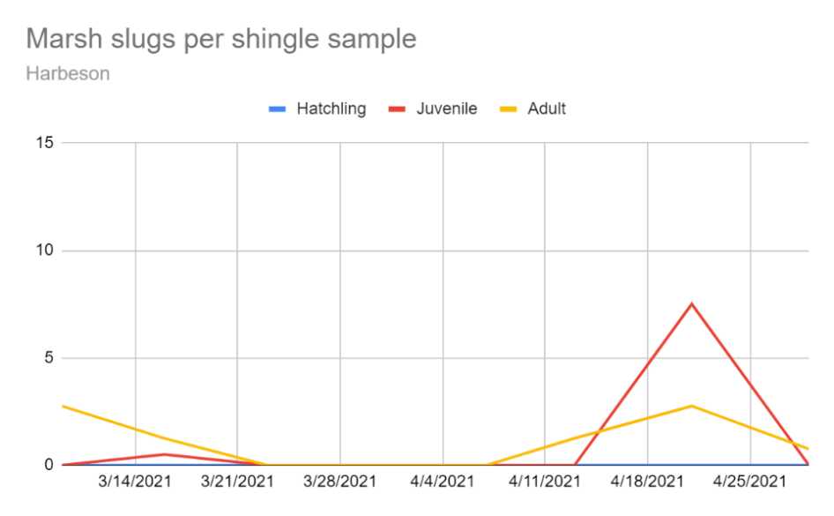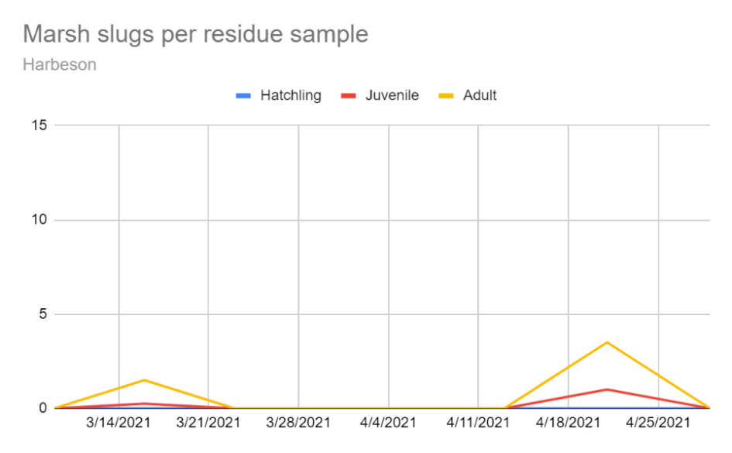
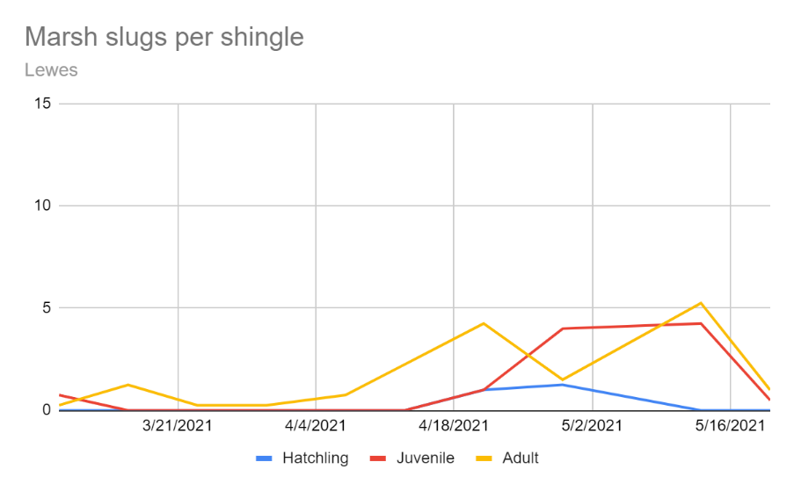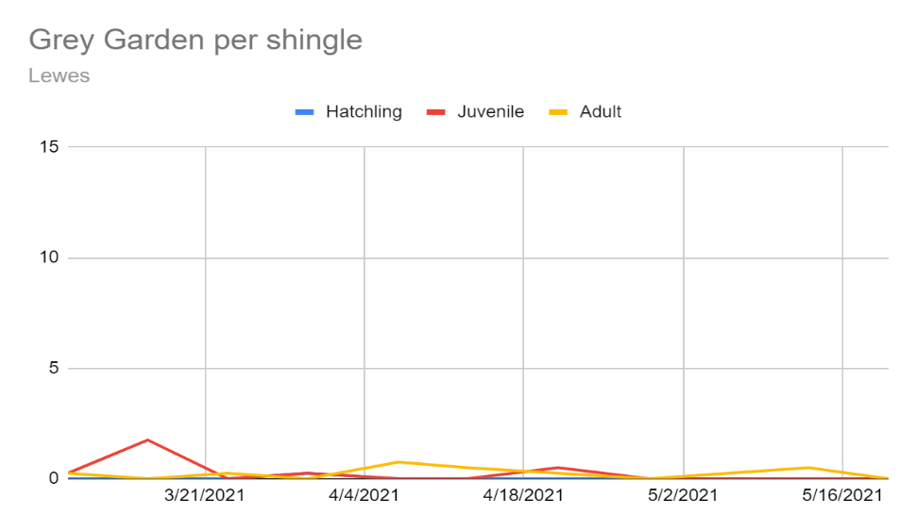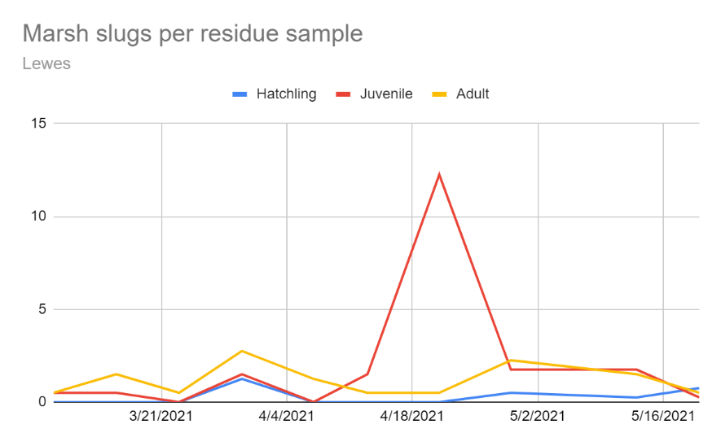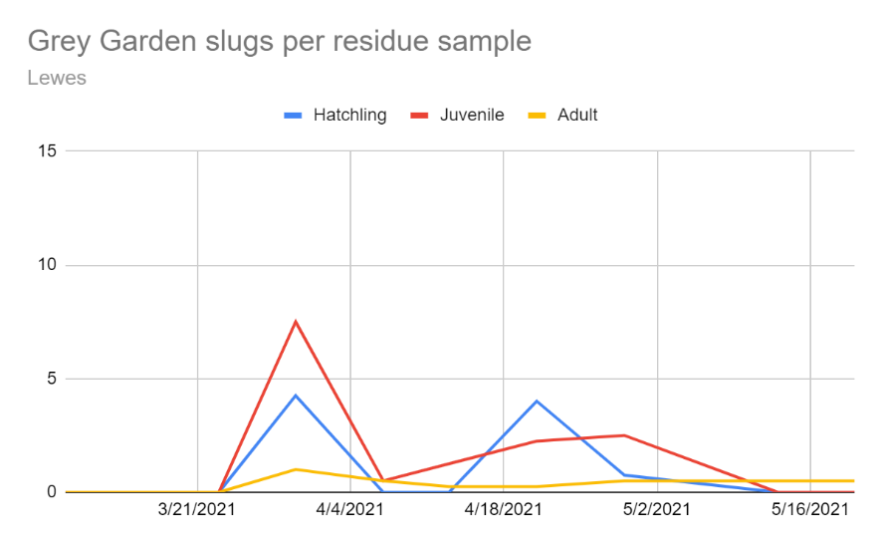

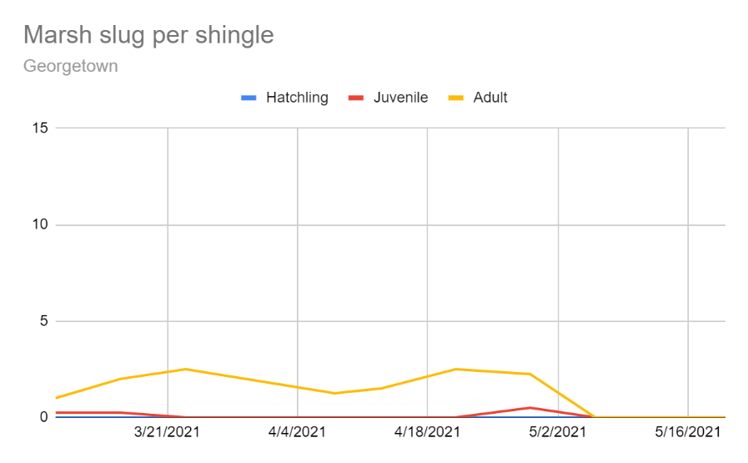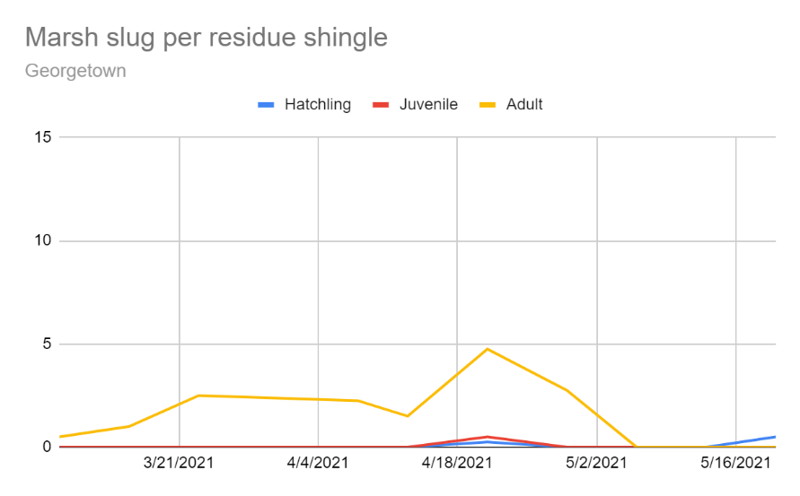

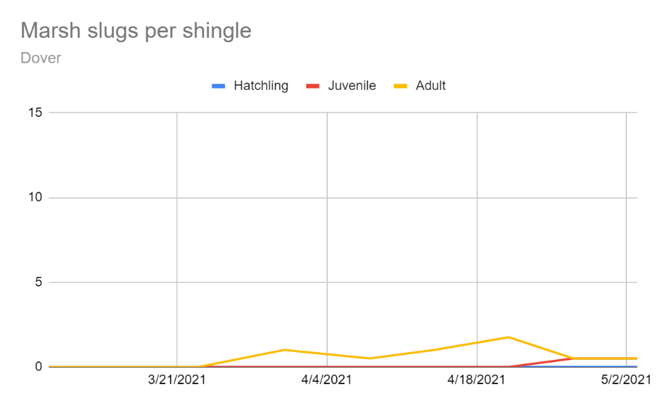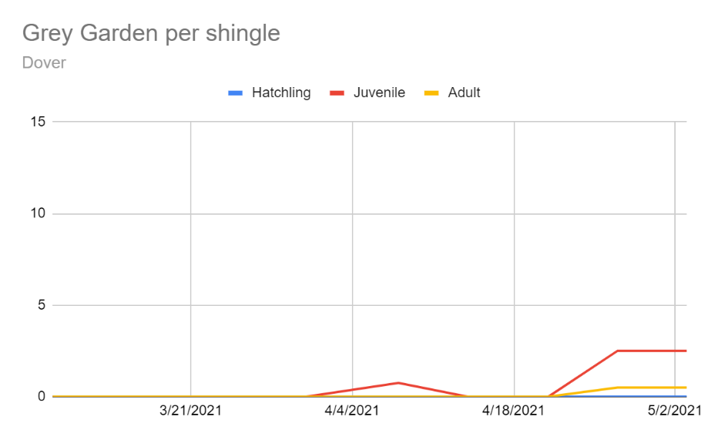
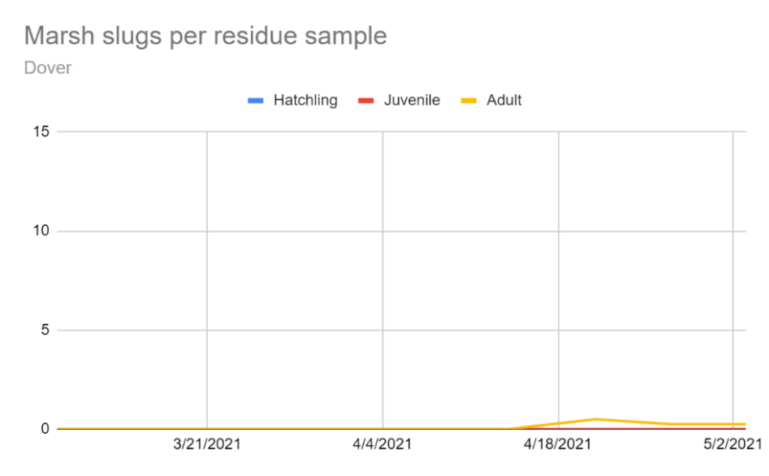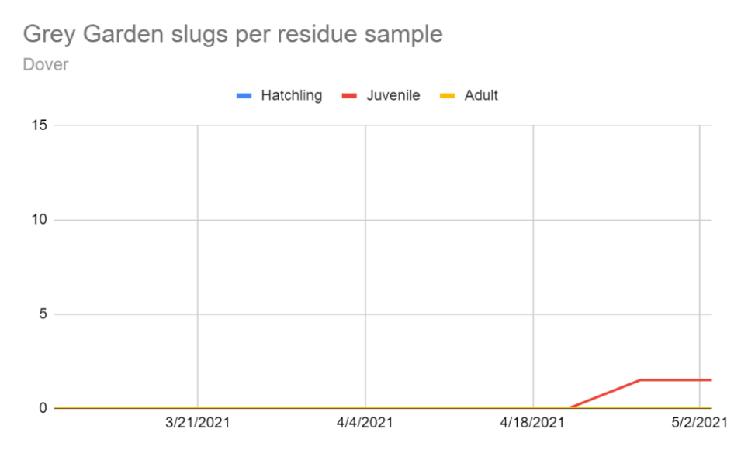
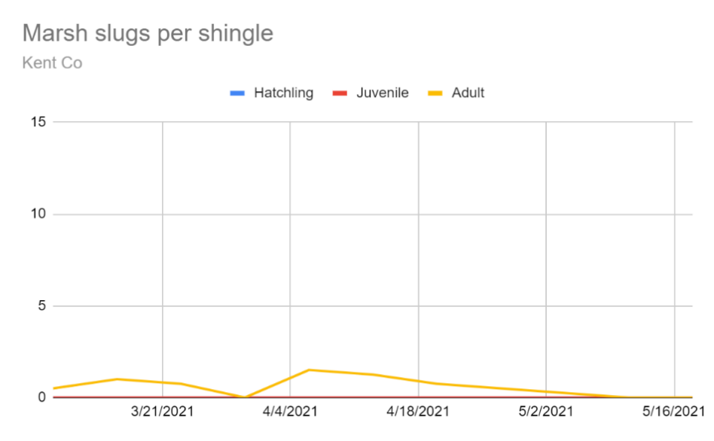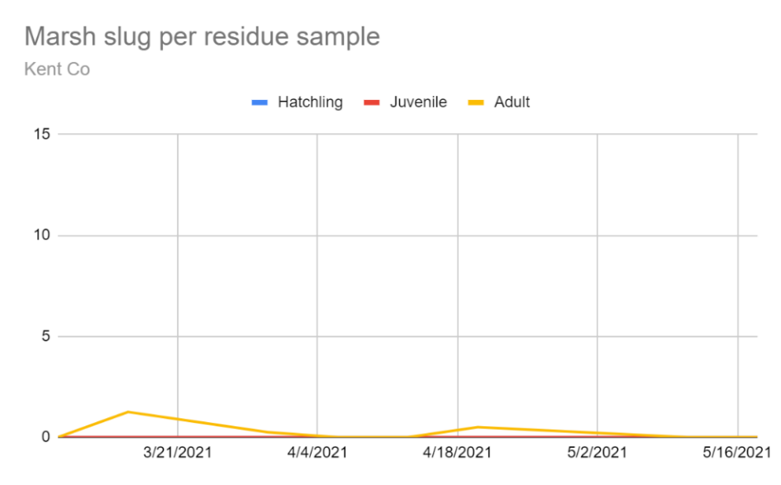
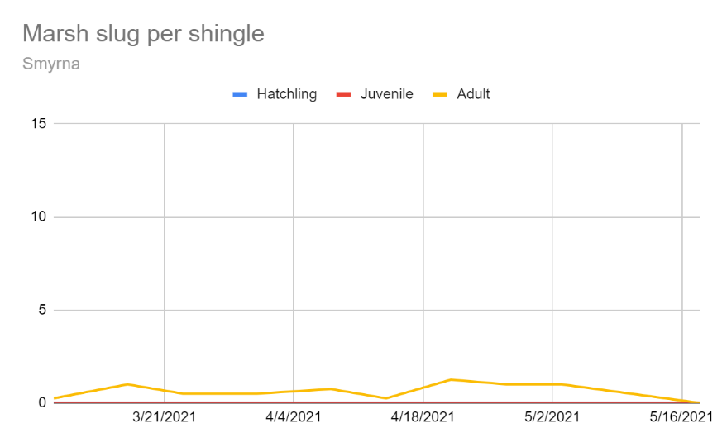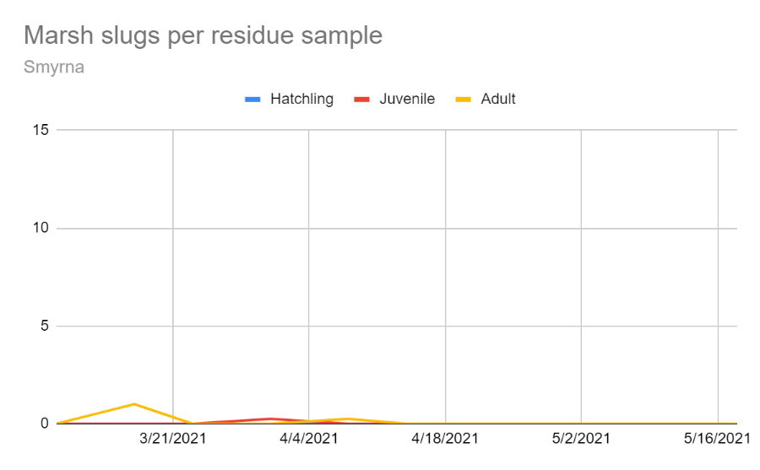

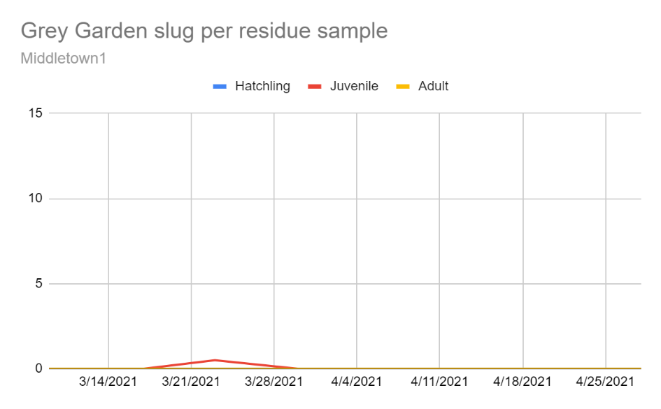

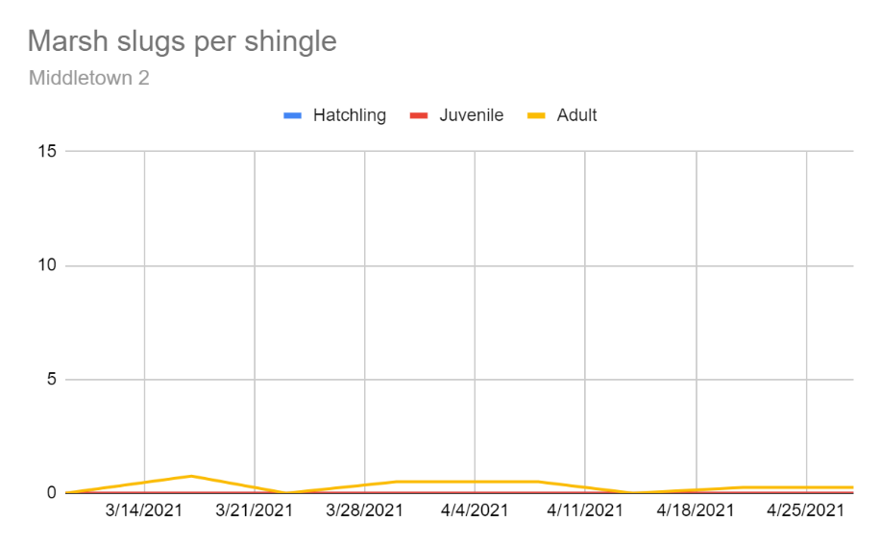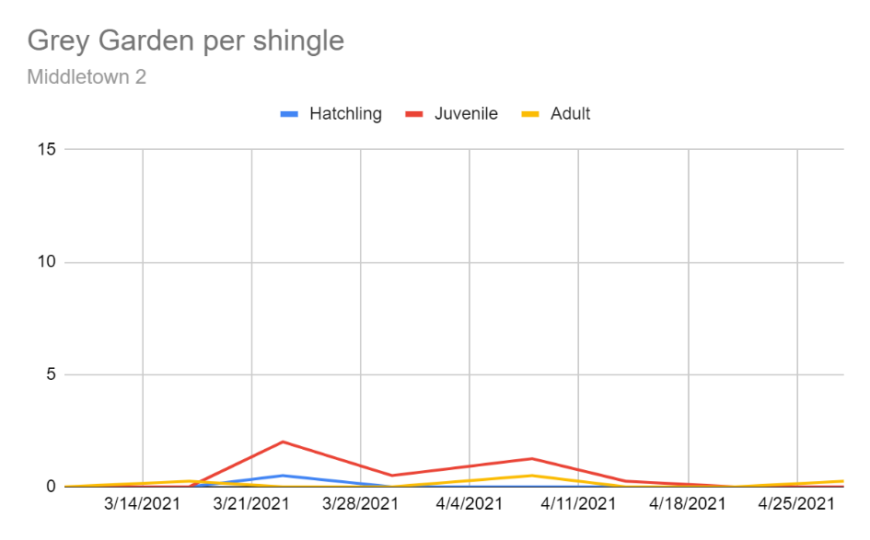
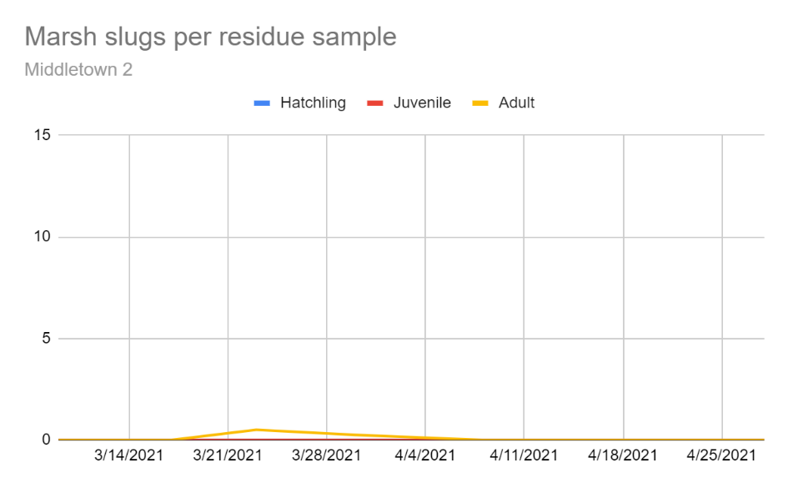

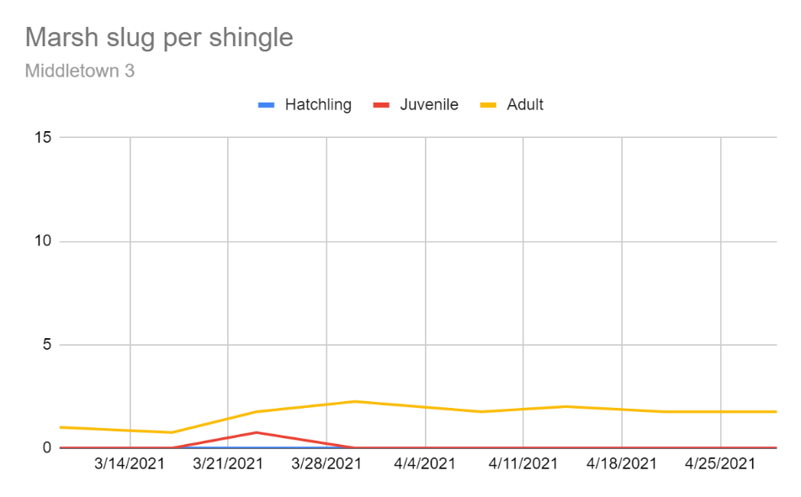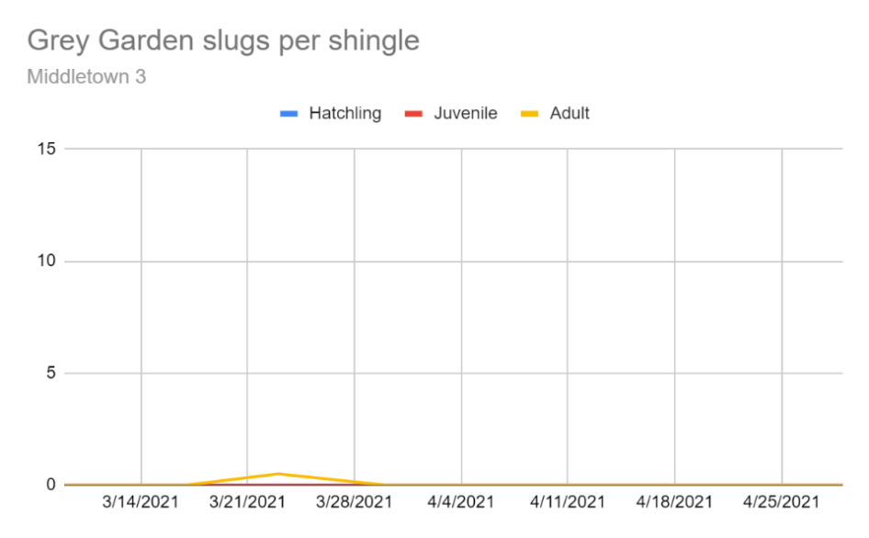
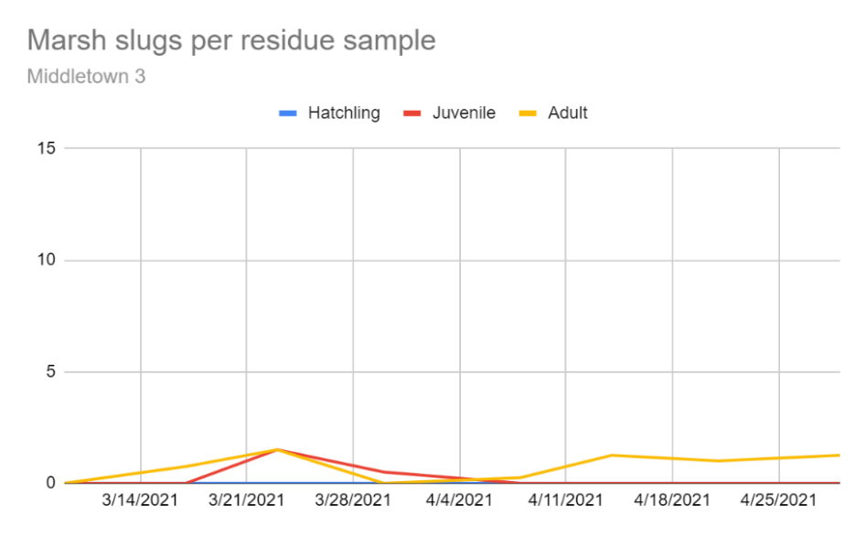

Soybean Prophylactic Insecticide Treatment Evaluation
In 2021, 8 cooperators (3 of which participated in the 2020 trial) installed pyrethroid treated areas of their fields during vegetative herbicide applications. Seven of the sites had replicated strips and were scouted during the course of the season. At each of the seven sites, a minimum of three treated strips were paired with three untreated strips. Strips were treated with Warrior II at 1.92 fl oz/acre. Strips were sampled weekly for beneficial insects and insect pests. In each strip, a series of four 10-sweep samples were collected and at least during the first week after application, 10 upper canopy leaflets from four locations in each strip were also collected to record thrips, mites, and pirate bugs. Each strip was geo-referenced. Useable yield data was collected from 6 sites. At three sites, yield data was collected by harvesting a full combine header width for 800 - 1600 feet and transferring beans to a weigh wagon. At one site, total yield was taken from paired field blocks, and at two sites, yield monitor data was analyzed such that 1-2 complete header passes in the center of the treated strips were selected for yield calculation.

Insect count data were averaged per strip and analyzed with T-test as well as analyzing the difference of means against a null hypothesis of 0, meaning no difference.

Location | Yield treated strips | Yield untreated strips | T-test
Harrington 1 | 54.7 ± 3.8 | 54.8 ± 3.2 | t = 0.03, df = 3.9, P = 0.978
Milford | 73.0 ± 0.5 | 71.6 ± 3.4 | T = -0.41, df = 1.04, P = 0.751
Whaleyville 1 | 64.9 ± 0.6 | 64.3 ± 1.2 | t = -0.45, df = 3.03, P = 0.680
Whaleyville 2 | 59.0 | 59.0 ± 0.5 | t = 0, df = 1, P = 1.0
Houston | 57.9 ± 1.3 | 58.2 ± 0.6 | T = 0.20, df = 2.73, P = 0.854
Seaford | 72.2 ± 0.4 | 70.4 ± 1.3 | T = -1.34, df = 2.38, P = 0.295
Harrington 2 | 84.4 ± 1.3 | 83.5 ± 1.4 | t = -0.484, df = 3.97, P = 0.654
OVERALL | 66.3 ± 2.5 | 66.0 ± 2.3 | t = -0.09, df = 34.5, P = 0.932

Field 1, Harrington
Date | Difference between Treated strips and Untreated Strips (treatment mean; untreated mean)
 | GCW | GH | JB | BLB | SL | Other Defol. | Total Defol. | DSB | CEW | SB | MPB | Total Preds. | Leaflet  MPB | Leaflet  Thrips | Leaflet  TSSM
Jul 7 | -0.4  (0.2, 0.6) | -0.4  (0.1, 0.5) | - | - | - | -0.2  (0.1, 0.3) | -1 | - | - | 0.1  (0.2, 0.1) | 0.7  (1.8, 1.1) |  | 0.6  (1.4, 0.8) | -11.3  (18.4, 29.7) | -0.1  (0.3, 0.3)
Jul 12 | -0.3  (0.6, 1.0) | -0.3  (0.4, 0.8) | 0 | - | - | -0.2  (0.1, 0.3) | -0.9 | - | - | 0.2  (0.2, 0) | 1.7  (2.8, 0.9) |  | -0.3  (1.2, 1.4) | 4.3  (23.6, 19.3) | -0.5  (0.5, 1.0)
Jul 20 | -0.4  (0.6, 1.0) | -0.2  (0.3, 0.5) | -0.1  (0.4, 0.5) | 1  (2.6, 1.6) | - | 0.2  (0.2, 0) | 0.5 | - | - | 0.1  (0.3, 0.3) | 0.2  (1.2, 1.0) |  | 0.3  (0.4, 0.2) | 5.6  (10.8, 5.2) | 2.8  (3.3, 0.4)
Jul 26 | 0.3  (2.5, 2.3) | -0.3  (0, 0.3) | -0.4  (0.3, 0.8) | -0.2  (1.7, 1.8) | - | - | 0.6 | 0  (0.3, 0.3) | - | -0.2  (0.1, 0.3) | -0.3  (2.8, 3.2) |  | 0.8  (1.3, 2.1) | 1.3  (16.5, 15.3) | -1.4  (16.5, 15.3)
Aug 2 | -1.6  (5.5, 7.1) | -1.1  (0.3, 1.3) | -0.8  (0.2, 1.0) | -0.4  (0.3, 0.8) | - | -0.2  (0.1, 0.3) | -0.2 | -0.3 | - | -0.3  (0.2, 0.4) | -0.1  (0.1, 0.2)
Aug 9 | -1  (5.4, 6.4) | -1.1  (0.3, 1.4) | -0.3  (0.3, 0.7) | -0.8  (0.4, 1.3) | - | 0  (0.2, 0.2) | -3.3 | 0  (0.2, 0.2) | - | -0.3  (0.2, 0.5) | -0.4  (0.2, 0.6)
Aug 19 | -0.7  (0.2, 0.8) | 0.3  (1.1, 0.8) | 0.1  (0.2, 0.1) | -0.6  (0.3, 0.8) | - | - | -0.8 | - | - | 0.1  (0.1, 0) | -0.3  (0, 0.3)
Aug 25 | -1.2  (1.0, 2.2) | -0.2  (0.5, 0.7) | - | 0.4  (0.5, 0.1) | - | 0.1  (0.3, 0.2) | -0.6 | -0.1  (0, 0.1) | - | -0.1  (0, 0.1) | 0.3  (0.3, 0)
Sept 1 | -0.5  (1.3, 1.8) | 0.2  (0.9, 0.8) | - | -0.2  (0.8, 1.0) | - | 0.1  (0.3, 0.2) | -0.4 | -0.2  (0, 0.2) | - | 0.2  (0.3, 0.1) | -0.3  (0.4, 0.7)
Sept 9 | 0.3  (1.2, 0.9) | -0.1  (0.7, 0.8) | 0  (0.1, 0.1) | 0.1  (1.3, 1.3) | - | 0.1  (0.3, 0.2) | 0.1 | - | - | -0.2  (0.3, 0.4) | -0.3  (0.1, 0.3)
Sept 15 | 0  (0.6, 0.6) | 0  (0.6, 0.6) | - | -0.3  (0.8, 1.1) | - | 0  (0.2, 0.2) | -0.3 | 0  (0.1, 0.1) | -0.2  (0, 0.2) | -0.3  (0.3, 0.6) | -
Sept 22 | 0.2  (1.0, 0.8) | -0.3  (0.3, 0.6) | - | -0.2  (0.4, 0.6) | - | 0.2  (0.3, 0.2) | -0.2 | - | - | 0.2  (0.7, 0.5) | -

Field 1, Harrington Season Total
Trt | JB | BLB | SB | DSB | GCW | GH | CEW | Other Defol | SL | Total Pred | MPB | LFL MPB | LFL Mites | LFL Thrips
UTC | 3.3 ± 0.8 | 10.3± 1.8 | 3.4± 0.7 | 1.1± 0.2 | 24.8± 1.4 | 8.9± 1.3 | 0.2± 0.2 | 1.8± 0.2 | 0 | 11.5± 0.3 | 8.1± 1.0 | 4.5± 0.4 | 4.8± 2.5 | 69.3± 6.1
Pyreth. | 1.75 ± 0.3 | 9.1± 0.2 | 2.8± 0.3 | 0.6± 0.2 | 19.3± 1.8 | 5.4± 0.5 | 0 | 1.8± 0.6 | 0 | 13.6± 1.6 | 9.3± 0.4 | 4.3± 2.0 | 5.8± 2.4 | 69.3± 8.7
T | P=0.2  df=2.5 | P=0.6  df=2.0 | P=0.5  df=2.7 | P=0.2  df=4 | P=0.1  df=3.8 | P=0.1  df=2.7 | P=0.4  df=2 | P=1.0  df=2.6 |  | P=0.3  df=2.1 | P=0.3  df=2.8 | P=0.9  df=2.2 | P=0.8  df=4.0 | P=1.0  df=3.6

Field 2, Milford
Date | Difference between Treated strips and Untreated Strips (treatment mean; untreated mean)
 | GCW | GH | JB | BLB | SL | Other Defol. | Total Defol. | DSB | CEW | SB | MPB | Total Preds. | Leaflet  MPB | Leaflet  Thrips | Leaflet  TSSM
July 29 | - | - | - | - | - | - | - | - | 0.1  (0.1, 0) | - | -0.1  (0.3, 0.3) |  | - | 0.6  (1.6, 1.0) | 0.4  (0.4, 0)
Aug 2 | -0.2  (0, 0.2) | -0.2  (0.1, 0.3) | -0.3  (0, 0.3) | - | - | -0.3  (0.1, 0.3) | -0.8 | - | - | -0.1  (0, 0.1) | -0.3  (0.6, 0.8)
Aug 9 | - | -0.5  (0, 0.5) | -0.1  (0, 0.1) | - | - | -0.4  (0.2, 0.6) | -1 | - | - | 0.3  (0.3, 0) | 0.3  (0.4, 0.1)
Aug 19 | -0.3  (0.1, 0.3) | 0.1  (0.3, 0.3) | 0  (0.1, 0.1) | -0.1  (0.2, 0.3) | - | 0.2  (0.5, 0.3) | -0.1 | - | - | 0  (0.2, 0.2) | -0.3  (0.2, 0.5)
Aug 25 | 0.1  (0.1, 0) | - | 0.2  (0.2, 0) | - | 0.1  (0.2, 0.1) | -0.3  (0, 0.3) | 0.1 | - | - | -0.1  (0, 0.1) | -0.8  (1.2, 2.0)
Sept 1 | 0.1  (0.2, 0.1) | 0  (0.1, 0.1) | -0.1  (0, 0.1) | 0.1  (0.2, 0.1) | -0.2  (0, 0.2) | 0.3  (0.4, 0.1) | 0.3 | - | -0.1  (0, 0.1) | 0  (0.2, 0.2) | 0.2  (0.8, 0.7)
Sept 9 | 0.2  (0.2, 0.1) | -0.2  (0.3, 0.4) | - | -0.3  (0.5, 0.8) | - | -0.2  (0.3, 0.4) | -0.8 | - | 0.1  (0.1, 0) | -0.3  (0.1, 0.4) | -0.3  (0.5, 0.8)
Sept 15 | 0  (0.3, 0.3) | -0.3  (0.4, 0.7) | - | -0.3  (0.2, 0.4) | - | 0.3  (0.3, 0.1) | -0.3 | - | - | -0.2  (0.1, 0.3) | -0.3  (0.8, 1.1)
Sept 22 | 0.1  (0.3, 0.3) | -0.1  (0.3, 0.4) | - | 0  (0.2, 0.2) | - | -0.1  (0.3, 0.4) | -0.1 | - | -0.1  (0, 0.1) | 0  (0.1, 0.1) | -0.3  (0.8, 1.0)
Sept 30 | 0.1  (0.2, 0.1) | -0.3  (0.3, 0.6) | - | 0.2  (0.3, 0.2) | - | 0.2  (0.5, 0.3) | 0.1 | - | - | 0  (0.1, 0.1) | -0.5  (0.5, 1.0)
Oct 6 | -0.2  (0, 0.2) | 0.2  (0.3, 0.1) | - | -0.1  (0.1, 0.2) | - | 0  (0.2, 0.2) | -0.1 | - | - | -0.1  (0.2, 0.3) | -

Field 2, Milford Season Total
Trt | JB | BLB | SB | DSB | GCW | GH | CEW | Other Defol | SL | Total Pred | MPB | LFL MPB | LFL Mites | LFL Thrips
UTC | 0.5 ± 0.3 | 2.0± 0.1 | 1.6± 0.1 | 0 | 1.7± 0.5 | 3.3± 0.8 | 0.2± 0.2 | 2.9± 1.2 | 0.3 | 9.3± 3.5 | 8.3± 3.2 | 0 | 0 | 1.0± 1.0
Pyreth. | 0.3 ± 0.1 | 1.6± 0.2 | 1.1± 0.1 | 0 | 1.3± 0.5 | 2.0± 0.6 | 0.2± 0.1 | 2.7± 0.5 | 0.2± 0.1 | 7.1± 2.1 | 5.9± 1.8 | 0 | 0.4± 0.4 | 1.6± 0.5
T | P=0.5  df=2.9 | P=0.2  df=3.4 | P=0.01  df=4 |  | P=0.6  df=4.0 | P=0.3  df=3.9 | P=1.0  df=2.9 | P=0.9  df=2.7 | P=0.4  df=2 | P=0.6  df=3.3 | P=0.6  df=3.2 |  | P=0.4  df=2 | P=0.6  df=3.0

Field 3, Whaleyville, MD
Date | Difference between Treated strips and Untreated Strips (treatment mean; untreated mean)
 | GCW | GH | JB | BLB | SL | Other Defol. | Total Defol. | DSB | CEW | SB | MPB | Total Preds. | Leaflet  MPB | Leaflet  Thrips | Leaflet  TSSM
July 30 | -0.9  (0.3, 1.1) | -0.1  (0.1, 0.3) | -0.1  (0.2, 0.3 | -0.3  (0.1, 0.4) | - | -0.5  (0.2, 0.7) | -6 | - | -0.2  (0, 0.2) | 0.2  (0.2, 0) | -2.5  (0.4, 2.9) |  | -0.3  (0.1, 0.4) | 1.1  (34.3, 33.2) | -
Aug 5 | -0.1  (0.2, 0.3) | -0.2  (0.2, 0.4) | -0.2  (0.4, 0.6) | 0  (0.1, 0.1) | - | -0.4  (0.2, 0.6) | -1.5 | - | - | 0.1  (0.1, 0) | 0.3  (0.9, 0.6)
Aug 11 | -0.9  (0.1, 0.9) | 0.1  (0.1, 0) | 0.4  (0.9, 0.5) | -0.3  (0, 0.3) | - | -0.1  (0.4, 0.5) | 0.3 | - | - | -0.1  (0, 0.1) | 1.7  (5.1, 3.4)
Aug 18 | -3.0  (2.7, 5.7) | 0  (0.2, 0.2) | -0.4  (0.3, 0.7) | 0.2  (0.4, 0.2) | 0  (0.1, 0.1) | -0.1  (0.2, 0.3) | -10.1 | - | - | 0.1  (0.1, 0) | -2.9  (7.6, 10.5)
Aug 27 | -1.1  (1.3, 2.3) | 0  (0.1, 0.1) | 0.1  (0.3, 0.1) | 0.5  (1.0, 0.4) | 0  (0.1, 0.1) | -0.1  (0.2, 0.3) | 0.1 | - | - | -0.1  (0.2, 0.3) | 1.4  (4.5, 3.1)
Sept 2 | -1.3  (1.1, 2.4) | 0.1  (0.2, 0.1) | -0.2  (0, 0.2) | 0.8  (0.9, 0.1) | - | 0.1  (0.1, 0) | -2.5 | - | - | 0.1  (0.1, 0) | -0.3  (2.9, 3.2)
Sept 10 | -0.4  (0.6, 1.0) | 0.3  (0.4, 0.1) | 0.1  (0.1, 0) | 0.3  (1.4, 1.1) | - | -0.2  (0, 0.2) | -1.4 | - | - | -0.3  (0, 0.3) | -1.1  (3.1, 4.5)
Sept 17 | -0.8  (0.7, 1.5) | 0.3  (0.3, 0) | - | -0.9  (1.2, 2.1) | - | 0.2  (0.3, 0.1) | -2.1 | - | 0  (0.1, 0.1) | -0.1  (0.2, 0.3) | -0.9  (2.0, 2.9)
Sept 24 | 0.1  (1.2, 1.1) | -0.1  (0, 0.1) | - | -0.5  (2.0, 2.5) | - | 0  (0.1, 0.1) | -0.5 | - | - | 0.1  (0.3, 0.3) | 0.1  (1.3, 1.2)
Oct 1 | -0.6  (0.7, 1.3) | 0.3  (0.5, 0.3) | - | -0.8  (1.3, 2.1) | - | - | -0.7 | - | -0.1  (0, 0.1) | -0.1  (0.3, 0.3) | 0.7  (1.1, 0.4)
Oct 8 | -0.3  (0.3, 0.5) | 0.3  (0.5, 0.2) | - | -0.6  (0.7, 1.3) | - | - | -0.3 | - | - | 0.1  (0.4, 0.3) | -0.1  (0.5, 0.6)

Field 3, Whaleyville Season Total
Trt | JB | BLB | SB | DSB | GCW | GH | CEW | Other Defol | SL | Total Pred | MPB | LFL MPB | LFL Mites | LFL Thrips
UTC | 2.5 ± 0.8 | 10.8± 1.1 | 1.9± 0.4 | 0 | 18.3± 4.1 | 1.7± 0.5 | 0.3± 0.2 | 2.9± 0.2 | 0.2± 0.2 | 35.6± 1.9 | 33.1± 2.4 | 0.4± 0.2 | 0 | 33.2± 6.5
Pyreth. | 2.2 ± 0.5 | 9.3± 1.4 | 1.7± 0.5 | 0 | 9.1± 3.2 | 2.7± 0.3 | 0.1± 0.1 | 1.8± 0.2 | 0.2± 0.1 | 31.7± 0.5 | 29.4± 0.9 | 0.1± 0.1 | 0 | 34.3± 8.5
T | P=0.8  df=6.5 | P=0.4  df=7.7 | P=0.8  df=7.7 |  | P=0.1  df=7.6 | P=0.1  df=6.6 | P=0.2  df=5.0 | P=0.01  df=7.1 | P=1.0  df=5.3 | P=0.1  df=4.5 | P=0.2  df=5.0 | P=0.1  df=5.3 |  | P=0.9  df=7.5

Field 4, Houston
Date | Difference between Treated strips and Untreated Strips (treatment mean; untreated mean)
 | GCW | GH | JB | BLB | SL | Other Defol. | Total Defol. | DSB | CEW | SB | MPB | Total Preds | Leafle  MPB | Leafle  Thrip | Leafle  TSSM
June 9 | - | -0.3  (0.2, 0.4) | - | -0.7  (0.1, 0.8) | - | - | -0.9 | - | - | - | - |  | - | - | -
June 14 | - | -0.3  (0.2, 0.4) | - | -0.3  (0.5, 0.8) | - | - | -0.6 | - | - | - | - |  | 0.3  (0.4, 0.1) | 1.4  (19.7, 18.3) | -
June 21 | 0  (0.3, 0.3) | 0.4  (0.6, 0.2) | - | -0.1  (0.5, 0.6) | - | - | 0.3 | - | - | - | - |  | 0.1  (3.1, 3.0) | 9.8  (23.0, 13.3) | -
June 29 | 0.3  (0.8, 0.5) | 0.3  (0.4, 0.2) | 0.1  (0.3, 0.2) | 0.1  (0.1, 0) | - | 0.1  (0.1, 0) | 0.9 | - | - | -0.2  (0.1, 0.3) | 0.9  (2.9, 3.8) |  | 0  (0.6, 0.6) | -19.1  (9.2, 28.3) | -0.2  (0, 0.2)
Jul 8 | -0.6  (0.3, 0.9) | 0  (0.2, 0.2) | -0.6  (0.4, 0.8) | 0.1  (0.1, 0) | - | -0.1  (0.1, 0.2) | -1.4 | - | - | 0.2  (0.3, 0.1) | 0.3  (1.6, 1.3) |  | -0.5  (0.3, 0.8) | -9.9  (9.3, 19.2) | 1.3  (1.3, 0.1)
Jul 12 | -0.3  (0.7, 0.9) | -0.3  (0.2, 0.4) | 0.3  (1.4, 1.1) | 0.2  (0.5, 0.3) | - | -0.5  (0.2, 0.7) | -0.9 | - | - | -0.2  (0.4, 0.6) | -1.3  (2.3, 3.6) |  | 0.4  (0.6, 0.2) | 2.8  (12.7, 9.9) | 0.3  (0.6, 0.3)
Jul 23 | -0.1  (0.2, 0.3) | 0  (0.3, 0.3) | -0.8  (2.0, 1.3) | -0.8  (2.8, 2.0) | - | - | -1.3 | 0.7  (1.2, 0.6) | - | -0.1  (0, 0.1) | -0.9  (0, 0.9) |  | -0.1  (0, 0.1) | 1.9  (3.7, 1.8) | -0.5  (0.2, 0.7)
Jul 27 | 0.2  (1.4, 1.3) | -0.1  (0.2, 0.3) | 0.3  (1.0, 0.8) | 0.3  (5.8, 5.5) | - | - | 0.7 | 0.1  (0.6, 0.5) | - | -0.2  (0.1, 0.3) | 1.5  (2.7, 1.2) |  | 0.2  (0.8, 0.7) | -0.5  (5.4, 5.9) | -0.2  (0, 0.2)
Aug 4 | 0  (1.8, 1.8) | 0.5  (0.8, 0.3) | 0  (0.7, 0.7) | 0.5  (6.3, 5.8) | - | -0.2  (0.2, 0.4) | 0.7 | 0.3  (0.4, 0.2) | - | -0.3  (0.4, 0.7) | 0.9  (1.8, 0.9)
Aug 10 | 0.1  (1.3, 1.3) | -0.3  (0.4, 0.7) | 0.1  (0.7, 0.6) | -3.3  (5.3, 9.3) | - | 0.2  (0.5, 0.3) | -3.6 | 0.1  (0.3, 0.3) | - | -0.3  (0.9, 1.3) | 0.9  (1.8, 0.9)
Aug 18 | -0.3  (2.2, 2.5) | 0.1  (0.7, 0.6) | 0.4  (0.6, 0.2) | -4.1  (5.3, 9.3) | 0.1  (0.1, 0) | 0.3  (0.4, 0.1) | -3.6 | -0.1  (0.5, 0.6) | -0.1  (0, 0.1) | -0.4  (0.9, 1.3) | -0.2  (0.7, 0.9)
Aug 31 | 0.2  (2.5, 2.3) | 0.1  (0.9, 0.8) | -0.1  (0.3, 0.4) | -1.5  (4.4, 5.9) | - | 0.3  (0.4, 0.1) | -1 | -0.1  (0.5, 0.6) | 0.1  (0.1, 0) | 0.2  (1.0, 0.8) | 0  (1.3, 1.3)
Sept 7 | -1.3  (1.9, 3.3) | 0.3  (0.3, 0.1) | -0.3  (0.1, 0.4) | -0.5  (3.2, 3.7) | - | 0.1  (0.1, 0) | -1.8 | -0.2  (0.2, 0.3) | - | -0.6  (0.6, 1.2) | -0.6  (1.4, 2.0)
Sept 16 | 0.8  (2.4, 1.7) | 0.3  (0.6, 0.3) | -0.1  (0.1, 0.2) | -1.3  (1.7, 2.9) | - | 0.3  (0.3, 0.1) | 0 | -0.3  (0.3, 0.6) | 0.1  (0.1, 0) | -0.2  (1.0, 1.2) | -0.9  (1.6, 2.5)
Sept 21 | -0.5  (1.2, 1.7) | -0.6  (0.3, 0.8) | - | -0.7  (1.8, 2.5) | 0.1  (0.1, 0) | 0.1  (0.1, 0) | -1.7 | -0.4  (0.4, 0.8) | - | -0.6  (0.6, 1.2) | -0.9  (1.0, 1.9)

Field 4, Houston Season Total
Trt | JB | BLB | SB | DSB | GCW | GH | CEW | Other Defol | SL | Total Pred | MPB | LFL MPB | LFL Mites | LFL Thrips
UTC | 6.5 ± 1.9 | 47.2± 3.1 | 8.3± 0.7 | 4.2± 0.5 | 18.3± 0.9 | 5.9± 0.7 | 0.1± 0.1 | 1.8± 0.5 | 0 | 24.2± 0.7 | 20.4± 1.0 | 2.4± 0.4 | 1.3± 0.4 | 83.3± 1.8
Pyreth. | 7.6 ± 0.8 | 36.9± 3.5 | 5.8± 0.8 | 4.2± 0.6 | 16.8± 3.0 | 5.7± 0.4 | 0.2± 0.2 | 2.2± 0.5 | 0.1± 0.1 | 22.4± 1.5 | 18.0± 1.3 | 2.7± 0.8 | 2.1± 0.7 | 59.9± 1.4
T | P=0.6  df=2.7 | P=0.1  df=4.0 | P=0.1  df=4.0 | P=1.0  df=4.0 | P=0.7  df=2.4 | P=0.8  df=2.9 | P=0.7  df=2.9 | P=0.6  df=4 | P=0.4  df=2 | P=0.4  df=2.7 | P=0.2  df=3.7 | P=0.8  df=2.9 | P=0.4  df=3.3 | P=>0.001  df=3.8

Field 5 Harbeson
Date | Difference between Treated strips and Untreated Strips (treatment mean; untreated mean)
 | GCW | GH | JB | BLB | SL | Other Defol. | Total Defol. | DSB | CEW | SB | MPB | Total Preds. | Leaflet  MPB | Leaflet  Thrips | Leaflet  TSSM
Jul 30 | -3  (2.3, 5.3) | -0.1  (0, 0.1) | -0.7  (0.1, 0.8) | 0.4  (1.4, 1.0) | - | -1.2  (0.9, 2.1) | -4.6 | -0.6  (0.2, 0.8) | -0.1  (0, 0.1) | -0.1  (0, 0.1) | 0.6  (1.3, 0.9) |  | 0.9  (1.0, 0.1) | -3.7  (22.6, 26.2) | -0.1  (0, 0.1)
Aug 5 | -9.7  (2.8, 12.4) | 0  (0.1, 0.1) | -0.3  (0, 0.3) | 0.2  (1.4, 1.3) | 0  (0.1, 0.1) | -3.3  (1.4, 4.8) | -13.1 | -0.1  (0, 0.1) | - | 0.1  (0.1, 0) | 0.8  (2.7, 1.9)
Aug 13 | -6.2  (3.4, 9.7) | 0.1  (0.2, 0.1) | 0  (0.1, 0.1) | 0.1  (1.4, 1.3) | - | -1.6  (2.1, 3.7) | -7.6 | 0.1  (0.1, 0) | - | -0.3  (0.1, 0.4) | 0.4  (2.9, 2.4)
Aug 18 | -1.3  (5.6, 6.9) | 0.5  (0.7, 0.2) | -0.1  (0, 0.1) | 0.4  (6.2, 5.8) | 0.1  (0.1, 0) | 0  (0.3, 0.3) | -0.4 | - | - | 0  (0.3, 0.3) | 0.8  (1.2, 0.4)
Aug 23 | -0.1  (3.6, 3.7) | 0.6  (1.2, 0.6) | - | -0.1  (5.0, 5.1) | 0  (0.1, 0.1) | 0  (0.1, 0.1) | 0.4 | - | - | -0.3  (0.1, 0.4) | 0.1  (0.3, 0.2)
Sept 2 | 1.2  (3.3, 2.1) | 0.1  (0.9, 0.8) | - | -3.0  (3.8, 6.8) | 0.1  (0.1, 0) | 0.1  (0.1, 0) | -1.4 | - | - | -0.6  (0.1, 0.7) | -0.3  (0.4, 0.8)
Spet 10 | -0.2  (1.1, 1.3) | 0.4  (0.7, 0.3) | - | -1.8  (8.6, 10.3) | - | 0.1  (0.2, 0.1) | -1.6 | - | - | 0  (2.3, 2.3) | -
Sept 17 | -0.2  (0.2, 0.4) | 0.1  (0.3, 0.2) | - | 2.6  (11.0, 8.4) | 0.2  (0.2, 0) | -0.4  (0, 0.4) | 2.2 | - | - | 1.7  (3.8, 2.1) | -
Sept 24 | 0.2  (0.2, 0) | 0  (0.2, 0.2) | - | -0.7  (8.6, 9.2) | -0.1  (0.1, 0.2) | -0.3  (0.2, 0.6) | -0.9 | - | - | -2.6  (1.7, 4.3) | 0.1  (0.2, 0.1)
Oct 1 | 0.2  (0.4, 0.2) | -0.1  (0.3, 0.4) | - | -1.1  (3.0, 4.1) | -0.1  (0, 0.1) | 0.1  (0.1, 0) | -1 | - | - | 0.1  (1.3, 1.2) | -
Oct 8 | 0.3  (0.6, 0.2) | -0.4  (0.2, 0.6) | - | -0.3  (1.6, 1.9) | - | 0.3  (0.3, 0) | 0 | - | 0.1  (0.1, 0) | -0.3  (1.0, 1.3) | -

Field 5, Harbeson Season Total
Trt | JB | BLB | SB | DSB | GCW | GH | CEW | Other Defol | SL | Total Pred | MPB | LFL MPB | LFL Mites | LFL Thrips
UTC | 1.3 ± 0.4 | 55.4± 5.7 | 13.2± 2.1 | 0.9± 0.5 | 42.3± 2.7 | 3.7± 0.9 | 0.1± 0.1 | 12.1± 1.8 | 0.6± 0.3 | 19.8± 1.5 | 6.7± 0.9 | 0.1± 0.1 | 0.1± 0.1 | 26.2± 3.0
Pyreth. | 0.2 ± 0.1 | 52.2± 6.4 | 10.9± 1.4 | 0.3± 0.2 | 23.6± 2.5 | 4.9± 0.9 | 0.1± 0.1 | 5.9± 1.3 | 0.8± 0.2 | 18.3± 1.6 | 9.1± 1.0 | 1.0± 0.4 | 0 | 22.6± 3.9
T | P= 0.1 df= 9.8 | P=0.7  df=15.8 | P=0.4  df=14.2 | P=0.3  df=12.0 | P=<.0001  df=15.9 | P=0.4  df=16.0 | P=1.0  df=16 | P=0.02  df=14.7 | P=0.6  df=13.8 | P=0.5  df=15.8 | P=0.1  df=15.7 | P=0.1  df=9.0 | P=0.3  df=8 | P=0.5  df=15.1

Field 6 Seaford
Date | Difference between Treated strips and Untreated Strips (treatment mean; untreated mean)
 | GCW | GH | JB | BLB | SL | Other Defol. | Total Defol. | DSB | CEW | SB | MPB | Total Preds. | Leaflet  MPB | Leaflet  Thrips | Leaflet  TSSM
June 21 | -0.5  (0.3, 0.8) | - | - | -0.3  (0.3, 0.5) | - | - | -0.8 | - | - | -0.2  (0, 0.2) | - |  | 0.1  (0.3, 0.2) | -9.6  (14.4, 24.0) | -
June 28 | -0.6  (0.3, 0.9) | 0.2  (0.2, 0) | -0.1  (0.1, 0.2) | -0.3  (0.1, 0.4) | - | 0.2  (0.2, 0) | -0.7 | - | - | - | 1.5  (4.5, 3.0) |  | 0.3  (0.5, 0.2) | 10.3  (43.3, 32.9) | 0  (0.3, 0.3)
July 7 | -0.3  (0, 0.3) | 0.1  (0.1, 0) | 1.3  (1.8, 0.5) | - | - | -0.1  (0.1, 0.2) | 1.0 | - | - | 0  (0.2, 0.2) | -1.0  (2.8, 3.8) |  | 0.1  (2.1, 2.0) | 13.3  (41.1, 27.8) | 0.8  (1.9, 1.1)
July 13 | -0.1  (0, 0.1) | - | 0.5  (1.6, 1.1) | 0  (0.8, 0.8) | - | - | 0.5 | - | - | -0.3  (0, 0.3) | 1.7  (4.3, 2.7) |  | 0.1  (1.1, 1.0) | -13.2  (15.3, 28.5) | 0.8  (1.5, 0.7)
July 23 | -0.1  (0.2, 0.3) | 0.1  (0.1, 0) | -0.3  (0.8, 1.1) | -1.5  (0.3, 1.8) | -0.1  (0, 0.1) | - | -1.8 | - | - | 0.1  (0, 0.1) | - |  | 0.4  (0.4, 0) | -2.3  (1.9, 4.2) | -2  (2.1, 4.1)
July 28 | -0.2  (0, 0.2) | -0.1  (0, 0.1) | -0.6  (0.5, 1.1) | 0.1  (0.3, 0.2) | - | - | -0.7 | - | - | -0.1  (0, 0.1) | -0.2  (1.1, 1.3) |  | -0.1  (0.4, 0.5) | -2  (5.3, 7.3) | 0.1  (0.2, 0.1)
Aug 3 | -0.2  (0.2, 0.3) | 0.2  (0.3, 0.1) | 0.8  (0.8, 0.1) | - | - | - | 0.8 | - | - | 0.2  (0.2, 0) | 2.6  (9.4, 6.9)
Aug 12 | -0.1  (0.3, 0.4) | -0.3  (0.1, 0.4) | -0.2  (1.0, 1.1) | -0.3  (0.4, 0.8) | - | - | -0.9 | - | - | -0.1  (0.3, 0.4) | 0.7  (10.2, 9.5)
Aug 19 | 0.2  (0.2, 0) | - | 0.3  (1.0, 0.8) | 0  (0.2, 0.2) | - | - | 0.4 | - | - | 0  (0.1, 0.1) | -0.8  (1.3, 2.2)
Aug 31 | -0.4  (0.4, 0.8) | -0.3  (0.2, 0.4) | -0.1  (0.8, 0.9) | -0.4  (0.4, 0.8) | - | 0.1  (0.3, 0.2) | -1.1 | 0  (0.1, 0.1) | - | -0.1  (0.2, 0.3) | 0.3  (1.3, 1.7)
Sept 7 | -0.7  (0.4, 1.1) | 0.1  (0.4, 0.3) | -1.0  (0.3, 1.3) | -1.3  (1.3, 2.6) | - | -0.2  (0, 0.2) | -3.1 | -0.1  (0, 0.1) | - | -0.2  (0.3, 0.5) | 0.1  (1.3, 1.2)
Sept 16 | -0.2  (0.9, 1.1) | -0.2  (0.3, 0.4) | -0.2  (0.2, 0.4) | -0.5  (0.8, 1.3) | 0.1  (0.1, 0) | -0.2  (0.1, 0.3) | -1.3 | - | - | -0.1  (0.3, 0.2) | -0.7  (0.3, 0.9)
Sept 21 | -0.2  (0.8, 0.9) | -0.5  (0.2, 0.7) | -0.3  (0.2, 0.5) | -0.5  (0.5, 1.0) | - | 0.1  (0, 0.1) | -1.4 | -0.1  (0, 0.1) | 0.1  (0.1, 0) | -0.2  (0.3, 0.5) | -1.0  (0.3, 1.3)

Field 6, Seaford Season Total
Trt | JB | BLB | SB | DSB | GCW | GH | CEW | Other Defol | SL | Total Pred | MPB | LFL MPB | LFL Mites | LFL Thrips
UTC | 9.1 ± 1.5 | 10.2± 2.0 | 2.8± 0.5 | 0.3± 0.1 | 7.2± 0.9 | 2.4± 0.3 | 0 | 0.9± 0.3 | 0.1± 0.1 | 35.6± 0.9 | 34.3± 1.3 | 3.8± 0.2 | 6.3± 0.4 | 124.6± 10.8
Pyreth. | 9.1 ± 2.0 | 5.3± 0.2 | 1.8± 0.3 | 0.1± 0.1 | 3.9± 1.0 | 1.7± 0.6 | 0.1± 0.1 | 0.7± 0.4 | 0.1± 0.1 | 38.4± 2.0 | 36.8± 1.9 | 4.8± 0.7 | 6.0± 2.8 | 121.3± 25.8
T | P=1.0  df=3.6 | P=0.1  df=2.1 | P=0.2  df=2.9 | P=0.4  df=3.2 | P=0.1  df=4.0 | P=0.3  df=2.9 | P=0.4  df=2 | P=0.8  df=3.6 | P=1.0  df=4 | P=0.3  df=2.9 | P=0.3  df=3.5 | P=0.3  df=2.2 | P=0.9  df=2.1 | P=0.9  df=2.7

Field 7, Harrington 2
Date | Difference between Treated strips and Untreated Strips (treatment mean; untreated mean)
 | GCW | GH | JB | BLB | SL | Other Defol. | Total Defol. | DSB | CEW | SB | MPB | Total Preds. | Leaflet  MPB | Leaflet  Thrips | Leaflet  TSSM
July 16 | -0.1  (0, 0.1) | - | -0.2  (0, 0.2) | - | - | -0.2  (0, 0.2) | -0.4 | - | -0.1  (0, 0.1) | - | -0.5  (0.3, 0.8) |  | 0.2  (0.4, 0.3) | -3.3  (10.1, 13.3) | 0.1  (0.2, 0.1)
July 20 | -0.3  (0, 0.3) | - | -0.3  (0, 0.3) | 0.1  (0.1, 0) | - | - | -0.5 | -0.1  (0, 0.1) | - | -0.1  (0, 0.1) | -0.9  (1.9, 2.8) |  | -0.1  (0.1, 0.2) | 1.7  (8.1, 6.4) | -0.1  (0, 0.1)
July 26 | -0.8  (0.1, 0.9) | -0.2  (0, 0.2) | -0.3  (0.4, 0.7) | 0  (0.3, 0.3) | - | - | -1.3 | 0.2  (0.2, 0) | - | -0.3  (0, 0.3) | 1.0  (3.3, 2.3) |  | -0.6  (1.5, 2.1) | 6.8  (16.1, 9.3) | -0.1  (0, 0.1)
Aug 2 | -1.5  (0.8, 2.3) | -0.1  (0.1, 0.2) | 0  (0.2, 0.2) | 0  (0.1, 0.1) | - | -0.2  (0.6, 0.8) | -1.8 | -0.1  (0, 0.1) | - | 0  (0.3, 0.3) | 0.4  (0.9, 0.5)
Aug 9 | 0.3  (1.3, 1.0) | -0.1  (0.2, 0.3) | 0  (0.3, 0.3) | -0.2  (0.1, 0.3) | - | -0.2  (0.1, 0.3) | -0.2 | -0.1  (0, 0.1) | - | 0  (0.3, 0.3) | 0  (0.4, 0.4)
Aug 19 | - | -0.1  (0, 0.1) | - | 0.1  (0.1, 0) | - | 0.1  (0.1, 0) | -0.1 | - | - | - | -0.7  (2.8, 3.5)
Aug 25 | - | - | - | 0.1  (0.1, 0) | - | 0.1  (0.1, 0) | 0.2 | - | - | - | 2.4  (12.2, 9.8)
Sept 1 | -0.3  (0.2, 0.4) | 0.1  (0.2, 0.1) | 0  (0.2, 0.2) | 0  (0.2, 0.2) | - | - | -0.2 | - | - | 0  (0.1, 0.1) | -1.1  (8.5, 9.6)
Sept 9 | -0.3  (0.1, 0.4) | -0.1  (0.2, 0.3) | -0.1  (0, 0.1) | 0.1  (0.4, 0.3) | - | 0  (0.2, 0.2) | -0.4 | - | 0.1  (0.1, 0) | 0.2  (0.3, 0.1) | -1.1  (8.3, 9.4)
Sept 15 | -0.3  (0.6, 0.8) | -0.1  (0.4, 0.5) | - | -0.5  (0.5, 1.0) | -0.1  (0, 0.1) | 0.3  (0.5, 0.2) | -0.6 | 0  (0.1, 0.1) | 0.1  (0.1, 0) | -0.3  (0, 0.3) | -1.8  (3.8, 5.6)
Sept 22 | 0  (0.6, 0.6) | -0.3  (0.4, 0.8) | - | -0.4  (0.4, 0.8) | - | - | -0.7 | - | - | -0.1  (0.1, 0.2) | 0.1  (1.4, 1.5)
Sept 30 | -0.1  (0.3, 0.4) | 0  (0.5, 0.5) | - | -0.3  (0.2, 0.4) | -0.1  (0, 0.1) | - | -0.4 | - | -0.1  (0, 0.1) | -0.3  (0.4, 0.7) | -0.1  (0.6, 0.7)
Oct 6 | 0.2  (0.4, 0.2) | -0.3  (0.3, 0.7) | - | -0.2  (0.4, 0.6) | - | -0.1  (0.2, 0.3) | -0.4 | - | 0  (0.1, 0.1) | -0.2  (0.1, 0.3) | -0.2  (0.7, 0.8)

Field 7, Harrington 2 Season Total
Trt | JB | BLB | SB | DSB | GCW | GH | CEW | Other Defol | SL | Total Pred | MPB | LFL MPB | LFL Mites | LFL Thrips
UTC | 1.7 ± 0.3 | 3.9± 0.7 | 2.5± 0.4 | 0.3± 0.1 | 7.3± 1.2 | 3.4± 0.3 | 0.2± 0.1 | 1.9± 0.2 | 0 | 49.6± 3.2 | 47.5± 3.0 | 2.5± 1.0 | 0.3 | 29.0± 2.6
Pyreth. | 1.0 ± 0.1 | 2.7± 0.1 | 1.4± 0.2 | 0.3± 0.1 | 4.3± 1.0 | 2.3± 0.5 | 0.3± 0.1 | 1.6± 0.4 | 0.2± 0.2 | 47.3± 5.2 | 45.3± 5.4 | 2.0± 0.7 | 0.2± 0.1 | 34.3± 2.0
T | P=0.1  df=4.5 | P=0.2  df=2.1 | P=0.1  df=3.2 | P=0.6  df=3.2 | P=0.1  df=3.9 | P=0.1  df=3.2 | P=0.6  df=3.2 | P=0.5  df=2.6 | P=0.4  df=2 | P=0.7  df=3.3 | P=0.7  df=3.1 | P=0.7  df=3.4 | P=0.4  df=2 | P=0.2  df=3.8

Corn Earworm Pyrethroid Susceptibility Bioassay 2021
Purpose: Determine CEW susceptibility to cypermethrin as a proxy for pyrethroid susceptibility
Method: Adult Vial Test
Procedure: Male CEW moths collected daily from Hartstack pheromone traps baited with Zealure pheromone strips. Moths placed in glass scintillation vials treated with 5 µg technical grade cypermethrin dissolved in acetone. Vials were replaced after 1 month post-preparation. Control vials were treated with acetone only. Moths kept in vials 24 hours before evaluation. Moths were placed in vials for 24 hours. Vials were loosely capped, and kept tilted at a 45° angle.

Evaluation Criteria: After 24 hours, moths were removed from vials. Moths that flew at least 3 feet were counted as alive, and moths that could not fly or were dead were counted as dead.

Data Analysis: Treated moth mortality was corrected for mortality in the untreated vials using Abbott’s formula Corrected morality = (Treated mortality - Control mortality)/ 1 - Control mortality.

Ideally, the number of treated moths would be greater than 10 for each date. Caution in data interpretation for mid to late July is advised.

Overall: 282 moths were treated and 286 served as controls. Overall survivorship was 36.5% (35.8% in 2020). June (105 treated): 19.6%; July (99 treated): 53.0%; August (82 treated): 40.6% survivorship.

Poultry 2021 Darkling Beetle Insecticide Bioassay
General Procedure: Approximately 2 teaspoons of dry poultry litter are added to the bottom of a 9 cm petri dish, enough to lightly cover the bottom. Dishes are treated in a Potter Spray Tower with a solution of insecticide corresponding to a label rate application of either ½ gallon per 1000 ft² or 1 gallon per 1000 ft². 25 beetles are introduced into the dishes after litter is treated. Dish lids are placed on top, and dishes are placed in an incubator set to 25C and 70% Rh. Treatments were replicated 4 times.

% Dead are dead beetles
% alive are beetles capable of walking without sign of intoxication or insecticide effects.
‘Number of walkers’ are the number (not %) of beetles that move off a paper towel sheet under bright light within 3 minutes.

Target Rates
Pyrofos 5 fl ounces/0.5 gallon/1000 ft²
Bifen IT 1 fl ounce/gallon/1000 ft²
Arkion 10 fl oz/gallon/1000 ft²
Dominion 3 fl ounces/0.5 gallons/1000 ft²

Colony 1
7 DAT
Dominion and Pyrofos: 25.03 gal/acre, Arkion and Bifen IT: 46.24 gal/acre
Material | %Dead | %Alive | Number walkers
UTC | 2.0 ± 1.2 b | 98.0 ± 1.2 a | 21.0 ± 2.7 a
Pyrofos | 4.0 ± 2.3 a | 92.0 ± 2.8 a | 15.3 ± 2.5 ab
Bifen | 16.9 ± 3.5 b | 55.4 ± 2.6 b | 10.3 ± 1.2 bc
Arkion | 11.1 ± 1.9 ab | 55.5 ± 1.2 b | 8.8 ± 1.3 bc
Dominion | 8.1 ± 0.1 ab | 47.4 ± 4.2 b | 6.5 ± 1.3 c
 | P = 0.0012; F = 7.89; df = 4, 15 | P<0.0001; F = 77.8; df = 4, 15 | P = 0.0006; df = 4, 15; F = 9.14

Colony 2
7 DAT
Dominion and Pyrofos: 25.03 gal/acre, Arkion and Bifen IT: 46.24 gal/acre
Material | %Dead | %Alive | Number walkers
UTC | 6.0 ± 3.5 a | 94.0 ± 3.5 bc | 8.8 ± 2.5
Pyrofos | 11.5 ± 4.0 ab | 87.5 ± 4.2 abc | 9.5 ± 1.8
Bifen | 24.7 ± 4.8 b | 70.4 ± 5.4 c | 8.3 ± 1.3
Arkion | 5.0 ± 3.0 a | 93.0 ± 4.1 a | 13.3 ± 6.3
Dominion | 22.0 ± 3.8 b | 70.0 ± 3.8 ab | 7.3 ± 2.2
 | P = 0.0062; F = 5.50; df = 4, 15 | P=0.0013; F = 7.8; df = 4, 15 | P = 0.1681; df = 4, 15; F = 1.9

Colony 3
8 DAT
Dominion and Pyrofos: 23.09 gal/acre, Arkion and Bifen IT: 43.56 gal/acre
Material | %Dead | %Alive | Number walkers
UTC | 3.0 ± 3.8 b | 97.0 ± 3.8 a | 9.5 ± 1.9 b
Pyrofos | 26.0 ± 18.0 a | 67.0 ± 16.1 c | 7.8 ± 2.5 a
Bifen | 7.0± 4.8 ab | 75.0 ± 6.8 bc | 5.3 ± 2.2 ab
Arkion | 2.0 ± 4.0 b | 96.0 ± 5.7 a | 7.5 ± 1.7 b
Dominion | 10.0 ± 6.9 ab | 89.0 ± 7.6 ab | 7.5 ± 2.6 ab
 | P = 0.0124; F = 4.6; df = 4, 15 | P=0.0008; F = 8.6; df = 4, 15 | P = 0.1742; df = 4, 15; F = 1.8

Colony 4
7 DAT
Dominion and Pyrofos: 25.03 gal/acre, Arkion and Bifen IT: 46.24 gal/acre
Material | %Dead | %Alive | Number walkers
UTC | 1.0 ± 2.0 b | 99.0 ± 1.9 a | 19.3 ± 2.2 ab
Pyrofos | 2.0 ± 4.0 b | 98.0 ± 4.0 a | 21.8 ± 2.6 a
Bifen | 7.0± 1.9 ab | 87.1 ± 3.8 a | 17.0 ± 2.2 ab
Arkion | 11.8 ± 7.0 a | 72.2± 10.4 b | 15.8 ± 2.9 b
Dominion | 3.0 ± 2.0 b | 91.0 ± 7.6 a | 14.3 ± 3.0 b
 | P = 0.008; F = 5.2; df = 4, 15 | P=0.0002; F = 11.7; df = 4, 15 | P = 0.0079; df = 4, 15; F = 5.2

Colony 5
8 DAT
Dominion and Pyrofos: 23.09 gal/acre, Arkion and Bifen IT: 43.56 gal/acre
Material | %Dead | %Alive | Number walkers
UTC | 2.0 ± 4.0 | 98.0 ± 4.0 a | 14.3 ± 4.2 a
Pyrofos | 3.0 ± 2.0 | 96.0 ± 3.3 a | 12.5 ± 2.1 ab
Bifen | 6.0± 4.0 | 48.6 ± 13.5 b | 7.0 ± 2.2 b
Arkion | 10.0 ± 7.7 | 77.0± 22.0 a | 13.0 ± 2.8 ab
Dominion | 7.0 ± 3.8 | 92.0 ± 4.6 a | 12.5 ± 1.9 ab
 | P = 0.1656; F = 1.9; df = 4, 15 | P=0.0002; F = 11.8; df = 4, 15 | P = 0.0191; df = 4, 15; F = 4.1

Colony 6
8 DAT
Dominion and Pyrofos: 23.09 gal/acre, Arkion and Bifen IT: 43.56 gal/acre
Material | %Dead | %Alive | Number walkers
UTC | 1.0 ± 2.0 | 99.0 ± 1.9 a | 11.3 ± 1.5 ab
Pyrofos | 1.0 ± 2.0 | 99.0 ± 2.0 a | 14.8 ± 2.1 a
Bifen | 13.0± 11.0 | 52.0 ± 15.7 b | 6.3 ± 1.9 c
Arkion | 4.0 ± 6.0 | 92.0± 3.3 a | 8.3 ± 2.1 bc
Dominion | 3.0 ± 3.8 | 97.0 ± 3.8 | 10.0 ± 2.9 bc
 | P = 0.623; F = 2.8; df = 4, 15 | P=<0.0001; F = 29.4; df = 4, 15 | P = 0.0007; df = 4, 15; F = 9.0
Colony
1 = Coleman; treated 2/22; collection made 1/19
2 = Mountaire; treated 2/22; collection made 12/10
3= Perdue; treated 2/11; collection made 1/6
4 = Amick; treated 2/22; collection made 1/12
5 = Mountaire; treated 2/11; collection made 12/10
6 = Amick; treated 2/11; collection made 12/8

Striped Cucumber Beetle Insecticide Efficacy Bioassay
Watermelon leaves were treated with Mustang (4 fl oz/acre) and Brigade (6.4 fl oz/acre) using a CO₂-pressurized backpack sprayer with a 6’ boom fitted with D5-45 nozzles calibrated to deliver 40 GPA at 30 PSI. Dyne-Amic was added to all foliar treatments at a rate of 4 pints/100 gallons. As soon as spray had dried, leaves were removed from plants, placed in Ziploc bags, and transported back to the laboratory. Leaves were placed in petri dishes. Cucumber beetles from the LESREC field were collected by hand and 5 beetles were placed in each petri dish. Each treatment was replicated 7 times. Petri dishes were held for 24 hours in an incubator 12:12 L/D, 82 F.

Total affected beetles
TRT | 24 hr
UTC | 2
Mustang | 1
Brigade | 5

On August 1, watermelon leaves were dipped in insecticide solution equivalent to the following specified rates in 50 GPA water: Mustang (4.0 fl oz), Brigade (12.8 fl oz) and Brigade (32.0 fl oz). Instead of 7 replicates, enough beetles were collected for only 5 replicates.

Total affected beetles
TRT | 24 hr
UTC | 0
Mustang | 24/25
Brigade 2X | 22/22
Brigade 5X | 22/24

Insect Trapping 2021
Corn earworm blacklight and pheromone trap data, European corn borer blacklight trap data, and stink bug blacklight trap data, can be found on our website at: https://www.udel.edu/academics/colleges/canr/cooperative-extension/sustainable-production/pest-management/insect-trapping/.

Other pests that we trapped for in 2021 include San Jose scale, beet armyworm, true armyworm, black cutworm, and European corn borer (E and Z strain). No European corn borer were captured in 6 pairs of wire cone traps in 2021.

Three San Jose scale traps were deployed at the end of March at Fifer Orchards, 2 at T.S. Smith’s, and 1 at Bennett Orchard. Traps were changed weekly. The first male scale were captured at the end of April. Date of first male capture can be used in conjunction with a degree day model to predict scale crawler emergence to time insecticide application should it be necessary. For more information on San Jose scale, please see the Virginia Tech fact sheet: https://www.virginiafruit.ento.vt.edu/SJS.html.

Date | N days since previous | Field | Site # | Count
4/28/2021 | 7 | Fifer | 2 | 1
4/28/2021 | 7 | Fifer | 3 | 6
4/29/2021 | 6 | Smith | 1 | 17
4/29/2021 | 6 | Smith | 2 | 30
4/29/2021 | 6 | Bennett | 1 | 18

True Armyworm
Location | Approximate Date (No. moths per night)
 | March 24 | March 30 | April 7 | April 14 | April 21 | April 27 | May 4 | May 11 | May 18 | May 25
Willards, MD | 0 | 0.71 | 1.0 | 1.29 | 1.29 | 0.67 | 0.29 | 0.14 | 0.14 | 0.14
Salisbury, MD | 0 | 0.33 | 0 | 0.33 | 0 | 0 | 0 | 0.14 | --- | 0
Laurel, DE | 0 | 0 | 0 | --- | 0.33 | 0.71 | 1.43 | --- | 0 | 0.43
Seaford, DE | 0 | 0 | 0.25 | 2 | 1.17 | 0.29 | 0.29 | 0.29 | 0.29 | 0.57
Sudlersville, MD | 0 | 0.38 | 0.13 | 0.14 | 0.14 | 1.83 | 1.57 | 0 | 0 | 0
Harrington, DE | 0.14 | 0.29 | 1.3 | 3.25 | 0.43 | 1.43 | 1.0 | 0.43 | 0.14 | 1.0
Smyrna, DE | 0 | 1.86 | 7.1 | 40.6 | 24.0 | 53.57 | 103.5 | 8.29 | 4.71 | 12.89
Middletown, DE | 0 | 0.57 | 0.56 | 2.33 | 12.14 | 9.33 | 14.71 | 2.43 | 2.71 | 0.14

Black Cutworm
Location | Approximate Date (No. moths per night)
 | March 24 | March 30 | April 7 | April 14 | April 21 | April 27 | May 4 | May 11 | May 18 | May 25
Willards, MD | 0 | 0.29 | 0 | 0.14 | 2.43 | 3.33 | 8.57 | 0.43 | 0.29 | 1.0
Salisbury, MD | 0 | 0 | 0 | 0.33 | 1.0 | 1.14 | 0.57 | 0.14 | --- | 0.86
Laurel, DE | 0 | 1.00 | 0 | --- | 1.83 | 3.0 | 5.57 | 1.71 | 0.43 | 0.86
Seaford, DE | 0 | 0.5 | 0.63 | 1 | 1.17 | 2.14 | 6.14 | 1.43 | 0.57 | 1.14
Sudlersville, MD | 0 | 0.13 | 0.13 | 0.14 | 0.29 | 1.0 | 2.29 | 0 | 0.14 | 0.43
Harrington, DE | 0 | 0 | 1.2 | 2.0 | 2.14 | 4.42 | 13.29 | 4.43 | 2.14 | 0
Smyrna, DE | 0 | 0.57 | 1.3 | 3.2 | 2.0 | 5.14 | 13.83 | 0.57 | 2.57 | 3.44
Middletown, DE | 0 | 0.29 | 1.56 | 0 | 2.0 | 5.17 | 8.0 | 1.86 | 1.71 | 2.86

A green bucket trap was setup and monitored at the Carvel REC for Beet armyworm. Bolded dates are when pheromone was replaced.
Date | # BAW | Date | # BAW | Date | # BAW
6/22 | 0 | 7/20 | 3 | 8/5 | 1
6/25 | 0 | 7/21 | 2 | 8/6 | 9
6/29 | 0 | 7/22 | 2 | 8/9 | 14
6/30 | 0 | 7/26 | 3 | 8/10 | 32
7/6 | 1 | 7/29 | 7 | 8/11 | 8
7/7 | 4 | 8/2 | 32 | 8/19 | 37
7/12 | 16 | 8/4 | 9

Brown Marmorated Stink Bug
Field | 8/4 | 8/18 | 9/1 | 9/16 | 9/27
Dover Main Farm |  | 3 | 3 | 1 | 1
Dover Airport Orchard |  | 3 | 2 | 7 | 3
Dover Westville Rd |  | 1 | 4 | 9 | 7
Bridgeville | 2 |  | 8 | 7 | 1

Hemp 2021 CEW Survey
Wire “Maryland” cone traps and universal moth bucket traps were placed at hemp fields in mid-August and serviced until hemp was harvested in early to mid-September. Traps were baited with Scentry lures and replaced at 2-3 week intervals. At each sampling date, 30 buds were examined for the presence of corn earworm. Pheromone traps were deployed at Location 2 on 8/18

Location 1 (Sussex) | 8/19 | 8/23 | 8/27 | 9/1 | 9/7
Bucket Trap | 34 | 14 | 5 | 13 | 23
CEW/30 buds | 0 | 0 | 7 | 33 | 29
Location 2 (Kent) | 8/23 | 8/28 | 9/1 | 9/10 | 9/13 | 9/20
Bucket Trap | 7 | 43 | 8 | 11 | 7 | 0
Cone Trap | 29 | 4 | 32 | 17 | 2 | 3
CEW/30 buds | 0 | 0 | 0 | 24 (11 small, 9 medium, 4 large) | 15 | 16

Soybean 2021 Dectes Stem Borer Observations
Two locations were intermittently sampled for Dectes Stem Borer.
Location 1 – Houston, DE
The previous year’s soybean field was planted into corn with the exception of a corn piece that was planted into soybean. A single row of Clearfield sunflower was planted between the soybean and the corn. Across the road, soybeans were planted into corn stubble.

Soybean (corn previous)

Road
Soybean
Sunflower Row
Corn

On July 18, the farmer noticed many Dectes per sunflower plant and treated the sunflowers with lambda-cyhalothrin. On 27 July, 42 Dectes were observed on 50 sunflower plants along with 1,443 dead Dectes at the base of the plants from the 18 July treatment. On 4 August, 25 Dectes were observed on 50 sunflower plants. Four 25-sweep samples were taken of the soybean adjacent to the sunflower and soybean along the roadside edge, 31 m away. On 16 September, 100 soybean stems were collected from adjacent to the sunflowers, 31 m and 60 m away from the sunflower. Stems were split and examined for signs of infestation. Live Dectes were only recovered from a small percentage of infested stems. Of 56 sunflower stems collected, 52% had signs of Dectes tunneling in them.
Location | 27 July (4 sets of 25 sweeps) | % Infestation – 100 stems per location (% of damaged stems confirmed)
Edge | 5.5 ± 0.9 | 37% (10%)
31m | 2.8 ± 1.1 | 57% (68%)
60 m | --- | 23% (16%)
 | T-test: T = 1.95; df = 6, P < t = 0.049

Location 2 – Bishopville, MD
The soybean field was surrounded on 3 sides by corn (which was the previous year’s soybean). Sunflowers were planted 250m away from the soybean but adjacent to a field which had soybeans in 2020. Of 49 sunflower stems collected, all but 2 had signs of Dectes tunneling (96% infested). Dectes were recovered from 9 stems.
Location | 21 July (4 sets of 25 sweeps) | 5 August (4 sets of 25 sweeps) | % Infestation – 100 stems per location (% of damaged stems confirmed)
Edge | 36 | --- | 72% (48%)
20 m | 16 | 3 | 62% (48%)
100 m | 12 | 6 | 26% (64%)
# on sunflowers | 35/58 plants | 2/50 plants

Sunflower

Corn (2020 soy)
2020 Sunflower plot

Soybean

Soybean pest loss survey

