Name:_____________________________________
(Print your name clearly!)
Sametz: CHEM 322 2009
Organic Chemistry Final

All answers should be written CLEARLY in the space provided. (If it’s not clear, it’s wrong).
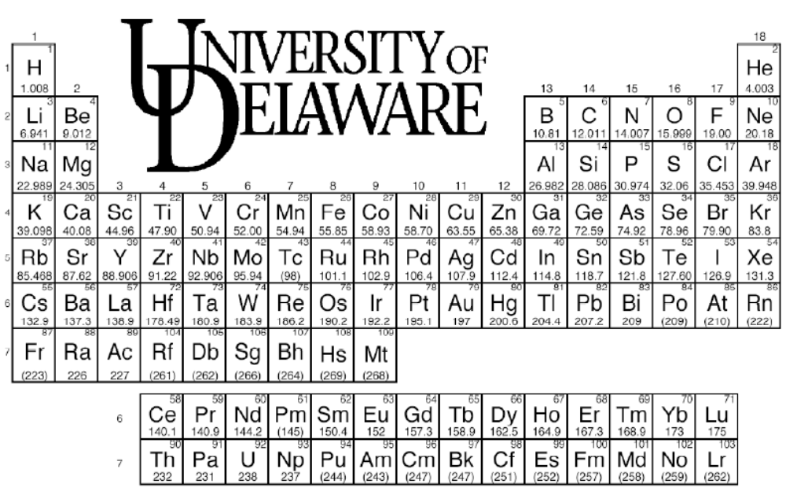

You may raise your hand to ask a question if you are unsure what a question is asking of you.
Part I Multiple Choice and Short Answer(28 points)
1. (Multiple choice, 4 points) Which of the following is an aldopentose?

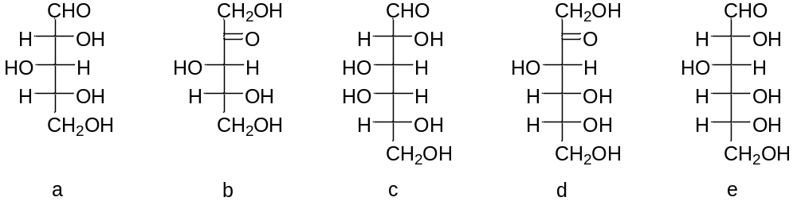

2. (8 points) Indicate for each of the following species whether they are aromatic, antiaromatic, or neither:
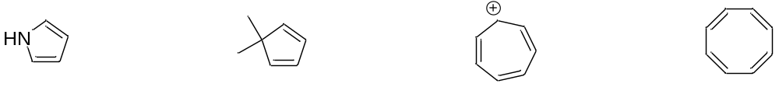

3. (6 points) Give IUPAC names for the following molecules:
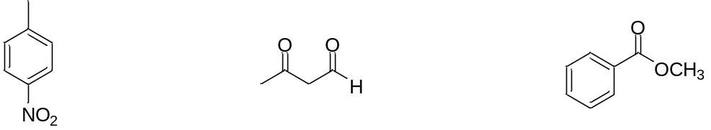

4a) (6 points) We have seen several examples of reactions that give one major product under kinetic conditions and another major product under thermodynamic conditions. Give an example of one such reaction. Indicate which product is favored kinetically, which is favored thermodynamically, and give appropriate conditions for the formation of each.

b) (4 points) We have seen several reactions where an otherwise reversible reaction is driven to completion by an (essentially) irreversible step. Give an example of one such reaction, and show the step in the mechanism that is (essentially) irreversible.

Part III: Reactions and Synthesis
5. (68 points) Give the major organic product(s) for 17 of the following 24 reactions: YOU CAN SKIP 7 problems by checking the “SKIP” box.
a. SKIP this one
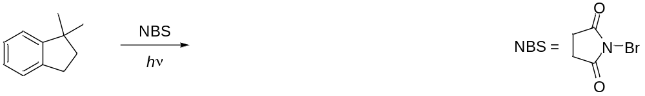
b. SKIP this one
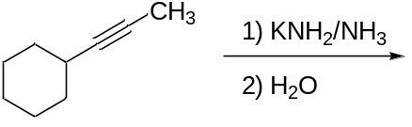

c. SKIP this one
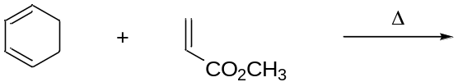

d. SKIP this one
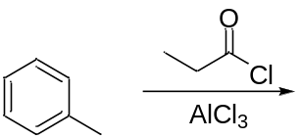

e. SKIP this one
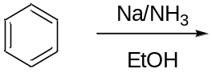

f. SKIP this one
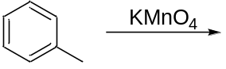
g. SKIP this one
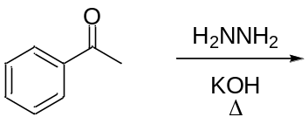

h. SKIP this one
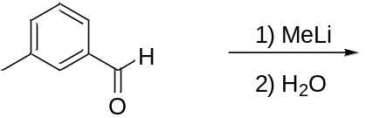

i. SKIP this one
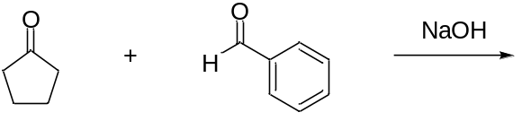

j. SKIP this one
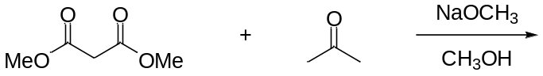

k. SKIP this one
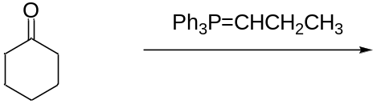

l. SKIP this one
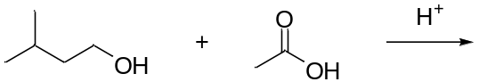

m. SKIP this one
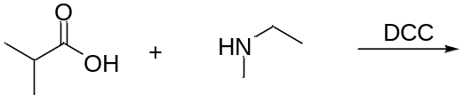

n. SKIP this one
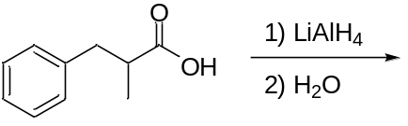

o. SKIP this one
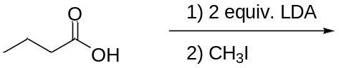

p. SKIP this one
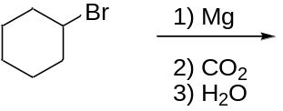

q. SKIP this one
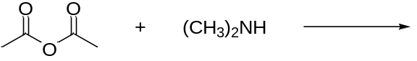

r. SKIP this one
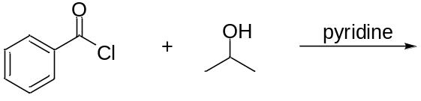
s. SKIP this one
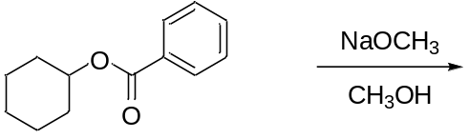

t. SKIP this one
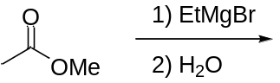

u. SKIP this one
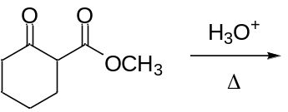

v. SKIP this one
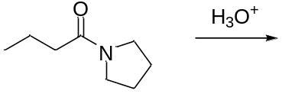

w. SKIP this one
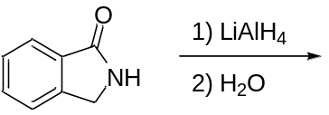

x. SKIP this one
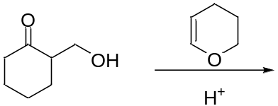

6. (15 points) Provide reagents to effect the following transformations. DO 5 OUT OF 7 PARTS. (YOU CAN SKIP 2 parts of Problem 8 by checking the “Skip” box).
a. SKIP this one
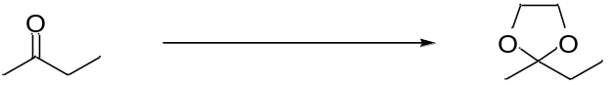

b. SKIP this one c. SKIP this one
d. SKIP this one
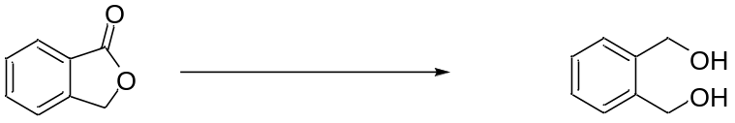

e. SKIP this one
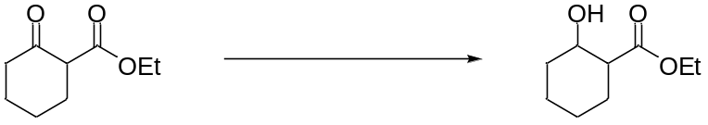

f. SKIP this one
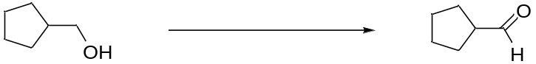

g. SKIP this one
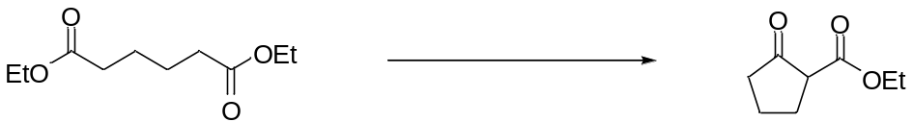

7. (10 points) Give detailed mechanisms for 2 of the following 4 reactions.
a)
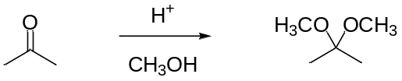
b)
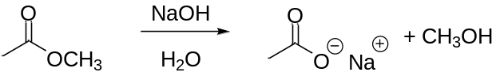
c)
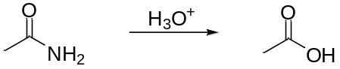
d)
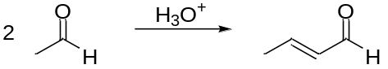

Multistep Synthesis (9 points)
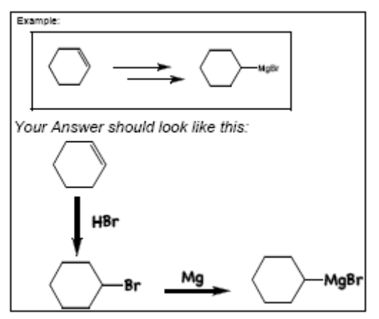
8. Choose TWO of the two following four synthesis problems. Show how you can synthesize the product on the left from the indicated starting material on the right. You can show a retrosynthesis for partial credit, but full credit requires writing out a sequence of forward reactions (see box at right for an example).
a)
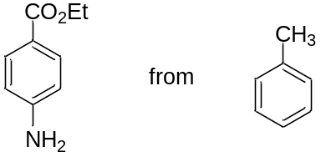
b)
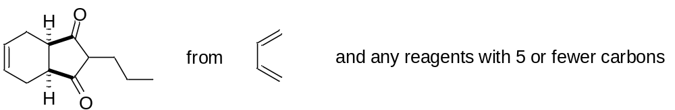
c)
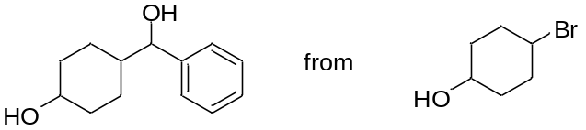
d)
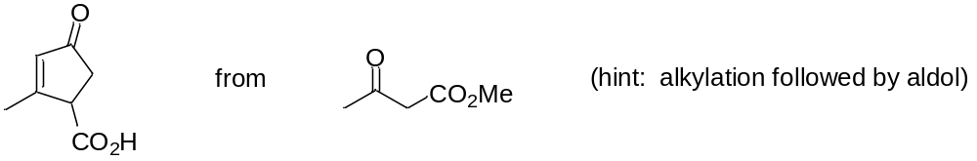

Part IV: NMR Spectroscopy
9. (8 points) The spectra for ethyl butyrate and propyl propionate are shown below. Determine which spectrum belongs to which compound. To obtain credit, you must explain how you determined which is which. It’s not necessary to analyze every signal in order to reach your conclusion.

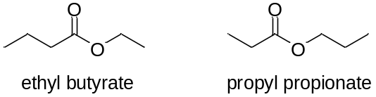
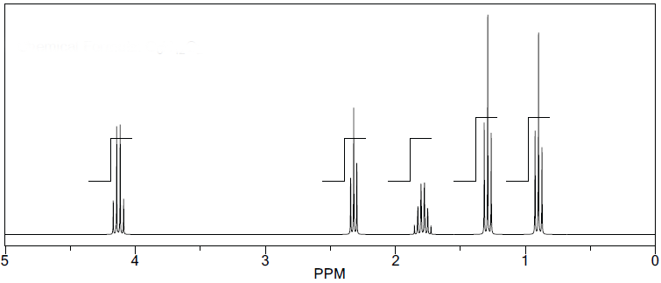
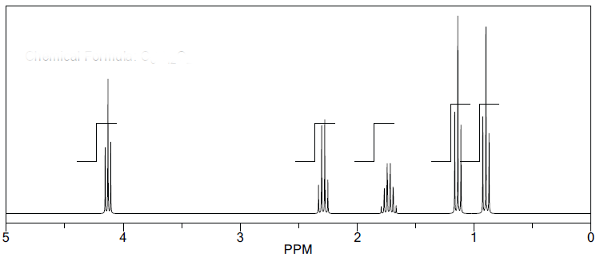

10. Spectroscopic Analysis of an Unknown Compound (10 points)
The ¹H (bottom) and ¹³C (top) NMR spectra for a compound with the formula C₆H₁₂O₂ is shown below. An expansion of the ¹H NMR, and an IR spectrum, are shown on the following page. The numbers on the NMR expansion indicate the integrations for each signal.
Identify the structure of the compound. Use the ¹H NMR data to construct a table (chemical shift, integration, multiplicity, assignment) to identify structural fragments, then arrive at the structure. You are being graded on your analysis. Any use of the degrees of unsaturation, IR, or ¹³C NMR data will be considered for extra credit
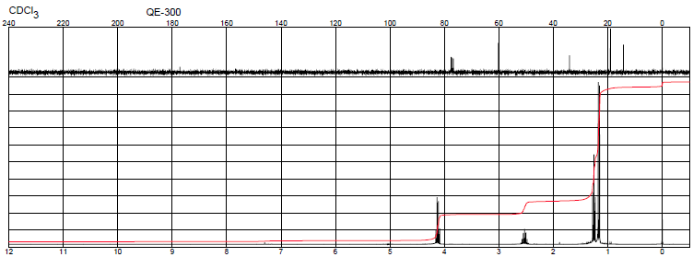

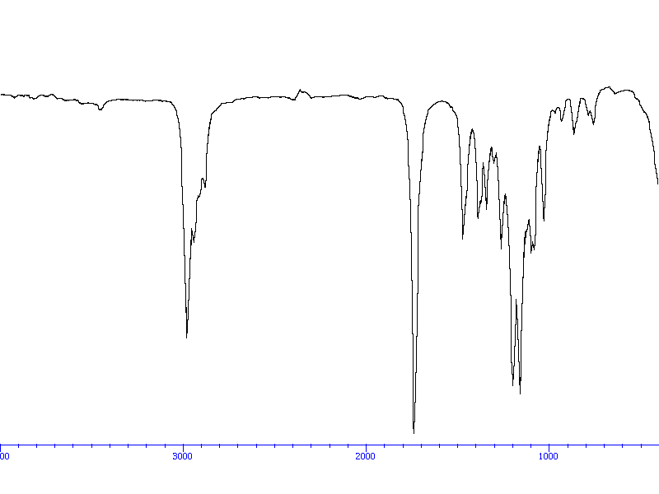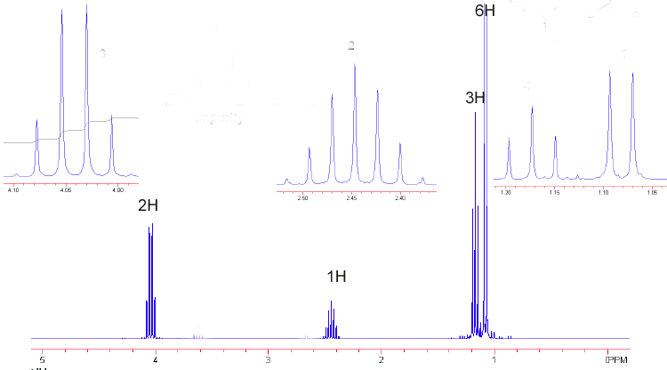

Extra Credit! (20 points): Chemical Synthesis of Fexofenadine (Allegra®).
This exam was written while I suffered from seasonal allergies. Answer as many of the following questions as you can for extra credit.
11. (9 points) For the following synthesis of fexofenadine, provide the missing reagents:

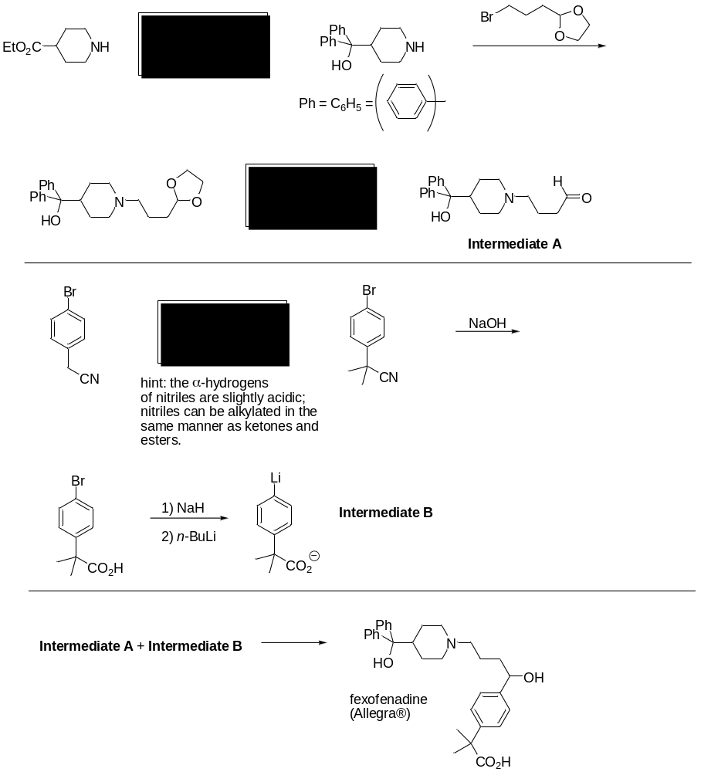
12. (3 points) Based on what you’ve learned so far, the organolithium Intermediate B looks unstable. Can you show a possible side reaction where it reacts with itself?

13. (2 points) Fexofenadine looks like it would be acid sensitive. Point out a part of the molecule that looks suspiciously sensitive to acid and explain why.

14. (4 points) An alternative synthesis involved the following reaction:

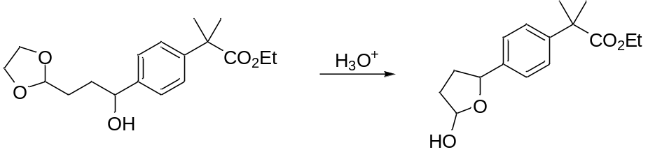
Explain how this transformation occurred.

15. (2 points) Another synthesis involved the following reaction:
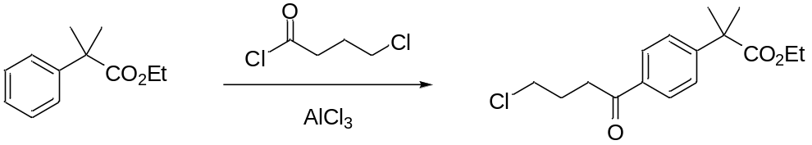

This is another reaction that looks potentially messy. Can you forsee possible complications in this reaction?

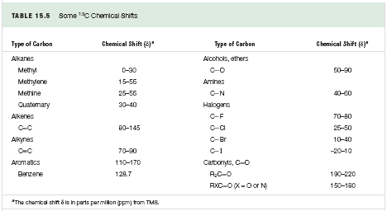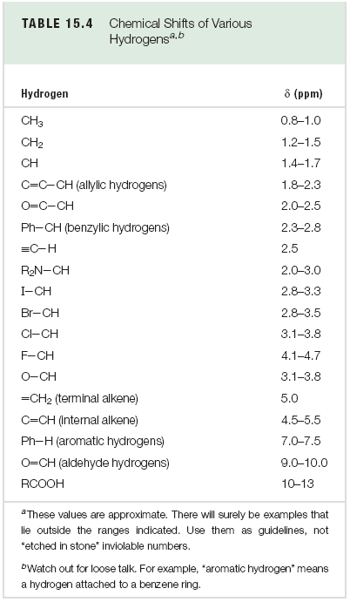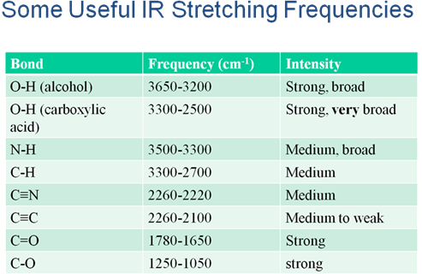

Cyanohydrins
Kinetic enolate
Td enolate
Reagents: Sandmeyer seres; cro3/pyr vs. h2cro4
Michael
SOCL2Saponification
Claisen
Aae/me;
O alkylation
Crossed claisen

