UD’s Dietetic Internship:

Accessing the Virtual Open House

- Access the virtual classroom at http://udel.adobeconnect.com/aleef. We recommend logging in 10-15 minutes prior to the scheduled start time in case you need to download any Add-Ins
- Select “Enter as Guest,” enter your first and last name, then click “Enter Room”
- The presentation will begin promptly at 7:00pm EST, followed by time for questions and answers
  - To ask a question, type it in the Chat box (see below)
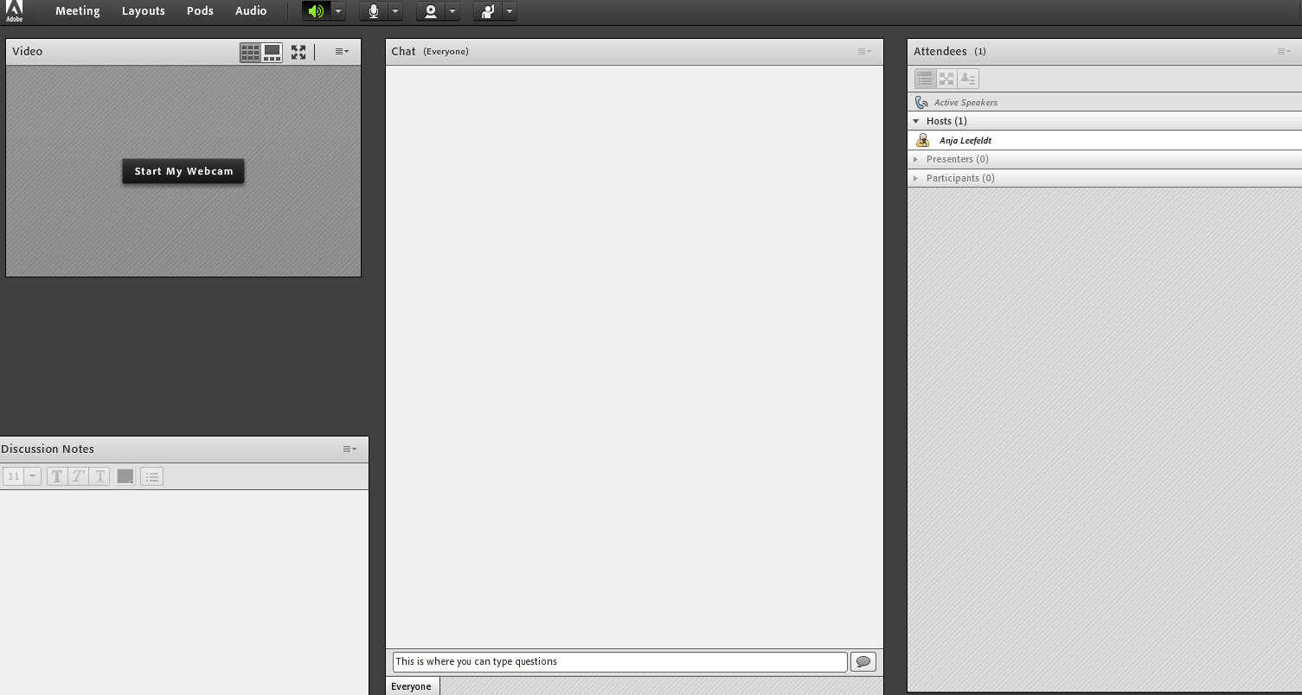

Tips for best audio & video quality:
- If possible, use a “wired” Internet connection instead of WiFi
- If you’re not able to hear the speaker, try logging out and back in
- Try a different Internet browser

