Query Booster
Grouping Criteria Example
2/25/2004

In the query class (exercise 9), it was presented that multiple criteria can be related with logical operators such as “AND” and “OR.” For example, you might want to see balances for certain Purposes AND a certain range of Accounts – in this case, you would have the operator AND between your criteria for Purpose and Account.

In another example, you may want to scan for transactions with large dollar values, say over $10,000, whether those values are positive OR negative. In this case, you would have the operator OR between a criterion that amount is greater than $10,000 and a criterion that amount is less than $10,000.

When your query includes multiple criteria, PeopleSoft Query checks the criteria according to the rules of logic: it evaluates criteria linked by ANDs before those linked by ORs. When all the criteria are linked by ANDs, this order always returns the correct results. When you mix in one or more ORs, however, this isn’t always what you want.
For example, suppose you wanted a list of all Purposes that start with a certain 4-character acronym that have digits 5 and 6 that are either 11 or 17. For this example, we will create a criterion that prompts the user to enter the first 4 characters of a purpose.

We will also create a field called “Fundtype” which is digits 5 and 6 of Purpose (this is done with an expression using the SUBSTRING function, also covered in the query class).

Our fields tab for this query looks like this:

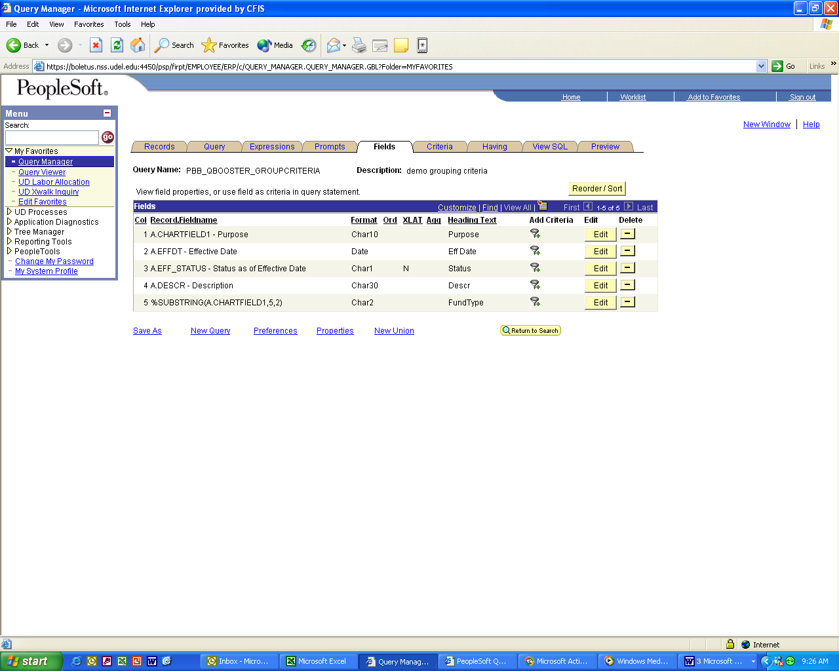

The record used in this query is CHARTFIELD1_TBL.

As noted, we will establish a criterion to prompt the user for the first four characters of purpose. We will then establish two criteria for this Fundtype field:

It must either equal 17 or equal 11.

Our criteria tab initially looks like this:

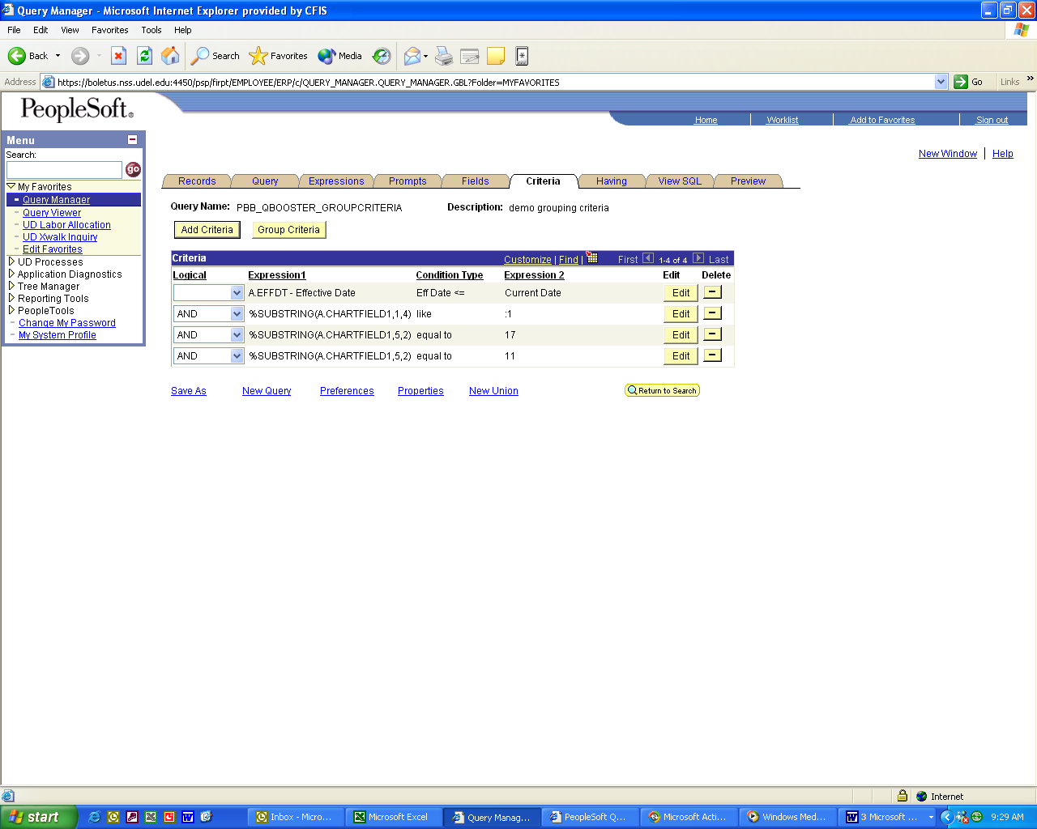

Again, as we know from query class, we much change the bottom logical operator from AND to OR, or we will get no results from this query, since Fundtype cannot equal 17 AND 11 at the same time. After we make that change, our criteria tab looks like this:

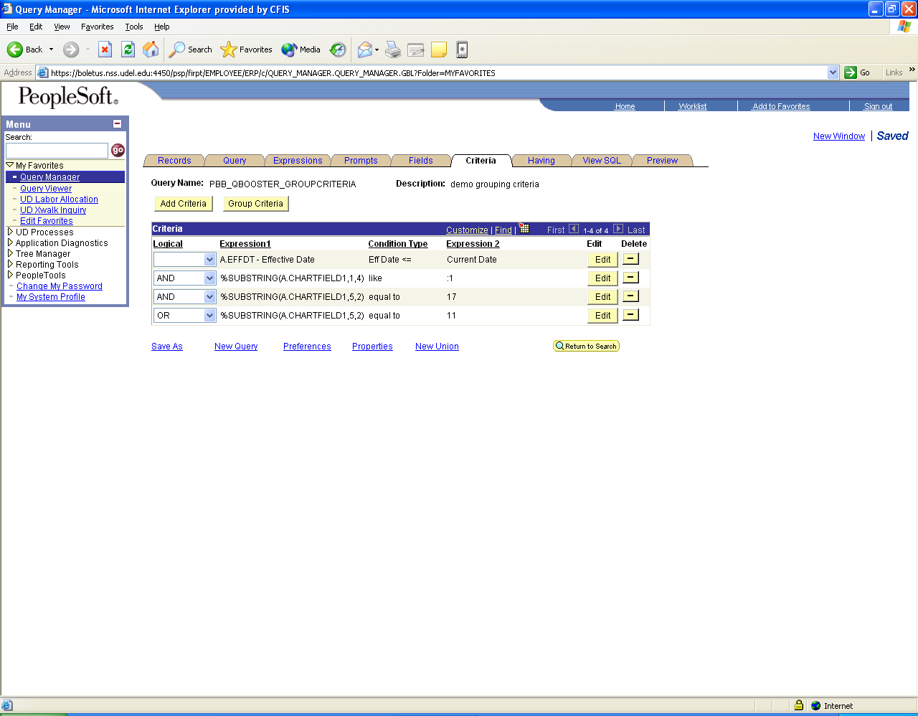

Let’s run this query. We are prompted for “Purpose4Characters.” We enter PROV because we are interested in Purposes that start with PROV.

Our results are not what we wanted: we see rows that start with things other than PROV, and have many more results than we expected. The first screen of results is below:

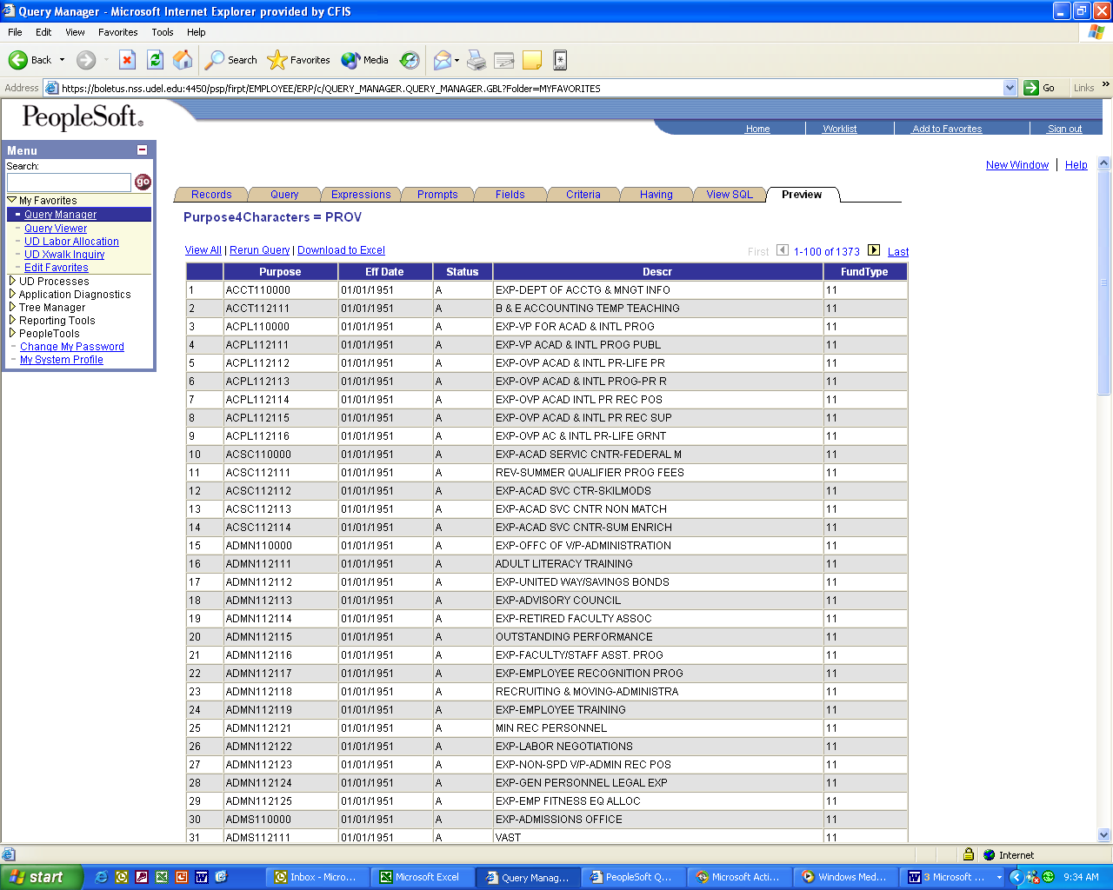

Why did this occur?

This happened because PeopleSoft Query checks the criteria according to the rules of logic: it evaluates criteria linked by ANDs before those linked by ORs. So, PeopleSoft gave us rows that meet these criteria:

Any Purpose that starts with PROV AND has a fundtype (digits 5 and 6) of 17
OR
Any Purpose that has a fundtype (digits 5 and 6) of 11.

So, we got every single Purpose with a fundtype (digits 5 and 6) 11, whether it starts with PROV or not.

The way to solve this problem is to group the criteria – that is, to tell PeopleSoft that we want it to evaluate the criteria in a certain order.

What we want PeopleSoft to do is to find all Purposes that start with PROV, AND all Purposes with fundtypes 17 OR 11. We do this by putting parentheses around the last two criteria.

Click the yellow “Group Criteria” button on the criteria tab. You will get a screen like this:
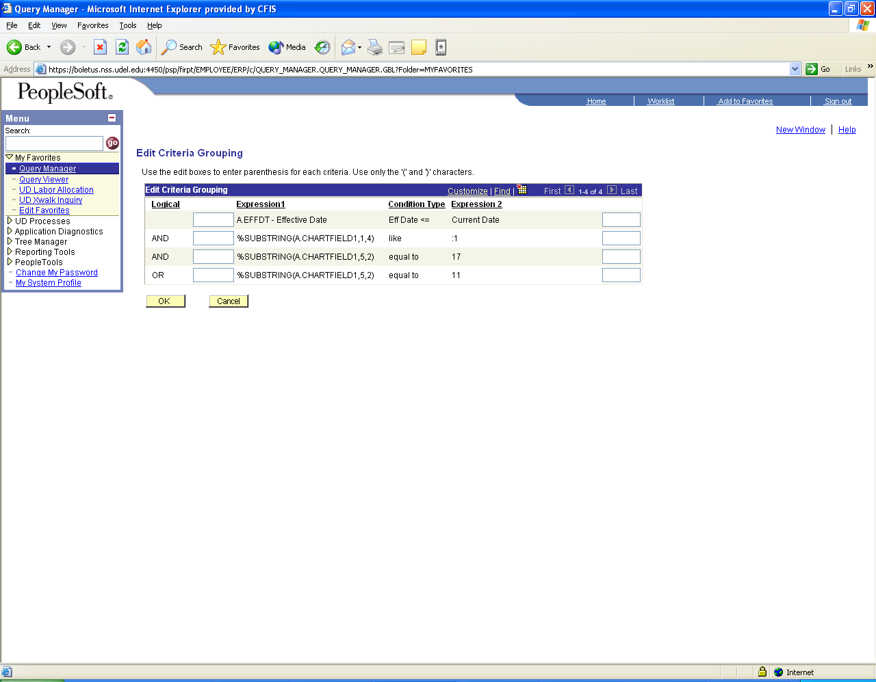

Now, manually enter parentheses around the last two criteria like this:
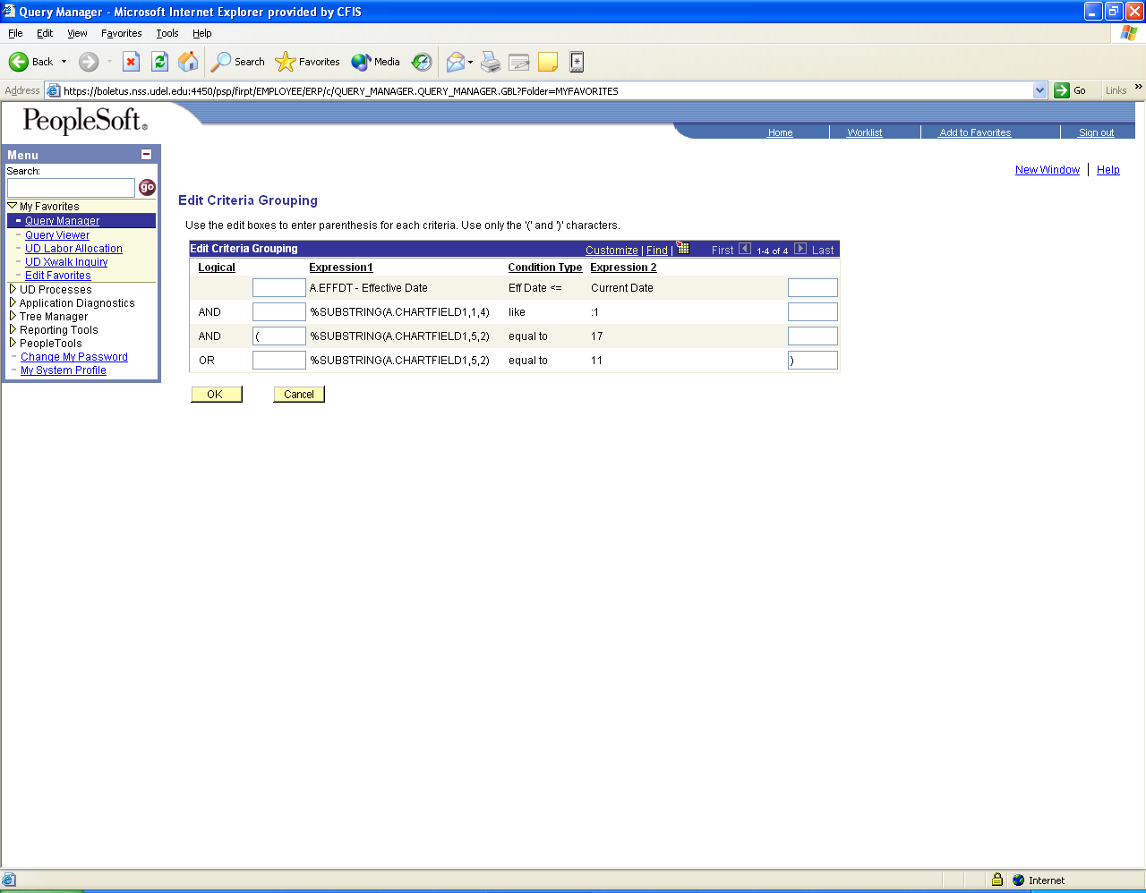

Click OK.

You will see these parentheses now from the criteria tab:

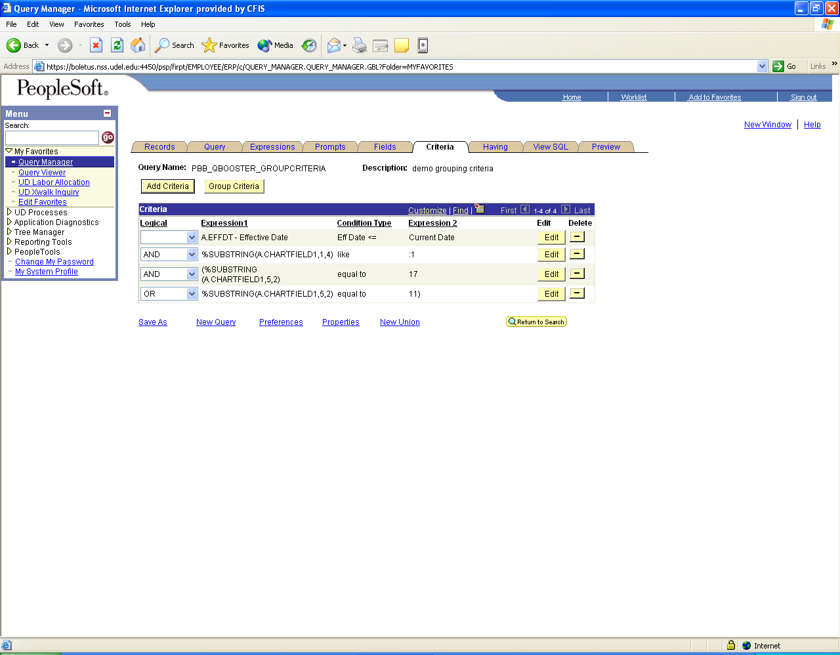

When we run the query again, and enter PROV at the prompt, we get the results we wanted:
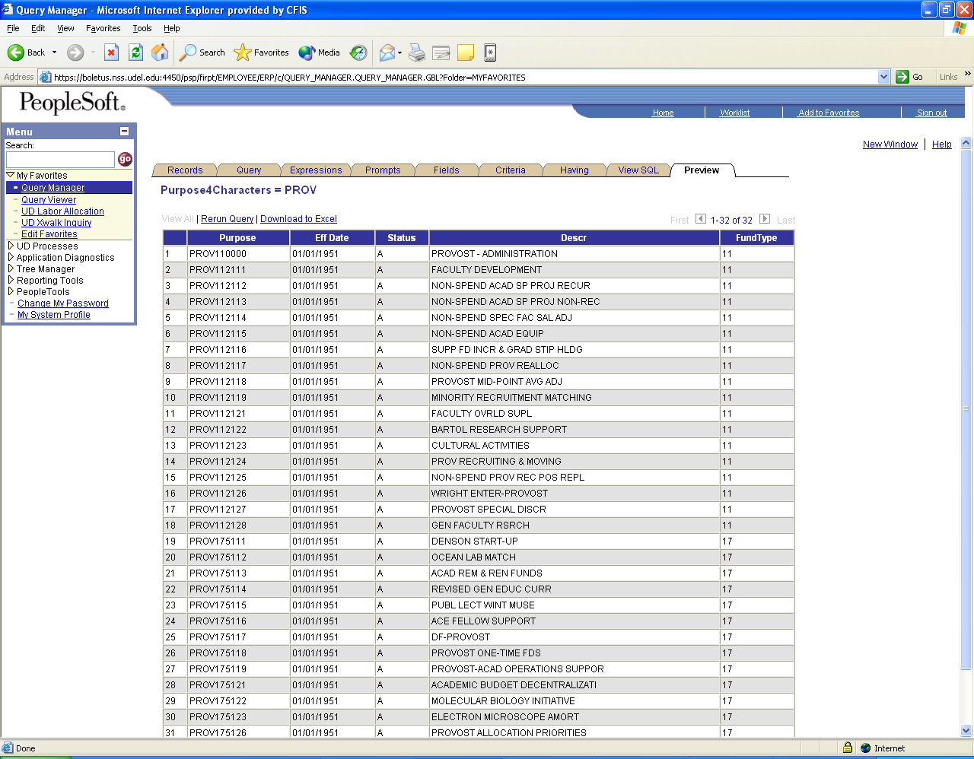

Note there are many fewer rows this time, and all start with PROV and have digits 5 and 6 of either 11 or 17.

This is a public query saved as PBB_QBOOSTER_GROUPCRITERIA.

