Reviewing Accounts Receivable Information

C-4 Running Departmental Aging Report
This process allows you to run an accounts receivable aging report for your department’s billing activity.

Navigation:
► Go to PeopleSoft menu: Accounts Receivable → Collections → Aging Reports → Aging Detail by Dept
► At Aging Detail by Dept, select Add a New Value or Find an Existing Value

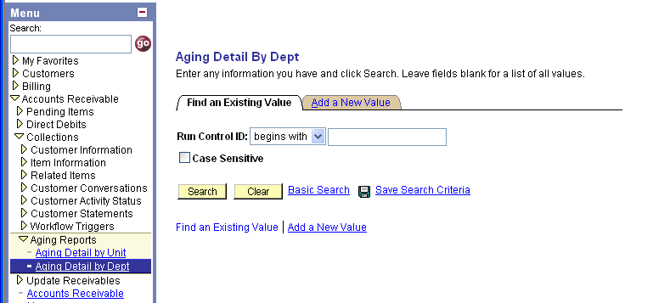
1

2

- The first time you run the aging report, click on “Add a New Value” tab.
- After the first time, stay in “Find an Existing Value” tab and type in the name of your Run Control ID from the previous time. If you don’t remember it, click the “Search” button to bring up a list. And then click on the Run Control ID.

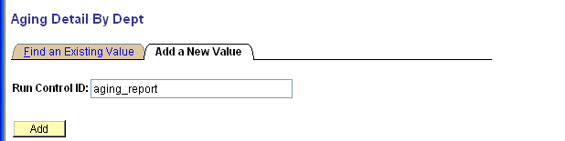
4

3

Add a New Value Tab:
- Name this Run Control ID (suggestion: aging_report OR dept_aging – please note that the name cannot have any spaces, the “_” is used instead.)
- Click the “Add” button

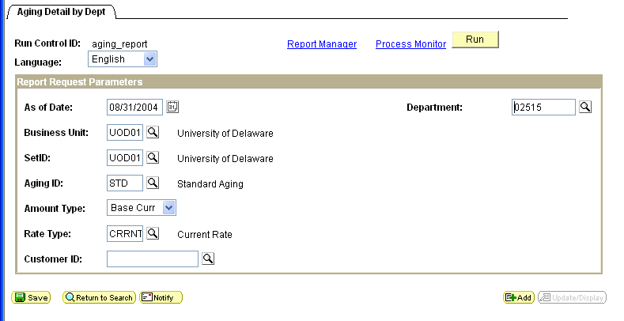
11

12

6

5

7

8

9

10

13

Aging Detail by Dept
- As of Date – enter the ending date (format is dd/mm/yyyy) for the time period on which you wish to report.
- Unit and SetID– these are always UOD01
- Aging ID – type STD for “Standard Aging”
- Amount Type – use drop down to select Base Curr
- Rate Type – type CRRNT (for current)
- Customer ID – leave blank
- Department – enter your department’s 5 digit Dept ID code
- Click “Save” button
- Click “Run” button

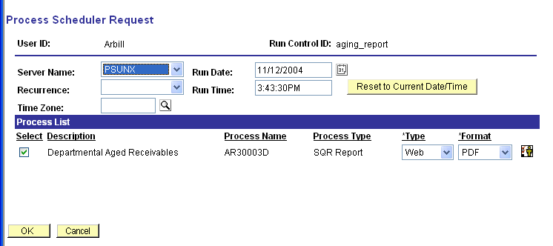
16

15

14

Process Scheduler Request
- Server Name – use drop down to choose PSUNX
- Click the box in front of “Department Aged Receivables”
- Click the “OK” button to run the report.
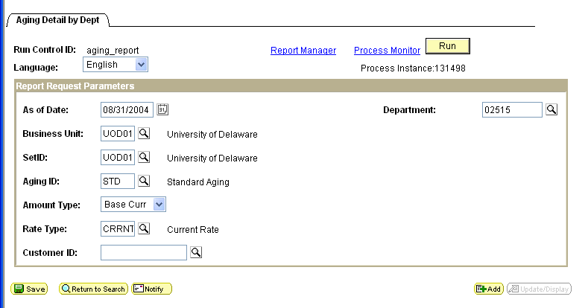
17

19

X
18

After you click the “OK” button on the Process Scheduler Request page, you will be returned to the Aging Detail by Dept page.

- DO NOT click the “Run” button again
- Click the “Save” button
- Click the Process Monitor link to make sure the report runs successfully

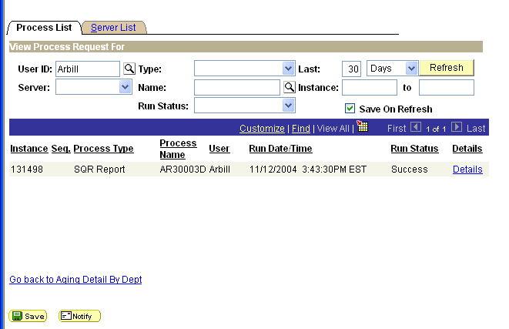
20

23

22

21

In Process List:
- Change Last to 30 Days
- Click “Save” button
- Run Status – click the “Refesh” button until the status is Success
- Click Details link on the report that you want to see.

(Note: Eventually you may have other Aging Reports listed here. These are ones you’ve run previously, the most recent one will be at the top of the list.)

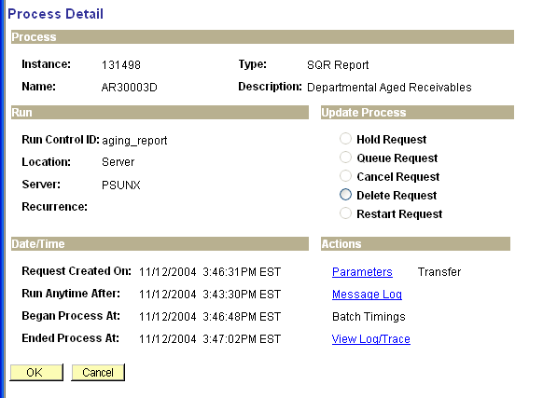
24

In Process Details page:
- Click on View Log/Trace link

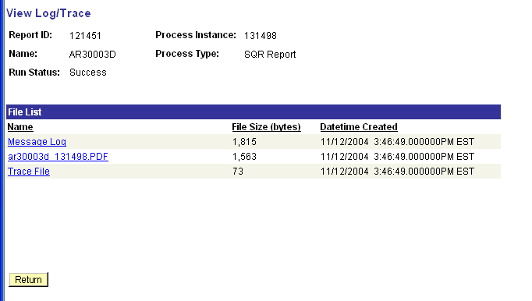
25

In View Log/Trace page:
- Click the PDF link

27

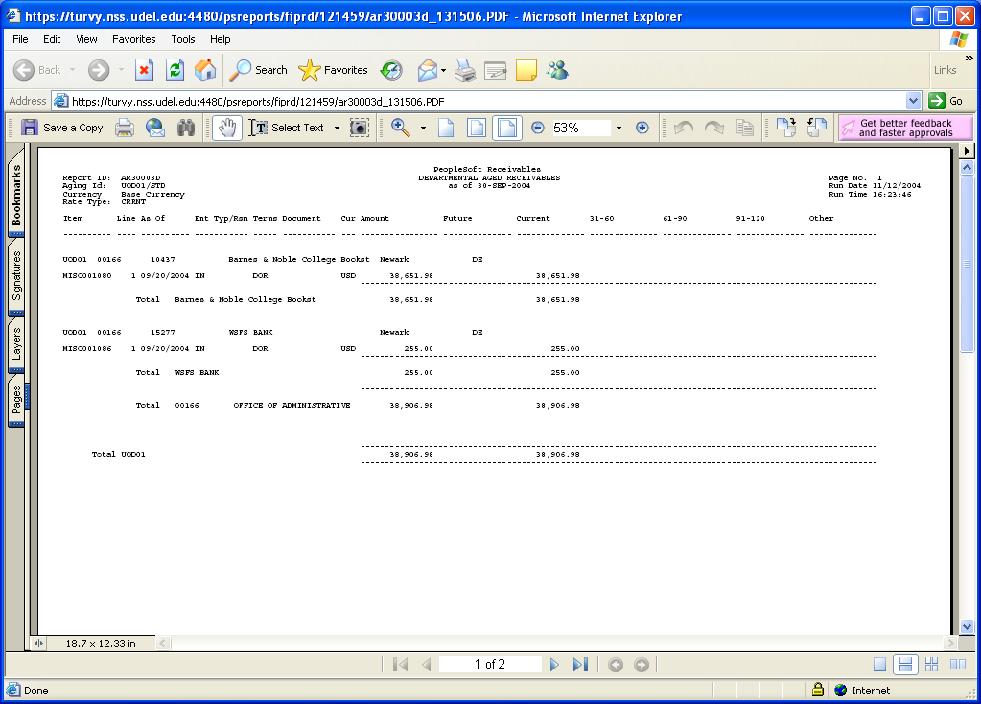
26

This launches Acrobat Reader:
- You can:
- print the report
- save the report to your hard drive
- view the report on-line

- Close this window (to return to PeopleSoft) by clicking the red “X” in the upper right corner.

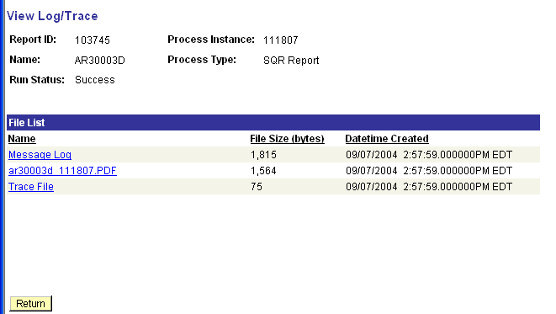

Click the "Return” button.

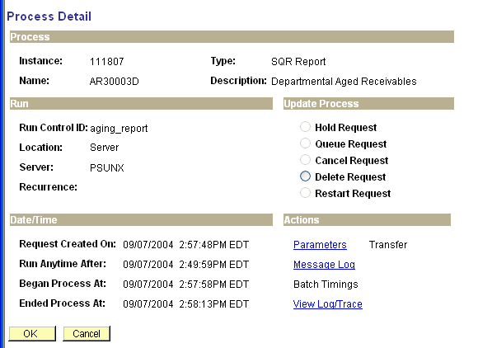

Click the “OK” button

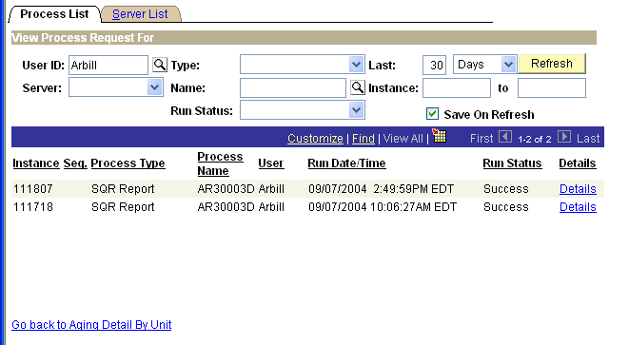

Click the Go back to Aging Detail By Dept link
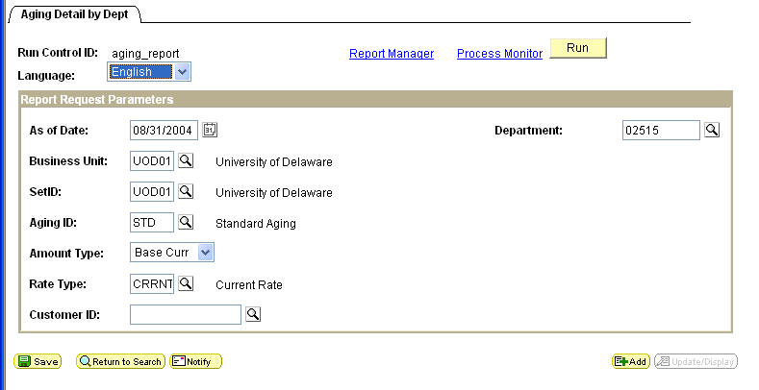

You are now back where you started at the Aging Detail by Dept.

