Academic Department Profiles:

Creating an On-Line Budget Support Notebook

Karen A. DeMonte

Office of Institutional Research and Planning

Institutional Research Analyst

University of Delaware

325 Hullihen Hall

University of Delaware

Newark, DE 19716

Ph: (302)831-2021

E-mail: kdemonte@udel.edu

Academic Department Profiles:

Creating an on-line Budget Support Notebook

Introduction

Academic department profiles are provided to the University of Delaware administration with our ‘Budget Support Notebook’. It is a resource document that academic administrators, chairs, deans, and provost use for decision making. It contains information on instructional, research, and service revenues and expenditures for each college and academic department. In addition to basic fiscal data, it provides information on instructional workload and productivity measures and the resulting management ratios. Data for three years are given to present trend patterns. A trend showing steadily declining productivity and increasing costs should be viewed as indicators that further, in-depth study of a unit is required to determine the underlying cause for those trends.

The Budget Support Notebook has evolved over time from a printed report of a series of hand entered Excel spreadsheets in the early 1990’s to a slicker looking report using an automated Access database in the late 1990’s. With the rising cost of printing and tighter budgets, today’s Budget Support Notebook is an extensive web site using Perl scripts and HTML templates that replaces the old 150+ page report.

The Budget Support Notebook web site is divided into four sections; the Main Menu (figure 1), College Level Menu (figure 2), and Summary Data (figure 3a and 3b). Each section begins with a college-wide summary, followed by departmental level summaries. Institutional workload data are displayed for fall and spring semesters, together with an academic year average. Financial data is presented on a fiscal year basis. The focus of analysis is the two major semesters that are supported by the University's Basic Budget in the academic year.

Methodology
At the conclusion of each fall and spring semester, an initial extract of course offering data from the Student Records and Human Resources systems is made. The extract contains course demographics, schedule information, student counts, and instructor data. Using Microsoft Access, course verification reports (figure 4) are produced and distributed to Department Chairs. The verification process requests Department Chairs to ensure that the instructor of record is getting full credit for courses taught. Since the management ratios within the Budget Support Notebook are closely tied to the departmental budget, it is important that the workload of all faculty in their department are accounted for regardless of where the courses are taught, i.e. cross-listed courses.

Once the course information is complete, a final run of the Faculty Workload Report is produced for each semester from the central mainframe. A report on basic expenditures is run on the mainframe after the fiscal year end close is completed. These reports produce extracts that summarizes the data by department and college, which are then downloaded and imported into Microsoft Access.
The Access database is comprised of several tables and queries that work together to present or calculate data points (figure 5a and 5b). The database contains data (attachment 1) for three years. Tables on number of degrees granted, faculty counts, and student counts are then created by either importing data produced from SPSS or entering data using Access Forms. Once all the data tables are updated, the data from the various sources and years are merged into a single tab-delimited file (attachment 2). Each line in the file represents a department or college and has more than 230 variables. Each variable represents a data point on the HTML page. This file is copied from Access to the IR server running Perl.

Creating separate HTML pages for each department and college was simplified by using a single Perl script (attachment 3) and an HTML template (attachment 4). The Perl script reads the data from the tab-delimited file, merges the variables by name with the HTML template, creates the directories, and saves the static HTML pages (figure 6a and 6b).
Figure 1:

Figure 2:
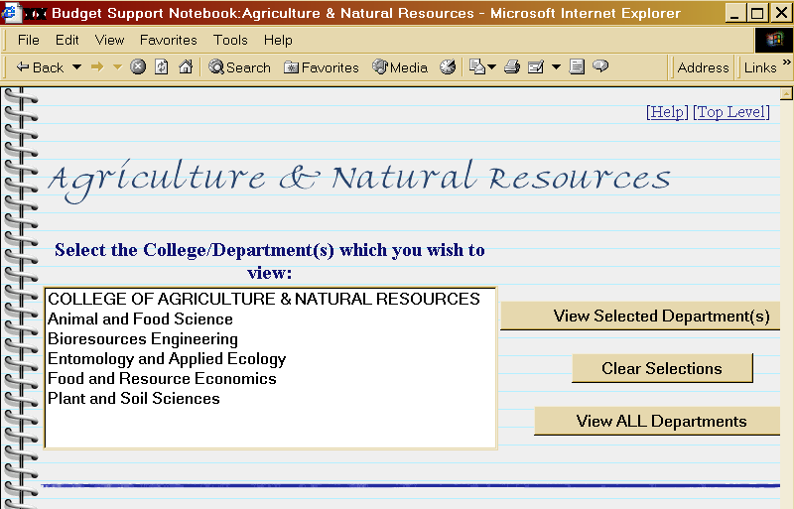
Figure 3a:
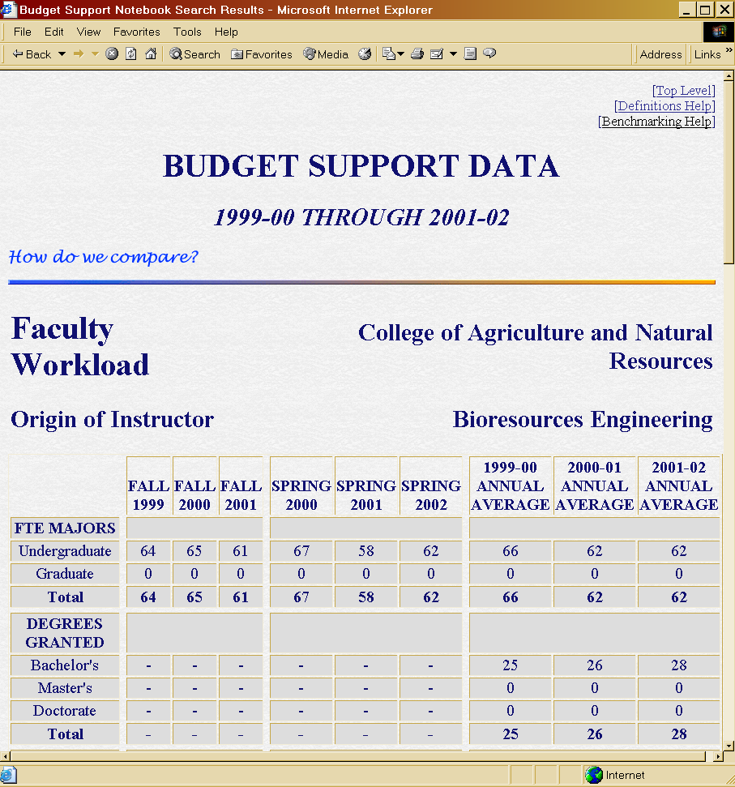
Figure 3b:
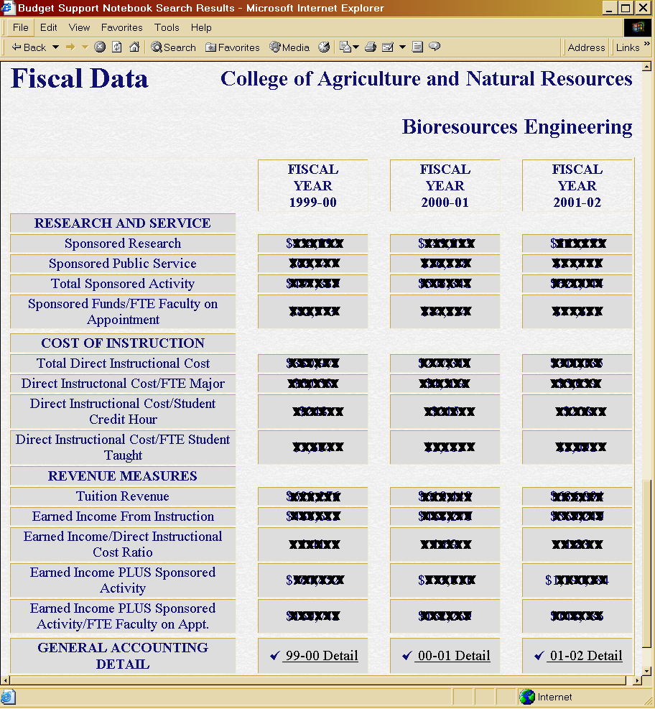
Figure 4:

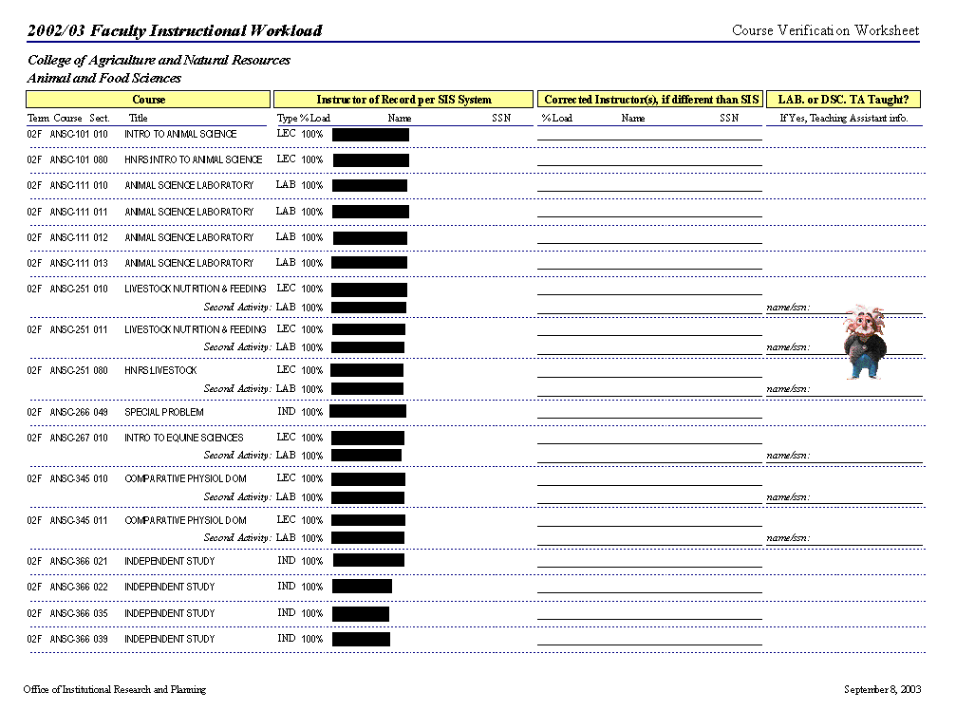
Sample of Course Verification Form
Figure 5a: 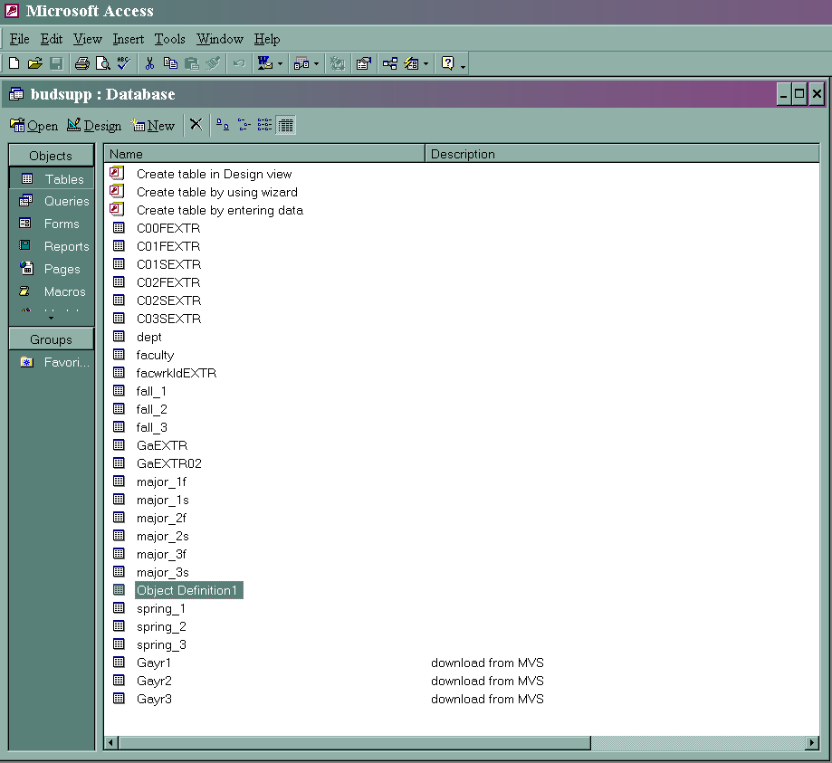
Access Tables
Figure 5b:
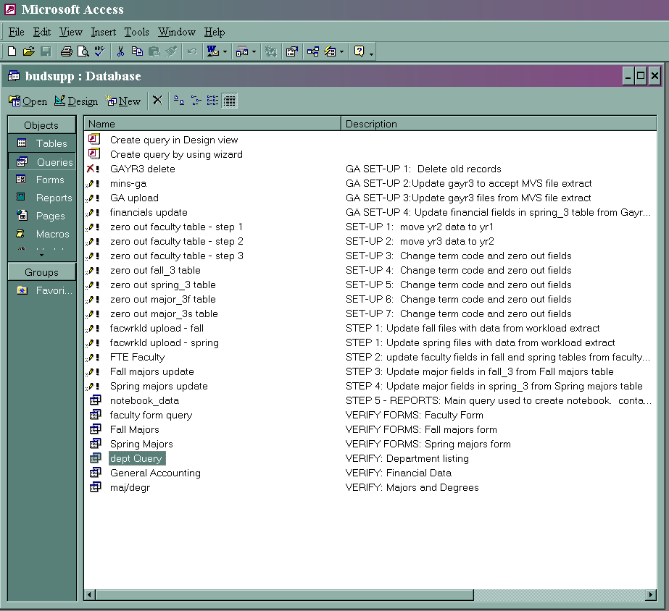
Access Queries
Attachment 1: Definitions

DATA DEFINITIONS

The following data elements are examined in this notebook:

1. FTE Majors: Full time equivalent (FTE) majors are a function of headcount enrollment and are calculated by dividing the total number of part time majors by 3, and adding the quotient to the number of full time majors. This method of calculating full time equivalency is consistent with that used in reporting enrollment to the Federal Government via the Integrated Postsecondary Educational Data System (IPEDS), the Commission on Higher Education of the Middle States Association of Colleges and Schools, and a host of other external agencies. Because most student majors attend the University in both the Fall and Spring Semesters, the Annual Average is used in relevant ratio calculations in this notebook as a means of eliminating double-counting. Data reflect primary majors only; double majors are not counted. DATA SOURCE: UPS 705 REPORT, Official 10th Day

2. Degrees Granted: The number of degrees granted at the baccalaureate, master's, and doctoral levels are presented as a basic measure of student outputs.
DATA SOURCE: IPEDS GRADUATION SUMMARY REPORT

Course-based data (i.e., student credit hour generation, student course enrollments, and FTE students taught) in this notebook are reported "Origin of Instructor." The use of this methodology is consistent with the National Study on Faculty Productivity and Costs. Origin of Instructor analysis captures all of the student credit hours, course enrollment, and FTE generation data from all courses taught by individuals budgeted to and paid by a given department, regardless of whether the course originated in that department. For courses taught by any Supplemental Faculty, which includes adjunct faculty, administrators who teach, graduate teaching assistants and anyone else with a non-recurring teaching contract, student credit hours, course enrollment, and FTE generation data is assigned to the department originating the course.

The source document for the credit hour and enrollment data, as well as the proportion of teaching activity done by faculty on appointment versus supplemental faculty, is the Faculty Instructional Workload Report. This report, which examines teaching activity by individual instructor, is provided to each dean and departmental chair along with a request to the latter for verification of the accuracy and completeness of the data therein. The information in that report, which is extracted directly from the Student Information System, is the basis for the workload analyses in this notebook. It is therefore essential that departments assist us in ensuring that the correct instructor is associated with every course taught in the department. In that way, every department receives complete credit for the full range of its instructional activity.

3. Student Credit Hours: Total student credit hours (course credits multiplied by course enrollment) are reported by level of instruction, i.e., lower division (100 and 200 level courses), upper division (300 and 400 level courses), and graduate (500 and above level courses).

4. Percent Credit Hours Taught by Faculty on Appointment and by Supplemental Faculty: It is useful for departments to know what proportion of their instruction is done by their own faculty on appointment and what proportion of teaching is done by supplemental faculty. For purposes of this analysis, faculty on appointment includes chairs, named professors, full professors, associate professors, assistant professors, instructors, lecturers, and others with active instructional appointments budgeted to that department. Supplemental faculty includes everyone else, i.e., adjunct faculty, administrators who teach, graduate teaching assistants and anyone else with a non-recurring teaching contract. The Faculty Instructional Workload Report was examined for each semester, and the proportion of student credit hours taught by faculty on appointment and by supplemental faculty was calculated

5. Total Student Course Enrollment: The total number of students enrolled in courses is displayed by level of instruction. In this instance, if a single student takes two courses in the same department in the same semester, he/she is counted twice, as enrollments - not individuals -- are being tallied.

6. FTE Students Taught: Where FTE Majors are a function of headcount enrollment, "FTE Students Taught" is a function of student credit hour generation from teaching within a department, and hence, is a far more meaningful measure of instructional productivity. Full time equivalent students generated from instructional activity is calculated on the verifiable assumption that a typical full time undergraduate carries a semester load of 15 credit hours, while that for a full time graduate student is 9 credits. If the total student credit hours generated in a given semester in lower and upper division courses are divided by 15, and total student credit hours in graduate courses are divided by 9, a full time equivalency is generated. This statistic is very important for departments such as Philosophy, with a relatively small number of declared majors, but with a large number of FTE students generated from teaching.

7. Full Time Equivalent Faculty: FTE Faculty is derived from two sources. The full time equivalency for chairs and bargaining unit faculty is taken directly from the University's Personnel Data Base for the respective semesters. Full time equivalency for supplemental faculty is calculated by taking the total teaching credit hours in regularly scheduled courses taught by those individuals, and dividing by 12. Twelve credits is the contractually administered teaching load for a semester.

8. Workload Ratios: Three workload ratios have been calculated. They are Student Credit Hours/FTE Faculty; Students Enrolled/FTE Faculty; and FTE Students Taught/FTE Faculty. Chairs are included in the FTE Faculty calculations relating to workload ratios, as they frequently generate instructional activity.

Each college and department is examined with respect to fiscal data for sponsored research, sponsored public service, and total instructional costs. Specifically, for each of the fiscal years 1996 through 1998, data were extracted from the University Accounting System for direct expenditures for instruction, separately budgeted research, and separately budgeted public service. These data have been assembled into detailed summary sheets that are being provided to deans and department chairs along with this notebook, for their respective units.

9. Sponsored Research: Sponsored research activity is reflected in terms of total expenditures for organized (separately budgeted) research activity, as extracted directly from the University Accounting System. Sponsored research expenditures include both external funds and separately budgeted University funds for sponsored research activity charged to accounting function codes 21 through 39.

10. Sponsored Public Service: Sponsored public service activity is reflected in terms of total expenditures for that function as reflected in the University's Accounting System. As with sponsored research, sponsored public service includes both external funds and separately budgeted University funds charged to accounting function codes 41 through 43.

11. Total Sponsored Activity: This is the sum of sponsored research and service expenditures as defined in items 9 and 10 above.

12. Sponsored Funds per Faculty on Appointment: This is the sum of total sponsored activity, as defined above, divided by the full time equivalency for chairs and bargaining unit faculty, as defined in item 7. Chairs are included in the FTE Faculty calculations, as in many instances they generate considerable contract and grant activity.

13. Total Direct Instructional Cost: Total direct expenditures for instructional activity have been isolated in the University Accounting System. These are expenses associated with accounting function codes 01 through 08, and do not include indirect costs.

14. Direct Instructional Cost per FTE Major, per Student Credit Hour, and per FTE Student Taught: Total direct instructional cost, as defined in the preceding item, is divided by Total FTE Majors (annual average) as defined in item 1; by Total Student Credit Hours (sum of Fall and Spring semesters) as defined in item 3; and by Total FTE Students Taught (sum of Fall and Spring semesters) as defined in item 6.

Three instructional revenue measures have been calculated for each college and department:

15. Tuition Revenue: This is an estimation of the tuition revenue generated from majors in a college or department. For purposes of this estimation, total University revenue from credit bearing instruction in the Fall and Spring semesters for each fiscal year was divided by the full time equivalent enrollment on the Newark Campus to arrive at a "per FTE major" annual tuition rate. This rate was then multiplied by the annual average FTE majors in the respective college or department to produce an estimation of the tuition revenue generated by those majors.

16. Earned Income from Instruction: Tuition revenues "earned" by a college or department as the result of instructional activity, measured in student credit hours, is estimated here. A "per credit hour" tuition rate was calculated by taking total University tuition revenue for credit bearing instruction during the Fall and Spring semesters in a given fiscal year, and dividing by the total number of student credit hours taught on the Newark Campus during those semesters. The per-credit hour rate is then multiplied by the number of student credit hours, as defined above, to arrive at an estimation of the income generated by that unit's instructional activity during the academic year.

17. Earned Income from Instruction to Direct Instructional Expenditures Ratio: Earned income from instruction, as defined above, is divided by direct expenditures for instruction, as described in Item 13, to arrive at a ratio which estimates the extent to which a college or department supports its direct instructional costs through revenue generation from teaching activity. Units with ratios at or in excess of 1.0 "earn" at least as much tuition revenue from student credit hour generation as they expend in direct instructional costs; the reverse is true where the ratio is less than 1.0. In instances where a unit's direct instructional costs exceed revenues from teaching, it is useful to examine measures associated with sponsored research and service to determine the extent to which other returns on investment may be evident in that unit. The reader is urged to exercise caution in interpreting this ratio, as it deals with direct expenditures only. Best estimates suggest that when indirect costs are taken into consideration, the ratio would have to be at least 2.0 to demonstrate true self-sufficiency.

NOTE: All of the management ratios in this notebook are intended to be viewed as barometers rather than as empirical absolutes. Trend data are more important than a single year. Trend lines that show steadily declining productivity and increasing costs should be viewed as indicators that further, in-depth study of that unit is required to determine the underlying cause for those trends.
Attachment 2: notebook_data file

Friday, May 28, 2004
Query: notebook_data Page: 1
Properties
DatasheetFontHeight: 9 DatasheetFontItalic: False
DatasheetFontName: Arial Narrow DatasheetFontUnderline False
DatasheetFontWeight: Normal DatasheetForeColor: 33554432
Date Created: 3/5/2000 4:02:20 PM Description: STEP 5 - REPORTS: Main query
used to create notebook.
contains all fields for input into the
report.
FrozenColumns: 1 Last Updated: 5/27/2004 1:28:38 PM
MaxRecords: 0 ODBCTimeout: 60
OrderByOn: False Orientation: 0
RecordLocks: No Locks RecordsAffected: 0
RecordsetType: Dynaset ReturnsRecords: True
TabularCharSet: 0 TabularFamily: 34
Type: 0 Updatable: True
Columns
Name Type Size
mins Text 4
dept.Coll_ID Text 2
College Text 60
dept.Dept_ID Text 4
Department Text 60
fall_1.term Text 3
fall_1.Coll_ID Text 50
fall_1.Dept_ID Text 4
fall_1.maj-u Long Integer 4
fall_1.maj-g Long Integer 4
fall_1.oisch-l Long Integer 4
fall_1.oisch-u Long Integer 4
fall_1.oisch-g Long Integer 4
fall_1.oienr-l Long Integer 4
fall_1.oienr-u Long Integer 4
fall_1.oienr-g Long Integer 4
fall_1.oittc-all Long Integer 4
fall_1.oittc-tt Long Integer 4
fall_1.oisch-tt Long Integer 4
fall_1.chair Double 8
fall_1.faculty Double 8
F_1suppf Double 8
F_1totfac Double 8
F_1schT Long Integer 4
F_1schfa Double 8
F_1enrT Long Integer 4
F_1stuL Double 8
F_1stuU Double 8
F_1stuG Double 8
F_1stuT Double 8
fall_2.term Text 3
fall_2.Coll_ID Text 50
fall_2.Dept_ID Text 4

Query: notebook_data Page: 2
fall_2.maj-u Long Integer 4
fall_2.maj-g Long Integer 4
fall_2.oisch-l Long Integer 4
fall_2.oisch-u Long Integer 4
fall_2.oisch-g Long Integer 4
fall_2.oienr-l Long Integer 4
fall_2.oienr-u Long Integer 4
fall_2.oienr-g Long Integer 4
fall_2.oittc-all Long Integer 4
fall_2.oittc-tt Long Integer 4
fall_2.oisch-tt Long Integer 4
fall_2.chair Double 8
fall_2.faculty Double 8
F_2suppf Double 8
F_2totfac Double 8
F_2schT Long Integer 4
F_2schfa Double 8
F_2enrT Long Integer 4
F_2stuL Double 8
F_2stuU Double 8
F_2stuG Double 8
F_2stuT Double 8
fall_3.term Text 3
fall_3.Coll_ID Text 50
fall_3.Dept_ID Text 4
fall_3.maj-u Long Integer 4
fall_3.maj-g Long Integer 4
fall_3.oisch-l Long Integer 4
fall_3.oisch-u Long Integer 4
fall_3.oisch-g Long Integer 4
fall_3.oienr-l Long Integer 4
fall_3.oienr-u Long Integer 4
fall_3.oienr-g Long Integer 4
fall_3.oittc-all Long Integer 4
fall_3.oittc-tt Long Integer 4
fall_3.oisch-tt Long Integer 4
fall_3.chair Double 8
fall_3.faculty Double 8
F_3suppf Double 8
F_3totfac Double 8
F_3schT Long Integer 4
F_3schfa Double 8
F_3enrT Long Integer 4
F_3stuL Double 8
F_3stuU Double 8
F_3stuG Double 8
F_3stuT Double 8
spring_1.term Text 3
spring_1.Coll_ID Text 50
spring_1.Dept_ID Text 4
spring_1.maj-u Long Integer 4
spring_1.maj-g Long Integer 4
spring_1.degr-b Long Integer 4
spring_1.degr-m Long Integer 4

Query: notebook_data Page: 3
spring_1.degr-d Long Integer 4
spring_1.oisch-l Long Integer 4
spring_1.oisch-u Long Integer 4
spring_1.oisch-g Long Integer 4
spring_1.oienr-l Long Integer 4
spring_1.oienr-u Long Integer 4
spring_1.oienr-g Long Integer 4
spring_1.oittc-all Long Integer 4
spring_1.oittc-tt Long Integer 4
spring_1.oisch-tt Long Integer 4
spring_1.research Currency 8
spring_1.pubsevc Currency 8
spring_1.instruct Currency 8
spring_1.chair Double 8
spring_1.faculty Double 8
FY_1spon Currency 8
S_1suppf Double 8
S_1totfac Double 8
S_1schT Long Integer 4
S_1schfa Double 8
S_1enrT Long Integer 4
S_1stuL Double 8
S_1stuU Double 8
S_1stuG Double 8
S_1stuT Double 8
spring_2.term Text 3
spring_2.Coll_ID Text 50
spring_2.Dept_ID Text 4
spring_2.maj-u Long Integer 4
spring_2.maj-g Long Integer 4
spring_2.degr-b Long Integer 4
spring_2.degr-m Long Integer 4
spring_2.degr-d Long Integer 4
spring_2.oisch-l Long Integer 4
spring_2.oisch-u Long Integer 4
spring_2.oisch-g Long Integer 4
spring_2.oienr-l Long Integer 4
spring_2.oienr-u Long Integer 4
spring_2.oienr-g Long Integer 4
spring_2.oittc-all Long Integer 4
spring_2.oittc-tt Long Integer 4
spring_2.oisch-tt Long Integer 4
spring_2.research Currency 8
spring_2.pubsevc Currency 8
spring_2.instruct Currency 8
spring_2.chair Double 8
spring_2.faculty Double 8
FY_2spon Currency 8
S_2suppf Double 8
S_2totfac Double 8
S_2schT Long Integer 4
S_2schfa Double 8
S_2enrT Long Integer 4
S_2stuL Double 8

Query: notebook_data Page: 4
S_2stuU Double 8
S_2stuG Double 8
S_2stuT Double 8
spring_3.term Text 3
spring_3.Coll_ID Text 50
spring_3.Dept_ID Text 4
spring_3.maj-u Long Integer 4
spring_3.maj-g Long Integer 4
spring_3.degr-b Long Integer 4
spring_3.degr-m Long Integer 4
spring_3.degr-d Long Integer 4
spring_3.oisch-l Long Integer 4
spring_3.oisch-u Long Integer 4
spring_3.oisch-g Long Integer 4
spring_3.oienr-l Long Integer 4
spring_3.oienr-u Long Integer 4
spring_3.oienr-g Long Integer 4
spring_3.oittc-all Long Integer 4
spring_3.oittc-tt Long Integer 4
spring_3.oisch-tt Long Integer 4
spring_3.research Currency 8
spring_3.pubsevc Currency 8
spring_3.instruct Currency 8
spring_3.chair Double 8
spring_3.faculty Double 8
FY_3spon Currency 8
S_3suppf Double 8
S_3totfac Double 8
S_3schT Long Integer 4
S_3schfa Double 8
S_3enrT Long Integer 4
S_3stuL Double 8
S_3stuU Double 8
S_3stuG Double 8
S_3stuT Double 8
ayr1majU Double 8
ayr2majU Double 8
ayr3majU Double 8
ayr1majG Double 8
ayr2majG Double 8
ayr3majG Double 8
ayr1majT Double 8
ayr2majT Double 8
ayr3majT Double 8
ayr1schL Double 8
ayr2schL Double 8
ayr3schL Double 8
ayr1schU Double 8
ayr2schU Double 8
ayr3schU Double 8
ayr1schG Double 8
ayr2schG Double 8
ayr3schG Double 8
ayr1schT Double 8

Query: notebook_data Page: 5
ayr2schT Double 8
ayr3schT Double 8
ayr1schfa Double 8
ayr2schfa Double 8
ayr3schfa Double 8
ayr1enrL Double 8
ayr2enrL Double 8
ayr3enrL Double 8
ayr1enrU Double 8
ayr2enrU Double 8
ayr3enrU Double 8
ayr1enrG Double 8
ayr2enrG Double 8
ayr3enrG Double 8
ayr1enrT Double 8
ayr2enrT Double 8
ayr3enrT Double 8
ayr1stuL Double 8
ayr1stuU Double 8
ayr1stuG Double 8
ayr1stuT Double 8
ayr2stuL Double 8
ayr2stuU Double 8
ayr2stuG Double 8
ayr2stuT Double 8
ayr3stuL Double 8
ayr3stuU Double 8
ayr3stuG Double 8
ayr3stuT Double 8
ayr1char Double 8
ayr2char Double 8
ayr3char Double 8
ayr1fac Double 8
ayr2fac Double 8
ayr3fac Double 8
ayr1sfac Double 8
ayr2sfac Double 8
ayr3sfac Double 8
ayr1facT Double 8
ayr2facT Double 8
ayr3facT Double 8
Attachment 3: Perl Program

#!/usr/bin/perl -s
#
# A data overlay program for the Budget Support Notebook

#Example:
#./buds -all /inet/www/ir/bsn/data/ /inet/bin/bsn/0203/

eval 'exec perl -s -S $0 ${1+"$@"}'
if 0;

=head1 NAME

buds.pl - Overlay the Budget Support Notebook data into a template

=head1 SYNOPSIS

B<buds.pl> [C<-all>] <C<Destination Dir.>> <C<Data Dir.>> [C<query>]

=cut

my($home, $data_dir, $query)=@ARGV;

=head1 INITIALIZATION

This program creates summary data HTML file for the
Budget Support Notebook (BSN). This programs runs on the server where the data
should be housed, currently Basie. It requires, as arguments, the destination
directory and a data directory. These directories must be specified using
full paths in perl/UNIX style notation. For example:

C<./buds.pl -all /inet/www/ir/bsn/data/ /inet/bin/bsn/>

The data directory must contain three files, they are as follows:

=over 5

=item mins.txt

The mins.txt file is retrieved from the MVS system, an example which shows
the format is in L<"APPENDIX">.

=item notebook_data.txt

The notebook data is exported from Access. It has one line for each
department/college with more than 230 variables each. This file should
be exported in TAB-delimited format.

=item template.html

The template.html file is a normal HTML document. Inside of this HTML file
are codes which signify variables from the notebook_data.txt file. This
program replaces these codes with the actual data the variable contains.
In a sense, overlaying this data into the template.

These codes are of the form C<${code}>, where C<code> is a variable name;
these variable names are defined below. Calculations may also occur in
these template files, they are as such: C<#[${code1}+${code2}]>; any
perl statement may appear inside this calculation.

=cut

my($mins_file, $data_file, $template)=(
$data_dir.'/mins.txt',
$data_dir.'/notebook_data.txt',
$data_dir.'/template.html');

my(@line, %mins);

=back 5

Each variable inside the notebook data set must be supplied inside
this program. If variable names change order or new ones are added, this
program must be updated. All periods (.) and hyphens (-) from the notebook
data set should be converted to underscores (_) to follow perl variable
naming conventions. The value of each of these variables is the index
into the array which will eventually hold the data. Array indicies begin
at 0.

=cut

my($mins, $dept_Coll_ID, $College, $dept_Dept_ID, $Department, $fall_1_term,
$fall_1_Coll_ID, $fall_1_Dept_ID, $fall_1_maj_u, $fall_1_maj_g,
$fall_1_oisch_l, $fall_1_oisch_u, $fall_1_oisch_g,
$fall_1_oienr_l, $fall_1_oienr_u, $fall_1_oienr_g,
$fall_1_oittc_all, $fall_1_oittc_tt, $fall_1_oisch_tt,
$fall_1_chair, $fall_1_faculty, $F_1suppf, $F_1totfac, $F_1schT,
$F_1schfa, $F_1enrT, $F_1stuL, $F_1stuU, $F_1stuG, $F_1stuT,
$fall_2_term, $fall_2_Coll_ID, $fall_2_Dept_ID, $fall_2_maj_u,
$fall_2_maj_g, $fall_2_oisch_l, $fall_2_oisch_u, $fall_2_oisch_g,
$fall_2_oienr_l, $fall_2_oienr_u, $fall_2_oienr_g,
$fall_2_oittc_all, $fall_2_oittc_tt, $fall_2_oisch_tt,
$fall_2_chair, $fall_2_faculty, $F_2suppf, $F_2totfac,
$F_2schT, $F_2schfa, $F_2enrT, $F_2stuL, $F_2stuU, $F_2stuG,
$F_2stuT, $fall_3_term, $fall_3_Coll_ID, $fall_3_Dept_ID,
$fall_3_maj_u, $fall_3_maj_g, $fall_3_oisch_l, $fall_3_oisch_u,
$fall_3_oisch_g, $fall_3_oienr_l, $fall_3_oienr_u,
$fall_3_oienr_g, $fall_3_oittc_all, $fall_3_oittc_tt,
$fall_3_oisch_tt, $fall_3_chair, $fall_3_faculty, $F_3suppf,
$F_3totfac, $F_3schT, $F_3schfa, $F_3enrT, $F_3stuL, $F_3stuU,
$F_3stuG, $F_3stuT, $spring_1_term, $spring_1_Coll_ID,
$spring_1_Dept_ID, $spring_1_maj_u, $spring_1_maj_g,
$spring_1_degr_b, $spring_1_degr_m, $spring_1_degr_d,
$spring_1_oisch_l, $spring_1_oisch_u, $spring_1_oisch_g,
$spring_1_oienr_l, $spring_1_oienr_u, $spring_1_oienr_g,
$spring_1_oittc_all, $spring_1_oittc_tt, $spring_1_oisch_tt,
$spring_1_research, $spring_1_pubsevc, $spring_1_instruct,
$spring_1_chair, $spring_1_faculty, $FY_1spon, $S_1suppf,
$S_1totfac, $S_1schT, $S_1schfa, $S_1enrT, $S_1stuL, $S_1stuU,
$S_1stuG, $S_1stuT, $spring_2_term, $spring_2_Coll_ID,
$spring_2_Dept_ID, $spring_2_maj_u, $spring_2_maj_g,
$spring_2_degr_b, $spring_2_degr_m, $spring_2_degr_d,
$spring_2_oisch_l, $spring_2_oisch_u, $spring_2_oisch_g,
$spring_2_oienr_l, $spring_2_oienr_u, $spring_2_oienr_g,
$spring_2_oittc_all, $spring_2_oittc_tt, $spring_2_oisch_tt,
$spring_2_research, $spring_2_pubsevc, $spring_2_instruct,
$spring_2_chair, $spring_2_faculty, $FY_2spon, $S_2suppf,
$S_2totfac, $S_2schT, $S_2schfa, $S_2enrT, $S_2stuL, $S_2stuU,
$S_2stuG, $S_2stuT, $spring_3_term, $spring_3_Coll_ID,
$spring_3_Dept_ID, $spring_3_maj_u, $spring_3_maj_g,
$spring_3_degr_b, $spring_3_degr_m, $spring_3_degr_d,
$spring_3_oisch_l, $spring_3_oisch_u, $spring_3_oisch_g,
$spring_3_oienr_l, $spring_3_oienr_u, $spring_3_oienr_g,
$spring_3_oittc_all, $spring_3_oittc_tt, $spring_3_oisch_tt,
$spring_3_research, $spring_3_pubsevc, $spring_3_instruct,
$spring_3_chair, $spring_3_faculty, $FY_3spon, $S_3suppf,
$S_3totfac, $S_3schT, $S_3schfa, $S_3enrT, $S_3stuL, $S_3stuU,
$S_3stuG, $S_3stuT, $ayr1majU, $ayr2majU, $ayr3majU, $ayr1majG,
$ayr2majG, $ayr3majG, $ayr1majT, $ayr2majT, $ayr3majT, $ayr1schL,
$ayr2schL, $ayr3schL, $ayr1schU, $ayr2schU, $ayr3schU, $ayr1schG,
$ayr2schG, $ayr3schG, $ayr1schT, $ayr2schT, $ayr3schT,
$ayr1schfa, $ayr2schfa, $ayr3schfa, $ayr1enrL, $ayr2enrL,
$ayr3enrL, $ayr1enrU, $ayr2enrU, $ayr3enrU, $ayr1enrG, $ayr2enrG,
$ayr3enrG, $ayr1enrT, $ayr2enrT, $ayr3enrT, $ayr1stuL, $ayr1stuU,
$ayr1stuG, $ayr1stuT, $ayr2stuL, $ayr2stuU, $ayr2stuG, $ayr2stuT,
$ayr3stuL, $ayr3stuU, $ayr3stuG, $ayr3stuT, $ayr1char, $ayr2char,
$ayr3char, $ayr1fac, $ayr2fac, $ayr3fac, $ayr1sfac, $ayr2sfac,
$ayr3sfac, $ayr1facT, $ayr2facT, $ayr3facT)=(0 .. 235);

%mins=&read_mins($mins_file);

chdir($home);

=head1 DESCRIPTION

Each line of the notebook_data.txt file is read and the data is overlayed
into the template. A directory is created for the college in which the
data for each department will reside. The file created will be called
"report.html". Security information is also written in the file
called ".htaccess"; this file holds MINS hierarchy codes to
secure the files in that directory.

=cut

open(DATA, $data_file);
while(<DATA>) {
y/"$//d;
@line=split("\t");
if(defined($all) || $line[$dept_Dept_ID] eq $query) {
mkdir($line[$dept_Coll_ID], 0755);
$webdir="$line[$dept_Coll_ID]/$line[$dept_Dept_ID]";
&write_dept($template, $webdir, "report.html");
&write_security($webdir);
}
}
close(DATA);

exit(0);

=pod

Z<>

The overlay process is rather simple. First, the default precision is
set on all references. Then, each reference to the notebook_data is
substituted for the real value. Commas are added to this value if
it is deemed necessary. Finally, calculations are evaluated and
substituted into the document, commas are also added when necessary.

=cut

sub write_dept {
my($template, $data_dir, $data_file)=@_;

mkdir($data_dir, 0755);

open(IN, $template);
open(OUT, ">$data_dir/$data_file");

while(<IN>) {
while(s/\#\[(.*?\$\{[^@]*?)(\}.*?)\]/\#\[$1\@5$2\]/) { ; }

while(m/\$\{(.*?)(|\@(\d+))\}/) {
($var, $precision)=(eval('$line[$'."$1".']'), $3?$3:0);

if($var =~ m/^[\d\.]/) {
s/\$\{.*?\}/&commaify(sprintf("%.${precision}f", $var))/e;
} else {
s/\$\{.*?\}/$var/e;
}
}

while(m/\#\[(.*?)(|\@(\d+))\]/) {
($var, $precision)=($1, $3?$3:0);
$var=~s/(\d),(\d\d)/$1$2/g;
$var=eval($var);

if($var =~ m/^[\d\.]/) {
s/\#\[.*?\]/&commaify(sprintf("%.${precision}f", $var))/e;
} else {
s/\#\[.*?\]/$var/e;
}
}

print OUT;
}

close(OUT);
close(IN);
}

=pod

Z<>

The security file is written in standard Apache-style ".htaccess" format.
It has a Limit statement with a require statement inside of it. It requires
users with particular mins codes, 8075 (Provost) is always allowed access.
8075 is also considered the administrative code. However, this security
is not functioning through Apache's builtin security mechanism. A cgi-bin
script uses this information to provide the security.

=cut

sub write_security {
my($dir)=@_;
my($mins_codes)=$mins{$line[$mins]};

open(HTACCESS, ">$dir/.htaccess");
print HTACCESS <<EOT;
<Limit GET>
require user $mins_codes
</Limit>
EOT
close(HTACCESS);
}

sub commaify {
local($_)=lc $_[0];
s/(\d)(\d\d\d)(,|\.|$)/$1,$2$3/ while(m/^\d\d\d\d/);
$_;
}

sub read_mins {
my($file)=@_;
my(%mins, $code, @list);

open(MINS, $file);
while(<MINS>) {
s/^(....).{35}(.*?)(0000)*$/\1\2/;
($code, @list)=m/(....)/g;
$mins{$code}=join(' ', @list);
}
close(MINS);

%mins;
}

Attachment 4: HTML Template


