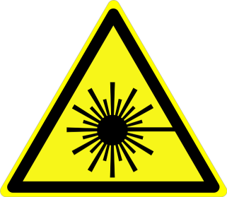 | LASER REGISTRATION FORM
Instructions: All Class 3b and 4 lasers are required to be registered with the University of Delaware Laser Safety Committee. Complete this form for each laser to be registered and forward to

Laser Safety Officer, Environmental Health and Safety FAX: 831-1528

Principal Investigator: |  | Phone:

Laser Manufacturer:

Model Name/Number:

Serial Number:

UD Property Tag Number:

Laser Location:
 | Building | Department | Room Number

Laser Type (Nd:YAG, HeNe, etc):

Classification (3b or 4):

Wavelength(s) (nm):

Beam Diameter at laser output (mm):

Beam Divergence (mrad):

Continuous Wave: | Average Power (Watts):
or
Repetitively Pulsed: | Energy (Joules per pulse):
 | Pulse duration (s):
 | Pulse repetition frequency (Hz):
or
Single Pulse | Pulse duration (s):
 | Energy (Joules per pulse):

Purpose or Use:

Comments:

Principal Investigator’s Signature |  | Date

